REPUBLIC OF GHANA



ENVIRONMENTAL PROTECTION AGENCY/MINISTRY OF ENVIROMENT SCIENCE TECHNOLOGY AND INNOVATION

MINISTRY OF LANDS AND NATURAL RESOURCES

GHANA LANDSCAPE RESTORATION AND SMALL-SCALE MINING PROJECT
(P171933)

ENVIRONMENTAL AND SOCIAL MANAGEMENT FRAMEWORK (ESMF)

APRIL 2021

LIST OF FIGURES iv
LIST OF TABLES iv
LIST OF ABBREVIATIONS AND ACRONYMS v
EXECUTIVE SUMMARY vii
1.0 INTRODUCTION 1
1.1 Background 1
1.2 Scope and Objectives of the ESMF 2
1.3 Methodology for Preparing the ESMF 2
1.4 Project Description 3
1.5 Description of Project Location 4
1.6 Key Project Implementing Agencies 6
2.0 ENVIRONMENTAL AND SOCIAL CHARACTERISTICS OF PROJECT LOCATION 9
2.1 Northern Savannah 13
2.2 Forest and Transition-Zone (South-Central) 14
2.3 Environmentally Sensitive and Protected Areas 16
2.4 Socio-Economic Characteristics of ASM 17
3.0 RELEVANT LAWS, REGULATIONS AND POLICIES 23
4.0 ENVIRONMENTAL AND SOCIAL RISKS AND IMPACTS 32
4.1 Positive Environmental and Social Impacts of Landscape Restoration and ASM Activities 32
4.1.1 Positive Environmental Impacts 32
4.1.2 Positive Social Impacts 32
4.1.3 Positive Impacts Associated with Reclamation of Degraded Lands 33
4.2 Potential Negative Environmental and Social Risks and Impacts 33
4.2.1 Negative Environmental Impacts 33
4.2.2 Negative Social Impacts 34
4.3 Potential Unintended E&S Impacts of Expanding the Stock of Minable Land for ASM 35
4.4 Identified Potential Risk/Impacts of Project Activities and Mitigation Measures 37
4.5 Negative Lists 47
5.0 ENVIRONMENTAL AND SOCIAL PROCEDURES 48
5.1 Instruments Anticipated 48
5.2 Environmental and Social Screening Process 48
5.3 Environmental and Social Procedure for ASM Reclamation Activities 56
5.4 Cultural Heritage 58
5.5 Labour Management Procedures 60
5.6 Incident and Accident Reporting 61
5.7 Grievance Mechanism 62
5.7.1 Grievance Redress Structure 62
5.7.2 Grievance Resolution Procedure 63
6.0 PUBLIC CONSULTATIONS, PARTICIPATION AND INFORMATION DISCLOSURE 67
6.1 Objective and Purpose for Stakeholder Engagement and Consultation 67
6.2 Stakeholder consultations 67
6.2.1 Consultation with Municipal and District Assemblies on Landscape Restoration 67
6.2.2 Consultation with Communities 68
6.3 Framework for Sub-Project level Consultations 69
6.4 Dissemination and Public Disclosure of ESMF and ESIAs/ESMPs 70
7.0 MONITORING AND REPORTING 71
7.1 Environmental and Social Monitoring and Reporting 71
7.1.1 E&S Monitoring 71
7.1.2 Environmental and Social Reporting 71
8.0 MANAGEMENT FOR ESMF IMPLEMENTATION 73
8.1 Institutional/Implementation Arrangement 73
8.2 Institutional Strengthening and Capacity Building for ESMF Implementation 75
8.2.1 Capacity Building at National Level 76
8.2.2 Capacity Building at District Level 76
8.2.3 Capacity Building at Local Level 76
8.3 Financial Resources 78
ANNEXES 79
Annex 1: GLSSMP Detail Sub-Components and Activities 79
Annex 2 National Legal &Policy Framework and World Bank ESF 84
Annex 3: Description of Implementation Arrangements 100
Annex 4A: Environmental and Social Safeguards Screening Checklist for SLWM (Component 3) subprojects 106
Annex 4b: GLRSSMP Activity Screening Form for all other project activities 110
Annex 5a: Environmental and Social Management and Monitoring Guidelines during Project Implementation 117
Annex 5b: Results of physico-chemical analysis and Transparency of water samples at the various stations 120
Annex 6: Template for Semi-Annual Environmental and Social Reporting 122
Annex 7a: Responsibilities of E&S Specialists and Focal Points 123
Annex 7b: LABOUR MANAGEMENT PROCEDURES 124
Annex 8: Draft Terms of Reference for ESMP 135
Annex 9: Draft Terms of Reference for ESIA 137
Annex 10: Draft Terms of Reference for Biodiversity Management Plan (BMP) 139
Annex 11: Evidence of Community Engagements and Consultations 141
Annex 12: Complaints Submission Form 149
Annex 13 Grievance Register 152
Annex 14: Target Wildlife Protected Areas and Forest Reserves 153
Annex 15: Incident Reporting Form and Types of Incidents to be Reported 161
Appendix 16: INTEGRATED PEST MANAGEMENT PLAN(IPMP) 166

LIST OF FIGURES
Figure 1 : Project Districts location Map 5
Figure 2: Agro-ecological Zones in Ghana 10
Figure 3:Disregard for Health and Safety Issues at ASM Site, an ASM operator descending and working 20
Figure 4 : Sub-Surface Hard Rock Miners in Ghana at The Entrance of an Excavated Mine Shaft. 37
Figure 5:Environmental and Social Screening Process 53
Figure 6: A flow chart showing criteria for site selection and possible reclamation 60
Figure 7: Grievance Mechanism Flowchart 69
Figure 8 : Map of Environmentally Sensitive and Protected Areas - 161 -

LIST OF TABLES

Table 1: Key Implementing and Beneficiary Agencies, Mandates and Roles 6
Table 2 : Regional and District Profile 11
Table 3 : Gap Analysis – Comparison of Ghana’s Regulations/Policies and World Bank ESF for Handling Environmental and Social Risks 24
Table 4: Summary Mitigation and Monitoring Plan for GLRSSMP Activities 39
Table 5:Grievance Redress Roles 66
Table 6:Grievance Priority Classification 67
Table 7: Grievance Actions 68
Table 8. Roles and Responsibilities of Management and Key Actors in ESMF Implementation 77
Table 9:Summary of Environmental and Social due Diligence Capacity and Training Programs 79
Table 10:Estimated Cost of Implementing ESMF for Project Duration 81
Table 11:International Treaties, Conventions and Protocols Applicable to Project 96

LIST OF ABBREVIATIONS AND ACRONYMS

AFDB African Development Bank
AFR African Forest restoration
ARAP Abbreviated Resettlement Action Plan
ASM Artisanal and Small-Scale Mining
BMP Biodiversity Management Plan
CBD Convention on Biological Diversity
CERC Contingency Emergency Response Component
CFI Cocoa Forest Initiative
CMS Convention on Migratory species
COCOBOD Ghana Cocoa Board
CREMA Community Resource Management Area
CSA Civil Service Act
CSIR Council for Scientific and Industrial Research
CWMT Community Watershed Management Team
DADU Department of Agriculture District Unit
DSC Directorate of Crop Services
DWMT District Watershed Management Team
E&S Environmental and Social
EA Environmental Assessment
EI Executive Instrument
EIA Environmental Impact Assessment
EITI Extractive Industries Transparency Initiative
EPA Environmental Protection Agency
ESF Environmental and Social Framework
ESHS Environmental Social Health and Safety
ESIA Environmental and Social Impact Assessment
ESIS Environmental and Social Impact Statement
ESMF Environmental and Social Management Framework
ESMP Environmental and Social Management Plan
ESRC Environmental and Social Risks Classification
ESS Environmental and Social Standards
FASDEP Food and Agriculture Sector Development Policy
FC Forestry Commission
FDMP Forest Development Master Plan
FIP Forest Investment Programme
FSD Forestry Services Division
GAEC Ghana Atomic Energy Commission
GBV Gender Based Violence
GDP Gross Domestic Product
GHG Greenhouse Gases
GLSSMP Ghana Landscape and Small-Scale Mining Project
GoG Government of Ghana
GPRS Ghana Poverty Reduction Strategy
GRM Grievance Redress Mechanism
GRR Gbele Resource Reserve
IA’s Implementing Agencies
ICR Implementation Completion Report
IDA International development Association
IPM integrated Pest Management
ISR Implementation Supervision Report
LC Lands Commission
LRP Land Registration Policy
LUSPA Land use and Spatial Planning Authority
MC Minerals Commission
MDA Municipal and District Assemblies
MESTI Ministry of Environment, Science, Technology and Innovation
METASEP Medium Term Agricultural Sector Investment Plan
MLGRD Ministry of Local Government and Rural Development
MLNR Ministry of Lands and Natural Resources
MOF Ministry of Finance
MOFA Ministry of Food and Agriculture
MOGCSP Ministry of Gender, Children and Social protection
MTDP Medium Term Development Plan
NBA National Bio Safety Authority
NCCP National Climate Change Policy
NGO Nom Governmental Organization
NTEPs Non-Traditional Forest Products
PAP’s Project Affected Persons
PCU Project Coordinating Unit
PDO Project Development Objective
PMMC Precious Minerals Marketing Company
PMP Pest Management Plan
PSC Project steering Committee
RAP Resettlement Action Plan
REDD Reducing Emissions from Deforestation and Degradation
RPF &PF Resettlement Policy Framework and Process Framework
SEA Sexual Exploitation and Abuse
SLWM Sustainable Land and Water Management
SLWMP Sustainable Land and Water Management Project
SPSC Sub-Project Steering Committee
TCO Technical Coordinating Office
UMaT University of Mines and Technology
VPA Voluntary Partnership Agreement
WB World Bank
WD Wildlife Division
WRC Water Resources Commission or World Resources Institute

EXECUTIVE SUMMARY
Ghana’s rural economy is highly dependent on the agriculture and forestry sectors, thus making land resources including agricultural lands, forests, natural habitats, and water bodies critical for growth. The Forestry and agriculture sectors, including cocoa production, account for more than 53 percent of land use and employ about 60 percent of the population, including 53 percent of women. Cocoa has been the backbone of the economy for decades. An estimated 800,000 farmer households directly depend on cocoa production for their livelihoods. Nationally, the potential of the forest and land management sector to contribute to the economy and job creation is challenged by severe land degradation and competing land use due to expansion of agricultural activities into forest landscapes.

Ghana’s artisanal and small-scale mining industry comprises both a formalized segment of licensed operators and an illegal segment of miners working without required permits. In parallel to the 15 large-scale mining operations, which produce about 60% of the national gold output, the Artisanal and Small-Scale Mining (ASM) subsector includes about 1,300 registered small operations. Illegal operators are estimated to account for the same or even a higher number of businesses. It is estimated that approximately one million people in Ghana are engaged in ASM on full or part-time basis, placing it as the second-most important source of job creation after agriculture. As of 2018, the ASM subsector generated approximately 30 percent of total revenue from mining. ASM accounts for the entire diamond production of Ghana and 43 percent of total gold production.

Unsustainable agriculture and mining contribute significantly to land degradation. Annual cost of land degradation is high. Recent published assessments show that the total annual cost of environmental degradation is estimated at US$6.29 billion — this is equal to 10.7 percent of the national GDP in 2017. A considerable share of this cost is attributed to agricultural land degradation which is estimated at average annual of US$0.54 billion equal to 0.9 percent of country’s GDP. The total annual cost attributed to ASM-related mercury exposure is estimated at US$240 million, or 0.4 percent of 2017 GDP. A recent study estimates that US$250 million is required just for the Western Region to restore lands and water bodies destroyed by illegal ASM (colloquially called “galamsey”). The costs of action to address land degradation are often several times lower than those of inaction. Regardless, land degradation is persisting, due to inadequate levels of investments in sustainable land and water management.

Project Description
The development objective of the Ghana Landscape Restoration and Small-Scale Mining Project (GLRSSMP) is to strengthen integrated natural resource management and increase benefits to communities in targeted savannah and cocoa forest landscapes.

The project’s total financing is US$102.76 million, financed by the World Bank’s International Development Association (US$75 million credit), the Global Environment Facility (US$12.76 million grant), and the PROGREEN Multidonor Trust Fund (US$15 million grant).

Specifically, the project will be implemented through the following components:

Component 1: Institutional Strengthening of Governance for Participatory Landscape Management - : The component aims to strengthen the planning and policy framework at the sub-national level by carrying out spatial planning and implementation, policy support and capacity-building, working with administrative and technical agencies within the regions and districts that are within the sub-basins in the project area. This component will also enhance multi-purpose land and water management models at central level through acquisition of remote sensing data and airborne geo-physics which will allow new layers of data to be added to modelling exercises. This component includes support for integrated landscape management planning and fostering partnerships to support adoption of sustainable landscape management approaches at scale within project areas.

It will also support effective monitoring of sustainable cocoa production through the use of this improved Forest Monitoring System to ensure compliance with the cocoa standards; this will include training of the COCOBOD and FC staff as well as decision-makers. This activity will help ensure that the footprint of forest loss and degradation due to cocoa development is being reduced and adequately monitored. This will address an existing need to harmonize efforts by diverse partners operating in the landscape and monitor compliance with agreed standards of sustainable cocoa production.

Component 2: Enhanced governance in support of sustainable ASM - This component aims to strengthen the regulatory framework for ASM, with a focus on modernizing regulatory instruments and building the capacity of key government agencies involved in ASM regulation and compliance monitoring (such as Minerals Commission (MC), Forestry Commission (FC), and Environmental Protection Agency (EPA) as well as District Mining Committees. It will also support ASM formalization through appropriate registration of ASM permits, streamlining ASM administration, mainstreaming ASM in sector reporting and enhancing district capacity to manage ASM.

Component 3: Sustainable Crop and Forest Landscape Management - The component aims to link improved food production and ecological integrity. The component activities will support sustainable production practices for key food crops; sustainable water and land management interventions supporting silvopastoral and riparian vegetation establishment activities; value chains for key commodity crops including cocoa and shea; value-addition for food crops; financial mobilization for sustainability of established interventions; and income generation and income diversification at community level with a view to integrated natural resource management in target cocoa, savannah and forest transition zone landscapes.

This component will also aim to establish and scale up forest landscape restoration activities in the target landscapes, focusing on enhancing forest cover and management and restoration of mined-out sites. This component will primarily focus on scaling up the interventions within forest landscapes based on the lessons learnt from SLWMP (in Northern Savannah region) and ongoing work in the Forest Investment Programme (FIP) the cocoa landscapes (in the Transition Zone). The target areas under this component will include forested landscapes within protected areas and their buffer zones, and off-reserve areas within the biological corridors, managed by the communities, including under the Community Resource Management Area (CREMA) arrangements.

Component 4. Monitoring and Project and Knowledge Management: - This component aims to support: robust project management and implementation (including financial, internal audit and procurement management, monitoring and evaluation, safeguards supervision, implementation and monitoring of the grievance redress mechanism, monitoring implementation of the gender action plan, etc.); better communication outreach and dissemination; appropriate stakeholder engagement; and adequate knowledge management.

Component 5. Contingent Emergency Response - A Contingent Emergency Response Component (CERC) with zero allocation will be created and made implementation-ready to allow the GoG to respond quickly in case of an eligible emergency. The mechanism will be defined in a specific CERC Operational Manual that will clearly outline the triggers, eligible expenditures, procurement thresholds, and procedures for using part of IDA resources of the project to respond quickly in the event of an eligible emergency.
The project will be implemented in the Northern Savannah Zone (North East, Savannah, Upper East, Upper West Regions) and the South-Central Region (Western, Eastern and Central and Ashanti Regions). The project will also support conservation and restoration activities in the Gbele Resource Reserve (GRR), Mole National Park (MNP), and Digya National Park (DNP) and fringe communities around these protected areas as well in the Community Resource Management Area (CREMA) areas in target wildlife corridors (Western Wildlife Corridor, Eastern Wildlife Corridor, and Digya-Kogyae Wildlife Corridor).

The main beneficiaries of the proposed project are small-scale crop farmers investing in improved practices for crop production and landscape planning and management and ASM operators who will benefit from enhanced productivity due to formalization, introduction of new technologies, and alternative livelihoods support. Also, communities living in areas impacted by ASM activities will benefit from better environmental and social stewardship. The target communities will enjoy multiple benefits due to participation in the planning and management of the resources, improved yields for subsistence and cash crops, higher incomes as a result of better value addition, and enhanced ecosystem services provided by the landscapes, such as watershed protection, better water availability and quality, and reduced soil erosion. Support to livelihoods activities will create gainful employment. The tourism-related benefits will accrue to both the protected areas system and the neighboring communities.

The landscape restoration activities, including sustainable land and water management (SLWM) activities, will build on lessons learnt of the Sustainable Land and Water Management Project (SLWMP).

SLWM means specific farm level activities such as appropriate land preparation, crop rotation, mixed cropping, inter cropping, contour ploughing, tree growing, agroforestry systems and water harvesting systems implemented to ensure sustainable production from the piece of land.

SLWMP is the Sustainable Land and Water Management Project designed to support the promotion and adoption of SLWM practices in the landscape. As usual, it goes beyond the implementation of SLWM activities to cover coordination, monitoring, fiduciary and other administrative issues to ensure the successful implementation of management and field level activities.

Objective of Environmental and Social Management Framework (ESMF)
The objective of the ESMF is to provide a general impact identification framework to assist project implementers to screen the project activities and institute measures to address adverse E&S impacts. Specifically, the ESMF will: (a) help assess the potential adverse E&S impacts commonly associated with the sub-projects and the way to avoid, minimize or mitigate them; (b) establish clear procedures and methodologies for the E&S planning, review, approval and implementation of sub-projects; (c) establish an E&S assessment screening process; and (d) Specify the roles and responsibilities and the necessary reporting procedures for managing and monitoring sub-project E&S concerns.

Policies, Regulations and Standards
The key national laws policies, regulations related to environmental and social impact assessment, public consultation and engagement for projects such as the GLRSSMP includes the 1992 Constitution of the Republic of Ghana, the Environmental Protection Agency (EPA) Act (Act 490), the Environmental Assessment Regulation – Legislative Instrument (LI) 1652, the Right to Information (RTI) Act (Act 989), the National Environmental Policy (2010), the National Climate Change Policy (2013), Forest and Wildlife Policy, 2012 (draft), the Forestry Commission Act of 1999 (Act 571), the National Mining Policy –June 2007 (draft), Mining and Minerals Act of 2006 (Act 703), Food and Agriculture Sector Development Policy (FASDEP), Medium Term Agriculture Sector Investment Plan (METASIP), the Local Governance Act, 2016 (Act 936), the Land Use and Spatial Planning Act 2016 (Act 925), and the Labour Act 2003 (Act 651).

The Environmental and Social Framework (ESF) of the WB will guide the design and implementation of the project. The project also will comply with all the relevant legal requirements in Ghana. Under the ESF, the Environmental and Social Risk Classification (ESRC) for the project is substantial and the project design and implementation will particularly be governed by eight (8) of the ten (10) Environmental and Social Standards (ESS) which are currently relevant for this project. These include: (ESS1) Assessment and Management of Environmental and Social Risks and Impacts, (ESS2) Labor and Working Conditions, (ESS3) Resource Efficiency and Pollution Prevention and Management, (ESS4) Community Health and Safety, (ESS5) Land Acquisition, Restrictions on Land Use and Involuntary Resettlement, (ESS6) Biodiversity Conservation and Sustainable Management of Living Natural Resources, (ESS8) Cultural Heritage, and (ESS10) Stakeholder Engagement. ESS6-Indigenous Peoples/Sub-Saharan African Historically Underserved Traditional Local Communities, and ESS9-Financial Intermediaries, are not relevant to this project since there are no Indigenous Peoples in Ghana and the project does not include financial intermediaries respectively.

Environmental and Social Impacts
Overall, the project will have positive impacts as it will support conservation and land restoration for improved food and ecosystem services in the targeted savannah and cocoa and degraded landscapes. It will also promote the sustainable management of natural resources and enhance the livelihoods of local communities depending on these natural resources. Planning tools will allow a more balanced and sustainable co-existince of ASM, forestry and agro-business. Good practices of small-scale mining will promote less intrusive land and water usages and will also introduce principles of rehabilitation and repurposing of mined-out areas. The potential adverse impacts of the proposed project, which were identified through this E&S assessment process, include loss of flora and fauna, disturbance to ecosystem and loss of natural habitat, soil and water contamination associated with ASM and the use of agro-chemicals, disturbance to wildlife from ecotourism activities, air and noise pollution, sexual exploitation and abuse (SEA) and sexual harassment (SH), and differentiated impacts on gender and other vulnerable groups (i.e. persons with disabilities) etc.

Mitigation Measures
The ESMF considered a number of mitigation and enhancement measures and principles for implementation to enhance the social acceptability, environmental soundness and sustainability of the project. The principles and measures include the following: air quality control principles; health and safety principles; mitigation principles for impacts of activities on environment, labour influx control principles; socio-cultural conflicts prevention principles; gender and vulnerable groups impact mitigation principles; prevention of SEA/SH, stakeholder consultation and engagement and grievance mechanism.

Environmental and Social Screening Process
Environmental and social screening marks the beginning of risk management process for any planned activity. The screening shall be initiated as early as possible along with the activity planning process after the activity is conceived. The extent of environmental and social assessment that might be required to be carried out in respect of a proposed activity will depend on the outcome of the screening process.

The implementing agencies will have designated officers who will be directly responsible for carrying out preliminary screening of all sub-projects under the guidance of the Environmental Safeguard Specialists or Focal Point. The officers will complete the Environmental and Social Screening Forms.
Once the sites and activities are identified and screened during project implementation, the project may prepare the following instruments:
- Site specific Environmental and Social Management Plans (ESMPs)
- Site specific Environmental and Social Impact Assessments (ESIAs)
- Biodiversity Management Plan
- Resettlement Action Plans (RAPs) or Abbreviated RAP (ARAPs)

Grievance Mechanism
The grievance mechanism structure for the project has been developed from the existing grievance mechanism for resolving grievances under the Sustainable Land and Water Management Project (SLWMP), a decentralized and transparent system which ensured quick resolution of complaints and disputes. The GM will address concerns promptly, using an easy to understand and transparent process that is culturally appropriate and readily accessible and that meet the needs of the disadvantaged and vulnerable groups, and at no cost and without retribution. It will not impede access to the already established judicial and administrative remedies.

Monitoring and Reporting
The project implementing agencies will employ a monitoring and reporting framework in the execution of the ESMF. The framework sets specific indicators that will be monitored by the project on a regular basis in relation to the mitigation measures proposed in this ESMF.

Management for Implementation
The successful implementation of the ESMF depends on the commitment of implementing agencies and the capacity within these institutions and the appropriate and functional institutional arrangements among others. The key ESMF implementation areas and the relevant institutional roles as well as the institutional arrangement at national, regional, district, community levels and collaboration for successful implementation of the ESMF have been determined and outlined.

1.0 INTRODUCTION

1.1 Background

Ghana’s rural economy is highly dependent on the agriculture and forestry sectors, thus making land resources, including agricultural lands, forests, natural habitats, and water bodies critical for growth. Forestry and agriculture sectors, including cocoa production, account for more than 53 percent of land use and employ about 60 percent of the population, including 53 percent of women. Cocoa has been the backbone of the economy for decades. An estimated 800,000 farmer households directly depend on cocoa production for their livelihoods.

Skilled agricultural, forestry and fishery workers constitute the largest occupational group; these sectors form the main occupation for people in the rural localities. Thus, there is a need to focus on reforms which promote labor-intensive sectors, such as agriculture and forestry which have the potential to be one of the leading sectors for a more diverse economy due to large multiplier effect for job creation. Nationally, the potential of the forest and land management sector to contribute to the economy and job creation is challenged by severe land degradation and competing land use due to expansion of agricultural activities into forest landscapes.

Unsustainable agricultural and mining practices contribute significantly to land degradation. Annual cost of land degradation is high. Recent published assessments show that the total annual cost of environmental degradation is estimated at US$6.29 billion equal to 10.7 percent of the national GDP in 2017. A considerable share of this cost is attributed to agricultural land degradation which is estimated at average annual of US$0.54 billion equal to 0.9 percent of country’s GDP. The total annual cost attributed to ASM-related mercury exposure is estimated at US$240 million, or 0.4 percent of 2017 GDP. A recent study estimates that US$250 million is required to restore lands and water bodies destroyed by illegal ASM (colloquially called “galamsey”) in the Western Region alone. The costs of action to address land degradation are often several times lower than those of inaction. Regardless, land degradation is persisting, due to inadequate levels of investments in sustainable land and water management.

Ghana’s artisanal and small-scale mining industry comprises both a formalized segment of licensed operators and an illegal segment of miners working without required permits. In parallel to the 15 large-scale mining operations, which produce about 60% of the national gold output, the Artisanal and Small-Scale Mining (ASM) subsector includes about 1,300 registered small operations. Illegal operators are estimated to account for the same or even a higher number of businesses. It is estimated that approximately one million people in Ghana are engaged in ASM on full or part-time basis, placing it as the second-most important source of job creation after agriculture. As of 2018, the ASM subsector generated approximately 30 percent of total revenue from mining. ASM accounts for the entire diamond production of Ghana and 43 percent of total gold production.

The Government of Ghana (GoG) with support of the World Bank (WB) under the proposed Ghana Landscape Restoration and Small-Scale Mining Project (GLRSSMP) will: (a) support restoration of degraded lands for agricultural productivity; (b) strengthen sustainable management of forest landscapes for biodiversity conservation and ecosystem services; (c) support formalization of illegal ASM for sustainable mining; and (d) support land use planning for integrated landscape management to optimize land use to land characteristics. Specifically, the project will be implemented through the following components: (1) Institutional Strengthening of Governance and Partnerships for Participatory Landscape Management (2) Regulatory strengthening and formalization of sustainable ASM, (3) Investments for Sustainable Crop Management and Production, (4) Forest Landscape Management and Restoration, (5) Landscape Monitoring and Project and Knowledge Management, and (6) Contingency Emergency Response.

1.2 Scope and Objectives of the ESMF
The ESMF describes the process of how environmental and social impacts will be addressed and managed during the project implementation, when technical aspects and location of project activities will be identified, measures for mitigation, monitoring and institutional responsibilities that should be taken during project implementation to manage environmental and social impacts. It covers general mitigation measures for possible impacts of different proposed activities to be supported by the GLRSSMP, implementation arrangements for project environmental and social aspects, relevant capacity building activities and consultation processes.

The objectives of the ESMF are to:
- Establish procedures for screening all proposed investments and identifying the initial environmental and social risks
- Specify measures to manage, mitigate and monitor environmental and social impacts throughout the project lifespan
- Develop project tailored capacity building plan based on the assessment of existing institutional capacity on environmental and social management

Specifically, the ESMF will:
- Assess the potential adverse E&S impacts commonly associated with the projects activities and the way to avoid, minimize or mitigate them;
- Establish clear procedures and methodologies for the E&S planning, review, approval and implementation of projects activities;
- Develop an E&S assessment screening process;
- Specify the roles and responsibilities and the necessary reporting procedures for managing and monitoring sub-project E&S concerns; and
- Establish capacity building and training requirements in support of implementation of this ESMF.
A Resettlement Policy Framework and Process Framework (RPF&PF) and a Stakeholder Engagement Plan (SEP) were also prepared for the project. The RPF&PF aims to clarify resettlement principles, organizational arrangements, and design criteria to be applied to project activities that would involve involuntary resettlement as well as establish a process by which members of communities potentially affected by restrictions of access in legally gazetted national parks and forest reserves can participate in design of project components, in accordance with principles of ESS5 Land Acquisition, Restrictions on Land Use and Involuntary Resettlement. The SEP defines an approach and process to stakeholder engagement as part of the GLRSSMP.

1.3 Methodology for Preparing the ESMF
This ESMF has been prepared in accordance with the ESF and Ghana’s laws and regulations. The process involved participatory public consultations and discussions with relevant sector institutions and data collection and analysis, and reviews of relevant project documents including the following:
- Concept papers of the project
- The PAD and PIM documents for the Sustainable Land and Water Management Project (SLWMP)
- The PAD and PIM for the Ghana Landscape Restoration and Small-Scale Mining Project (P171933)
- Safeguards reports on field activities of the SLWMP
- World Bank ESF document
- Aide memoires
- ESMF documents prepared for other related projects
- Environmental and Social screening and scoping studies;
- Field visits were carried out to introduce the concept of the project, seek their support and collect their inputs into the ESMF preparation;
- Determination of potential impacts; Identification of impacts mitigation measures; Preparation of an Environmental and Social Management Plan; and Preparation of sub-project guidelines.
- Workshops
- Review of comments from stakeholders; and
- Preparation and submission of reports

1.4 Project Description

The project will focus on the following core interventions: (a) restoration of degraded lands for agricultural productivity; (b) strengthening sustainable management of forest landscapes for biodiversity conservation and ecosystem services; (c) formalization of ASM for sustainable mining; and (d) land use planning for integrated landscape management to optimize land use to land characteristics. In light of the recent COVID-19 pandemic the project support will have additional relevance for local communities through land and livelihoods resilience. For example, the informal nature of ASM and the low barriers to entry mean that there is a risk of increased ASM activity in response to the economic impact of the COVID-19 on the formal economy. The formalization efforts, and alternate livelihoods support through the project will help mitigate some of the risks associated with informal ASM activities. Coordinated action would deliver a complementary range of environmental and economic benefits related to better functioning and more resilient ecosystems, and the protected areas, wildlife, mining, production, protection, and tourism opportunities. The project will be implemented through the following Components:

Component 1: Institutional Strengthening for Participatory Landscape Management: The component aims to strengthen the planning and policy framework at the sub-national level by carrying out spatial planning and implementation, policy support and capacity-building, working with administrative and technical agencies within the regions and districts that are within the sub-basins in the project area. This component will also enhance multi-purpose land and water management models at central level through acquisition of remote sensing data and airborne geo-physics which will allow new layers of data to be added to modelling exercises. This component includes support for integrated landscape management planning and fostering partnerships to support adoption of sustainable landscape management approaches at scale within project areas.

It will also support effective monitoring of sustainable cocoa production through the use of this improved Forest Monitoring System to ensure compliance with the cocoa standards; this will include training of the COCOBOD and FC staff as well as decision-makers. This activity will help ensure that the footprint of forest loss and degradation due to cocoa development is being reduced and adequately monitored. This will address an existing need to harmonize efforts by diverse partners operating in the landscape and monitor compliance with agreed standards of sustainable cocoa production.

Component 2: Enhanced governance in support of sustainable ASM - This component aims to strengthen the regulatory framework for ASM, with a focus on modernizing regulatory instruments and building the capacity of key government agencies involved in ASM regulation and compliance monitoring (such as Minerals Commission (MC), Forestry Commission (FC), and Environmental Protection Agency (EPA) as well as District Mining Committees. It will also support ASM formalization through appropriate registration of ASM permits, streamlining ASM administration, mainstreaming ASM in sector reporting and enhancing district capacity to manage ASM.

Component 3: Sustainable Crop and Forest Landscape Management - The component aims to link improved food production and ecological integrity. The component activities will support sustainable production practices for key food crops; sustainable water and land management interventions supporting silvopastoral and riparian vegetation establishment activities; value chains for key commodity crops including cocoa and shea; value-addition for food crops; financial mobilization for sustainability of established interventions; and income generation and income diversification at community level with a view to integrated natural resource management in target cocoa, savannah and forest transition zone landscapes.

This component will also aim to establish and scale up forest landscape restoration activities in the target landscapes, focusing on enhancing forest cover and management and restoration of mined-out sites. This component will primarily focus on scaling up the interventions within forest landscapes based on the lessons learnt from SLWMP (in Northern Savannah region) and ongoing work in the Forest Investment Programme (FIP) the cocoa landscapes (in the Transition Zone). The target areas under this component will include forested landscapes within protected areas and their buffer zones, and off-reserve areas within the biological corridors, managed by the communities, including under the Community Resource Management Area (CREMA) arrangements.

Component 4. Monitoring and Project and Knowledge Management: - This component aims to support: robust project management and implementation (including financial, internal audit and procurement management, monitoring and evaluation, safeguards supervision, implementation and monitoring of the grievance redress mechanism, monitoring implementation of the gender action plan, etc.); better communication outreach and dissemination; appropriate stakeholder engagement; and adequate knowledge management.

Component 5. Contingent Emergency Response - A Contingent Emergency Response Component (CERC) with zero allocation will be created and made implementation-ready to allow the GoG to respond quickly in case of an eligible emergency. The mechanism will be defined in a specific CERC Operational Manual that will clearly outline the triggers, eligible expenditures, procurement thresholds, and procedures for using part of IDA resources of the project to respond quickly in the event of an eligible emergency.

1.5 Description of Project Location
The project will be implemented in the Northern Savannah Zone (North East, Savannah, Upper East, Upper West Regions) and the South-Central Region (Western, Eastern, Bono East, Central and Ashanti Regions).
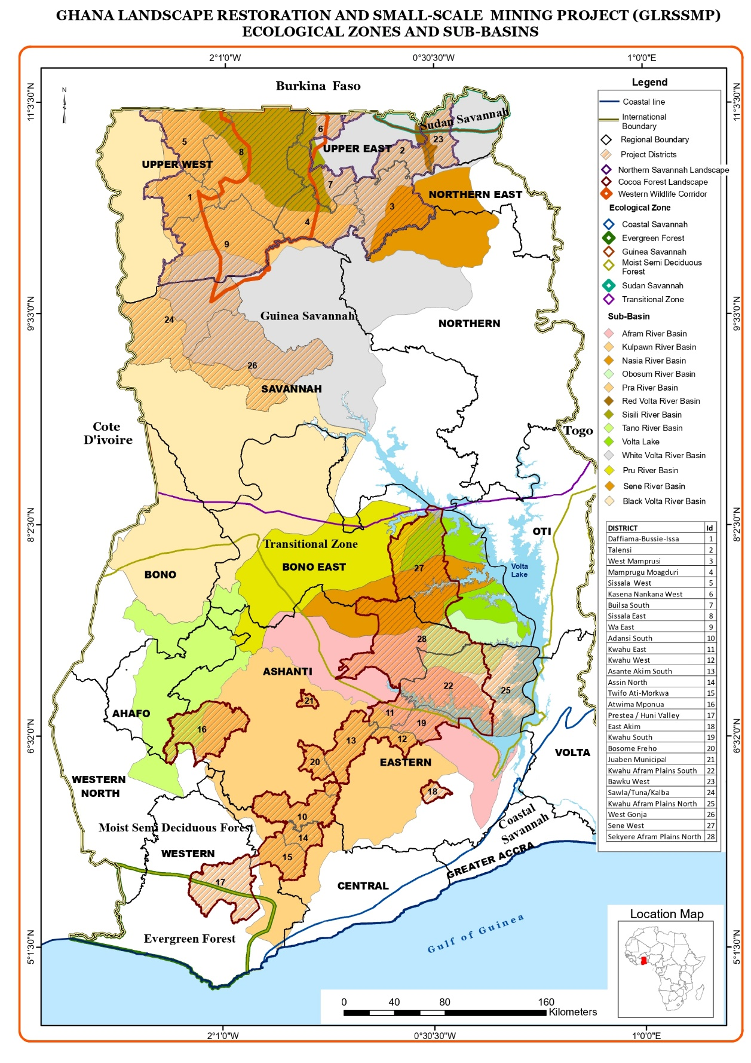
Figure 1 : Project Districts location Map

In the Northern Savannah Region, project area will fall mainly within the Guinea and Sudan Savannah Zones of Ghana. Project activities will focus on the sub-watersheds of two Volta River tributaries flowing into the country from Burkina-Faso in order to concentrate impacts and affect outcomes at the sub-watershed level. The Kulpawn-Sisilli and the Red Volta sub-watersheds have been prioritized due to sustainable land and water management needs, high poverty and presence of biodiversity corridors and newly established Community Resources Management Areas (CREMAs).

In the South-Central Region, the project area will be located within the forest and the transitional zone where the Pra basin is located, one of the most intensively used basins in Ghana for settlement, agriculture, logging and mining. The total Basin area is approximately 23,200 km² and it extends through almost 55 percent of Ashanti, 23 percent of Eastern, 15 percent of Central, and 7 percent Western Regions of Ghana. The Pra Basin falls within the Upper Guinean rainforest, which has been recognized as a global biodiversity hotspot due to a high presence of endemic species. Nationally, the Ashanti region, which covers more than half of the Basin, is the second largest producer of cocoa beans in Ghana and an area with substantial active ASM.

Project target areas include 28 rural districts as per below – the target districts were selected based on their location within biological corridors and land degradation and illegal mining pressures. Districts in the Northern Savannah Zone have been prioritized based on their potential to intensity successful impacts achieved under the ongoing World Bank funded Sustainable Land and Water Management Project. Districts in the Transitional Forest Zone have been prioritized based on feasibility of success based on results from ongoing initiatives. Specific intervention areas for implementation of project activities within these districts will be selected using criteria developed during project preparation and included in the Project Implementation Manual. The target areas for capacity building of sustainable mining practices will be determined on the basis of baseline assessments and preparatory studies in the early stages of project implementation. Figure 1 shows the specific regions and districts of the project areas.

1.6 Key Project Implementing Agencies

There will be two implementing agencies under the project – the Environmental Protection Agency (leading engagement on the landscape restoration activities) and the Ministry of Lands and Natural Resources (leading engagement on the ASM formalization activities). The Implementing Agencies will work with a number of other sectoral agencies (Beneficiary Agencies). Table 1 describes the Key Project Implementing Agencies and Beneficiary Agencies, their mandate, and role in the project.
Table 1: Key Implementing and Beneficiary Agencies, Mandates and Roles
Implementing Agencies | Institutional Mandate and Activities | Role in the Project
Landscape restoration
IMPLEMENTING AGENCY  Environmental Protection Agency (EPA) | EPA is the lead implementing agency for the landscape restoration activities under the project and will provide a coordination and monitoring role in the implementation. EPA is the principal institution established for environmental protection in Ghana, created under the Environmental Protection Agency Act, 1994 (Act490). The EPA's policy direction is articulated by the Environmental Assessment Regulations, 1999 (LI1652). These two pieces of legislation mandate the EPA to manage, control and monitor compliance of environmental regulations by specific industries. The EPA has an important role in the project implementation as the lead environmental regulator, which oversees compliance with environmental assessment requirements, facilitate public participation and disclosure and issue environmental permits for the project. The EPA has the mandate to decide on project screening, guide the conduct of the environmental assessment studies and to grant environmental approval for the project to commence. Its mandate also covers monitoring of implementation phase of the project to confirm compliance with approval conditions, mitigation measures, and other environmental commitments and quality standards. | The Project Coordinating Unit – Landscape Restoration (PCU-LR) will be housed within the EPA Headquarters with a full-time coordinator, and other relevant staff, and will amongst others, to manage and coordinate operations of implementing agencies, preparation of workplans and reporting. EPA will lead activities on integrated landscape management planning, demonstration of policy measures and incentives for innovation to enable upscaling of restoration activities, and sustainable production and value chains within the landscape and incentives for watershed services provision.
BENEFICIARY AGENCIES
Ministry of Environment, Science, Technology and Innovation (MESTI) | The ministry is mandated to have oversight responsibility to provide leadership and guidance for Environment, Science, Technology and Innovation within the broad sector of the economy through sound policy formulation and implementation. It ensures the establishment of the regulatory framework and setting of standards to govern the activities of science and technology and the management of the environment for sustainable development. MESTI also has the responsibility to analyze and coordinate all planned programs in the environment, science, technology and innovation sector of the economy for purposes of achieving a single integrated management system. MESTI is the lead implementing agency for the Sustainable Land and Water Management Project (P098538) and will ensure effective coordination and continuity of activities in the Savannah landscape. MESTI is the sector Ministry to which the Environmental Protection Agency reports to. | MESTI will have oversight responsibility for the coordination and implementation of landscape restoration activities.
Ministry of Food and Agriculture (MOFA) | MOFA promotes sustainable agriculture and thriving agribusiness through research and technology development, effective extension and other support services to farmers, processors and traders for improved livelihood. Its primary roles are the formulation of appropriate agricultural policies, planning & co-ordination, monitoring and evaluation within the overall national economic development. | Under the project, MOFA will lead and support DAs on activities relating to the development and implementation of participatory micro watershed / community level plans, Community subprojects: silvopastoral, rangelands, and water management investments.
Forestry Commission (FC) (Forest Service Division and Wildlife Division) | FC is the implementation arm of MLNR responsible for regulation, control and management of forest and wildlife resources, the conservation and management of those resources and the coordination of policies related to them. The Commission embodies the various public bodies and agencies that were individually implementing the functions of protection, management, the regulation of forest and wildlife resources. The FC has the following divisions:  - Forest Services Division (FSD);  - Wildlife Division (WD);  - Timber Industry Development Division (TIDD);  - Wood Industries Training Centre (Forestry Commission Training School);  - Resource Management Support Centre (RMSC) | Under the project, activities on forest management planning and investments in and around forest reserves will be implemented by the FSD while activities on management of wildlife protected areas and biological corridors will be implemented by the WD.
Ghana Cocoa Board (COCOBOD) | COCOBOD is responsible for the production, research, extension, internal and external marketing and quality control of cocoa, coffee, and shea nut. The functions are classified into two main sectors; Pre-harvest and Post-harvest. The Pre-harvest Sector functions are performed by the Cocoa Research Institute of Ghana (CRIG), the Seed Production Unit (SPU) and the Cocoa Swollen Shoot Virus Disease Control Unit (CSSVDCU) deal with fundamental issues on actual cocoa production at the farm gate level. The Post-Harvest Sector functions are undertaken by the Quality Control Division (QCD) and the Cocoa Marketing Company (CMC) Limited. The post-harvest activities of COCOBOD start with quality control measures of QCD which farmers must observe to facilitate the acceptance of their produce at the buying centers by the licensed buying companies engaged in internal marketing of cocoa at the time. | Under the project, COCOBOD will undertake activities to ensure improved cocoa production on moribund farms. As part of the community planning exercise of the project, COCOBOD will collate data for the cocoa management and farmer database system. This is to ensure and promote effective policy-making and delivery of interventions in the cocoa sector. This will assist in the building a strong biodata for cocoa farmers and a platform for effective management of cocoa beans and inputs sales and the deployment of subsidies to cocoa farmers.
Mining
IMPLEMENTING AGENCY  Ministry of Lands and Natural Resources (MLNR) | MLNR has the oversight responsibility for the land and natural resources sector and its functions include policy formulation, coordination, monitoring and evaluation, validation of policies, programmes and project, supervision of sector departments and agencies; and negotiations with development partners. The ministry is thus responsible for the management of Ghana's land, forests, wildlife and mineral resources.  MLNR is the lead implementing agency for the Ghana Forest Investment Program (FIP) - Enhancing Natural Forest and Agroforest Landscapes Project (P148183) and will ensure will ensure effective coordination between this project and the FIP. MLNR is the sector Ministry to which the Forestry Commission and Minerals Commission reports. | Under the project, the Project Coordinating Unit on Mining (PCU-Mining) will fall under the leadership of MLNR and will be responsible for project coordination, fiduciary management, and supervision of implementation, as appropriate. The PCU-Mining will coordinate closely with all Implementing Agencies of mining-specific project components.
BENEFICIARY AGENCIES
Minerals Commission (MC) | Minerals Commission has the responsibility to oversee regulation and management of the utilization of the mineral resources of Ghana, and to co-ordinate the policies in relation to them. The main functions of the MC include the following:  - formulate recommendations of national mining policies and monitor their implementation;  - monitor the operations of all bodies or establishments with responsibility for minerals and report to the Minister;  - receive and assess development agreements relating to minerals and report to Parliament;  - secure comprehensive data collection on national mineral resources; and  - perform such other functions as the Minister may assign to it.  A foremost responsibility of the MC is the administration of minerals rights. For this purpose, the MC maintains a cadastral system and a register of mineral rights. The various mining and mineral permits include reconnaissance license, prospecting license, and mining lease. Actual decisions in matters of mineral rights are taken by the Minister of Mining, but only after recommendation of the MC. | Under the project, MC will lead activities under the formalization of ASM sector and together with the EPA and FC, will lead activities on reclamation of mined out sites and waterways and alternative livelihoods.
Precious Minerals and Marketing Corporation (PMMC) | PMMC is mandated to purchase gold produced by small-scale miners through its licensed buyers; it has a network of 800 licensed merchants. | Under the project, PMMC will support activities on establishment and strengthening of ASM mining cooperatives, supply chains and marketing and operation of the assay center.
The EPA and FSD will be also implementing activities under the ASM components.

2.0 ENVIRONMENTAL AND SOCIAL CHARACTERISTICS OF PROJECT LOCATION

As indicated in section 1.5, the project will be implemented in the Northern Savannah and the South-Central Regions. This section describes the E&S baseline characteristics of the project area. The district/regional profile information of the GLRSSMP area of operation depicting the population, age structure, sex structure, land use pattern, economic activity, ethnicity, festivals, migration etc. is presented in a table 2 below.

Figure 2 presents the agro-ecological zones of Ghana. In common use (and for the purposes of this project) the Deciduous Forest zone is included in the Transitional Zone. The northern savannah region encompasses the agro-ecological zones of the Sudan and Guinea savannah whilst the south-central regions covers the transitional and the deciduous forest zones.

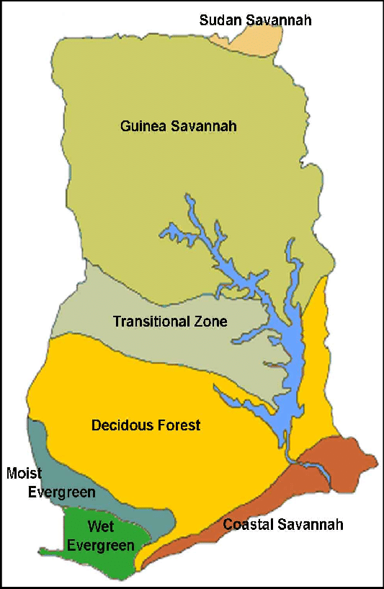
Figure 2: Agro-ecological Zones in Ghana

Table 2 : Regional and District Profile
Region | District | Population | Age  Structure |  |  | Sex  Structure |  | Landuse  Pattern | Economic  Activity | Income | Agriculture |  | Main Ethnicities | Religious  Group | Social  Cohesion | Festivals | Conflicts | Resolution  System | Housing |  | Migration |  | Poverty | Covid-19
Region | District | Population | Below  15 | 15-65 | Above  65 | M | F | Landuse  Pattern | Economic  Activity | Income | Cash  Crop | Food  Crop |  |  |  |  |  |  | House  Hold Size | Structure | Immi | Emmi | Poverty | Covid-19
Upper East Region | Talensi | 94, 793 | 41.5% | 52% | 6.5% | 46,556 | 48,237 | Agriculture Lands | Livestock rearing and Agriculture | - | Shea | Maize, Millet, Sorghum, groundnut, vegetables | Frafra | African traditional, Christians and Muslims | Strong | Gologo | No |  | 80.612 (1.) |  |  |  | High poverty among rural farmers
Upper East Region | Bawku West | 94, 043 | 45.2% | 47.9% | 6.9% | 45,114 | 48, 920 | Agriculture Lands | Trade and Agriculture  Livestock | - | Shea and Dawadawa | Maize, Sorghum, Millet, soyabean, yam, groundnut | Kusasis | African traditional, Christians and Muslims | Strong | Samanpiid | No |  | 15,169 (6.1 per household) | Mud/ Earth and Concrete | 5,033 |  | High poverty among rural farmers
Upper West Region | DBI | 38,008 | 42% | 51.2% | 6.5% | 18671 | 19337 | Agriculture Lands | Trade and Agriculture | - | Shea, Dawadawa | Maize, Sorghum, Millet, yam groundnut and vegetable | Dagaaba, Sissala | African traditional, Christians and Muslims | strong | Jimbenti and Dunyee | No |  | 5030 (6.4 per household) | Mud/ Earth and Concrete | 5,319 |  | High poverty among rural farmers
Upper West Region | Sissala East | 56,528 | 32.7% | 61.1%) | 6.2% | 27,529 | 28,999 | Agriculture Lands | Agriculture, Livestock |  | Shea, Dawadawa, cowpea | Maize, Sorghum, Millet, groundnut and Cassava | Sissala, Kasena, Moshie | African Traditional Religion, Christianity and Islam | Strong | Paragbielle | No |  | 8,652 (6.4 per household) | Concrete and Mud Brick | 45,335 |  | High poverty among rural farmers
Upper West Region | Wa East | 72,074 | 45% | 47.7% | 9.8% | 36,397 | 35,677 | Agriculture Lands | Agriculture, Industry and services |  | Shea | Maize, Sorghum, millet, groundnut, Yam | Funsi, Sissala, Gwolla | African Traditional Religion, Christianity and Islam | Strong | Tenghana | No |  | 10,768 (6.6 per household ) | Concrete and Mud Brick | 15,065 | - | High poverty among rural farmers
North East Region | West Mamprusi | 121, 117 | 45% | 48.1% | 6.9% | 59,590 | 61,527 | Agriculture lands | Trade and Agriculture | - | Shea | Maize, groundnut, sorghum,millet, Rice, Yam, vegetables | Mampusi, Kantosis and Comas | African Traditional Religion, Christianity and Islam | Strong | Damba | No |  | 14 432 (8.4 per household), | Mud/ Earth and Concrete | 6,038 |  | High poverty among rural farmers
Eastern Region | Kwahu West | 93,584 | 37.8% | 63.1%) | 5.2% | 44,875 | 48,709 | Agriculture Lands | Trade, Manufacturing, Fishing and Agriculture |  | Cocoa | Maize, Cassava, Plantain, Rice, Yam | Kwahu  Ewes | African Traditional Religion, Christianity and Islam | Strong | Kwahu Easter Festival | No |  | 23,296 (3.9 per household) | Concrete and Mud Brick | 21,858 | 15,873 | High poverty among rural farmers
Ashanti | Adansi  South | 69,593 | 15.60% | 78.80% | 4.60% | 34,563 | 35,029 | Agriculture,  settlement | Farming,  Fishing,  Livestock |  | Cocoa | Maize |  | African Traditional Religion, Christianity and Islam | strong | Akwasidayea | No |  |  |  |  |  | High poverty among rural farmers
Ashanti | Asante Akim South | 145,349 | 60,550 | 76,248 | 8,551 | 72,939 | 72,410 | Agriculture,  settlement | Farming,  Small-scale  Mining, Manufacturing, |  | Cocoa, oil palm, cola, orange | plantain,  cassava,  rice,  vegetables, yam, cocoyam | Akan,  Kusaasi,  Ewes | African Traditional Religion, Christianity and Islam | weak | Kwadutown, ogyeman | No |  |  |  | 90,492) |  | High poverty among rural farmers
Ashanti | Atwima  Mponua | 147,829 | 63,272 | 77,902 | 6,655 | 76,890 | 70,939 | Agriculture,  settlement | Farming  Livestock  fishing  Metal works  Building  Lumber/sawn milling  Carpentry  Footworks  Gari processing  Bakery |  | Cocoa,  Oil Palm  citrus | Maize,  Cassava,  Cocoyam,  Plantain,  Rice | Akans (60.2%)  Dagbani (19.1%)  Gurma (7.9%)  Ewe (4.6%)  Mande (3.9%) | African Traditional Religion, Christianity and Islam | strong | Amanano Asuabo,  Akwasidae,  Awukudae | No |  |  | most houses in the District are built with either landcrete or swish walls and also roofed with either roofing sheet or thatch | 48,949 |  | High poverty among rural farmers, particularly migrants
Eastern | Kwahu  Afram  Plains  South | 146,  026 | 62,  139 | 79,  068 | 4, 819 | 62,  450 | 53, 362 | Agricultural and  Settlement  Land scape | Farming  Forestry,  Fishing,  Agro-forestry,  livestock  Oil palm  Extraction,  Sawmilling,  Wood  carving,  carpentry |  | Cashew  Orange  Oil palm | Maize  Yam  Plantain  Cocoyam  Groundnut | Ewes,  Kwahus,  Ashantis,  Northerners | Christians’  Islam,  Traditional,  Pagans | Strong | Akwasidae ,  Fetu  Afahye,  and  Easter  festivals | No |  | 25,007 | Mud bricks  with  concrete  floors and  metal  sheets | 37,636 | 16,509 | High poverty among rural farmers
Eastern | Kwahu  south | 87,  912 | 34,  655 | 46,  802 | 6,  455 | 41,  876 | 46,  036 | Agriculture,  Settlements | Crop  Farming, f  Fishing,  livestock  Pottery,  trading ‘  Gari-  Processing |  | Cocoa, citrus, | Plantain  Cassava  Cocoyam  Yam  maize | Kwahus  Ewes  Dangme  Ashantis | Christianity  Islam  Traditional | strong | Easter,  Akwasi-  daekese,  And  Afahye  festivals | No |  |  |  | 11,881
Eastern | Kwahu  East | 97,206 | 38,  395 | 50,  905 | 7,  904 | 48.  8% | 51.  2% | settlement | Farming,  Livestock  rearing,  fish  processing |  | Cocoa, citrus | Maize,  Cassava,  Plantain,  Yam,  Vegetables  Cocoyam | Akans,  Ewes,  Ga-  Adangbe,  Fulani | Christianity’,  Islam,  Traditional’  Pagans | strong | Akwasid-  aekese,  Afahye  and  E-aster  festivals | No |  |  |  |  |  | high level  of poverty  of 38%
Central | Assin  north | 80,  534 | 35,  206 | 41,  673 | 3,  655 | 41,  907 | 38,  627 | Agriculture,  settlement | Forestry,  Fishing,  Farming,  livestock  Illegal  Mining,  Oil extraction,  Cassava  processing |  | Oil palm,  Cocoa,  Rubber  Citrus | Maize,  Cassava,  Rice, plantain | Akans,  Ewes | Christianity,  Islam | Strong | Tutu  Festival | No |  | 36,317 | Mud bricks,  and cement  with metal  sheets as  roof. | 44.  6%
Central | Twifo Atti Morkwa | 61,743 | 41.8% | 54.5% | 3.7% | 30,254 | 31,489 | Agriculture, Wetlands | Agriculture and fishing |  | Cocoa, oil palm | Maize, Cassava, Plantain, Rice, Yam | Akans | African Traditional Religion, Christianity and Islam | Strong | - | No |  | 59,284 (2.1 per household) | Concrete | 26,179 |  | High poverty among rural farmers

2.1 Northern Savannah

Climatic Characteristics: The Guinea and Sudan Savanna zones are both characterized by a unimodal rainfall regime lasting from April to October, although mean annual rainfall is higher in the Guinea Savanna zone (1000‐1200 mm), than in the Sudan Savanna (900‐1000 mm) The period between November and March is dry and characterized by the desiccating harmattan winds, rendering the zone prone to bush fires. The mean annual maximum temperature ranges from 33°C to 35°C with a minimum of about 22°C. During the dry season, the harmattan prevails, causing high rate of evapo‐ transpiration and soil moisture deficiency. Relative humidity is high during the rainy season but falls to about 20 % in the dry season.

Geology and Topography: The Upper East and the Upper West regions are underlain by granitoids of post Birimian age while the Northern region is underlain by sandstones, shales and limestones of the Voltaian system fringed at the west part by the post Birimian granitoids. The granitoids include granitic and gneissic rocks of grey colours and shades of pink. The gneisses are folded and also jointed with the rest of the formation. These rocks tend to be hard and less weathered due to the drier climatic conditions prevailing in the Northern Savanna Zone. There are two main physiographic regions recognisable in the zone viz. the Savanna High Plains and the Voltaian Sandstone Basin.

Hydrology: The Northern Savanna Zone is mainly drained by the White Volta and its tributaries Morago, Red Volta, Atankwindi and Asibelika in the Upper East Region, Kulpawn with its tributary, Sisili in the Upper West Region and the Black Volta, Nasia and Oti in the Northern Region. All the principal branches of the Volta flow permanently during the wet periods. In the dry season the volume of water in the rivers of the two upper regions reduce considerably, breaking into pools or drying up at the peak of the dry period. The Volta with its tributaries is an important source of surface water in the Northern Savanna Zone. Ground water is the most important source of potable water in the project area. However, the yields are in general insufficient to meet the needs of large communities or irrigation agriculture. Water supply thus becomes one of the key demands of the project areas.

Forest and Protected Areas: There are 72 forest reserves in the northern savannah. They range in size from 0.4km² to 1,116 km². However, many of these areas are under pressure from subsistence farmers, livestock herders and others who engage in illegal activities in the reserves. Mole National Park (Ghana’s largest) and Gbele Resource Reserve are gazetted wildlife protected area.

Flora The area contains 1,519 vascular species known to be indigenous or naturalised. Six species including Ceropergia gemmifera, Commiphora dalzielii, Ptleopsis habeensis and Eugenia coronta are rare in Ghana and internationally. The Guinea Savanna consists generally of fire tolerant, deciduous, broad‐ leaved trees interspersed in a ground flora of mainly grass, sometimes more than 1.5m high.

Fauna: Savanna fauna comprises at least 93 mammal species, about half of which can be considered to be large ones, over 350 bird species, 9 amphibians and 33 reptiles. About 13% of the 860 recorded butterfly species in Ghana are associated with the savanna.

Socio-Cultural Environment: According to the Ghana Statistical Services, the population by region in 2019 of the three northern Savannah regions which currently are five after-creations of two more regions, namely Northern, Upper East, Upper West, Savannah and North-East stands at 5,184,994. The main ethnic groups in the project areas include the Dagbani, Mamprusi and Gonja in the Northern Region, Dagaaba and Sisala in the Upper West Region, Builsa, Kassena, Nankani, Grunnie, Nabdam and Kussasi in the Upper East Region. In all these ethnic patrilineal inheritances is the norm and traditional authority is vested in the chief, who sits on a skin, an acknowledged symbol of identity of the group and authority.

The majority of people in the five northern regions are traditionally crop and livestock farmers, growing cereals, root and tubers and keeping livestock, mainly goats, cattle and sheep for subsistence and gain. Outside farming season activities include farm produce processing and marketing, livestock grazing and "pastoralling" and bush fire prevention. It is also common for farmers to engage in artisanal or small-scale mining as a means to diversify income opportunities. A smaller segment of the population engages in ASM activities and quarrying. Women engage in collection and processing of shea nuts for own consumption and sale.

2.2 Forest and Transition-Zone (South-Central)

Climatic Characteristics: The climate is sub-equatorial wet, with two rainy seasons (May-July and September - November). The mean annual rainfall is relatively high, about 1,500mm but is also highly variable, ranging between 1300 mm and 1900 mm. Both the spatial and temporal distributions are high and increase westwards and south-westwards. The basin is warm and moist throughout most of the year. Relative humidity is between 70% to 80% throughout the year. In the drier seasons, temperatures are around 26ºC in August and 30ºC in March.

Geology and Topography: The Basin is underlain by Birimian geological formations, which comprise of the Lower Birimian (metasediment rocks) and the Upper Birimian (metavolcanic rocks). The Lower Birimian underlies over 80% of the total landmass of the basin while the Upper Birimian crops out in the eastern and extreme southern sections of the basin. The topography of the Pra Basin is characterised by relatively flat land in the southern half, which gives way to few peaks in the mid to northern sections of the basin. The highest elevations in the basin are located in the northern sections and the fringes of the eastern parts where elevations of up to 800 metres above sea level are common. See Figure 3 (a).

Hydrology: The Pra River and its major tributaries (Rivers Anum, Birim, Offin and Oda), originate from the eastern and north-western fringes and flows southwards. The main Pra River takes its source from the highlands of Kwahu Plateau in the Eastern Region and flows for some 240km before entering the Gulf of Guinea near Shama in the Western Region. See Figure 3 (b).

Forest and Protected Areas: There are some isolated forest reserves (e.g. Atiwa Forest Reserve). Digya National Park and Kogyae Strict Nature Reserve are important wildlife protected areas. More than 50 percent of the original forest area in the 60’s has been converted to agricultural land and for human settlements. Currently, the main land cover types are estimated as follows: Agricultural (60%), forest (30%), grassland and human settlement cover 10%. See Figure 3 (c).

Vegetation: Vegetation of the basin is of moist semi-deciduous forest type. Coconut plantations were also abundant in the southern portions towards the coastal areas until the onset of the Cape Saint Paul’s Wilt disease that has rapidly destroyed vast areas of plantations and virtually collapsed the coconut industry.

Socio-Cultural Environment: The Pra Basin supports approximately 4.2 million people, who live and work in the various villages, medium sized towns and metropolitan cities within the basin. Population growth rate is estimated to be 2.2% per annum. The entire Pra Basin covers 41 administrative districts made up of: 20 in the Ashanti Region, 11 in the Eastern Region, 6 in the Central Region, and. 4 in the Western Region

The Pra Basin has considerable potential for development in agriculture, forestry, tourism, and mining, and provides livelihoods for many through these. Over 63% of the population is engaged in the Agriculture and related sectors of the economy. Both commercial and subsistence agricultural activities are practiced, with cocoa being the main commercial crop. Cocoa accounts for 70-100% of household incomes of cocoa farmers.

Baseline Water Quality Data (Physical parameters, nutrients, BOD, Do, and COD) for Pra Basin
A baseline study on water quality for the Pra River has been undertaken as part of the project preparation. The study identified that; the pH of the surface waters ranged from 6.90 pH units (slightly acidic) to 7.61 pH units (slightly alkaline). The pH values all fell within the natural background level range of 6.50 to 8.50 pH units of freshwater bodies (Chapman, 1996). All temperature values are fairly constant at all surface water sampling stations ranging from 25.0˚C to 27.4 ˚C. Surface waters are typically within the range of 0˚C to 30˚C (Chapman, 1996). Conductivity of the water samples ranged from 89.4µS/cm to 525µS/cm. TDS values ranged from River Birim at Kade (53.6 mg/l) to River Oda at Anwia Nkwanta (315 mg/l). These values were generally low and far below the water quality guideline of 1000 mg/l.
Turbidity and Total Suspended Solids (TSS) levels recorded for all the sampling locations exceeded the WHO/GS 175-1 acceptable limit. They were generally high ranging from 18.9 NTU to 6300 NTU and 21.0 mg/l to 4920 mg/l respectively. About (75 %) of the sampling stations had turbidity values in excess of 100 NTU with Birim River at Bunso recording the highest turbidity as seen in Figure 56. This suggests that most of the surface waters within the Pra River Basin are polluted with the activities of illegal miners. They greatly influence the water quality by stirring up the water in search of gold. Figures 52 to 55 shows the state of the surface waters in the study area during field sampling. Treatment cost of municipal waters is likely to increase with an increase in excess suspended solids from their activities. Similarly, suspended particles serve as a source of food for pathogens and if not filtered can cause the re-growth of pathogens in municipal distribution systems leading to undesirable human health conditions.
Nitrate values observed within the study area were all within acceptable levels. River Anum at Konongo recorded the highest nitrate value of 1.66 mg/l, while River Offin at Barekese recorded the least nitrate value of 0.047 mg/l. The high nitrate value recorded could be as a result of surface run-off, sewage from homes, agricultural activities near the river. High nitrate concentrations can cause eutrophication in water bodies.

Nitrite values were generally low and below the acceptable limit according to the GS 175-1/WHO guideline. They ranged from 0.009 mg/l to 0.523 mg/l. River Oda at Anwia Nkwanta had the highest nitrite value of 0.523 mg/l. There was a corresponding increase in nitrate at the same station suggesting the introduction of organic matter into the river body.

Phosphate is essential for all living organisms and the limiting nutrient for algae growth. Excess phosphate from runoff of agriculture-based products and discharge from detergents can cause eutrophication. Phosphate values ranged from 0.075 mg/l to 0.169 mg/l which is above the natural surface water range (0.005 mg/l-0.02 mg/l) (Chapman, 1996).

High ammonia levels indicate organic pollution from discharge of waste from industries, domestic and fertilizer run-offs. Ammonia concentrations ranged from 0.101 mg/l (River Offin at Barekese) to 0.630 mg/l (River Anum at Konongo). The high ammonia value recorded observed may due to the introduction of organic matter into the water body.
Silica is a critical element for diatom production. Silica values observed within the surface water ranged from 21 mg/l to 34 mg/l. All silica concentrations fell within the range of 1.00 mg/l and 30.0 mg/l for most rivers (Chapman, 1996) except for River Offin at Dunkwa-on-Offin which recorded 34 mg/l.

High sulphate concentrations have a laxative effect on most people. Sulfate also acts a source of oxygen for microorganism under anaerobic conditions. Sulfate concentrations observed were generally low and were all within the acceptable level of GS 175-1/WHO guideline.
High fluoride concentrations have a detrimental effect to humans and animals. All fluoride values observed within the study area fell within the acceptable international limit (1.50 mg/l).

Dissolved Oxygen (DO) is essential to aquatic organisms in natural waters. According to Chapman (1996) DO concentrations below 5 mg/l may adversely affect the continued existence of biological organisms and lower than 2 mg/l may lead to death of aquatic fauna (fishes). The DO values ranged from 5.08 mg/l to 6.81 mg/l. This indicates all the waters could support aquatic life, including fishes.

Biological Oxygen Demand (BOD) is the measure of the organic matter obtained from natural and anthropogenic sources. High BOD values indicate pollution. BOD values indicated that the surface waters were generally of good water quality with respect to liable organic matter.
Chemical Oxygen Demand (COD) represents chemical oxidizable load of organic matter in water. COD values observed within the study area ranged from 12.8 mg/l to 728 mg/l. COD concentrations in River Birim at Bunso (480mg/l) and River Birim at Oda (728 mg/l) were extremely high. This indicates the presence of high amount of organic and inorganic materials resulting from illegal mining and industrial discharge.

2.3 Environmentally Sensitive and Protected Areas
The project will support conservation and restoration activities in / around the Gbele Resource Reserve (GRR), Mole National Park (MNP), Digya National Park (DNP), and Kogyae Strict Nature Reserve and fringe communities around these protected areas as well in the CREMA areas in target wildlife corridors (Western Wildlife Corridor and Eastern Wildlife Corridor). The project will also support selected forest reserves the Northern Savannah and Forest Transition Zone, as listed in Annex 14.

Western and Eastern Wildlife Corridors
The Western Wildlife Corridor connects Nazinga Game Ranch in southern Burkina Faso and Gbele Resource Reserve and Mole National Park in Ghana. The fauna in the corridor includes the African elephant, buffalo, roan, oribi, common duiker, buffon kob, hartebeest, waterbuck, bushbuck, baboon, patas monkey, squirrel, python, cayman, green monkey and the African elephant.

The Eastern Wildlife Corridor stretches from the Kaboré Tembi National Park in Burkina Faso through the border with Ghana, extending down along the Red Volta River through the Red Volta East and West Forest Reserves. It continues through Morago East and West Forest Reserves to the Gambarga Scarp and eastward to conservation areas in Togo along the White Volta and Morago Rivers. The corridor serves as an important migratory route for elephants movements between Ghana and Burkina Faso . There area also bout 100 resident elephants in the cluster of Forest Reserves in the Red Volta Valley as well as many species of antelopes, reptiles, monkeys and birds.

The area enclosed by the proposed Digya – Kogyae Wildlife Corridor (DKWC) protect vital ecosystems such as the Afram and Nene Rivers and their tributaries while providing a natural and safe passageway for several wildlife species between the Digya National Park and the Kogyae Strict Nature Reserve in the Transitional belt of Ghana. Some of the notable wildlife species that are either resident in the corridor or make seasonal movement between the two PAs include the African elephant, buffalo, waterbuck, baboon, patas monkey and several species of reptiles, amphibians and avifauna.

2.4 Socio-Economic Characteristics of ASM

There is no exact deﬁnition for ASM in Ghana, the term is used almost exclusively to refer to licensed operations based on a concession not exceeding 25 acres, along with several other pre-qualiﬁcations legislated by the Minerals and Mining Act, 2006 (Act 703) where a small-scale mining licence applicant must be a citizen of Ghana and must be at least 18 years of age.

In Ghana, two main forms of ASM are present, i.e. formal (or legal) and informal (or mostly illegal) ASM. The “formal or legal” ASM is the one in which ASM operators obtain permits from the agencies that regulate mining activities (Minerals Commission, Environmental Protection Agency, Water Resources Commission and Lands Commission) in order to undertake mining. The “informal or illegal” ASM, popularly called “galamsey”, denotes, ASM operators, who operate or undertake mining activities without obtaining a license or permit from the relevant regulatory agencies.

Demographic Profile
Due to the highly dynamic nature of ASM activities, i.e. nomadic, seasonal, ease of entry and exit of participants, etc., it is often very difficult to obtain reasonably accurate estimates of ASM populations within any given period. Observations at many ASM sites generally suggest that people of diverse age groups (young and old) and backgrounds (ethnic, social, education, gender, skill, occupation, economic, political) are involved either directly or in-directly in the ASM sector in Ghana. For instance, at some ASM sites, children as young as eight (8) years or below to people as old as seventy (70) and above may be present. Again, contrary to previous studies, which suggested that people in remote agricultural regions tended to undertake ASM as a seasonal activity, there is increasing evidence that many participants present at ASM sites nowadays consist of a mix of educated to illiterate (uneducated), skilled to unskilled, local to international migrants. Thus, ASM activities at any particular site may present a complex mix of people of different socio-economic background and interest.

Migration
Both national and transnational migrations are essential features of the ASM landscape in Ghana. In many gold- and diamond-rich areas of the country, ASM sites that operate anywhere from about six months to several years often display a multiplicity of ethnic groups or people of different ethnicity all of whom migrated from various regions of the country to congregate at ASM sites. Transnational migrants, though comparatively fewer than migrants from various regions of the country, are also typically present. Nyame and Grant (2012) observed at Akwatia in eastern Ghana people from within the West African sub-region (Togo, Burkina Faso, Mali) and southern Africa (Angola) at the diamond mine site. Recently, an influx of foreigners, many of whom provide critical investment in the form of money, machinery and “manpower”, have transformed the ASM landscape from an essentially simple, low capital, low investment and low output activity to a fairly mechanized or complex economic venture with substantial net profits not captured by official statistics or documentation.

Transitory Mining
Transitory mining is used to describe the phenomenon whereby migrating groups of ASM operators strategically ‘‘hop’’ from one mine to another in a bid to exploit low-yield gold and diamond deposits in some mining regions of the country (Nyame and Grant, 2014).In order to accomplish this, ASM operators forge strong bonds with host communities by sending pre-mining negotiation teams and employing extended family networks to arrange mutually beneficial agreements with local actors. These strategies and techniques lower the entry barriers into ASM by facilitating access to mineral-bearing lands.

Land Tenure and Land Availability or Access
ASM operators secure access to land through either formal licensing from the Minerals Commission or informal arrangements with traditional or customary land-owning groups through agreements with families, clans, skins and chiefs, who are usually the allodial landowners (Nyame and Blocher, 2010). In some cases, customary landowners, their relatives or representatives also engage in illegal mining activities on their own lands. Through such relationships, mineral-rich lands are frequently traded between local landowners and ASM operators or interested groups outside the official legal regime. According to Nyame and Blocher (2010), such informal arrangements not only perpetuate illegal mining but also contribute significantly towards proliferation of illegal ASM activities in many areas in Ghana and thus potentially hinder attempts by the Government and development partners to formalise the ASM sector.

Labour Specialization
Specialization of labour relates to quite distinct processes used in the production of goods and services (e.g. Lindbeck and Snower, 1977; Luthans, 1998). In Ghana, as in many other ASM countries, research and policy studies have been done over the years, some of which documented limited occurrence of mainly gender (male-female) and/or age (children/adults) related labour differentiation in the mining process (e.g. Yakovleva, 2007). Women and children, for instance, have been reported to frequently work as porters or carriers of ore and waste rock from mine pits to processing and waste dump sites, respectively, whereas young men predominated in the physically demanding, strength sapping chiselling, digging and shovelling of ore bearing or waste materials. Even though observations at artisanal gold and diamond mining sites still reveal such differences, there is increasing evidence to suggest tremendous transformation towards distinct differentiation or “specialization” beyond the gender-and/or age-based categorisation (Nyame, 2013). It is thus quite common to see individuals or groups of people perform “specialized or semi-specialized” tasks (labour) for a fee that may include the search for minerals (exploration), removal of ore (extraction), conveying ore to prepared sites (transportation) and separating the mineral from associated waste material (processing). Other important services that are integral components of an ASM activity include financing of operations through sponsors (investors), equipment leasing or renting and trading in various goods.

Socio-Cultural Practices
Social and cultural practices of various ethnic groups that participate in ASM activities are often brought to ASM sites as part of the belief systems of ASM operators. Where ASM operators are mainly migrants, they are still required to adhere to the traditional practices of people in host ASM communities in the belief that good or bad omens befell people depending on whether they followed such beliefs and practices or not. For example, on certain taboo days, ASM operators are not expected to work and may only choose to do so at their own risk. Fetish priests and priestesses also provide spiritual protection for ASM operators, perform some rites before extraction of gold or diamond and are sometimes called upon to cast spells out when production is very low or when ASM operators suddenly fall into problems that they find difficult to explain or understand. In the event of calamities, certain rites are performed to pacify the gods and ancestral spirits. Some people also believe that fatalities, such as death or loss of life of ASM operators in pits or cave-ins, usually “bring good output” of gold or diamond, for example. Again, women may not be allowed to participate or even go near processing sites for fear of the gold or diamond vanishing. Also, because it is a male dominated activity, women in their menstrual periods may not even be allowed at ASM sites.

Socio-Cultural Dynamics
The effects of ASM activities on certain socio-cultural dynamics within local communities are yet to be fully explored. By bringing together people of different ethnicity, tribe, culture, belief system, status, interest and in some cases nationality into a spatially small local community to mine gold or diamond, ASM activities tend to forge closer cooperation, strong bonds and social harmony between ASM operators and local communities. People of different cultures inter-mingle, inter-marry or work together without many problems. At the same time, however, having so many people with different socio-cultural backgrounds can be a potential source of or lead to social disruption, tension and conflict which, if not managed properly, can have serious implications that may threaten community cohesion. For example, research work done in some artisanal gold and diamond mining communities in Ghana suggests that ASM activities may have affected the mainly rural, traditionally conservative communities in which traditional family structures became unstable or are partly or wholly destroyed due to an influx of ASM operators.

Growth in Local Mining Communities
Communities or towns where ASM activities take place appear to show “physical growth in size and population”, which encourage or stimulate local economic activity or enterprise development. Many inhabitants therefore not only welcome but also actively seek ASM operators to explore and exploit, where available, gold and diamond in their areas. For example, about two decades ago, the mining towns of Prestea, Tarkwa, Dunkwa and Konongo were nearly ghost towns after the collapse of large-scale mining activities that operated in those areas for a long time. When ASM operators thronged to these areas to exploit marginal or low-grade gold ores, these towns suddenly sprang back to life with brisk economic activities (Nyame et al., 2009). It is however surprising to note that in spite of the enormous wealth generated from mining activities, host communities still persist in lifestyles of abject poverty seen in deteriorated livelihoods and inadequate housing and road infrastructure. This alludes to the fact that the expectations of most communities in this district have not been fully met.

Unrestricted gold mining is increasingly being considered as a threat to livelihood and ultimately the very human existence, as far as these local communities are concerned. It is therefore not surprising that a lot of organizations with human rights perspectives, both national and international alike have commented in protest to unsustainable mining and its impacts on host communities. A well developed and improved gold mining sector has the potential of becoming a major growth centre with its attendant benefits for Ghana. This will lead to development of the country in general and the mining communities in particular in a trickling-down effect fashion

Lack of Social Amenities at ASM Sites
Because ASM, unlike large-scale mining, usually springs up spontaneously when ASM operators discover a deposit in an area, not enough planning goes into settlements or shelters to cater for the infrastructural needs of ASM operators and communities. In addition, many ASM sites are very far from towns and/or villages; hence, infrastructural facilities, such as electricity and pipe-borne water supply, are usually absent. Make-shift structures, established to shelter or accommodate ASM operators and mining groups, not only lack adequate utilities, such as clean water and sanitation, but they also tend to lead to a spread of diseases among ASM populations due to unhygienic living conditions.

Teenage Pregnancy and Physical Abuse of Women
At many ASM sites, women are typically engaged to carry ore materials from pits or points of extraction to processing sites for a fee or undertake petty trading of goods and services, including sale of food, to ASM operators. Because of limited economic opportunities in such rural, often remote areas, young sexually active teenage girls who dominate the female population are extremely vulnerable to various incidences that lead to teenage pregnancy, physical abuse and violence by their male counterparts at ASM sites.

Illegal Business Dealings
Because the ASM sector is largely informal and unregulated, there is very little transparency and accountability in the way ASM operations are conducted, unlike formal large-scale mining companies, which are required to provide good accounting and management practices. This means that a greater portion of gold and diamond produced by ASM operators are not only undocumented but also do not go through official channels. A great portion find its way into a huge black-market trade in gold and diamond either within or smuggled across the country’s borders, which denies the Government substantial tax revenue and also encourages black marketeering. In addition, chemicals and mercury in particular are used extensively at gold mining sites and are traded through the black market with little or no control by regulatory agencies.

Health and Safety Concerns or Issues
Because most ASM sites often spring up in a spontaneous manner compared to large scale mining sites, little or no effort is made to put in measures to address the health and safety needs of ASM operators and those that depend on the ASM activity. This results in serious disregard for basic health and safety concerns, as shown in Figure 4. For example, the walls of pits may not be supported with wood, which results in frequent caving-in of overlying material that lead to unfortunate fatalities. The management of waste, i.e. both directly from the mining activities and those generated domestically, therefore becomes a problem such that both solid and liquid wastes are often strewn around mining sites posing serious health risks to people.

Figure 3:Disregard for Health and Safety Issues at ASM Site, an ASM operator descending and working

Child Delinquency and Child Labour
Children in ASM areas tend to be attracted to mining activities, either out of curiosity or to work as errand boys and girls to ASM operators. Many children of school-going age thus do not go to school and others already in school stop going to school. Truancy inschools is therefore a serious problem in such communities and is having an effect on the education of children in such areas. Again, some children actually participate in ASM activities, a form of “mining child labour” which is prevalent in ASM areas in Ghana.

Substance Abuse
Due to the often physically demanding nature of ASM work, substance abuse is an increasingly worrying problem. ASM operators patronize a range of pain-relieving and narcotic substances, including amphitamines, paracetamol, indomethacin (locally called “akokorabebo” in the Akan language the old man will be able to play soccer), marijuana, cocaine, alcoholic drinks, etc., to help them overcome excessive pain after a day’s work. Because the demand for these substances increases among ASM operators, these are also introduced to other people in the ASM communities. ASM operators also become addicted to these substances, which, in the long term, create or lead to serious health problems.

Prostitution and Promiscuity
Due to the lack of a rigid social control at temporarily constructed or settled ASM sites or camps compared to what often prevails in surrounding communities, prostitution and promiscuity among ASM operators and mining groups are of great concern. These camps often display hastily or shabbily constructed dwellings in which mining groups dwell or inhabit. Even where ASM activities take place in the communities themselves, instantaneous disruption of the social structure in towns and villages by groups of different tribes or ethnicity or nationalities mean traditional authorities are either unable to, become powerless or find it difficult to exert authority and control over such people. This, in most cases, becomes a recipe for chaos and disorder in the communities.

Sexually Transmitted Diseases
Data on incidences of diseases or disease burdens at ASM sites are not easy to come by. However, there is a general perception of a prevalence of sexually transmitted diseases in ASM areas in Ghana as most ASM sites, being spontaneous settlements, tend to be populated by sexually active young men and women under no strict parental control.

Food Security
Because many people in artisanal, mainly rural, mining communities abandon traditional subsistence agriculture for mining, food becomes scarce in the immediate environments of ASM sites. Even though data on spatial extent or acreage of destroyed cocoa farms and resultant economic implications (through loss of revenue to the state) is still unknown, it is generally held that economic security via, e.g. cutting of cocoa trees in favour of mining, potentially harms overall cocoa production in many originally cocoa growing areas. Furthermore, long-term sustainability of farming incomes in many rural households may be seriously affected as people, especially the young, abandon traditional agriculture and transit into mining, which activities and economic benefits are only temporary. These two effects, i.e. abandonment of food and cash crop farming and destruction of cocoa farms, tend to impact negatively on and/or threaten the overall economic health of both communities and the country.

Crime, Gangsterism and Human Security
ASM sites, as local centers of economic activity, attract not only ASM operators and groups that provide essential services to ASM operators but also bands of people who threaten, rob and occasionally kill ASM operators or raid communities for gold, money, vehicles and other valuable items. At some sites, fairly organized criminal groups periodically tax or take tolls from ASM operators either in the form of cash or portions of the gold or diamonds produced. Clashes between ASM operators and criminals appear to have increased with increasing ASM activities throughout the country in the past decade. In response to these, some ASM operators arm themselves with weaponry, which also poses a serious threat to the lives of ASM operators, communities, security agencies and national security as well.

Socio-Political Factors
Over a decade ago, large-scale mining companies were seen as the main culprits of social disruption, displacement and re-settlement of local mining communities (Akabzaa, 2000). Governments, regulatory bodies and civil society organizations all faulted such companies for encumbering large tracts of unused or unmined land to the detriment of subsistence agricultural land users. With the present outcry over environmental degradation and other social ills in the ASM sector, one would have assumed that large-scale mining companies, many of which have for long borne the brunt of illegal ASM activities on their legally acquired mining properties, would have been fully engaged and/or involved as partners or stakeholders in the fight against illegal ASM activities. The activities of illegal ASM also seem to fairly correlate with the political calendar of the country with governments at the start of their tenure often coming down hard on the practice but tolerating the activity close to national election periods.

3.0 RELEVANT LAWS, REGULATIONS AND POLICIES
This section comprises national laws and regulations, gap analysis (comparison of World Bank’s environmental and social standards with national regulations and policies). The following are national laws, regulations and policies relevant to the GLRSSMP:
- The Constitution of Ghana
- Environmental Protect Act, 1994 (Act 490)
- Environmental Assessment Regulations 1999 (LI 1652)
- National Environmental Policy (2010)
- National Climate Change Policy (NCCP 2013)
- National Land Policy (1999)
- Forestry Commission Act of 1999 (Act 571)
- Forest and Wildlife Policy (2012)
- Forest Development Master plan
- Ghana Forest and Plantation Strategy (2015-2040)
- National Mining policy (2007)
- Mining and Minerals Act of 2006 (Act 703)
- Food and Agricultural Sector development policy (FASDEP
- Medium Term Agricultural Sector Investment Plan (METASIP)
- Gender and Agricultural Development Strategy (GADS)
- Land use and Spatial Planning Act 2016 (Act 925)
- The Labour Act 2003 (Act 651)
- Workman’s Compensation law (1987)
- Public Health Act (Act 851)
- Ghana Disability Act (Act 715)

A detailed narrative of Ghana’s laws/policies, World Bank’s environmental and social standards and relevant international treaties, conventions and protocols are presented in annex 2 of this document.
Gap analysis
This gap analysis of national regulation as compared with the ESS presented in table 3 covers ESS1, ESS2, ESS3, ESS4, ESS6, ESS8, and ESS10. The columns describe the scope and objectives of the aforementioned ESS’s, description of WB policies, description of government regulation, identified gaps and how these gaps will be addressed during project implementation. Detailed gap analysis for ESS5 is included in the RPF&PF. ESS7 and ESS9 are not relevant to this project.

Table 3 : Gap Analysis – Comparison of Ghana’s Regulations/Policies and World Bank ESF for Handling Environmental and Social Risks

Scope/Objective | Description of Bank Policy | Description of Government of Ghana Regulation | Gaps Identified | Gap Bridging Actions
ESS 1: Assessment and Management of Environmental and Social Risks and Impacts
- identify, evaluate and manage the environment and social risks and impacts of the project in a manner consistent with the ESSs.  - To adopt a mitigation hierarchy approach to:  (a) Anticipate and avoid risks and impacts  (b) Where avoidance is not possible, minimize or reduce risks and impacts to acceptable levels;  (c) Once risks and impacts have been minimized or reduced, mitigate; and  (d) Where significant residual impacts remain, compensate for or offset them, where technically and financially feasible. | The standard provides guidance on assessing the Project’s potential environmental and social risks and impacts and addressing potential impacts through planning and mitigation hierarchy approach. | Environmental Assessment. Regulation 1 (2) of LI 1652 mandates that no person shall commence an undertaking which in the opinion of the Agency has or is likely to have adverse effects on the environment or public health unless, prior to the commencement, the undertaking has been registered by the EPA and an environmental permit has been issued by the Agency in respect of the undertaking. | Even though the regulation seeks to anticipate and mitigate/avoid risks and impacts, it does not fully address potential impacts and mitigation hierarchy approach e.g. content wise it does not address impacts on the vulnerable | - Assistance /compensations are provided for the affected parties by government through the district and municipal assemblies at various project locations.  - The MDA’s were fully involved in the project preparatory stage through consultations for them to become abreast with project components roles they will play during implementation.  - The capacities of the MDAs staff on world bank ESF will also be built at the early stage of project implementation to enable them collaborate effectively in addressing this gap
ESS2: Labour and Working Conditions
- To promote safety and health at work, fair treatment, non-discrimination and equal opportunity of project workers including vulnerable workers such as women, persons with disabilities, children  - To prevent the use of all forms of forced labor and child labor. • To support the principles of freedom of association and collective bargaining of project workers in a manner consistent with national law. • To provide project workers with accessible means to raise workplace concerns. | ESS2 promotes the fair treatment, non-discrimination and provision of equal opportunities for workers engaged on projects it supports. It strongly encourages protection of all project workers, including vulnerable groups such as women, persons with disabilities, children (of working age) and migrant workers, contracted workers and primary supply workers, as appropriate. It provides certain requirements that the project must meet in terms of working conditions, protection of the work force (especially the prevention of all forms of forced and child labour), and provision of a grievance mechanism that addresses concerns on the project promptly and uses a transparent process that provides timely feedback to those concerned. | - The Labour Act 2003 (Act 651) provides for the rights and duties of employers and workers; legal or illegal strike; guarantees trade unions the freedom of associations and establishes Labour Commission to mediate and act in respect of all labour issues. Under Part XV (Occupational Health Safety and Environment), the Act explicitly indicates that it is the duty of an employer to ensure the worker works under satisfactory, safe and healthy conditions.  - The Workmen's Compensation Law 1987 (PNDC 187) seeks to address the necessary compensations needed to be awarded to workers for personal injuries arising out of and in the course of their employment | The Ghanaian laws do not explicitly or specifically consider protection of vulnerable group and prevention of all forms of forced and child labour.  - it does not provide for grievance mechanism that addresses concerns promptly and transparent process that provides timely feedback  - Currently Ghana does not have a national policy on occupational health and safety | -The project will adopt and enhance and existing transparent GRM which addresses concerns promptly  - It has also developed labour management procedures e.g. working conditions, occupational health and safety, child labour etc. (section 5.4). which will guide project implementers in managing labour related issues. For instance, in to avoid child labour the acceptable age will be 18 years and the Ghana 2010 risks assessment technique of child labour monitoring (CLM) described under (section 5.4.4) will also be observed to ensure that labour management procedures in respect of child labour is respected.  The 3 main regulations that deals with OHS issues are Factories, Offices and Shops Act 1970, (Act 328), Workmen's Compensation Law 1987 (PNDC 187) and the Labour Act 2003 (Act 561), have regulations that deal with health and safety management at the work environment. OHS issues are regulated by the Department of Factories Inspectorate of the Ministry of Employment and Labour Relations (MELR). The project will work closely with the department to ensure that issues on OHS are dealt with to meet standards set out in the ESS2
ESS3: Resource Efficiency and Pollution Prevention and Management
To achieve the sustainable use of resources, including energy, water and raw materials, as well as implement measures that avoids or reduces pollution resulting from project activities and to minimize and manage the risks and impacts associated with pesticide use. | The ESS3 provides requirements for projects to achieve the sustainable use of resources, including energy, water and raw materials, as well as implement measures that avoids or reduces pollution resulting from project activities. The standard places specific consideration on hazardous wastes or materials and air emissions (climate pollutants) given that the current and projected atmospheric concentration of greenhouse gases (GHG) threatens the welfare of present and future lives. | The Act 490 mandates the EPA to enforce compliance with established EIA procedures among companies and businesses in the planning and execution of development projects, including existing projects.  - Part II of the Act also mandates the Agency to register and manage all pesticides to ensure that the approved ones are used.  - There are also national standards for wastewater discharges and ambient air and noise quality. These are:  1. Ghana standards for environmental protection and health requirement for effluent discharges, GS1212, 2019  2. Ghana standards for environmental protection and health requirement for ambient air quality and dust/point source emissions GS 1236, 2019  3. Ghana standards for environmental protection and health requirement for ambient noise control GS1222, 2018  4. Ghana standards for acoustic guide for measurement of outdoor weighted sound level, GS1253, 2018  5. Ghana standards for environment and health protection requirement for motor vehicle emissions GS1219, 2018 | The regulation ensure that measures are put in place by polluters through routine monitoring by regulatory agencies and institutions i.e. EPA, WRC etc. it does not address the risks associated with the use of pesticides by prospective users | The Project has developed a pest management plan (PMP)to be implemented holistically by all implementing Agencies i.e. MOFA, EPA and FC to ensure that pesticides use is reduced to the barest minimum whilst promoting integrated pest management techniques.
Ess4: Community Health and Safety
- To anticipate and avoid adverse impacts on the health and safety of project affected communities during the project life-cycle from both routine and nonroutine circumstances.  - To promote quality and safety, and considerations relating to climate change, in the design and construction of infrastructure, including dams.  - To ensure that safeguarding of personnel and property is carried out in a manner that avoids or minimizes risks to the project-affected communities. | This standard recognizes that project activities, project equipment and infrastructure increase the exposure of project stakeholder communities to various health, safety and security risks and impacts and thus recommends that projects implement measures that avoids or limits the occurrence of such risks. It provides further requirements or guidelines on managing safety, including the need for projects to undertake safety assessment for each phase of the project, monitor incidents and accidents and preparing regular reports on such monitoring. ESS4 also provides guidance on emergency preparedness and response. | The Public Health Act, 2012, Act 851 revises and consolidates all the laws and regulations pertaining to the prevention of disease, promote, safeguard and maintain and protect the health of human and animals, and to provide for related matters. The law has merged all provisions in the criminal code, ordinances, legislative and executive instruments, acts, bye-laws of the District Assemblies etc. The Act enjoins the provision of sanitary stations and facilities, destruction of vectors including mosquitoes, protection of water receptacles and the promotion of environmental sanitation. | The regulation do not consider assessment of events and measures to deal with occurrences and emergencies | The law provides the platform to engage with stakeholders and with the stakeholder engagement plan in place for project implementation community needs with respect to project activities will be assessed and necessary measures taken. The national disaster management organisation (NADMO) and Ghana National Fire Service are represented in the zonal TCOs and have the responsibility to deal with emergency issues e.g. bushfires, flooding etc.
 |  |  | - | -
Ess6: Biodiversity Conservation and Sustainable Management of Living Natural Resources
- To protect and conserve biodiversity and habitats. • To apply the mitigation hierarchy and the precautionary approach in the design and implementation of projects that could have an impact on biodiversity.  - To promote the sustainable management of living natural resources.  - To support livelihoods of local communities, including Indigenous Peoples, and inclusive economic development, through the adoption of practices that integrate conservation needs and development priorities. | ESS6 promotes the conservation of biodiversity or natural habitats. and supports the protection and maintenance of the core ecological functions of natural habitats and the biodiversity they support.  It also encourages projects to incorporate into their development, environmental and social strategies that address any major natural habitat issues, including identification of important natural habitat sites, the ecological functions they perform, the degree of threat to the sites, and priorities for conservation. | The 1994 Forest and Wildlife Policy was revised in 2011 and subsequently approved in 2012 aims at the conservation and sustainable development of forest and wildlife resources for the maintenance of environmental stability and continuous flow of optimum benefits from the socio-cultural and economic goods and services that the forest environment provides to the present and future generations, whilst fulfilling Ghana’s commitments under international agreements and conventions.  Ghana has ten other regulations on fest (refer to annex…..) but they are established to manage forests | All national laws relate to protection and management of forest and wildlife and not biodiversity holistically | The project implementing agencies in collaboration with PCU will take measures to protect and conserve biodiversity and habitats and all requirements specified in the ESS6
To ensure that the development process fosters full respect for the human rights, dignity, aspirations, identity, culture, and natural resource-based livelihoods of Indigenous Peoples/Sub-Saharan African Historically Underserved Traditional Local Communities. |  |  |  | -
ESS8: Cultural Heritage
- To protect cultural heritage from the adverse impacts of project activities and support its preservation.  - To address cultural heritage as an integral aspect of sustainable development.  - To promote meaningful consultation with stakeholders regarding cultural heritage.  - To promote the equitable sharing of benefits from the use of cultural heritage. | This standard sets out general provisions on cultural heritage preservation and recommends protecting cultural heritage from the adverse impacts of project activities. It addresses physical or tangible cultural resources, which are defined as movable or immovable objects, sites, structures, groups of structures, and natural features and landscapes that have archaeological, paleontological, historical, architectural, religious, aesthetic, or other cultural significance. Physical cultural resources may be in urban or rural settings, and may be above or below ground, or underwater. It also addresses intangible cultural heritage such as practices, representations, expressions, instruments, objects and cultural spaces that communities recognize as part of their cultural heritage. Projects involving significant excavations, demolition, movement of earth, flooding, or other environmental changes are to take cognizance of this standard in the ESMF. | The Fourth Republican Constitution (1992) recognizes culture as a necessary tool for national integration and development and, under the Directive Principles of State Policy (Article 39), declares as follows:  “(1) Subject to clause (2) of this article,  the State shall take steps to encourage integration of appropriate customary values into the fabric of national life through formal and informal education and the conscious Introduction of cultural dimensions to relevant Aspect of national planning.  (2) The State shall ensure that appropriate customary and cultural values are adapted and developed as an integral part of the growing needs of the society as a whole; and in particular, that traditional practices which are injurious to the health and well-being of the person are abolished.  (3) The State shall foster the development of Ghanaian languages and pride in Ghanaian culture.  - The Ghana cultural policy (2004) enjoins the National Commission on Culture to undertake the following actions to protect and preserves monument, forests reserves, national parks and recreational facilities | The regulations and policies do not address cultural heritage as an integral part of sustainable development and promotion of equitable sharing of benefits | The National commission on culture provides a platform for collaboration with Chiefs, opinion leaders and community representatives and other institutions to protect cultural assets. The project will go by the procedures outlined by the Commission in respect of cultural assets. The project will also go the extra mile to complement this collaboration with stakeholder engagement procedures enshrined in the SEP to educate communities to appreciate the role of cultural values and assets in sustainable development and also the need to share benefits accruing from the use of cultural assets.
 |  |  | - | -
Ess10: Stakeholder Engagement and Information Disclosure
- To establish a systematic approach to stakeholder engagement that will help Borrowers identify stakeholders and build and maintain a constructive relationship with them, in particular project-affected parties. To assess the level of stakeholder interest and support for the project and to enable stakeholders’ views to be taken into account in project design and environmental and social performance  - To promote and provide means for effective and inclusive engagement with project-affected parties throughout the project life-cycle on issues that could potentially affect them.  - To ensure that appropriate project information on environmental and social risks and impacts is disclosed to stakeholders in a timely, understandable, accessible and appropriate manner and format.  - To provide project-affected parties with accessible and inclusive means to raise issues and grievances, and allow Borrowers to respond to and manage such grievances. | ESS10 seeks to encourage open and transparent engagement between the Borrower and the project stakeholders project-affected parties) throughout the project life cycle. The standard establishes a systematic approach to stakeholder engagement that potentially helps the Borrower to identify stakeholders and build and maintain a constructive relationship with them, as well as disclose information on the environmental and social risks and impacts to stakeholders in a timely, understandable, accessible and appropriate manner and format. It recommends that stakeholder engagements are commenced as early as possible in the project development process and continued throughout the lifecycle of the Project. This allows for stakeholders’ views to be considered in the project design and environmental and social performance. The Borrower is also expected to implement a grievance mechanism to receive and facilitate resolution of concerns and grievances. | The key laws most relevant to stakeholder engagement are:  - Article 21(1) (f) of the 1992 Constitution of Ghana which recognizes the right to information for all citizens as a fundamental human right. To fully operationalized the right to information, people need to be effectively engaged and provided with information on issues that affect their lives.  - The Right to Information Act, 2019 (Act 989), which was also passed into law in 2019 by Ghana’s parliament is meant to put into effect the aforementioned article in the constitution of the Republic of Ghana.  - Articles 40 to 48 of the Local Governance Act, 2016 (Act 936), mandate local authorities to create opportunities for residents and other stakeholders to access information and to participate in decision making.  - Stakeholder engagement is an integral part of the Environmental Impact Assessment process. Ghana Environmental Assessment Regulation LI 1652 (1999), as amended (2002), requires effective public consultation and participation as an integral component of Environmental and Social Impact Assessment (ESIA) procedures  - Strategic goal 4 of the National Environmental Policy, which focuses on participation and coordination in environmental governance, charges the lead institutions in environmental governance to ensure active participation in all environmental matters. | The national regulations and policies do not have structures through which grievances could be addressed and also mechanisms to disclose or disseminate information to the required audiences | - The project has developed a stakeholder Engagement Plan. The SEP also includes a GRM based on an existing grievance redress mechanism for resolving grievances for the Sustainable Land and Water Management Project (SLWMP).  The GRM is a decentralized and transparent system which ensured quick resolution of complaints and disputes, it also has the structure for disclosing vital information to requisite stakeholders  - It also provides means for effective and inclusive engagement This instrument which satisfy almost all the requirements of ESS 10 will jealously be applied during project implementation to bridge the gaps in national regulations and policies

World Bank Group Environmental Health and Safety Guidelines Applicable to the Project. . The project shall be carried out in accordance with the provisions of the ESMF and any other applicable policies of the Government of Ghana and the World Bank including WBG EHS Guidelines on mining (relevant sections on Mine Closure and Post-Closure for the artisanal and small-scale mining (ASM) reclamation subprojects. In case there is a difference between the ESF and the GOG requirements, the ESF takes precedence.

The following subsections of the WBG Environmental Health and Safety Guidelines are relevant to the project:
https://www.ifc.org/wps/wcm/connect/topics_ext_content/ifc_external_corporate_site/sustainability-at-ifc/policies-standards/ehs-guidelines

1. Environmental
1.1 Air Emissions and Ambient Air Quality
1.2 Energy Conservation
1.3 Wastewater and Ambient Water Quality
1.4 Water Conservation
1.5 Waste Management
1.6 Noise
1.7 Contaminated Land

2. Occupational Health and Safety
2.1 General Facility Design and Operation
2.2 Communication and Training
2.3 Physical Hazards
2.4 Chemical Hazards
2.5 Personal Protective Equipment (PPE)
2.6 Monitoring

3. Community Health and Safety
3.1 Water Quality and Availability
3.2 Structural Safety of Project Infrastructure
3.3 Life and Fire Safety (L&FS)
3.4 Traffic Safety
3.5 Disease Prevention
3.6 Emergency Preparedness and Response

4. Construction and Decommissioning
4.1 Environment
4.2 Occupational Health and Safety
4.3 Community Health and Safety

4.0 ENVIRONMENTAL AND SOCIAL RISKS AND IMPACTS

This section describes the environmental and social impacts of the project. The assessment combines “landscape restoration” activities and “ASM formalization” activities, consistent with the implementation modality agreed for this project.

4.1 Positive Environmental and Social Impacts of Landscape Restoration and ASM Activities

Overall, landscape restoration activities will have positive impacts as the project will support conservation and land restoration for improved food and ecosystem services in the targeted savannah, cocoa and degraded landscapes. It will also promote the sustainable management of natural resources and enhance the livelihoods of local communities depending on these natural resources.

    - 4.1.1 Positive Environmental Impacts
The project aims to promote conservation and land restoration, and to improve the management of natural habitats and natural resources. These activities are expected to have the following environmental benefits:
- Enhancement of terrestrial biodiversity through improved protection of both wildlife and habitats, more complex agro-ecologies, and improved connectivity between protected areas.
- Reduced run-off, soil erosion and risk of desertification.
- Improved regulation of hydrological flows and reduced sedimentation of watercourses.
- Reduced pollution of water bodies through introduction of sustainable mining practices outreach, including mercury abatement.
- Reduced requirements for agricultural chemicals due to better management of natural soil fertility and promotion of IPM techniques.
- Protection of aquatic biodiversity by maintaining dry season flows and reducing sedimentation in water courses.
- Increased carbon sequestration from restoration of natural habitats, and higher soil organic content and above ground biomass in agricultural systems.
- Agroforestry systems can provide positive benefits in terms of productive outputs (timber, fruits, leaves etc.) as well as other beneficial ecosystem services (nutrient recycling, shelter for various symbiotic species and shade etc.).
- Soil fertility improvement and greater agricultural productivity, with lower dependence on chemical inputs, resulting in greater returns to participating farmers once improved technologies have been established.
- Old mine-out sites would be rehabilitated and good practice methodlogies developed for future rehabilitation.

    - 4.1.2 Positive Social Impacts
These, and the implementation approach pursued by the project will produce substantial local social benefits, including:
- Job creation and employment.
- Enhanced income generation as a result of better marketing channels for gold sales.
- Creation of economic linkages and job opportunities for supply and sub-contracting to mining operations.
- Reduced health risks due to improved mining operations from skills training and provision of Personal Protective Equipment.
- Improvement in food security through the harnessing of previously degraded land for agricultural purposes
- Diversified livelihoods from wider opportunities in agro‐forestry and natural resource based activities, potentially including eco-tourism.
- Greater availability of natural resources such as wood, wildlife and medicinal plants which would reduce frictions over scarcity of resources
- Increased climate resilience of livelihood systems through (i) improved soilmoisture retention and water availability, (ii) livelihood diversification, and (iii)availability of natural resources as insurance against agricultural impacts.
- Increase in social interactions.
- Enhance food security through improved agriculture production on farmed lands to reduce pressures on forest
- Reduction in risk of major bush fires that endanger property or life.
- Community empowerment and organisational capacity building, including greater voice in District‐level decision‐making through participatory planning,and
- Active promotion of participation of women and appreciation of their critical roles in both agricultural production and natural resource management.

    - 4.1.3 Positive Impacts Associated with Reclamation of Degraded Lands
The positive impacts which may be associated with reclamation of degraded lands include:
- creation of opportunities for marginalized groups to access land;
- restoration of authority to chiefs and elders or the original landowners;
- creation of available lands for social activities (recliamed lands close to settlements which can no longer be used for any viable economic activity can be designed for recreational purposes
- creation of employment;
- increasing the skills and capacity of youths to find employment;
- protection of traditional activities such as indigenous medicines;
- mine waste material will be appropriately be disposed of as a result of enhanced land planning and formalization of ASM activities
- improvement of the aesthetic beauty of the land;

4.2 Potential Negative Environmental and Social Risks and Impacts

    - 4.2.1 Negative Environmental Impacts

Negative environmental impacts are expected to be limited and easy to mitigate as appropriate mitigation measures exist and are well known to the implementing agencies. Furthermore, the project has developed negative lists of activities that will not be financed. The scope of civil works will be very limited under the project, including construction of camps for rangers in some areas (small building of no more than 10 rooms in total), small-scale ecotourism infrastructure (bird hides), small water dugouts and check dams, and renovation of MC offices.

Biodiversity
- Restoration activities in on-reserve or in off-reserve areas may have negative impacts e.g agroforestry activities may involve the use of pesticides and herbicides which can cause impacts to plants, soil health, associated wildlife and runoff into nearby streams and water bodies if not adequately applied and managed.
- Noise pollution emanating from vehicular movement likely to scare away animals.
- Water-bodies and aquatic organisms downstream may be impacted by pesticide usage and erosion. Fertilizers can cause outbreaks of algae and invasive water plants. Increased turbidity from suspended particles affects aquatic fauna.
- Basic infrastructure works in the national forests and protected areas could lead to ecosystem disturbances and loss of natural habitats e.g. construction of tracks and trails, satellite camps for rangers
- Rehabilitation of abandoned ASM sites also requires earthworks and the borrow material's haulage to fill these sites could disturb biodiversity of affected areas
- Construction of water systems e.g. dugouts could have impacts on cultural heritage if their siting is not adequately discussed with the communities
- Promotion of tourism (picnic sites and bird hides) and habitat enhancement activities may affect the natural environment e.g. waste disposal, noise could affect natural habitats (wildlife)

Water Resources
- Some trees grow rapidly, taking up nutrients and water from the soil. Through transpiration they may contribute to locally increased air moisture levels. This may in turn result in more precipitation, but not necessarily at the planting site. As trees age, hydrological conditions can be altered in a number of ways:
- reduced soil moisture in the immediate vicinity (root-zone);
- progressively incremental uptake of ground water via the tap-root;
- increased local temperatures due to decomposing grassland plants.
Soils
- Agriculture and agroforestry activities may impact soil fertility.
- Changes in soil nutrient cycles (fertility and carbon storage capacity).
- Increased soil erosion due to repeated disturbance.

Air quality (temporary and limited impacts)
- Noise and dust pollution from equipment that will be used for construction of water systems e.g. dugouts and mechanized ASM.
- Deterioration from burning of biomass from clearing
- Dust emissions from cutting and filling operations
- Noise and emissions from equipment during construction of water systems e.g. dugouts

Pesticides and chemicals
- Improper application of pesticide amounts in nursery operations and SLWM practices
- Application in rainy season resulting in ineffective targeting and increased runoff and uptake by soils and water bodies
- Improper use, contamination by high exposure, no precautionary measures leading to health impacts.

    - 4.2.2 Negative Social Impacts

Land tenure and ownership
- Conflicts in land claims
- Increased values in land prices leading to economic displacement of poor land tenants
- Lack of transparency in rules for benefit sharing between landowners and farmer tenants
Maintaining Livelihoods
- Potential expansion of negative activities by admitted settlements and farms that result in biodiversity loss, ecosystem changes, depletion of natural resources
- Increasing demand for forest lands for farming/ settlements by fringe communities because productive lands not available;
- Lost opportunity to earn income through illegal gold mining
- Inequitable supply of seedlings;

Forest Management
- Lack of protection of rights to use forest resources
- Restricted access to non-timber forest products (NTFPs)
- Degradation of forest sacred groves
Security and Safety
- Safety and security of community informants’/ whistle blowers;
- Safety and security of FSD field staff and forest guards;
- Delayed court processes and low fines which do not create proper structures to punish/deter violations;
- Low motivation of FSD field staff – no proper incentive structure;
- Unavailability and poor use of personal protective equipment and limited/ no enforcement process;
- Workers’ sexual relations with minors and resulting pregnancies;
- Presence of sex workers in the community;
- Spread of HIV/AID;
- Sexual harassment of female employees working on project related activities;
- Child labour and abuse that can be associated with project activities

Occupational health and Safety
- Lack of awareness creation programs on health and safety including chemical handling.
- Unavailability and poor use of personal protective equipment and limited/ no enforcement process

4.3 Potential Unintended E&S Impacts of Expanding the Stock of Minable Land for ASM

The following indirect unintended impacts can be anticipated with increase mining which can be a result of expanding the stock of mineable land for artisanal and small-scale mining, if appropriate environmental and social management systems are not put in place:

Forest, Land and Soil Degradation
Forest lands will be stripped of vegetation cover in order to get access to ore material that is mined on the surface or even in sub-surface or deep mining. This will expose the land’s surface directly to rainfall, enhance infiltration by rain water into soils and remove material that binds soil particles together leading to erosion and transport of soil material away from mining sites. Increased surface run-off (water) erodes topsoil, resulting in soil infertility. In addition, such areas will be prone to severe evapotranspiration leading to loss of soil water, which helps to loosen soil particles and further increases the rate of erosion. Fauna and flora will also be affected as some will be dislodged from their habitats, destroyed or lost as a result of removal of vegetation. Soil nutrients, elements and microbes essential for growth of plants and animals are also affected. Adequate restoration would need to be pursued to reduce negative impacts.

Mercury Pollution and Poisoning
Artisanal gold miners extensively use mercury during processing to extract gold from processed gold-bearing materials. The resulting gold-mercury mixture (usually called amalgam) is then heated to obtain “fairly pure” gold, as shown in Figure 5. Some artisanal gold miners also sprinkle or deposit mercury on sluice boxes used for processing to collect much of the gold along the sluice box. Even though this process reduces losses of fine gold at the initial stage of processing and thereby leads to better recovery, it tends to directly contaminate wastewater that runs off into the environment as well as surrounding soils. Miners also usually gather around the gold-mercury mixture during heating to prevent possible theft of gold. This makes miners extremely vulnerable to mercury poisoning as they directly and unknowingly inhale mercury vapour that is released during heating of the amalgam making them prone to mercury-related illnesses such as neurological disorders and organ failures.

Surface and Ground Water Pollution
ASM operators prospect or search for, mine and process such materials within or near the banks of streams and rivers thereby directly polluting the water with various forms of waste, including physical and chemical waste. Some solid waste materials are directly dumped into streams and rivers or indirectly washed into stream channels by surface run-off. Some waste materials are also dumped or piled close to or along stream channels.
These deposited materials find their way into streams resulting in siltation or shallowing, i.e. partly or completely blocking, of stream channels, which ultimately increase the risks of flooding in such areas. Pits and excavations created in mined-out areas also collect water and contaminants, which infiltrate and pollute ground water. In addition, turbid water that remains after processing of ore materials is released directly into soils and streams, which heavily pollutes the water. A diversion of streams or river courses (channels)is commonly done by ASM operators for them to get access to and mine gold and diamond -bearing gravels in the streams and rivers.

Air Quality
ASM practices often release lots of dust during extraction, transport and processing of ore materials, which affect the quality of air both at the mine site and in the surrounding areas. Depending on the nature, composition, size fraction and wind direction, for example, these dust particles can affect the health of ASM operators as they unknowingly breathe in air whilst working (Plumlee, 1999). Communities in the vicinity of the ASM site can also be affected as dust particles are transported and inhaled by people. Waste material left at ASM sites after mining and processing can also be picked up and transported by wind to affect air quality in areas surrounding ASM sites. Such transported material can seriously impact the quality of air long after mining has ceased in an area.

Noise and Vibrations
In recent times, ASM operators employ sophisticated extraction and processing methods that generate lots of noise and vibrations. For example, tools, equipment or machinery including excavators, bull dozers, vehicles, bore mills and other mechanized processing and grinding equipment that can seriously affect the health of ASM operators and the local mining communities. In some cases, unauthorized drilling and blasting of ore materials lead to deafening noises and vibrations that lead to hearing impairment and crack in residential facilities of neighboring communities, respectively. ASM operators and mining groups are also directly affected because they mostly do not employ safety or monitoring equipment to reduce the effects and determine the extent of impacts, respectively.

Mine Waste Materials
ASM waste materials, including waste rock (gangue) and tailings (fine-sized materials left after processing), are often dumped in and around mine sites. With time, these materials break down as a result of interaction with water, air and organisms to release various elements and/or substances into the surrounding environment. In some cases, toxic elements such as mercury, arsenic, cadmium and lead either present as natural components in the waste rock or introduced during processing are released into and contaminate the surrounding environment (Plumlee, 1999).

Health and Safety of Miners and Communities
Because humans depend directly on air and indirectly on various resources available on land and in water, the overall health of ASM operators, mining groups and local mining communities in an area where ASM activities take place may be linked to the nature and extent of ASM activities and, in particular, interactions between the materials or minerals mined and occupation or behaviour of people. Many ASM operators disregard basic health and safety regulations, such as wearing personal protective gear during mining. Many do not put on helmets, earplugs, dust masks, safety googles, hand gloves and hard boots to protect themselves, as shown in Figure 40. This makes them excessively vulnerable to in- juries some of which may be fatal. Many ASM operators and communities are also often unaware or unconcerned about environmental issues and only consider the short-term gains made from ASM activities. Landscapes dotted with un-reclaimed pits and excavations, some of which are filled with water, serve as traps especially when covered with vegetation and have resulted in loss of lives of many people including ASM operators and local inhabitants.

Figure 4 : Sub-Surface Hard Rock Miners in Ghana at The Entrance of an Excavated Mine Shaft.
Occupational Health and Safety Risks in Confined Spaces

- Walls of pits cave in and fall on workers causing injuries and loss of life
- Landslides may occur during heavy rains and fall on workers
- Heavy rains may also flood pits which pose serious threat to life of workers
- Workers may suffocate as a result of low oxygen in the pits

4.4 Identified Potential Risk/Impacts of Project Activities and Mitigation Measures
This section is presented in a tabular form as table 4 to detail out the potential environmental and social impacts/risks likely to be associated with the GLRSSMP activities and proposed mitigation measures.

Table 4: Summary Mitigation and Monitoring Plan for GLRSSMP Activities
Project Activities | Potential Risks/Impacts of Activities | Proposed Mitigation Measures | Responsible/Lead Institution
1. 1. (a) Supporting sub-national multi-stakeholder coordination platforms on land-use planning through sub-basin management boards | - Prepared plans do not give due consideration to E&S impacts of proposed land uses and development  - Policy measures proposed are developed without adequate stakeholder - | Ensure inclusive composition of multi-stakeholder coordination platforms that adequately incorporate relevant stakeholders, including vulnerable groups | EPA/WRI
1.1 (b) Developing and facilitating integrated sub-basin level land-use plans |  | Include analysis of E&S aspects as part of preparation of all sub-basin plans | FC (RMSC)  EPA, MC, GSA
1.2 (a) supporting relevant policy measures and incentives |  | Ensure that all Terms of Reference (TOR) for policy reform initiatives and Technical Assistance to review policy changes are reviewed to verify that due consideration is given to E&S implications of proposed reforms, including, as relevant, provisions for stakeholder engagement- | EPA
1.2 (b) supporting advancement of relevant guidelines, manuals and standards | - Newly developed guidelines, manuals and standards can, due to inadequate consideration of E&S implications, lead to unintended environmental and social negative impacts | Ensure that all Terms of Reference (TOR) for policy reform initiatives and Technical Assistance to review policy changes are reviewed to verify that due consideration is given to E&S implications of proposed reforms, including, as relevant, provisions for stakeholder engagement. | PCU coordinating with relevant agencies (b and c).
1.2 (c) supporting/establishing partnerships for multisectoral and integrated land use action planning | Inadequate consideration of E&S aspects and implications during implementation | - Strengthen decentralized structures at the district and local levels through support from TCOs for integrated land use planning and training of District Watershed Management teams on E&S risk management
1.3. (a) Airborne geo-physics and geological surveys | Pitting and trenching may cause loss of vegetation and erosion.  Geological surveys may cause temporary disruption to economic activities of the community members, possibly denying community members | Geological investigations will be on Minerals Commission’s blocked out areas  Standard Initial Environmental and Social Impact Assessment (Screening)  Establish eligibility criteria (See GHLRSSM Resettlement Policy Framework (RPF) Table 6-2: Eligibility Criteria and Entitlement Matrix, Pages 59-62) for affected persons, set out procedures and standards for crop compensation and incorporate arrangements for consultations, monitoring and addressing grievances | EPA
2.1. (a) regulatory strengthening for ASM |  | - Strengthen and modernize existing regulatory instruments for ASM per SESA recommendations | MC and EPA
2.1. (b) Monitoring and inspection of ASM operators |  | - Build the capacity of key government agencies involved in ASM regulation and compliance monitoring (such as MC, FC, and EPA) as well as district mining committees per SESA recommendations | MC, EPA and FC
2.1(a) Multi-stakeholder engagement |  | - Conduct regular multi stakeholder engagements on regulatory requirements and solicit grievances from stakeholders for redress | MLNR-PCU
2.2. (a) Update of the mineral cadaster to include ASM | N/A
2.2. (b) Establishment of a one-stop-shop for all ASM permits | N/A
2.2. (c) Mainstreaming ASM into EITI reporting | N/A
2.2. (d) District level ASM management support | Rehabilitation of district MC offices may cause temporary dust and noise disruptions | Implementation of appropriate noise and dust suppression measures by contractors | MC
2.3. (a) and (b) Establishment and operation of ASM incubation (1 unit) and demonstration (1 unit) centres | Rehabilitation of district MC offices may cause temporary dust and noise disruptions | Facilities will be located on existing campus or MC premises.  All contrators must incorporate respective elements of this ESMF  Implementation of appropriate noise and dust suppression measures by contractors | MLNR
2.3. (c) Dissemination of improved technologies to ASM operators | Incorrect use of new technologies could cause operational health and safety risks | All new technologies to be accompanied by appropriate training and communication methods | UMaT
(d) Skills development for youth | N/A
2.3. (e) Women economic empowerment | N/A
2.4. (a) Establishment and strengthening of ASM mining cooperatives | Will enhance productivity of ASM operators and could give rise to increase demand for land | Strengthen and modernize existing regulatory instruments for ASM per SESA recommendations | MC, UMaT
2.5. (b) Strengthening PMMC supply chains and marketing | N/A
2.5. (c) Equipping and operation of the assay centre at PMMC | Inadequate handling of chemicals and waste may pose an environmental risk | Adoption of standard procedures for waste management; training of the assay center staff on adequate chemicals handling; adequate provision of PPEs | PMMC
3.1 (a) development of participatory micro watershed / community level plans | Inadequate design of the micro watershed / community level plans where land uses proposed are not cognizant of baseline ecological conditions- | During development of plans, due consideration will be given to protection of existing natural vegetation and trees and to avoidance of promotion of agricultural activities in ecologically sensitive areas (such as riverbanks, areas prone to erosion, etc). - | MOFA & COCOBOD
3.1 (b) strengthen extension and service provision network for scaling-up SLWM and sustainable cocoa technologies | - Capacity building activities do not integrate adequately elements of E&S risk management | - Ensure that all trainings especially of service providers and extension agents incorporates respective elements of this ESMF and appropriate awareness creation on ESF and Ghana law | EPA & COCOBOD
3.1 (c) Monitoring of subprojects | - Inadequate technical capacities of district and local monitoring teams | - Conduct regular training of district and community monitoring focal persons for effective sub-projects monitoring to ensure minimization and mitigation of E&S impacts | EPA (coordinates inputs from MOFA, FSD, EPA, and COCOBOD)
3.1 (d) individual sub-projects for improved food production for smallholder farmer groups | - Increased use of mineral fertilizers, poor management of nitrogen and manure, over extraction of non-timber products, timber extraction, excessive removal of vegetation, inadequate tilling of slopes resulting in increased runoff.  - Pollution of water bodies/threat to human life  (Inappropriate use of agro-chemicals)  - Sedimentation of water bodies  (farming close to water bodies)  - Frequent pest infestation on farms | Project design will ensure appropriate training for farmers in environmentally sound SLWM practices and monitoring to ensure that these are implemented. Inputs, including fertilizers, will be provided in appropriate quantities.  - Provide farmers with extension services on use of agro-chemicals and provide support for the production of compost material for use on their farms. Encourage mixed farming systems (as opposed to monocropping) to reduce pest vulnerability.  - Creation and maintenance of a 50-metre buffer between farms and water bodies. Also planning for watershed restoration activities in critical watersheds.  - Develop and operationalize PMP for both cereal and cocoa production | MOFA /  FSD; centralized provision of inputs by PCU
3.1 (e) improved cocoa production on moribund farms |  | - Support and encourage farmers to use short maturing and high fruiting cocoa varieties  - Provide suitable cocoa seedlings and extension services to farmers  - Educate farmers on how planting of trees on farms is done and benefits to be derived  - Apply techniques recommended for pest management in the PMP developed for the project | COCOBOD
3.1 (f) Community subprojects:  - Silvopastoral activities  - Rangelands  - Riparian restoration activities  - Water management investments | - Threat of bushfires  - Risk of introduction of inappropriate species for planting  - Health risks to communities  (noise and dust emissions) to nearby communities during construction of water systems  - potential impact on cultural heritage due to inappropriate siting | - Create fire prevention techniques (fire belts) around rangelands  - Support formation of fire volunteer squads and provision of firefighting equipment  - Support training of fire volunteer squads in communities  Use native tree species for recovering degraded native forests as well as in agroforestry and riparian restoration.  - Ensure proper maintenance of equipment  - Sprinkling of water by machine operators to suppress dust if facility is close to communities  - Careful selection of sites for such facilities to reduce noise and dust emission impact on communities  - consult with communities on site selection for water infrastructure (dugouts) | MOFA for silvopastoral activities and rangelands, EPA for riparian restoration, and FSD for woodlots
3.2 (a) provision of small post-harvest structures, improved market access, and value addition for selected cash crop commodities and food crops | - Rotting of farm produce during bumper harvest | - Provide support for construction of simple structures (drying platforms and storage) facilities  - Support farmers to have access to existing marketing outlets  - Provide shea nut and cassava processing facilities to communities to improve value addition | MOFA / COCOBOD; centralized provision of inputs by PCU
3.2 (b) gender inclusive alternative natural-resources based livelihoods | -Men centred alternative natural resources-based livelihoods  - Exclusion of vulnerable groups in providing alternative natural resource-based livelihoods | - Consult widely with both men, women and vulnerable groups as basis for providing alternative livelihood opportunities  -Operationalize an all-encompassing SEP that takes care of vulnerable groups e.g. aged, disabled etc. | MOFA / COCOBOD; centralized provision of inputs by PCU
3.2. (c) Financial resource mobilization for sustaining SLWM activities in communities | - Inequity of VLSA support activities | - Improve on existing community base mobilization initiative i.e. VSLA as a means to support project communities to sustain project activities | EPA/MOFA
3.2 (d) Incentives for watershed services provision | - Low level of commitment for watershed service provision | - Provide adequate incentives for services that will enhance investment for sustainable crop management and production | EPA
Activity 3.3 (a) - improved management of target forest reserves | - Threat of bushfires  - Degradation of targeted forest reserves due to activities of adjacent communities | - Create fire-belts during the dry season around targeted FRs and work with adjacent communities to monitor fire threats during the dry season  - Establishment of 10- metre wide green fire breaks along targeted forest reserves and green fire breaks within reserves  - Undertake enrichment planting of degraded parts of targeted forest reserve- | FC-FSD
Activity 3.3 (b) – engagement with Admitted Settlements and Farm Owners to limit their illegal expansion in FRs | - Encroachment on FRs by peripheral communities and admitted farm owners | - Border planting along targeted FRs  - Re-demarcation and pillaring of existing admitted farms to authenticate original boundaries agreed upon by regulators and admitted settlers and farm owners | FC-FSD in collaboration with COCOBOD
Activity 3.3. (c) - livelihoods activities in buffer communities of target FRs | - Limited alternative livelihood opportunities which do not equitably cater to different population groups within target communities | - Provide support to community members to establish community nurseries  - Provide support for the establishment of woodlots  - Ensure adequate engagements with target beneficiaries as part of identification of proposed livelihoods support | FC-FSD  Direct procurement of inputs by PCU
Activity 3.4. (a) - improved management of target wildlife protected areas | Poor and uncoordinated management of PAs and biological corridors  Construction of of tracks and trails, satellite camps for rangers, and ecotourism infrastructure (picnic sites and bird hides) | - Provide support for effective coordination and management of targeted PAs and of the corridor areas working through the CREMAs  Careful environmental planning (routing alignment selection) and close supervision and monitoring of grading and construction works to minimize impacts, including on animals and vegetation, e.g. on erosion, sediment-laden run-off, dust and noise management. | FC-WD
Activity 3.4 (b) – engagement with Admitted Settlements and Farm Owners to limit their illegal expansion in Pas | - Increased illegal expansion of activities in Pas | - Effective collaboration with admitted settlements and farm owners to adhered to laws governing management of PAs  - Provide other alternative livelihood opportunities for communities | FC-WD
Activity 3.4 (c) - collaborative resource management around target PAs and in the biological corridors | -  This will provide opportunities for work and employment and will bring substantial economic benefits through increasing forest productivity and environmental benefits through restoring ecosystem services  Human wildlife conflict | - Intensify collaboration between national and regional managers of connected biological corridors  - Intensify education on seasonal movement of animals in communities located along these corridors  - Intensify controls by equipping PAs guards to prevent wild animals from causing fatal injuries and loss of human life | FC-WD
Activity 3.4 (d) - incentives to communities for sustainable forest management | - This will provide opportunities for work and employment and will bring substantial economic benefits through increasing forest productivity and environmental benefits through restoring ecosystem services.  Low level of community commitment in sustainable forest management | - Provide incentives and alternative livelihood opportunities to communities  - Intensify and improve modes of community education | FC-WD  Direct procurement of inputs by PCU
Activity 3.5 (a) - mapping, feasibility studies, and monitoring of abandoned mine sites with potential for restoration | N/A |  | MC and EPA, in coordination with WRC
Activity3.5 (b) - reclamation of abandoned ASM sites and waterways | Environmental risks caused by disturbance of land areas: rehabilitation of abandoned ASM sites also requires earthworks and the borrow material's haulage to fill these sites  Risk of disruption to economic activities which are dependent on mine site environment (e.g. hunting and fishing) | - Preparation of ESIA  - Abandoned artisanal and small-scale mining (ASM) sites and waterways will be screened to establish whether the existing level of pollution could pose a significant risk to human health or the environment, and if such risk is identified, undertake a health and safety risk assessment of the existing pollution and incorporate mitigation measures in the site-specific ESMP.  - Additionally, it is recommended to prepare reclamation plans for each ASM abandoned site that incorporate both physical rehabilitation and socio-economic considerations, designed so that future public health and safety are not compromised; the after-use of the site is beneficial and sustainable to the affected communities in the long term; adverse socio-economic impacts are minimized, and socioeconomic benefits are maximized.  - Given the particularities of the ASM reclamation subprojects, and the specific risks and impacts mining sites reclamation have, it is recommended, to have a dedicated section in the ESMF for this type of subprojects, to better inform ESMF users for preparing environmental and social management instruments.  Establish eligibility criteria for affected persons, set out procedures and standards compensation and incorporate arrangements for consultations, monitoring and addressing grievances | MC and EPA, in coordination with WRC
Activity 4.3. (c) - alternative livelihoods programs | See Component 3 above | See Component 3 above | MC in coordination with UMaT, MOFA, and FC

4.5 Negative Lists
To avoid adverse impacts on the environment and people, the following activities will not be financially or technically be supported by the GLRSSMP:
- Use of pesticides - will only be allowed in exceptional cases e.g. incidence of army worm infestation or in areas where cowpea is selected for cultivation or in tree nursery operations, the project IA’s will educate and encourage beneficiaries to cultivate more of soya beans since it does not require the use of pesticides. In cases where pesticides would have to be used only recommended pesticides on the World Health Organization and EPA Ghana pesticides registration lists would be allowed. The project specific Integrated Pest Management Plan guides use of pesticides under the project.
- Manufacturing, distribution and sale of banned pesticides and herbicides
- Works which would adversely affect cultural property, including archaeological and historical sites
- Activities that negatively affect natural protected areas recognized by national, regional or municipal governments (or buffer zones thereof)
- Land reclamation such as drainage of wetlands or filling of water bodies to create land.
- Land clearance and leveling (when affecting critical natural habitats and natural land contours, natural habitats for this purpose being those water or land areas where most of the original plant and animal species are still present).
- Trade in wildlife and wildlife products prohibited under the CITES convention,
- Farming close to water bodies or within a 50-meter buffer
- Use of any land that has disputed ownership or tenure rights;
- Provision of facilities beyond the scope of the scope of the project
- Release of genetically altered organisms into the natural environment,
- Project activities liable to encourage the use of any child labor (including employment of children that is economically exploitative, or is likely to be hazardous to, or to interfere with, the child's education, or to be harmful to the child's health or physical, mental, spiritual, moral, or social development).
- Project activities liable to encourage the use of forced labor (all work or service not voluntarily performed that is extracted from an individual under threat of force
- The ASM formalization component of the project will not include activities listed under “mining” i.e. mining and processing of minerals in areas where the mining lease covers a total area in excess of 10 hectares but rather formalization of small-scale mining activities.

Additional specific positive and negative lists for SLWM practices have also been incorporated in the sub-project screening checklist in annex 4a of this document.

5.0 ENVIRONMENTAL AND SOCIAL PROCEDURES

This section describes the environmental and social procedures that will be undertaken.

5.1 Instruments Anticipated

Once the sites and activities are identified and screened during project implementation, the project may prepare the following instruments:
- Site specific Environmental and Social Management Plans (ESMPs) (see annex 8 for draft ToR for ESMP)
- Site specific Environmental and Social Impact Assessments (ESIAs) (see annex 9 for draft ToR for ESIA)
- Biodiversity Management Plan (see annex 10 for draft ToR for Biodiversity Management Plan)
- Resettlement Action Plans (RAPs) or Abbreviated RAP (ARAPs): Processes for the RAPs is outlined in the project’s RPF.

The ESMF provides the framework, including principles as well as regulatory and institutional arrangements, within which to mitigate negative environmental and social impacts of the project. The project will have several activities which are yet to be determined and the ESMF therefore defines the procedures for screening and further environmental assessment of these sub-projects as they become known during implementation. To this end, the ESMF:
- Establishes the legal framework, procedures, and methods for the environmental and social planning, review, approval and implementation of investments to be financed under the project;
- Identifies roles and responsibilities, including reporting procedures and monitoring and evaluation;
- Identifies capacity or training needs for the different stakeholders to ensure implementation of the provisions of the ESMF; and
- Determines cost implications and funding requirements and resources needed to ensure effective implementation of the ESMF.

The project shall be carried out in accordance with the provisions of the ESMF and any other applicable policies of the Government of Ghana and the World Bank. In case there is a difference between the ESF and the GOG requirements, the ESF takes precedence.
For the ASM restoration activities (component 4.5.), the project will follow WBG EHS Guidelines on mining (relevant sections on Mine Closure and Post-Closure, and an adequate ESMP shall be prepared for such restoration activities (see details in section 5.3.)

5.2 Environmental and Social Screening Process

Environmental and social screening marks the beginning of risk management process for any planned activity. The screening shall be initiated as early as possible along with the activity planning process after the activity is conceived. The extent of environmental and social assessment that might be required to be carried out in respect of a proposed activity will depend on the outcome of the screening process.

The World Bank ESS1 provides guidance on the environmental assessment procedure for WB funded projects, whilst the Ghana ESIA procedure (EPA, 1995) have also established an acceptable process to screen and evaluate all developments projects which have the potential to give rise to significant environmental impacts. The two process are largely similar and the procedures are therefore given in the following sections.

The IA shall have a designated Officer who shall be directly responsible for carrying out preliminary screening of all sub-projects under the guidance of the Environmental Safeguard Specialists or Focal Point. The Officers shall complete the Environmental and Social Screening Form (see Annex 4 a and 4b).

Screening will follow two tracks:
SLWM means specific farm level activities such as appropriate land preparation, crop rotation, mixed cropping, inter cropping, contour ploughing, tree growing, agroforestry systems and water harvesting systems implemented to ensure sustainable production from the piece of land.

SLWMP is the Sustainable Land and Water Management Project designed to support the promotion and adoption of SLWM practices in the landscape. As usual, it goes beyond the implementation of SLWM activities to cover coordination, monitoring, fiduciary and other administrative issues to ensure the successful implementation of management and field level activities.
- For SLWM subprojects under Component 3, a subproject specific screening form will be applied to each proposed subproject. See Annex 4a. This form was informed by implementation of the SLWM activities and lessons learnt under the on-going Sustainable Land and Water Management Project.

- All other activities, as needed, will be screened as per steps described below using the form in Annex 4b.
- The IA shall carry out the preliminary environmental and social screening for each proposed activity as required under this ESMF coordinate with the PCUs, EPA and confirm with the World Bank to:
- Determine whether proposed activities are likely to have(i) no or minimal impacts, (ii) minimal or not likely to be significant Impact, (iii) significant negative environmental and social impacts; and identify appropriate mitigation measures for activities with adverse impacts;
- Identify the type and depth of environmental and social assessment or instrument (i.e. ESIA, ESMP, RAP) to be carried out for the sub projects; in order that the project implementation is in compliance with the World Bank ESF and national environmental requirements;
- Determine the need for EPA environmental permit (LI 1652) and if Form EA1 needs to be submitted to EPA;
- Determine the need for permits from other regulatory agencies (e.g. Building permits, water abstraction permits etc.)

No or Minimal Impacts:
- When there are minimal or no impacts, IA must consult internally with their PCU safeguard persons and get a confirmation from the World Bank if no further E&S instrument required. Once an agreement is reached, the IA may proceed with the minimum regular reporting requirements which will be discussed and agreed with the PCU and the World Bank prior to commencement of works/action.
- No sub-project requiring preparation of an environment and social instrument shall commence until the said instrument has been completed, approved by the World Bank, and disclosed publicly in Ghana and on the World Bank external website. The diagram below summarizes the screening process.
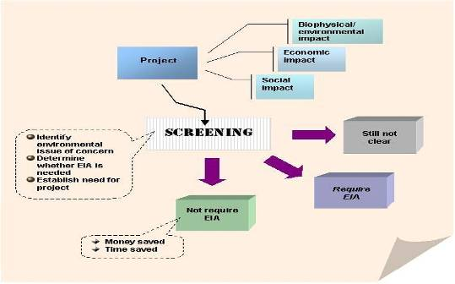
Figure 5:Environmental and Social Screening Process

Minimal or not likely to be significant Impact:
- When there are minimal or not likely to be significant impacts and there is low probability of serious adverse effects, the World Bank may require the project to prepare an Environmental and Social Management Plan (ESMP). The ESMP is an instrument that details (a) the measures to be taken during the implementation and operation of a project to eliminate or offset adverse environmental and social impacts, or to reduce them to acceptable levels; and (b) the actions needed to implement these measures.
- The EPA may require the project to register the sub-project activity and prepare Preliminary Environmental Report and Environmental Impact Statement per LI 1652. Follow the step on Environmental Registration of the Project and Initial Environmental and Social Assessment (Screening)

Significant Impact:
- When there are likely to be significant impacts the World Bank and the EPA may require the project to prepare an Environmental and Social Impact Assessment (ESIA). The following steps should be followed in the preparation of an ESIA.

Step 1: Environmental Registration of the Project
- The IA/Safeguard Officer shall have completed the relevant EPA Environmental Assessment Registration forms. The completed forms shall be submitted to the PCU for checking and onward transmission to the EPA when required in accordance with the Environmental Assessment Regulation, 1999.

Step 2: Initial Environmental and Social Assessment (Screening)
- Upon submission of sub-project registration particulars and information to the EPA, the IA/Safeguard Officer shall collaborate with the EPA to undertake physical visit to the proposed project site to conduct an initial environmental and social assessment taking into consideration factors such as:
- Location, size and likely output of the undertaking;
- Technology intended to be used;
- Concerns of the general public, if any, and in particular concerns of immediate residents, if any; and
- Land use and other factors of relevance to the particular undertaking to which the application relates.
- Following the field visit with EPA, the implementing agencies (under the leadership of the PCU safeguards specialists) shall prepare and submit a Screening Report to EPA and the World Bank. The PCU Safeguards Specialist shall continue to liaise with the EPA to take a decision by placing the sub-project at the appropriate level of environmental assessment. This decision, as prescribed by the Ghana EIA procedures, is expected within 25 days of receiving the Registration Form and could be any of the following:
- Objection to the project;
- No objection to the project;
- Preliminary Environmental Assessment (PEA) required and
- Environmental and Social Impact Assessment (ESIA) required.
- In instances where the EPA concludes that an activity requires a preliminary environmental report (PER), the IA or PCU shall prepare and submit a PER to the EPA The PER will contain details extending beyond that contained in the initial application. The PER must state specifically the detailed effects of the proposed undertaking on the environment and social setting.
- Where a PER is approved by EPA, it is registered, and an environmental permit is issued. In the event that on receipt of a PER the EPA is satisfied that there will be significant adverse impact on the environment and social setting, the IA or PCU shall submit an environmental and social impact statement (ESIS) on the undertaking.
- Notwithstanding EPA’s decision, the World Bank may still require the project prepare an ESIA.

Step 3: Scoping and Preparation of Terms of Reference
- The World Bank requires that the extent of ESIA be outlined in a Term of Reference (TOR). The EPA also requires the preparation of a Scoping report which must indicate the essential issues to be addressed in the ESIA. The TOR and scoping report shall be submitted to EPA and the World Bank for approval and clearance. The TOR will be prepared by the Focal Person of the beneficiary IA in conjunction with the Safeguard Officer.

Step 4: Selection of Consultant
- The selection process shall be in conformance with provisions under the procurement policies and procedures of the World Bank Group and the Ghana Public Procurement Act, 2003 (Act 663) as amended 2016 (Act 913).

Step 5: Conduct Environmental and Social Impact Assessment Studies
- The consultant shall prepare conduct the Environmental and Social Impact Assessment per the requirements of the TOR.
- As part of the process the consultant must engage relevant stakeholders and project affected persons.
- It will be the responsibility of the Focal Person of the beneficiary IA in conjunction with the Safeguard Officer.

Step 6: Preparation of the ESIA with Community Consultation.
- The Environmental and Social Impact Statement (ESIS) or Environmental and Social Impact Assessment report must address potential direct and indirect impact of the undertaking on the environment and social setting at the pre-construction, construction, operation, decommissioning and post-decommissioning phases. Additionally, potential changes in social, cultural and economic patterns must be dealt with in the ESIA.
- The ESIA shall also include an Environmental and Social Management Plan (ESMP) in accordance with the Environmental Assessment Regulations of 1999 (LI 1652) to ensure that the project activities are carried out in an environmentally safe and sustainable manner. The ESMP should outline management commitment and measures, action plan for implementation of mitigation measures and a monitoring plan to ensure the sustainable implementation of the proposed sub-project. An estimated budget for the implementation of the ESMP shall also be included. The ESIA report will follow the following format:
- Description of the study area;
- Description of the sub-project;
- Discussion and alternatives;
- Environment description;
- Legal and regulatory context;
- Identifying potential impacts of proposed sub-projects;
- Process of public consultations; and
- Development of mitigation measures and a monitoring plan, including estimates of costs and responsibility for implementation of surveillance and monitoring activities.

Step 7: Review of the ESIA
- The IA/PCU shall submit the draft ESIA to the PC for onward transmission to World Bank and EPA for review. The EPA and World Bank laid down procedures for review of ESIA shall be followed. In addition, all EPA laid down procedure for public noticing and feedback shall be adhered to. If policy discrepancy exists in some domains, World Bank policies will override national policies and regulations.

- When the IA/PCU submits the draft ESIA to the EPA, it will be reviewed by a cross-sectoral National Environmental and Social Impact Assessment Technical Review Committee (ESIA/TRC) made up of representatives of relevant Ministries, Departments and Agencies as determined by the EPA after preliminary review of the pertinent environmental and social issues associated with the project. The review committee is expected to:
- Assist the Agency in screening/reviewing all Environmental Assessment Applications and Reports (Environmental Impact Statements, Annual Environmental Reports, Environmental Management Plans and other related reports);
- make recommendations to the Executive Director of the EPA for final decision-making;
- provide technical advice on conduct of assessments and related studies on undertakings and the reports submitted on them;
- make recommendations on the adequacy of the assessment and any observed gap;
- advise on the seriousness of such gaps and the risks or otherwise to decisions required to be made recommend whether the undertakings as proposed must be accepted and under what conditions, or not to be accepted and the reasons, as well provide guidance on how any outstanding issue/areas may be satisfactorily addressed.
- Copies of ESIA will be placed at vantage points including the EPA & MLNR Libraries, relevant District Assembly, relevant District and Regional FSD offices, EPA Regional Offices and the sector Ministry. EPA serves a 21-day public notice in the national and local newspapers about the ESIA publication and its availability for public comments.

Step 8: Public Hearing
- Where a Public Hearing is required, the IA/ Safeguard Officer will organize same. Regulation 17 of the LI 1652 (1999) specifies three conditions that may trigger the holding of a public hearing. These are:
- Where notice issued under EPA EA regulation 16 results in great public reaction to the commencement of the proposed undertaking;
- Where the undertaking will involve the dislocation, relocation or resettlement of communities, and;
- Where the EPA considers that the undertaking could have extensive and far-reaching effects on the environment.

The outcomes/concerns expressed by the stakeholders at the Public Hearing shall be used to finalize the ESIS document.

Step 9: Review and Approval of the ESIAs
- When acceptable, the World Bank and EPA will approve the ESIA. When the EPA approves the ESIA they will issue a permit. The EPA may require that an EMP/ ESMP is produced after 18 months of obtaining an environmental permit and commencement of the sub-project and thereafter every three years. The EPA may request the proponent to submit an EMP/ESMP prior to commencement of the sub-project in line with Act 490 and LI 1652.
- The ESIA shall be disclosed in-country and on the World Bank website. Copies of ESIA shall be placed at vantage points of PCU, the EPA Library, and EPA Regional Offices, Project website Project communities, etc. This will be coordinated by the Project Technical Officer at EPA.

Step 10: Procedures That May Require Permits
The Focal Persons/ Safeguard Officer should determine if there is the need to obtain other national required permits such as:
- Building/ Development Permit from the District/ Municipal Assemblies;
- Fire Permit from GNFS;
- Water abstraction permit from Water Resources Commission
Additional steps required to cover the entire process of the subproject's life cycle until the completion of their construction include the following:
- Preparation of bidding documents,
- Contractor's mobilization and preparation of contractor’s ESMPs and OHS plans,
- Implementation of contractor’s ESMPs and their monitoring,
- Preparation of reports, and
- Decommissioning of sub-projects

The additional steps include the following:
Step 11: Preparation of Bidding Documents,
The contractor selection process would involve a multidisciplinary team, including the E&S Specialists/Focal Points with primary responsibility with the aim of providing an early consideration of E&S matters and variables when selecting a contractor.

The first step in the contractor procurement process is the preparation of a Request for Proposal (RFP) preparation. This RFP is typically prepared by procurement staff with input from the Project Coordinator, technical specialists and E&S specialists and lawyers. Sometimes a request for information (RFI), “expression of interest,” and/or a qualification questionnaire is issued prior to an RFP. RFIs are typically brief and include limited information. They are used to determine market interest and solicit preliminary information on potential vendors or contractors, and potentially to create a short list of contractors from whom to issue RFPs.

The Safeguard Officer will prepare a Contractor Management Plans (CMP) or similar documents, which describe in a comprehensive and structured manner the various E&S considerations, controls, and commitments related to the main activities that the contractor will be required to implement as part of its scope of work. This management plan will spell out E&S requirements to proactively manage risks and impacts in their activities including clear definitions of responsibilities, training needs, performance measurement tools, and reporting requirements.

Step 12: Contractor's Mobilization and Preparation of C-ESMPs and OHS plans,
As part of the mobilization process, the contractors would be asked by the Safeguard Officer to provide details including (but not limited to) past Environmental, Health and Safety (EHS) performance; number and qualifications of ESHS personnel; occupational health and safety procedures and controls; HR policies, codes of conduct, and grievance mechanism controls, including means to address harassment and other forms of GBV plus prior reported incidents of SEA and GBV; and supply chain management as criteria for inclusion on such lists. The number of documents and level of information and detail that are requested to contractors shall be commensurate to the scope of work and other specific features that the contractor is being prequalified against.

The Safeguard Officer will develop an evaluation criterion which will be established alongside the bid packages and that these are included with the package so that prospective bidders can see early on the relative weightings of the environmental, social, and health and safety aspects of their proposal.

Step 13: Implementation of C-ESMPs and their Monitoring
Evaluation methodology, criteria, key performance indicators (KPIs), and weightings would be established in discussion with the rest of the project team by the Safeguard Officer. The following questions would be asked when developing the weightings: What answers are we looking for? And what KPI scores are acceptable? Significant E&S records and safety metrics are important, and poor records related to these matters should preclude the contractor from qualifying, regardless of technical aspects or price.

The Project Procurement Officer will ensure inclusion of project-specific E&S requirements. To require contractors to implement E&S commitments specified in project specific ESIAs and E&S management plans, clients should include and directly reference these requirements (as annexes or appendixes), regardless of contract type.

The Safeguard Officer will ensure identification of E&S plans to be developed by contractor. The project will list in the E&S conditions of the contract all E&S management plans and associated documentation (C-ESMP, LMP, OHS) that must be prepared or refined and implemented by the contractor, and require that these documents be submitted for client review and approval within an agreed timeline relative to the project schedule, contractor mobilization, and commencement of work.

Provision of E&S personnel and resources allocated to the contract or service. The project will include the requirement that appropriate resources and key E&S personnel be appointed as part of the contract, throughout project implementation, or during the period in which their services are needed to manage and implement E&S requirements. It is recommended that conditions for replacement of key personnel should be acceptable to the Safeguard Officer.

Step 14: Contractor Management, Oversight and Reporting
The Safeguard Officer would ensure that contractors employ qualified E&S personnel to oversee E&S performance, and that contractor staffing and resources are commensurate with the magnitude and timing of work and potential E&S risks. Clients would also approve documentation, including for training programs, to ensure all staff are aware of E&S commitments and their part in meeting them.

The Safeguard Officer/Focal Persons will monitor contractor E&S performance and ensure the contractor monitors its own and all subcontractors’ E&S performance throughout construction, including mobilization, the main construction phase, and demobilization. Clear responsibilities and reporting lines are essential to avoid duplication of effort or, conversely, gaps in monitoring. If operations are carried out under contract, or some work is performed by contractors, the client and contractor will monitor E&S performance during operations as well.

The project will require contractors to report on an agreed frequency their E&S performance and metrics (which shall include relevant information and data from subcontractors, as applicable). Timely reporting of E&S performance and results enables the client to identify opportunities for improvement, prevent poor performance issues, and assist contractors if remedial action is to be taken.

Ghana EIA Regulations and Their Relevance to the Project
According to the requirement of EIA regulations (LI 1652), various instruments (EIS, PEA and EMP) are to be prepared for new projects to acquire environmental permit before commencement of any project. Schedules 1 and 2 specified in the LI1652 relates to agricultural and related services (livestock farms and community pastures), forestry service (application of pesticides, introduction of exotic species), mining and manufacturing could be anticipated sub-project activities in the GLRSSMP. All sub-projects will be screened using checklists provided in annexes 4a and 4b to ascertain the scale of risks and impacts to prepare the required instruments stipulated in the LI 1652. Experience from the SLWMP shows that all agricultural sub-projects were not more than 2 acres and therefore were not required to obtain an environmental permit - which is needed when the activity requires clearing of land greater than 40 hectares. Community pastures like rangelands and fodder banks were also less than 40 hectares and were not sited close to sensitive areas. Forestry services provided for the project did not undertake the following activities:

- application of pesticides
- introduction of exotic species and
- establishment of forests in previously forested areas

and so did not require environmental permits. The ASM formalization component of the project will not include activities listed under “mining” i.e. mining and processing of minerals in areas where the mining lease covers a total area in excess of 10 hectares but rather formalization of small-scale mining activities.

The provision of water systems i.e. dugouts in the implementation of the SLWMP went through the screening process stipulated in the LI 1652 which culminated in the preparation of the preliminary environmental report to obtain the required permits for these facilities. The preparation of the EIS instrument per the requirements of the LI 1652 was not triggered by the SLWMP activities since all project anticipated risks and impacts fall below the scale for EIS mandatory projects specified by the LI 1652.

All these experiences would be considered in the GLRSSMP to ensure that requirements of national regulations relevant to the project are adhered to. Detailed procedures and process for preparing the LI 1652 instruments is provided in sections 5.1 and 5.2 of this document.

5.3 Environmental and Social Procedure for ASM Reclamation Activities

5.3.1 Terrestrial Habitats
As part of the land use and biodiversity management requirements, temporary and permanent terrestrial habitat alteration should be minimized to the extent feasible and be consistent with the requirement to protect and preserve critical habitat. Conserving the quality and composition of growth medium for use (e.g. for capping) during site reclamation and closure activities is a recommended management strategy to be considered among others.
ASM operations should prevent and minimize negative visual impacts through consultation with local communities about potential post-closure land use, incorporating visual impact assessment into the mine reclamation process. Reclaimed lands should, to the extent feasible, conform to the visual aspects of the surrounding landscape. The reclamation design and procedures should take into consideration the proximity to public viewpoints and the visual impact within the context of the viewing distance. Mitigation measures may include strategic placement of screening materials including trees and use of appropriate plant species in the reclamation phase as well as modification in the placement of ancillary facilities and access roads.
All ASM activities, including reclamation / restoration activities should also follow guidance included in the ASM Handbook (Tychsen, J; Boamah, D; Ahadjie, J; Sandow Ali, M; Alidu, S; Awuah, P; Quaicoe, I; Amankwah, R; Fobil, J; Nyame, F; Davis, E (2017), “ASM Handbook for Ghana” Geological Survey of Denmark and Greenland (GEUS), Copenhagen,
Denmark).

The positive impacts which may be associated with reclamation of degraded lands include:
- creation of opportunities for marginalized groups to access land;
- restoration of authority to chiefs and elders or the original landowners;
- revenue generation through the harvest and sale of economic trees;
- reduction in environmental health hazards pose by the pits;
- creation of available lands for social activities;
- creation of employment;
- increasing the skills and capacity of youths to find employment;
- preventing conflict and enhancing peace and stability;
- protection of traditional activities such as indigenous medicines;
- improvement of the aesthetic beauty of the land;
- free flow of local streams and rivers as their courses will be restored.

The following potential negative impacts are worth noting:
- reclaimed lands which require remediation cannot be used for farming or cultivation of edible crops;
- destruction of the re-colonising pioneer vegetation;
- destruction of habitat of the few hardy animals;
- destruction of animals living in burrows as well as those on the surface of the earth;
- noise pollution emanating from vehicular movement likely to scare away animals
- dusty environs as a result of deployment of heavy vehicles

5.3.2 Procedure and Steps for ASM Reclamation Activities
With project support, the MLNR will identify up to 1,000 ha of mined-out areas that will be restored through phytorestoration / reclamation.
Selection of potential sites for reclamation
In order to prioritise the identified sites and to fully engage the local communities to achieve the project objectives, the following processes described in the flow chart in Figure 6 will be followed for selection of specific restoration sites.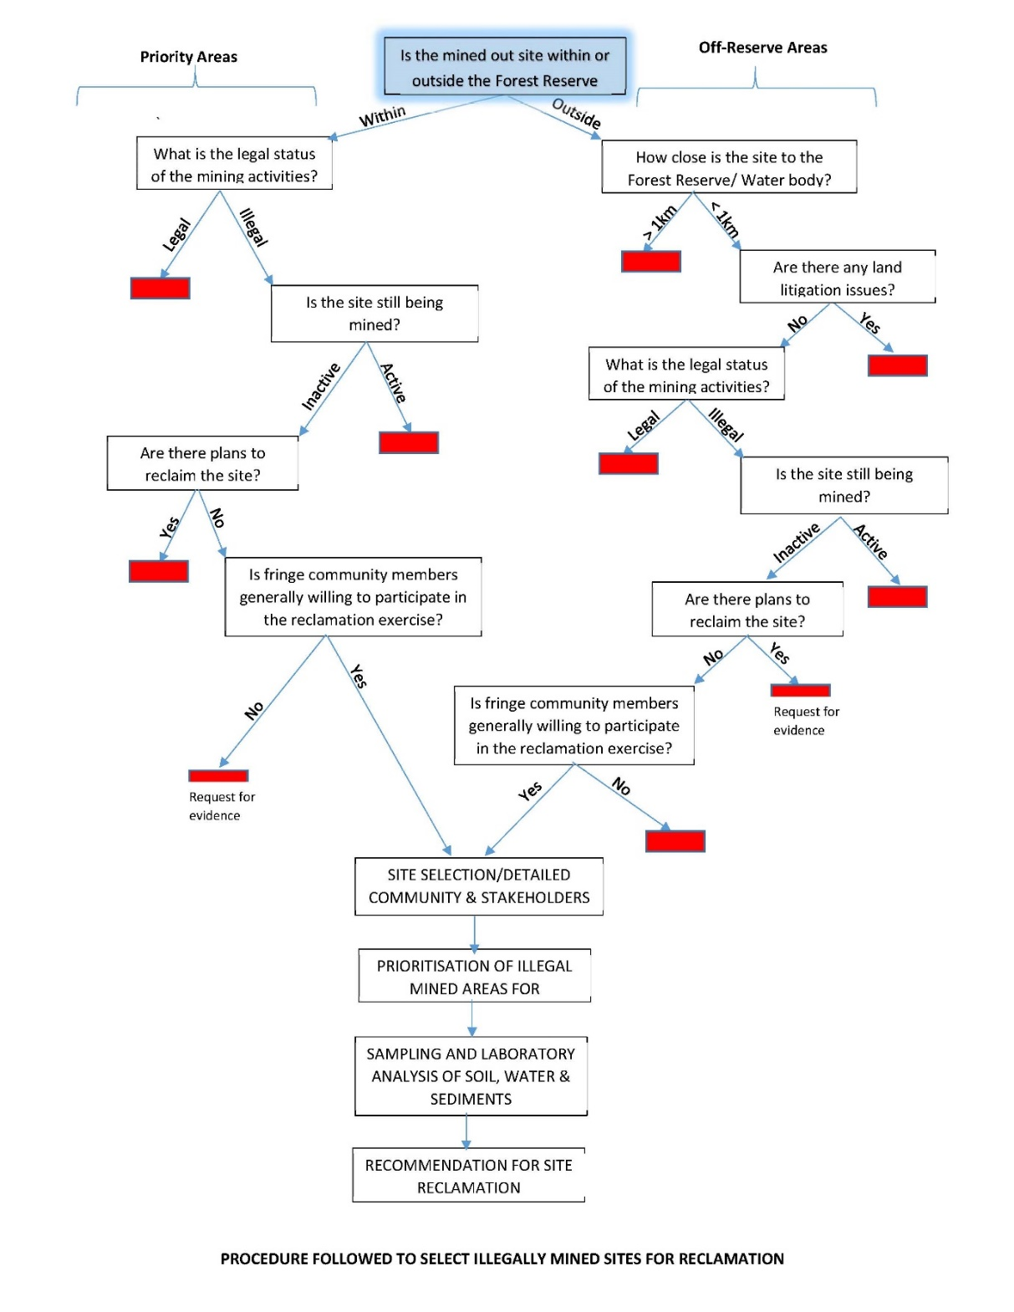
Figure 6: A flow chart showing criteria for site selection and possible reclamation
Note: a red block in the figure means that activities shall not proceed.

For reclamation, the engineering works required for the reclamation will include the following: (i) soil tests; (ii) cutting and haulage of fill materials to top up to the required ground elevations; (iii) earthworks which will involve spreading of stockpile of sandy/lateritic waste into pits; (iv) spreading of topsoil; (v) construction of crest for river/stream course (if needed); (vi) raising of cover crops; and (vii) tree planting (phytoremediation).
5.3.3 ESMP Requirements
An ESMP will be prepared for each activity related to restoration / rehabilitation of mined-out ASM sites. Such an ESMP would be required to cover the following aspects:
- Noise, dust and air quality during rehabilitation work
- Health and safety issues for workers
- Water quality
- Acid rock drainage
- Land restoration and land subsidence
- Hazardous waste management
- Erosion and stormwater management
- Terrestrial habitats and biodiversity
- Aquatic habitat
- Land rights
Post-closure monitoring and management

5.4 Cultural Heritage

The procedures to protect and preserve Ghanaian cultural heritage are enshrined in the 1992 constitution and Cultural Policy of 2004. The Fourth Republican Constitution (1992) recognizes culture as a necessary tool for national integration and development and, under the Directive Principles of State Policy (Article 39), declares as follows:
(1) Subject to clause (2) of this article,
the State shall take steps to encourage integration of appropriate customary values into the fabric of national life through formal and informal education and the conscious Introduction of cultural dimensions to relevant Aspect of national planning.
(2) The State shall ensure that appropriate customary and cultural values are adapted and developed as an integral part of the growing needs of the society as a whole; and in particular, that traditional practices which are injurious to the health and wellbeing of the person are abolished.
(3) The State shall foster the development of Ghanaian languages and pride in Ghanaian culture.
4) The State shall endeavour to preserve and protect places of historical interest and artifacts.”
The above four principles or directives support and complement the objectives of the World Bank’s ESS 8 on cultural heritage which include the following:
- To protect cultural heritage from the adverse impacts of project activities and support its preservation.
- To address cultural heritage as an integral aspect of sustainable development.
- To promote meaningful consultation with stakeholders regarding cultural heritage.
- To promote the equitable sharing of benefits from the use of cultural heritage.

The cultural policy of Ghana the following as the cultural heritage assets:
- Museums
- Galleries and craft centres
- Crafts
- Museums
- Monuments
- Forest reserves, National parks and Recreational facilities
- Festivals and special events
- Religion
- Traditional medicine
For the purpose of the GLRSSMP the major ones of importance are the monuments and forest reserves, national parks and recreational facilities. In the event of the project confronting with issues related to cultural heritage in undertaking project activities the following procedures will be followed:
- Stop the activities in the area where a cultural asset is found
- Delineate the discovered site or area.
- Secure the site to prevent any damage or loss to the asset
- Notify the responsible authorities at the community and representative of the National Commission on Culture at the district on how to deal with the situation
The Ghana cultural policy enjoins the National Commission on Culture to undertake the following actions to protect and preserves monument, forests reserves, national parks and recreational facilities:
Forest Reserves, National Parks and Recreational Facilities
- The National Commission on Culture in collaboration with the Environmental Protection Agency, Forestry Commission and other related agencies, shall identify sacred forests and other heritage sites of Ghana and collect, collate and store indigenous beliefs and practices associated with them with the aim of conserving the nation’s biodiversity and ecosystems and exploring their use as tourist attractions and sustainable sources of rare medicinal plants, animals and minerals.
- The National Commission on Culture shall recognise parks beaches, zoos, and game reserves, forge collaboration with the appropriate agencies and help to develop them for recreation, education and leisure.
- The National Commission on Culture shall encourage all communities to develop monuments and parks in commemoration of individuals, groups and events. Towards this end, communities would be encouraged to designate guard and preserve needed land in town planning
- The National Commission on Culture in collaboration with local administration shall propose names of distinguished personalities, objects and national icons for streets, parks and edifices.

Monuments
The National Commission on Culture shall preserve as monuments, all forts and castles, designated shrines, mosques, church buildings, old city walls and gates; cultural sites, palaces, public and private buildings of historical significance and monumental sculptures. These shall be protected from neglect, desecration and/or destruction.
The National Commission on Culture shall ensure that monuments shall be preserved through;
- Enactment of Legislative Instruments or Executive Instruments;
- Acquisition of monuments under legislative or executive Instruments;
- Legislation to enable the National Commission on Culture exercise planning control in matters threatening structures and sites of historical importance;
- Legislation to enable the National Commission on Culture protect private buildings of historical importance by preventing:
- alteration to their structures or facades,
- encroachment or other actions, which may endanger them;
- legislation empowering the National Commission on Culture to protect contemporary public buildings of exceptional design and excellence;
- appropriate maintenance; g. photographic and other means of documentation.

Chance Find Procedures:
In the event of finding previously unknown sites or feature of cultural value during project implementation, the following standard procedures for identification, protection from theft, treatment and recording should be followed.
Specifically,
- Stop the activities in the area of the chance find.
- Delineate the discovered site or area.
- Secure the site to prevent any damage or loss of removable objects.
- Notify the Supervising Engineer who in turn will notify the responsible authorities.
- The Ministry of Tourism, in collaboration with responsible local authorities (where applicable), would be in charge of protecting and preserving the site before deciding on subsequent appropriate procedures.
- The Ministry of Tourism and National Museums and Monument Board will make decisions on how to handle the findings. This could include changes in the layout (such as when finding irremovable remains of cultural or archaeological importance), conservation, restoration, and salvage.
- The Ministry of Tourism shall communicate implementation of the authority decision concerning the management of the finding in writing.
- Construction work could resume only after permission is given from Ministry of Tourism or other responsible authorities concerned with safeguarding the cultural heritage.

These procedures must be referred to as standard provisions in construction contracts, E&S Procedures for Inclusion in the Technical Specifications for Contracts. During project supervision, the Site Engineer shall monitor the above regulations relating to the treatment of any chance find encountered are observed. Relevant findings will be recorded in the Monitoring Reports and the World Bank Implementation Supervision Reports (ISRs), and Implementation Completion Reports (ICRs) will assess the overall effectiveness of the project’s cultural property mitigation, management, and activities, as appropriate.

5.5 Labour Management Procedures

The project recognizes the need to protect the fundamental rights of workers since the workforce is a valuable asset, and a sound worker-management relationship is a key ingredient in the sustainability of the project. Through a constructive worker-management relationship, and by treating the workers fairly and providing them with safe and healthy working conditions, the project will create tangible benefits, such as enhancement of the efficiency and productivity of their operations. The objectives of the labour management procedure are:

- To promote the fair treatment, non-discrimination, and equal opportunity of workers.
- To establish, maintain, and improve the worker-management relationship.
- To promote compliance with national employment and labour laws.
- To protect workers, including vulnerable categories of workers such as women.
- To promote safe and healthy working conditions, and the health of workers.
- To avoid the use of forced and child labour.

The project’s LMP is based on the requirements outlined in the ESS2 with following sub headings:

- Types and number of Project Workers
- Potential Labour Risks
- Working Conditions and Management of Worker Relationship
- Protecting the Work Force
- Occupational Health and Safety
- Workers Engaged by Third Parties

Detailed LMP is presented in annex 7b

5.6 Incident and Accident Reporting

In case of occurrence of an incident or accident related or having an impact on the Project which has, or are likely to have, a significant adverse effect on the environment, the affected communities, the public or workers, the implementing agency shall:
- As soon as reasonably practicable, but no later than five (05) calendar days after having been informed of the occurrence of such incident or accident, inform the Bank by any electronic means of its nature, or circumstance and any effect or impact resulting or likely to result there from;
- As soon as reasonably practicable, but no later than twenty (20) days after such incident or accident, provide the Bank with a summary report that includes a description of the incident or accident, and the measures, if any, that the Borrower is taking or plans to take to address it and to prevent any future similar event; and
- keep the Bank informed of the on-going implementation of the said measures and plans.

Regular reporting:
- Accidents and grievance log books are placed in all construction sites
- The supervision consultants’ monthly progress report will provide details on accidents
- All regular progress report to the Bank will include information on accidents and incidents
- Any severe injury (requiring off-site medical care) or fatality incident shall be reported to the Bank within 24 hours with basic information and a detailed incident report including the following will be submitted within 10 working days:
  - root cause analysis and
  - corrective action plan on
    - immediate mitigation measures in case of continuing danger (e.g. fencing, signboard, guards)
    - compensation to the affected family based on a clear rational
    - risk assessment and correct application of ESHS management procedures, and
    - medium- and long-term mitigation measures including enhancement of safety measures, audits, and additional training.
Incident reporting form is attached as annex 15

5.7 Grievance Mechanism

The legal framework for Grievance Redress has bases in the Constitution of Ghana (Article 20), as well as in the State Lands Act (1962). In accordance with the ESS10, a grievance mechanism needs to be developed when the possibility exists that communities may be affected by a project. The main objective of the grievance mechanism is to address project concerns promptly and effectively, in a transparent manner that is culturally appropriate and readily accessible to all project-affected parties and interested parties, at no cost and without retribution. The GM, process, or procedure does not prevent access to judicial or administrative remedies. Specifically, the GM:
- Provides affected people with avenues for making a complaint or resolving any dispute that may arise during the course of the implementation of projects;
- Ensures that appropriate and mutually acceptable redress actions are identified and implemented to the satisfaction of complainants; and
- Avoids the need to resort to judicial proceedings.

Grievances may take the form of specific complaints about actual damages or injury, general concerns about project activities, incidents and impacts, or perceived impacts. The project provides a grievance mechanism that would provide opportunity for all direct and indirect beneficiaries, service providers and other stakeholders to report and seek redress for project related complaints. Stakeholders would be informed about the project grievance redress mechanism, as well as measures put in place to address project related complaints at the community, district, regional and national levels in confidential manner. This will be done as part of the project stakeholder consultations.

5.7.1 Grievance Redress Structure
The grievance redress structure for the GLRSSMP was developed from the existing grievance redress mechanism for resolving grievances from the Sustainable Land and Water Management Project (SLWMP), a decentralized and transparent system which ensured quick resolution of complaints and disputes. Grievances were resolved or referred to the following levels depending on the nature of the complaint or dispute:
- Local – community watershed management team (CWMT)
- District – district watershed management team (DWMT)
- Regional – technical coordination office (TCO)
- National – project coordination unit (PCU)

Project staff at the local level maintain a grievance and conflict resolution log and report outcomes to the TCO and finally to the PCU if required. The transparent nature of resolving grievances and active involvement of local structures i.e. CWMT and DWMT supported by the TCO at the regional level enabled the system to address grievances amicably. This proven mechanism would be followed to facilitate all grievances or complaints at any point during the various phases of the project. The redress of grievances will be decentralized at the local/district levels where Grievance Redress Committees (GRCs) with community representatives will be formed to address any issues that may arise at any phase during the implementation of the project. Where a GRC cannot resolve any grievance at the local/district level, it would be escalated to the PCUs of the GLRSSMP who would coordinate with the relevant IAs/Agencies to find a solution to the complaint. The Communication Specialist will play a key role in coordinating the resolution of all grievances which will be logged for record-keeping and tracking purposes.

Table 5:Grievance Redress Roles
Level | Agency/Individual | Grievance Redress Role
National | PCUs | - Establish GRMs via circulars and memoranda  - Provide operational guidelines for GRMs, e.g., ceilings on compensation  - Provide necessary funds and staff to facilitate GRM operations  - Maintain databases on the status of grievance handling by different GRMs  - Participate in GRMs Monitoring grievance-handling processes by GRCs  - Coordinate the functions of GRCs  - Provide capacity-building training to GRC members
Local/District | Grievance Redress Committees | - Maintaining a list of those who are directly or indirectly affected by construction, operations, and maintenance work  - Addressing grievances excluding issues

5.7.2 Grievance Resolution Procedure
Information about the GM will be publicized as part of the initial programme consultations and disclosure in all the participating agencies. Brochures will be distributed during consultations and public meetings, and posters will be displayed in public places such as in government offices, project implementation unit offices, notice boards available to strategic stakeholders, etc. Information about the GRM will also be posted online on the websites of implementing agencies. The overall grievance resolution framework will include six steps described below. The six steps demonstrate a typical grievances resolution process.

Step 1: Reception and Registration
A formal grievance can be lodged at PCU offices in Accra or any district office of the IAs with trained dedicated staff to receive complaints for resolution. Grievances may be lodged by a variety of different means, including direct reporting in person to the project office/district office of the IA; at suggestion boxes; by posting in suggestions, by phone calls to IAs, WhatsApp, by mail or on the web. Due to the outbreak of COVID-19, a toll-free number/dedicated phone number will be promoted through posters for lodging formal complaints or grievances. Stakeholders will be required to report instances of gender-based discrimination, sexual harassment, and sexual violence either directly or through email or phone calls. The PCUs will accept any complaint submitted anonymously and any complaint from individuals who identify themselves initially but request anonymity during the investigation and adjudication process. Although it is inherently difficult to investigate anonymous complaints, investigations of such complaints will be as thorough as is practicable and will be appropriate to the allegations. All Project staff will be trained to pass all submissions that could be considered to form a grievance directly to the Communication Specialist/Project Liaison Officer as soon as possible after they are received. The complaints will be recorded on the complaint form in case the complainant did not fill the form (see Annex 12)

Details of the person lodging the grievance and information regarding the grievance will be recorded in the register (See Annex 13). All grievances will be recorded by the Communication Specialist or Environmental and Social Specialist, who will ensure the grievance is captured in a centralized electronic Grievance Database where the status of the grievance captured will be linked to all the IAs or various levels of grievance redress mechanism. Community and village leaders and government departments will also be advised to pass any complaints they receive to local offices of the IAs from where they will be forwarded to the PCUs.

The Communication Specialist or other responsible project staff will record each grievance on a standard Grievance Form and will ensure that the name of the village, the date recorded, the name of the complainant and the name of the person that received the grievance are noted. The complainant will be required to complete a grievance form with the assistance of the Communication Specialist, who will record the grievance in a grievance log according to the category of grievances (for example, unfair employment process being followed, loss of livelihood or communication and information not transparent). A grievance can also be lodged by sending a grievance form or written complaint directly to GLRSSMP’s Project Coordinators. All grievances will be logged in a grievance log file.

All incoming inquiries and grievances will be reflected in a dedicated grievance register (Annex 13) and assigned an individual reference number. The grievance register will also be used to track the status of an inquiry/grievance, analyse the frequency of complaints arising, their geographic distribution, typical sources and causes of complaints, as well as to identify prevailing topics and any recurrent trends. The grievance register will contain the following information:

Grievance Register
1. a unique reference number;
2. date of incoming grievance;
3. location where the grievance was received/submitted and in what form;
4. complainant’s name and contact details (in case of non-anonymous inquiries and grievances); contents;
5. identification of parties responsible for addressing and resolution of the issue;

Step 2 Screening, Prioritization and Assignment
Complaints received by the project will be handled as is reasonably practicable, depending on the nature and complexity of the grievance. To expedite the screening process, all incoming grievances will be lodged into the central database, according to their nature based on the following categories:
A0: Request for information not directly related to the Project
A1: Questions/Doubts
A2: Requests/Petitions
A3: Complaints
Following this preliminary assessment, the grievance will be directed to the respective PCU for resolution. The respective PCU will report back on the grievance. Grievances will be prioritized according to their severity and complexity level. The following table shows the priority levels that will be applied:

Table 6:Grievance Priority Classification
Priority Level | Description | Example
High | Concern, claim or grievance involving stakeholders of high priority, and:  - Reports a breach of human rights  - Relates to a legal non-compliance  - Pose a short-term risk to the project continuity | - Group complaints; Issues involving third parties (e.g., social, environmental impacts)
Medium | Concern, claim or grievance from stakeholders (individual or as a group) that could impact the project reputation or compromise its development at medium term. | - Individual complaints;  - Issues involving other departments within MLNR
Low | Concern, claim or grievance regarding lack of information or unclear information provided. | - Lack of information

Step 3: Examination
As part of the “admissibility verification,” an examination of the grievances shall be undertaken in order to verify the validity of the complaint, determine its causes and develop corrective actions to minimize or avoid recurrence of the causes. Then, a file and registration number are assigned, giving treatment within a period no longer than 30 days. The resolution process should be performed within 10 working days after having finalized the examination process for high priority grievance, 14 working days for medium priority and 28 days for low priority. In that period, the corresponding response must be raised, whether the complaint is justified or not, and leave a record of what has been expressed. The timeframe will be communicated to the complainant, in written form if needed. The approach definition depends on the priority level of the issue raised. The actions and accountability of managing every grievance will be different.

Table 7: Grievance Actions
Step | Action | Resolution Time
1 | Receive and register the grievance | within 5 Days
2 | Acknowledge, assess grievance and assign responsibility | within 7 Days
3 | Development of response | within 14 Days
4 | Implementation of response if an agreement is reached | within 1 Month
6 | Initiate a grievance review process if no agreement is reached at the first instance | within 1 Month
7 | Implement review recommendation and close grievance | within 2 Months
8 | Grievance taken to court by the complainant | -

Step 4: Grievance Closure
Once a complaint has been investigated, a letter will be sent to the complainant, explaining the outcome of the investigation and the proposed course of action to resolve the grievance. The Communication Specialist or the GRC, in the case where the grievances are addressed at the local level, will contact the complainant in person if this is required and explain the results of the investigation and the proposed course of action. If the complainant is satisfied that the complaint has been resolved, he/she will be required to sign a statement confirming that the complaint has been resolved. If the complaint has not been resolved by mutual agreement, a re-assessment may be undertaken if new information becomes available in support of the claim/complaint. If the complainant is still not satisfied with the resolution, the grievance will then go into mediation. If applicable, the grievance committee will monitor the implementation of the resolution and the claimant’s satisfaction with this implementation. Resolution and sign-off on the grievance captured will be noted in the grievance issues database. All grievances, regardless of their status, will be kept since it will provide proof in case of litigation.

Step 5: Appeals
Unresolved grievances will be investigated by a grievance committee formed at the level of the National Steering Committee. This committee will only meet to resolve problems that cannot be resolved during steps one to four. GLRSSMP will allow for an independent arbitrator if grievances cannot be resolved internally. It is important to note that the project will not cover the expenses for the services of the arbitrator. In exceptional cases, depending on the relevance of the grievance, the project may consider taking care of only transport costs borne by the plaintiff or complainant. Special attention will be given to SEA/SH grievances (marked as confidential) to ensure confidentiality and to avoid intimidation of complainants or survivors. The grievance procedure is illustrated in more detail in Figure 7:

Figure 7: Grievance Mechanism Flowchart

6.0 PUBLIC CONSULTATIONS, PARTICIPATION AND INFORMATION DISCLOSURE

6.1 Objective and Purpose for Stakeholder Engagement and Consultation

Stakeholder consultations are crucial component in the preparation and implementation of ESMF. Specifically, it aims to achieve the following objectives:
- To provide information about the project and its potential impacts to interested parties or beneficiaries or those affected by the project, and solicit their opinion in that regard;
- To educate and solicit views from all stakeholders to enhance the implementation mechanisms and processes;
- To manage expectations and streamline misconceptions regarding the project; and
- To ensure participation and acceptance of the project by all relevant stakeholders

Community participation is a vital in ensuring sustainability of any project. communities to be targeted by the project may be among the most deprived in the country. this makes it more meaningful that they understand the various components of the project for them to identify themselves with it for successful implementation and to derive its maximum benefits.

Community leaders i.e. chiefs, opinion leaders and assembly members should be involved in decision making processes. efforts should also be made to identify other groups in beneficiary communities e.g. children, women, groups, the poor, and parents etc. as they may constitute the major beneficiary group of the project. these groups should be educated on all aspects of the project intervention including the benefits, challenges and financial implications among others. various methods can be used to achieve this i.e. focus group discussions, public announcements, animation, film shows, drama, posters etc. are some of the methods that could be used to educate the people.

A separate Stakeholder Engagement Plan has been prepared for the project to guide stakeholder engagement during project implementation.

6.2 Stakeholder consultations

Stakeholder consultations will be carried out throughout the lifecycle of the project. Consultations with major stakeholders have already taken place throughout the country to sensitize major stakeholders from the IAs, MDAs, and communities at the national, district, and community levels and will continue throughout the life cycle of the project. The consultations with IAs, MDAs, and communities at the national, district, and community levels took place between the period of 12th to 20th January 2020 and 29th June to 16th July, 2020.

6.2.1 Consultation with Municipal and District Assemblies on Landscape Restoration

Consultations were held with MDAs in the Pra/Transitional Zone (Eastern, Ashanti and Central Regions) and the northern savannah region (Upper West, Upper East, Savannah and North East Regions) selected to be enrolled in the project. the specific objectives for these consultations were:
- To provide detail information about the project as a follow up to mails sent to introduce and explain to them in detail project objectives and components
- To solicit their views that could inform the project design
- To collect and find ways of collating data to enrich project design
- To identify other relevant stakeholders within the project area for further engagement

Municipal and district authorities were requested to provide the following documents and information:
- Current Medium-Term Development Plan
- 2020 Annual Operational Plan
- District Maps
- Land Use Maps (if available)
- 2018 annual progress report of the Municipal and District Assemblies
- Grievances redress Mechanism if any
- List of organizations working in the Municipality or District i.e. private companies, NGO’s, CBO’s, farmer associations etc
- Cultural/historical sites present that can be develop for ecotourism

These were to assist IA’s to ascertain existing activities, to develop synergies, identify gaps, avoid duplication of activities, mainstream issues and to identify potential risks/impacts that could result from implementation of project activities.

6.2.2 Consultation with Communities
Consultations were held with communities in eight districts in the northern savannah and thirteen districts in the forest and transitional zone. Communities consulted, their regional, district locations and dates of consultation are presented in a tabular form as annex1. Intended community engagements and consultations relating to the ASM aspects in communities such as Kyebi, Prestea, Tontokrom and bole have been hindered by the covid19 pandemic lockdown and restrictions. now that the covid-19 pandemic restrictions are gradually being relaxed by the president, field visits and engagements with communities in the designated project areas are being scheduled. the following activities were proposed by communities for consideration in the implementation of the landscape restoration aspect of the project:
- Alternative livelihood activities – shea nut processing, bee keeping, livestock/fowl rearing, cassava and maize processing, small ruminants rearing, pito brewing, rice processing, petty trading
- Cereal/legume rotation SLM technology considered very beneficial and should be intensified
- Provision of water systems i.e. dugouts for dry season farming and for their livestock
- Establishment of fodder banks to feed their livestock
- Cashew cultivation, maize/groundnuts as the major cereals, sweet potatoes/yam (tubers
- Regular provision of chemicals to deal with pests and diseases
- Provision of yam storage facilities
- Tree growing e.g. teak
- Upscaling of the Village Savings and loan Association (VSLA)
- Training of women in alternative livelihood activities such as soap making, bee keeping, tie and dye, hair dressing etc.
- Training in fire fighting against bushfires

Views, Concerns and Suggestions from Communities and Traditional Authorities
- The extent of destruction caused by sand winnowers was a great worry and queried whether they are issued environmental permit before they commenced the activity
- How the project would handle inputs e.g. fertilizers to ensure that they reach right beneficiaries
- Nananom (Chiefs) suggested that they should be consulted to assist in the distribution of inputs
- Need to establish nurseries close to communities
- Nananom lamented on the abrupt end of some previous projects and advise project implemented to ensure sustainability
- Communities and chiefs should be fully involved in al project activities
- The project should enrol only committed communities into the project
- Pollution and sedimentation of major rivers like the Pra
- Suggested the need to create buffer along the Prah basin to reduce sedimentation and pollution
- Timely and prompt delivery of inputs
- Requested support from the in respect of farm preparatory activities
- Project should create storage and marketing opportunities for their farm produce

Views, Concerns and Suggestions from the Youth, PWD’s etc.
- The project should provide incentives to the youth to garner interest in project activities
- The project should assist PWD’s and other vulnerable groups to form associations to have a voice in decisions to benefit from project activities
- PWD’s should be given the opportunity to partake in project activities to enhance their conditions of living

Concerns and suggestions from Municipal and District Assemblies
- Requested for more insight into project implementation procedures and their specific roles they will play in the project
- Requested for more consultations before the commencement of the project

Even though project coordinators and IA’s through online communication have informed municipal/district assemblies and coordinating councils on the project their concerns indicate low level of awareness and limited capacity for implementation. The project design would seek to upgrade their awareness level and scale up their capacities for them to effectively and efficiently play their roles during project implementation.

Government Plans Regarding Admitted Farms and Illegal encroachment of Forest Reserves

A number of Forest Reserves in the cocoa zone (Forest Transition Zone) have admitted farms. These are “farmers or cultivators who had their farms in forest reserve areas before their designation as reserves and they are entitled to continue to farm in designated areas” (Handbook for Paralegals in Ghana, CEPIL, 2009). These are recorded in management plans of forest reserves.

Most of the target forest reserves have no current management plans (Annex 14). In consultation with FSD it was revealed that government has put the following measures in place to ensure prevention of expansion of admitted farms:
- Forest guards will ensure that admitted farm owners will not extend their allocated lands and that boundaries of the Forest Reserves around these farms are clearly demarcation. This will be done through demarcation of plots and erecting of pillars to check boundaries
- The government through the Forestry Commission will intensify their education for admitted farmers and encroachers to appreciate the need to accept conditions stipulated in their agreements with the government.

In addition, the project has allocated funds to support preparation of management plans for those forest reserves that currently do not have them / where management plans have expired.

6.3 Framework for Sub-Project level Consultations

The project puts stakeholder engagement at the core of design of activities. All community level activities will be designed through a participatory process where decisions on use of resources are made by communities themselves.

In addition, representative consultations will be held regularly as the need arises for project related activities. Participants will cut across various focus groups in the selected communities, i.e. traditional leaders, women, youth, etc. Information obtained during consultations can be used to enhance the project database and will aid decision making and addressing grievances.

The project will organise events, including conferences, meetings and workshops on an as-needed basis aimed at seeking inputs from a broad variety of stakeholders. Given the global development of COVID-19 health issues and the uncertainties surrounding the period, the ESMF will be adaptable to new and challenging developments until the situation improves. In line with the WB guidance note on Public Consultations and Stakeholder Engagement in WB-supported operations when there are constraints on conducting public meetings issued on March 20, 2020 and national protocols on social distancing to deal with the pandemic, the project will minimize public gatherings and limit the number of participants at events. For such meetings the project will ensure compliance to the national and WB’s COVID-19 protocols as specified in the PIM.

6.4 Dissemination and Public Disclosure of ESMF and ESIAs/ESMPs

The World Bank policies require that environmental reports for projects are made available to project affected groups, local NGOs, and the public at large. Disclosure of environmental reports is also a national requirement and forms part of Ghana ESIA procedures. The project will disclosure these documents on website of the leading implementing agencies (EPA, MLNR, FSD, MOFA) as required by law for information and comments. The project will make available copies of the ESMF in selected public places as required by law for information and comments, including the relevant District Assemblies. Public notice in the media should be served for that purpose.
The notification should be done through a newspaper or radio announcement or both. The notification should provide:

- a brief description of the Project;
- a list of venues where the ESMF report is on display and available for viewing;
- duration of the display period; and
- contact information for comments.

To decentralize the disclosure process, all MDAs with websites will be made to disclose these documents at their websites as avaliable. In addition, all MDAs participating in the GLRSSMP will also be given hard copies of these reports for reference purposes.

7.0 MONITORING AND REPORTING

This section describes the monitoring and reporting framework for the implementation of the ESMF. It prioritizes elements that must be in place during the execution of the ESMF and prior to project implementation. The section will be periodically revised and updated as necessary during project implementation.

7.1 Environmental and Social Monitoring and Reporting

7.1.1 E&S Monitoring
Monitoring the implementation of the ESMF will be a collaborative effort between the stakeholders and the project implementation team. The project implementation team will establish a two-way flow of information where information flows from the project to the stakeholders and vice-versa.

Monitoring of environmental and social issues will form an essential part of activities to be conducted under the project. Oversight of the environmental and social monitoring will be ensured by the PCUs, management consultants, safeguards specialists on the project, supervising engineers and contractors if necessary. Environmental and social monitoring will aim at ensuring compliance with:

- The measures proposed in the E&S risk management instruments, including mitigation measures;
- Commitments of contractors in connection with environmental and other permissions required under the sub-project; and
- Requirements relating to laws and regulations.

Monitoring measures will focus on key indicators to be defined considering both the positive and negative impacts of the sub-projects. The monitoring indicators will be parameters which will provide quantitative and/or qualitative information on the impact. The choice of indicators will be guided by the characteristics of:

- Relevance;
- Reliability;
- Usefulness; and
- Measurability.

During preparation of sub-project specific instruments, it will be ensured that monitoring plans are prepared which encompasses clear and definitive parameters to be monitored for each sub-project.

7.1.2 Environmental and Social Reporting
Environmental and Social management reporting under the project will be done at all levels of project implementation; from the community, through the IAs to the PCU level. The IAs/PCUs shall report on the following:

- Environmental assessments reports for EPA as part of conditions to obtain environmental permits
- Terms of References and reports for E&S instruments e.g. ESIAs, EMPs, RAP/ARAP etc. will require Bank clearance
- The PCUs shall prepare and submit to the World Bank, semi-annual E&S report (see annex 6 for reporting template)

District and Community Level Reporting:
- The civil works (e.g. construction of water system facilities) will provide a monthly E&S Report to the Project Implementers for tracking of implementation of environmental and social mitigation issues.
- A monthly complaints report will also be provided by contractors through a dedicated safeguards officer.
- For other smaller activities (crop farming, tree growing, agroforestry, compost preparation etc.) at the community level the E&S reporting will be the responsibility of the community watershed mangement team (CWMT), made up of community representatives. The CWMT provides reports to the district watershed management team (DWMT) composed of district officers from all the implementing agencies who also make their verification visits on E&S issues and forward to the TCOs to undertake verification visits to finalize their reports and forward to the PCU
- Based on annual project workplans the head of the E&S team at the national level will quarterly undertake monitoring activities covering all project components at the community level and report to the PCU
- All these reports feed into PCU E&S reports submitted to the World Bank

8.0 MANAGEMENT FOR ESMF IMPLEMENTATION

The section outlines the institutional arrangements, roles, responsibilities, capacity building and resources required for E&S risks management and the implementation of the ESMF. The ESMF implementation arrangements form part of the overall project implementation arrangements which presented in annex 3

8.1 Institutional/Implementation Arrangement

The institutional arrangement for the implementation of the ESMF is as follows:

- Project Steering Committees: At the national level, the project will have a Joint Project Steering Committee (PSC), and respective Sub-Project Steering Committees (SPSC) on Mining and Land Restoration. The PSC will be co-chaired by MLNR and MESTI and comprising all implementing agencies relevant to both sectors to improve coordination. The PSC will operate as the primary policy decision-making body for the project, with overall oversight responsibility for project administration and joint project activities. The PSC will be responsible for project governance to ensure that the social and environmental aspects of the project’s responsibility are managed accordingly and in line with the WB and national environmental and social management requirements. In this regard, the PSC will provide overall oversight responsibility for the implementation of the ESMF.

- Project Coordinating Units: There will be two Project Coordinating Units: (1) Project Coordinating Unit – Landscape Restoration (PCU-LR) will be housed within the EPA Headquarters with a full-time coordinator, and other relevant staff, and will amongst others, to manage and coordinate operations of implementing agencies, preparation of workplans and reporting, and (2) the Project Coordinating Unit on Mining (PCU-Mining) will fall under the leadership of MLNR and will be responsible for project coordination, fiduciary management, and supervision of implementation, as appropriate.

- Project E&S Team: There will be a Project E&S risk management Team for each part of the project, each linked to the responsible PCU. These teams will be composed of the Project Coordinators, Environmental and Social Specialists/Focal Points, Communication Specialist/Focal Points and M&E Specialist/Focal Points. This will serve as coordinating team to ensure overall ESMF implementation.

- Screening will fall under two types:

  - For all GLRSSMP subprojects, screening will be undertaken by the respective TCO using the SLWM screening form (see Annex 4a)
  - For all other project activities, each IA will have a designated Officer who shall be directly responsible for carrying out preliminary screening of all activities under the guidance of the Environmental Safeguard Specialists or Focal Point. This screening will be done using screening form in Annex 4b.

- The designated safeguards officers of IA’s will work in collaboration with the zonal TCO’s who are responsible for backstopping the district watershed team (DWMT) and the community watershed management team (CWMT) to ensure that safeguards issues are managed in accordance with best practices. The reporting structure in section 7,1.2 (environmental and social reporting) will be followed for the national level safeguards team to make the necessary verifications for issues to be addressed.

The table below shows the key positions and their responsibilities.

Table 8. Roles and Responsibilities of Management and Key Actors in ESMF Implementation
Sub-project and Institution |  | Roles and Responsibilities
Landscape Restoration (LR) – Environmental Protection Agency | Project Coordination Unit (PCU-LR) | Ultimate responsibility and authority for implementing the ESMF and other E&S Instruments, especially as related to LR sub-project activities. The PCU-LR will plan, coordinate and collaborate with the PCU-mining to achieve this responsibility. The PCU-LR will coordinate closely with all Implementing Agencies of LR-specific project components.
Landscape Restoration (LR) – Environmental Protection Agency | Project Coordinator (PC-LR) | EPA has designated a PC who will be the administrative head of the LR part of the project and other relevant staff and will  oversee the implementation of the ESMF and other E&S instruments. The PC-LR will plan, coordinate and collaborate with the PC-mining to achieve this responsibility.
Landscape Restoration (LR) – Environmental Protection Agency | Environmental and Social Focal Point | EPA has designated an E&S Focal Point with the responsibility to lead the implementation of the ESMF and other E&S instruments. The E&S focal point will coordinate closely with the E&S Specialists for the Mining sub-project activities.
Landscape Restoration (LR) – Environmental Protection Agency | Monitoring and Evaluation Officer | EPA will designate a M&E Officer who will monitor the implementation of the ESMF as related to LR sub-project activities and support the development of reports.
Landscape Restoration (LR) – Environmental Protection Agency | Communications Officer | EPA will designate a Communications Officer who will work to implement communication, outreach, and information product management strategies, and to provide technical support on communication in the implementation of the ESMF as related to LR sub-project activities. Collaborate with project implementation team to develop key messages and communication materials, including but not limited to flyers, leaflets, short documentaries and other visuals and brochures to engage with and educate identified stakeholder groups Provide lead roles in developing and delivering outreach and education campaigns for stakeholders.
Mining - Ministry of Lands and natural Resources (MLNR) | Project Coordination Unit (PC-Mining) | Ultimate responsibility and authority for implementing the ESMF and other E&S Instruments, especially as related to LR sub-project activities. The PCU-Mining will plan, coordinate and collaborate with the PCU-LR to achieve this responsibility. The PCU-Mining will coordinate closely with all Implementing Agencies of mining-specific project components.
Mining - Ministry of Lands and natural Resources (MLNR) | Project Coordinator (PC-LR) | MLNR has appointed a PC who will be the administrative head of the mining sub-project and other relevant staff and will  oversee the implementation of the ESMF and other E&S instruments. The PC-Mining will plan, coordinate and collaborate with the PC-LR to achieve this responsibility.
Mining - Ministry of Lands and natural Resources (MLNR) | Environmental and Social Safeguards Specialist | The MLNR has appointed Environmental and Social Safeguards Specialists with the responsibilities to lead the implementation of the ESMF and other E&S instruments. The E&S Specialists will coordinate closely with the E&S Focal Point for the LR sub-project activities.
Mining - Ministry of Lands and natural Resources (MLNR) | Monitoring and Evaluation officers | MLNR has appointed a M&E Officer who will monitor the implementation of the ESMF as related to mining sub-project activities and support the development of reports.
Mining - Ministry of Lands and natural Resources (MLNR) | Communications Officer | MLNR has appointed a Communications Officer who will work to implement communication, outreach, and information product management strategies, and to provide technical support on communication in the implementation of the ESMF as related to mining sub-project activities. Collaborate with project implementation team to develop key messages and communication materials, including but not limited to flyers, leaflets, short documentaries and other visuals and brochures to engage with and educate identified stakeholder groups Provide lead roles in developing and delivering outreach and education campaigns for stakeholders.
Implementing agencies:  MOFA, FC, MC, COCOBOD | Implementing teams | The implementing agencies will be responsible for initial screening of all activities and for regular reporting on E&S activities and for incident and accident reporting as appropriate.

8.2 Institutional Strengthening and Capacity Building for ESMF Implementation

For effective implementation of the ESMF, there will be need for technical capacity in the human resource base of implementing agencies and other stakeholders. Coordinating sector ministries i.e. EPA and MLNR and their IA’s would need to identify and understand the social and environmental issues to develop training modules that would be rolled out to build capacities of staff at the district and community levels.

Appropriate understanding of the mechanisms for implementing the ESMF will need to be provided to the various stakeholders implementing project. To enhance the respective roles and collaboration of the relevant stakeholders, the following broad areas (not limited to) for capacity building have been identified as deserving of attention for effective implementation of the ESMF:
- Project Management (scope, implementation, time, budget, costs, resource, quality, procurement, monitoring and evaluation)
- World Bank Environmental and Social Framework
- National Environmental Requirements
- Sub-projects / Activities Screening and Scoping
- Preparation of ESIA, EA and ESMP Term of References/Implementation of requirements
- Grievance redress
- Occupational Health and Safety
- Environmental and Social Report preparation and other reporting requirements;

Capacity building efforts are needed at all levels to enable taking specific responsibilities at National, Regional, District and local levels. It has to be ensured that all authorities, institutions and organizations involved integrate their activities within appropriate co- coordinating mechanisms in order to achieve consistent results.

8.2.1 Capacity Building at National Level
The capacities of staff from the implementing agencies, namely MOFA, EPA, FC, COCOBOD and MC under the auspices of MESTI and MLNR have been built over the years and have adequate staffing and capacity for financial management, procurement, safeguards, monitoring and evaluation which would drive the implementation of the project. However, they would need to undergo refresher training in WB ESF to upgrade their skills. The successful implementation of the ESMF will depend on their broad knowledge base in their involvement of various WB projects. The MLNR and FC Are successfully implementing the FIP, in which COCOBOD is also involved whilst MOFA and EPA since 2011 have been implementing the ongoing SLWMP. The commitment and the appropriate functional arrangements within these institutions is an added advantage for effective management of the GLRSSMP. This notwithstanding, the IA’s should collaborate with the WB E&S team to have refresher training on the bank’s ESF procedures to deal with emerging issues. An initial introductory training will be required to sharpen skills of staff of these implementing agencies. Refresher trainings will be organized as needed during project implementation, including to onboard any new staff.

8.2.2 Capacity Building at District Level
An initial introductory training will be led by the national safeguards team will be organized for district level staff (representatives of IA’s departments in the districts and contractors/consultants on landscape and small-scale mining issues). This workshop will focus on discussing environmental and social issues that may arise and appropriate mitigation actions as identified in the ESMF and RPF. Such trainings will also include elements of incident / accident reporting.

8.2.3 Capacity Building at Local Level
At the local or community level existing local structures like the CWMTs will be strengthened in landscape restoration activities while small scale mining operators will be organized through cooperatives for training in affordable technologies, licensing procedure, and sensitization on the benefits of formalizing the sector. Sustaining these initiatives would be a major boost towards the formalization of the ASM sector and enhanced mining activities would minimize negative impacts on environment and safeguard public health. The UMaT will support district staff to train youth in mining communities and support them with demonstrations and start-up kits to ensure their skills development and become abreast with sustainable mining practices. Quarterly training and demonstration would be required to achieve the use of appropriate, safe & affordable technology.

The TCOs within the savannah region and Prah basin with the support from staff from FSD and WD on the other hand will lead community training initiatives on landscape restoration issues.

Table 9:Summary of Environmental and Social due Diligence Capacity and Training Programs
Institution | Environmental and social due diligence capability | Brief Description of situation | Recommendations
Sector Ministry and Agency
EPA | Functional at head office, regions and some districts | Capacity at the national, regional and district level exists | •mprove coordination and support for the permitting process
MLNR | Moderate | A full-time safeguards officer has been appointed. He has been involved in training at the regional and district levels together with a recruited safeguards consultant. | Training to be intensified along the chain down to community level
FC | Moderate | REDD+ officer appointed to be responsible for safeguards including gender. Has developed roadmap for training for regional and district officers but implementation has been slow. | Must collaborate with MLNR safeguards person to ensure consistency in message and achieve most impact
MC | Limited | Limited competence at the head office. Usually participates in all mining and forestry related discussions with sector agencies. | Must be invited to participate in all training programmes specially to involve their district level officers
MOFA | Established | Environmental Unit established at Ministry and also some competence at the Regional level. No capacity at districts | Environmental unit to establish coordination with the FC.
COCOBOD | Limited | Limited competence at the head office. Usually participates in forestry related discussions with sector agencies. | Must be invited to participate in all training programmes specially to involve their district level officers
MESTI | Established | Parent ministry of the EPA | Improve coordination with the project ministry, MLNR.
Relevant Regulatory Agencies
EPA | Functional at head office, regions and some districts | EPA has two functions under the project – as one of the lead implementing agencies but also as an EIA regulator that has a mandate for reviewing and clearing EIAs, etc. as per Government EIA regulations.  Capacity at the national, regional and some districts | Improve coordination and support for the permitting process
WRC | Functional | MoU with EPA on areas of mutual interest/ overlap. | Enhanced collaboration
Local Government Service
Coordinating Councils of MDA’s | Limited | Planning officers trained by EPA on SEA activities | Basic training in ESIA for identified staff and also for check list
MDA’s | Limited | Role performed by Planning officers. Coordination, implementation and oversight at district projects. They have been trained by the EPA to assess district plans for environmental sustainability and social acceptability | Basic training in environmental and social due diligence for forestry interventions and programmes
Private Sector
Contractors | Limited | Most contractors lack managers with the requisite background to design and implement E&S measures | Recruited companies will be required to have persons designated for E&S matters. Their required qualification and job descriptions will be provided in bidding documents

8.3 Financial Resources
Funding for the ESMF implementation has been included as part of the project. The following project activities would be undertaken for ESMF implementation:
- Screening
- Environmental assessment of project activities that require environmental permits
- Training programmes i.e. training of IA staff, field officers from IA district departments in WB ESF and relevant project E&S issues at the district and community levels
- E&S monitoring activities
- Upgrading and operationalization of a functional GRM system (logistics for upgrading and operationalization, training of project staff, district field officers and community representatives)
- E&S assessments/audit to ascertain the effectiveness of safeguards measures periodically
- Purchase of PPEs

The training and monitoring activities outlined above would be financed from component 5 of the project (project and knowledge management). Screening and preparation of required due diligence documentation is imbedded in costs of respective substantive components. The estimated cost for implementing the ESMF for project duration is presented in table 9 below. Though figures are provisional, they are estimated based on current prevailing conditions and may change during actual implementation.

Table 10:Estimated Cost of Implementing ESMF for Project Duration
Item No. | E&S Activities | Estimated Cost (USD)
1 | Environmental assessment and permitting of project activities that require EPA permits | 70,000.00
2 | Training Programmes (IA’s, District Assembly’s staff, district staff of IA’s. Community representatives etc.) on World Bank ESF and relevant E&S safeguards issues | 50,000.00
3. | E&S safeguards Monitoring of Activities | 90,000.00
4 | Upgrading and operationalization of a functional GRM | 55,000.00
5. | Purchase of PPEs | 20,000.00
6. | E&S Assessment or Audit | 25,000.00
7 | Coordinate and undertake environmental safeguards, climate change education and awareness creation for communities, including proper pesticide handling and use | 110.000
Total |  | 420,000.00

ANNEXES

Annex 1: GLSSMP Detail Sub-Components and Activities

Component 1 Institutional Strengthening for Participatory Landscape Management: The component aims to strengthen the planning and policy framework at the sub-national level by carrying out spatial planning and implementation, policy support and capacity-building, working with administrative and technical agencies within the regions and districts that are within the sub-basins in the project area. This component will also enhance multi-purpose land and water management models at central level through acquisition of remote sensing data and airborne geo-physics which will allow new layers of data to be added to modelling exercises. This component includes support for integrated landscape management planning and fostering partnerships to support adoption of sustainable landscape management approaches at scale within project areas.

It will also support effective monitoring of sustainable cocoa production through the use of this improved Forest Monitoring System to ensure compliance with the cocoa standards; this will include training of the COCOBOD and FC staff as well as decision-makers. This activity will help ensure that the footprint of forest loss and degradation due to cocoa development is being reduced and adequately monitored. This will address an existing need to harmonize efforts by diverse partners operating in the landscape and monitor compliance with agreed standards of sustainable cocoa production.

TABLE 1.1 SUB-COMPONENTS AND ACTIVITIES OF COMPONENT 1
Subcomponent | Activities | Lead agency
- Integrated landscape management planning and monitoring | 1. 1. (a) Supporting sub-national multi-stakeholder coordination platforms on land-use planning through sub-basin management boards | EPA
- Integrated landscape management planning and monitoring | 1.1 (b) Developing and facilitating integrated sub-basin level land-use plans | EPA, MC, GSA
 | - (c). Environmental and Forest Monitoring:  - Developing spatial planning tools  - Monitoring of sustainable cocoa production  - Remote sensing technology for ASM mapping and monitoring  - Strengthen environmental framework and monitoring  - Heavy equipment for monitoring  - Introduce and test drone technology for monitoring ASM operations | - FC-RMSC  - FC-RMSC, COCOBOD, EPA  - MC  - EPA  - MC  - MC
- Enabling environment for restoration activities, sustainable production and value chains within the landscape | 1.2 (a) supporting relevant policy measures and incentives | EPA
 | 1.2 (b) supporting advancement of relevant guidelines, manuals and standards | LR PCU coordinating with relevant agencies
 | 1.2 (c) supporting/establishing partnerships for multisectoral and integrated land use action planning | LR PCU coordinating with relevant agencies
- Airborne geo-physics and geological surveys | 1.3. (a) Airborne geo-physics and geological surveys | MC and GGSA

Component 2 Enhanced governance in support of sustainable ASM
This component aims to strengthen the regulatory framework for ASM, with a focus on modernizing regulatory instruments and building the capacity of key government agencies involved in ASM regulation and compliance monitoring (such as MC, FC, and EPA) as well as District Mining Committees. It will also support ASM formalization through appropriate registration of ASM permits, streamlining ASM administration, mainstreaming ASM in sector reporting and enhancing district capacity to manage ASM. Once the updated regulatory framework has been established, this component will also invest in improving capacity of ASM operators, by providing training on sustainable mining techniques and enterprise skills, supporting establishment of cooperatives, and promoting market linkages to help ASM gold miners get better value for their output.

TABLE 1.2 SUB-COMPONENTS AND ACTIVITIES OF COMPONENT 2
Subcomponent | Activities | Lead agency
2.1 Regulatory strengthening, compliance inspection, and consultations | 2.1. (a) regulatory strengthening for ASM | (a) MC and EPA
 | 2.1. (b) Monitoring and inspection of ASM operators | (b) MC, EPA and FC
 | 2.1.(c) Multistakeholder engagement | (a) MLNR-PCU
 | 2.1. (d) Outreach and awareness | (b) MLNR-PCU
2.2. Formalization of ASM | 2.2. (a) Update of the mineral cadaster to include ASM | MC
2.2. Formalization of ASM | 2.2. (b) Establishment of a one-stop-shop for all ASM permits | MC /EPA
2.2. Formalization of ASM | 2.2. (c) Mainstreaming ASM into EITI reporting | EITI
2.2. Formalization of ASM | 2.2. (d) District level ASM management support | MC
- Training and technology transfer | 2.3. (a) Establishment and operation of ASM incubation centers | UMaT
- Training and technology transfer | 2.3. (b) Establishment and operation of ASM demonstration centers | UMaT
- Training and technology transfer | 2.3. (c) Dissemination of improved technologies to ASM operators | UMaT
- Training and technology transfer | - (d) Skills development for youth | UMaT
- Training and technology transfer | 2.3. (e) Women economic empowerment | UMaT
2.4. Traceability of ASM production and value addition | 2.4. (a) Establishment and strengthening of ASM mining cooperatives | PMMC, MC, UMaT
2.4. Traceability of ASM production and value addition | 2.4. (b) Strengthening PMMC supply chains and marketing | PMMC
2.4. Traceability of ASM production and value addition | 2.4. (c) Equipping and operation of the assay center at PMMC | PMMC

Component 3 Sustainable Crop and Forest Landscape Management
The component aims to link improved food production and ecological integrity. The component activities will support sustainable production practices for key food crops; sustainable water and land management interventions supporting silvopastoral and riparian vegetation establishment activities; value chains for key commodity crops including cocoa and shea; value-addition for food crops; financial mobilization for sustainability of established interventions; and income generation and income diversification at community level with a view to integrated natural resource management in target cocoa, savannah and forest transition zone landscapes. The component will also include regular monitoring of these interventions.
In addition, this component will aim to establish and scale up forest landscape restoration activities in the target landscapes, focusing on enhancing forest cover and management and restoration of mined-out sites. This component will primarily focus on scaling up the interventions within forest landscapes based on the lessons learnt from SLWMP (in Northern Savannah region) and ongoing work in the FIP the cocoa landscapes (in the Transition Zone). The target areas under this component will include forested landscapes within protected areas and their buffer zones, and off-reserve areas within the biological corridors, managed by the communities, including under the CREMA arrangements. In view of the growing significance of mining as a driver of forest loss, and the impacts of mining on waterways, the component will support appropriate forest landscape restoration opportunities and reclamation of mined out sites as well as provide livelihoods support to illegal miners to help them create alternative sources of income.

TABLE 1.3 SUB-COMPONENTS AND ACTIVITIES OF COMPONENT 3

Subcomponent | Activities | Lead agency*
3.1. Planning, capacity and implementation of SLWM in target micro-watersheds | 3.1 (a) development of participatory micro watershed / community level plans | MOFA & COCOBOD
 | 3.1 (b) strengthen extension and service provision network for scaling-up SLWM and sustainable cocoa technologies | EPA & COCOBOD
 | 3.1 (c) Monitoring of subprojects | EPA (coordinates inputs from MOFA, FSD, EPA, and COCOBOD)
 | 3.1 (d) individual sub-projects for improved food production for smallholder farmer groups | MOFA /  FSD; centralized provision of inputs by PCU
 | 3.1 (e) - improved cocoa production on moribund farms | COCOBOD
 | 3.1 (d) Community subprojects:  - Silvopastoral activities  - Rangelands  - Riparian restoration activities  - Water management investments | MOFA for silvopastoral activities and rangelands, EPA for riparian restoration, and FSD for woodlots
3.2. Value addition, market access, and income diversification | 3.2 (a) provision of small post-harvest structures, improved market access, and value addition for selected cash crop commodities and food crops | MOFA / COCOBOD; centralized provision of inputs by PCU
 | 3.2 (b) gender inclusive alternative natural-resources based livelihoods | MOFA / COCOBOD; centralized provision of inputs by PCU
 | 3.2. (c) Financial resource mobilization for sustaining SLWM activities in communities | EPA/MOFA
 | 3.2 (d) Incentives for watershed services provision | EPA

Subcomponent | Activities | Lead Agency
3.3. Forest Management Planning and Investments in and around Forest Reserves | Activity 3.3. (a) - improved management of target forest reserves | FC-FSD
 | Activity 3.3 (b) – engagement with Admitted Settlements and Farm Owners to limit their illegal expansion in FRs | FC-FSD in collaboration with COCOBOD
 | Activity 3.3. (c) - livelihoods activities in buffer communities of target FRs | FC-FSD  Direct procurement of inputs by PCU
3.4. Management of Wildlife Protected Areas and Biological Corridors | Activity 3.4. (a) - improved management of target wildlife protected areas | FC-WD
 | Activity 3.4. (b) – engagement with Admitted Settlements and Farm Owners to limit their illegal expansion in Pas | FC-WD
 | Activity 3.4. (c) - collaborative resource management around target PAs and in the biological corridors | FC-WD
 | Activity 3.4. (d) - incentives to communities for sustainable forest management | FC-WD  Direct procurement of inputs by PCU
3.5. Reclamation of mined out sites and waterways and alternative livelihoods | Activity 3.5. (a) - mapping, feasibility studies, and monitoring of abandoned mine sites with potential for restoration | MC and EPA, in coordination with WRC
 | Activity 3.5. (b) - reclamation of abandoned ASM sites and waterways | MC and EPA, in coordination with WRC
 | Activity 3.6. (c) - alternative livelihoods programs | MC in coordination with UMaT, MOFA, and FC

Component 4. Monitoring and Project and Knowledge Management: This component aims to support: robust project management and implementation (including financial, internal audit and procurement management, monitoring and evaluation, safeguards supervision, implementation and monitoring of the grievance redress mechanism, monitoring implementation of the gender action plan, etc.); better communication outreach and dissemination; appropriate stakeholder engagement; and adequate knowledge management. This component will finance workshops and training, consulting and non-consulting services, incremental operating costs, and goods (including logistics).

TABLE 1.5 SUB-COMPONENTS AND ACTIVITIES OF COMPONENT 4
Subcomponent | Lead Agency
4.1. Monitoring and Project and Knowledge Management (EPA PCU) | PCU (at EPA)
4.2. Monitoring and Project Management (MLNR PCU) | and PCU at MLNR

Component 5. Contingency Emergency Response
A Contingency Emergency Response Component (CERC) with zero allocation will be created and made implementation-ready to allow the GoG to respond quickly in case of an eligible emergency. The mechanism will be defined in a specific CERC Operational Manual that will clearly outline the triggers, eligible expenditures, procurement thresholds, and procedures for using part of the International Development Association resources of the project to respond quickly in the event of an eligible emergency.

Details of Project Areas
Project Regions | Project Districts
Ashanti | - Adansi South (Pra River Basin)
Ashanti | - Asante Akim South (Pra River Basin)
Ashanti | - Atwima Mponua (Tano River Basin)
Ashanti | - Bosome Freho (Pra River Basin)
Ashanti | - Juaben Municipal (Pra River Basin)
Ashanti | - Sekyere Afram Plains North (Afram River Basin)
Bono East | - Sene West (Sene River Basin)
Central | - Assin North (Pra River Basin)
Central | - Twifo Ati Morkwa (Pra River Basin)
Eastern | - East Akim (Pra River Basin) (ASM)
Eastern | - Kwahu Afram Plains North (Afram River Basin)
Eastern | - Kwahu South (Pra River Basin)
Eastern | - Kwahu East (Pra River Basin)
Eastern | - Kwahu West (Pra River Basin)
Eastern | - Kwahu Afram Plains South (Obosum River Basin / Afram River Basin)
North East | - Mamprugu Moagduri (Nasia River Basin)
North East | - West Mamprusi (Nasia River Basin)
Savannah | - Sawla-Tuna-Kalba (Black Volta River Basin)
Savannah | - West Gonja (Black Volta River Basin)
Upper East | - Builsa South (Sisili River Basin)
Upper East | - Bawku West (Red Volta River Basin)
Upper East | - Kassena-Nankana (Sisili River Basin)
Upper East | - Talensi (Red Volta River Basin)
Upper West | - Daffiama-Bussie-Issa (Kulpawn River Basin)
Upper West | - Sissala East (Sisili River Basin)
Upper West | - Sissala West (Kulpawn River Basin)
Upper West | - Wa East (Kulpawn River Basin)
Western | - Prestea-Huni Valley (Pra River Basin) (ASM)

Annex 2 National Legal &Policy Framework and World Bank ESF

This section describes the legal, policy and standards that will guide the implementation of the ESMF and the project in general.

National Legal, Regulation and Policy Framework

The national laws policies, regulations related to the sector and environmental and social impact assessment, public consultation and engagement for projects such as the GLRSSMP are described below.

The Constitution of Ghana - The 1992 Constitution of Ghana sets out the first source of environmental protection requirements in Ghana. Article 36 (9) of the Constitution states that “the State shall take appropriate measures needed to protect and safeguard the national environment for posterity; and shall seek co-operation with other states and bodies for purposes of protecting the wider international environment for mankind”. In addition, Article 41 (k) requires that all citizens protect and safeguard the natural environment of the Republic of Ghana.

Article 269 (1) and (2) states that subject to the provisions of this Constitution, Parliament shall, by or under an Act of Parliament, provide for the establishment, within six months after Parliament first meets after the coming into force of this Constitution, of a Minerals Commission, a Forestry Commission, Fisheries Commission and such other Commissions as Parliament may determine, which shall be responsible for the regulation and management of the utilization of the natural resources concerned and the co-ordination of the policies in relation to them.
Notwithstanding article 268 of this Constitution, Parliament may, upon the recommendation of any of the Commissions established by virtue of clause (1) of this article, and upon such conditions as Parliament may prescribe, authorize any other agency of government to approve the grant of rights, concessions or contract in respect of the exploitation of any mineral, water or other natural resource of Ghana.

Article 21(1) (f) of the 1992 Constitution of Ghana recognizes the right to information for all citizens as a fundamental human right. To fully operationalized the right to information, people need to be effectively engaged and provided with information on issues that affect their lives.
The Right to Information Act, 2019 (Act 989), which was also passed into law in 2019 by Ghana’s parliament is meant to put into effect the aforementioned article in the constitution of the Republic of Ghana

Environmental Policies and Regulations

Laws, Regulations and Policies | Description | Relevance to the Project
Environmental Protection Act, 1994 (ACT 490) | The Environmental Protection Act, 1994 (Act 490) came into being to establish the EPA as a body for the protection, conservation and management of environmental resources for the Republic of Ghana. The Act mandates the EPA with the formulation of environmental policy, prescribing of standards and guidelines, issuing of environmental permits and pollution abatement notices. Section 2 (i) of Act 490 further mandates the EPA to enforce compliance with established EIA procedures among companies and businesses in the planning and execution of development projects, including existing projects. | This law is relevant since the EPA is a key implementing agency and has the responsibility enforce compliance to the national environmental regulation.
Environmental Assessment Regulations, 1999 (LI 1652) | The Environmental Assessment Regulations is established to provide a framework for environmental assessment of development projects in Ghana. The LI 1652 is organized into five schedules of categorised projects which may either be subjected to a complete EIA or a Preliminary Environmental Assessment. Regulation 1 (2) of LI 1652 mandates that no person shall commence an undertaking which in the opinion of the Agency has or is likely to have adverse effects on the environment or public health unless, prior to the commencement, the undertaking has been registered by the EPA and an environmental permit has been issued by the Agency in respect of the undertaking. | This regulation is relevant since the LI prescribes requirements for the following:  - Environmental Impact Statement (EIS).  - Preliminary Environmental Assessment (PEA).  - Environmental Management Plan (EMP).  - Annual Environmental Report (AER).  - Environmental Permits and Certificates
The National Environmental Policy (2010) | The 2010 National Environmental Policy (NEP) sets out a new vision for environmental management in Ghana and is based on an integrated and holistic management system for the environment. It is aimed at sustainable development now and in the future. The policy seeks to unite Ghanaians in working toward a society where all residents of the country have access to sufficient and wholesome food, clean air and water, decent housing and other necessities of life that will further enable them to live in a fulfilling spiritual, cultural and physical harmony with their natural surroundings. The NEP is intended to serve as the roadmap for Ghana towards protection, management and promoting sustainability of environmental objects. | This policy is relevant since it sets outs the framework for environmental management in Ghana.
National Climate Change Policy (NCCP) (2013) | The main purpose of the NCCP is to help policy makers think about the national policy actions and programmes needed to contribute to the fight against climate change and how such needs can be articulated in order to seek or leverage internal and external resources from public, private and international organizations. | This policy is relevant since it sets outs the framework for climate change issues and the project will contribute to mitigations efforts of the country.
National Land Policy 1999 | The Policy provides a framework that enables the opinions of all identifiable stakeholders to be part of the decision-making process, thereby aiming to address some of the fundamental problems associated with Ghana’s land management and ensure equity in land allocation. These constraints of Ghana’s land sector are listed in section 2 and also include weak land administration systems and conflicting land uses. The actions of the policy, stated in section 5, include methods to protect land rights (5.3) and ensure planned land use (5.4). The strategies listed in 5.4 include the creation of a comprehensive District, Regional and National Land Use Plan and Atlas, as well as an inter-ministerial technical working group, with the Ministry of Lands and Forestry (now the Ministry of Lands and Natural Resources) as the lead agency, to settle disagreements among competing users. The Policy establishes that that no primary forest land or tree plantations will be cleared for the purpose of establishing a mining activity. | This policy is relevant since it sets outs the framework for land management issues and the project will engage communities on land related activities.

Forest and Wildlife Policies and Regulations

Laws, Regulations and Policies | Description | Relevance to the Project
Forest and Wildlife Policy, 2012 (draft) | The 1994 Forest and Wildlife Policy was revised in 2011 and subsequently approved in 2012. The policy aims at the conservation and sustainable development of forest and wildlife resources for the maintenance of environmental stability and continuous flow of optimum benefits from the socio-cultural and economic goods and services that the forest environment provides to the present and future generations, whilst fulfilling Ghana’s commitments under international agreements and conventions. | This policy is relevant since it sets outs the framework for Forest and Wildlife Management and the project will include activities on management of protected area and nature conservation areas.
Forest Ordinance of 1927 (Cap 157) | This is the principal statute governing the constitution and management of forest reserves in Ghana. The ordinance vests in the central government the power to create forest and protected area reserves. Forest Ordinance (Cap 157) – This Act provided guidelines for constitution of forest reserves and the protection of forests and other related matters.
Forest Development Master Plan (FDMP) | In 1996, the Government of Ghana launched a Forestry Development Master Plan (FDMP) to guide the execution of the FWP to 2020. Four key elements of the Master Plan are: (1) ensure the legality of timber; (2) ensuring sustainable financing for the sector; (3) improving the quality of forest management and; (4) ensuring transparency in distribution of resources to forest communities.
Ghana’s Forest and Plantation Strategy 2015 -2040, (Draft October 2013) | The goal of this strategy is to achieve sustainable supply of planted forest goods and services to deliver a range of economic, social and environmental benefits. The purpose of the strategy is to optimize the productivity of planted forests by identifying suitable tree species and improving their propagation, management, utilization and marketing.
Forestry Commission Act of 1999 (Act 571) Forestry Commission Act, 1999 (Act, 571) | This Act repealed Act0 453 and re-establish the Forestry Commission as a semi-autonomous corporate body and also brought under the Commission, the forestry sector agencies implementing the functions of protection, development, management and regulation of forest and wildlife resources. Section 2 (1) states: “The Commission shall be responsible for the regulation of the utilization of forest and wildlife resources, the conservation and management of those resources and the co-ordination of policies related to them.
Forest Protection Decree of 1974 (NRCD 243) | This attempt to protect the integrity of forest reserves by prohibiting virtually all activities therein if done without the written authorization of the Forestry Department. Forest Protection Decree, 1974 (NRCD 243) – This Act defined forest offences and prescribed sanctions and or penalties for such offences.
Trees and Timber Decree 1974 (NRCD 273) | This law prescribed guidelines for participation in the logging/ timber industry and provided for the payment of fees as well as sanctions for non- compliance with the guidelines for participation and also export of unprocessed timber and makes it a criminal offence to fell timber for export without a valid property mark.
Economic Plant Protection Act of 1979 | This abolishes the grant of timber felling rights in farms having trees, such as cocoa, with economic value. This Act provides for the prohibition of the destruction of specified plants of economic value and for related matters.
Trees and Timber (Amendment) Law of 1983 (PNDCL 70) | This imposes harsher penalties for violation of the Trees and Timber Decree than as provided in the 1974 NRCD 273 Decree.
Trees and Timber (Amendment) Act 1994 (Act 493) | This Act reviewed the fees and fines for the renewal of property marks upwards and also introduced export levy for air-dried lumber and logs.
Timber Resources Management Act 1997 (Act 547) | This repealed the Concessions Act, 1962 (Act 124) other than Sections 1 and 16 of Act 124 and provided for the grant of timber rights in a manner that secures the sustainable management and utilization of timber resources. The Act introduces Timber Utilization Contracts (TUCs) for timber harvesting and enhanced benefits for landowners and farmers for harvesting of trees on their land and provides for payment of royalties in respect of timber operations.
Timber Resources Management Regulations of 1998 (LI 1649) and its amendment (LI 1721, Regulation 2003) | Establishes regulations for the management of timber pursuant to the Timber Resources Management Act of 1997.
Forest Plantation Development Fund Act of 2000 (Act 583) | This provides for the grant of financial assistance for the development of private forest plantations on lands suitable for commercial timber production.
Timber Resources Management (Amendment) Act 2002, Act 617 | This Act amends the Timber Resources Management Act 1997 (Act 547) to exclude from its application land with private forest plantation; to provide for the maximum duration, and maximum limit of area, of timber rights; to provide for incentives and benefits applicable to investors in forestry and wildlife and to provide for matters related to these.
The Forest Protection (Amendment) Act 2002 (Act 624) | This Act repealed the Forest Protection (Amendment) Law, 1986 (PNDCL. 142) and amends the Forest Protection Decree 1974 (NRCD 243) to provide for higher penalties for offences. It reviewed forest offences fines upwards and introduced joint liability in the commitment and prosecution of forest offences.
The Forest Plantation Development Fund (Amendment) Act 2002 (Act 623) | This Act amended ACT 583 to enable plantation growers, both in the public and private sectors to participate in forest plantation development.

Mining Policies and Regulations

Laws, Regulations and Policies | Description | Relevance to the Project
National Mining Policy –June 2007 (draft) | The mining policy has a section on environmental regulation of mining and the objective stated under this section is to achieve a socially acceptable balance, between mining and the physical and human environment and to ensure that internationally accepted standards of health, mining safety and environmental protection are observed by all participants in the mining sector. It mentions also that procedures for the assessment of applications will take into consideration inter-agency consultation. It will establish arrangements under which the Minerals Commission will consult with the EPA, the Forestry Commission, District Assemblies and other relevant departments and agencies during the evaluation of applications for mineral rights. The policy mentions under land use that “In the case of forest reserves the Forestry Commission must explicitly waive any restrictions to entry before any mining activity can take place”.
Mining and Minerals Act of 2006 (Act 703) (repeals and replaces Minerals and Mining Law 1986, Minerals and Mining (Amendment) Act of 1994 among others) | It vests the ownership of all minerals in its natural state in, under or upon land in Ghana, rivers, streams, watercourses throughout the country, the exclusive economic zone in the President in trust for the people of Ghana. The Minerals and Mining Act represent the central pieces of legislation for the exploitation of minerals. The Act establishes detailed rules regarding the ownership of minerals, mineral rights, various licenses required, royalties/rentals/fees, surface rights and compensation issues among others.

Agriculture Policies and Regulations
Laws, Regulations and Policies | Description | Relevance to the Project
Food and Agriculture Sector Development Policy (FASDEP) | The first Food and Agriculture Sector Development Policy (FASDEP) was developed in 2002 as a framework for the implementation of strategies to modernize of the agricultural sector. In 2006, after nearly four years of its implementation, the FASDEP was revised to reflect lessons learned and to respond to the changing needs of the sector. The revised policy of 2006 (FASDEP II) encourages the formation of inter-ministerial teams to ensure environmental sustainability in agricultural production systems. FASDEP II emphasizes the sustainable utilization of all resources and commercialization of activities in the sector with market-driven growth in mind and with emphasis on environmental sustainability. | Project activities which will be implemented by MoFA will be guided by this Policy.
Medium Term Agriculture Sector Investment Plan (METASIP) | The Government of Ghana developed the Medium-Term Agriculture Sector Investment Plan (METASIP) to implement the Food and Agriculture Sector Development Policy (FASDEP II) over the medium term 2011-2015. The METASIP comprises of six key programmes:  (i) Food security and emergency preparedness;  (ii) Improve growth in incomes;  (iii) Increased competitiveness and enhanced integration into domestic and international markets;  (iv) Sustainable management of land and environment;  (v) Science and technology applied in food and agriculture development;  (vi) Enhanced institutional coordination. | Project activities which will be implemented by MoFA will be guided by this investment plan.
Tree Crop Policy | GPRS I and GPRS II emphasized the need for the country to make tree crops a pivot of the country’s development agenda. GPRS II stated that tree crop development should be used as a strategy to reduce poverty. The tree crops listed include cashew, citrus, cocoa, coconut, coffee, dawadawa, kola, mangoes, oil palm, rubber tree, and shea. Others include acacia (Gum Arabic), avocado, baobab, and tamarind. | Project activities which will be guided by this Policy.
The Ghana Irrigation Policy | The objective of irrigation policy is to expand and improve the efficiency of irrigation to support agricultural development and growth. It will be pursued with principles of sustainability in operation and maintenance, and use of natural resources, equitable access by women to benefits of irrigation, and the rights to participate in irrigation management. | Project activities which will be implemented by MoFA will be guided by this Policy.
Gender and Agricultural Development Strategy (GADS) | The Gender and Agricultural Development Strategy (GADS) was developed in 1997 by MOFA, specifically by the Directorate of Agricultural Extension Service (DAES), with support from FAO; it was not operationalized until 2004 (Opare and Wrigley-Asante, 2008). GADS highlight a number of issues that are important for addressing gender in agriculture, including better access to credit, improved access by women to extension services, and increased access to and control over land. Other issues identified by MOFA include low access to labor and technology, high illiteracy and lack of management skills (ibid). | Project activities which will be implemented by MoFA will be guided by this strategy.

Other Policies and Regulations
Laws, Regulations and Policies | Description | Relevance to the Project
Ghana National Fire Service Act, 1997 (Act 537) | This act makes provision for the management of undesired fires and as per the functions of the service provides technical advice for building plans in respect of machinery and structural layouts to facilitate escape from fire, rescue operations and fire management. Other functions of the service are:  - Organize public fire education programmes;  - Inspect and offer technical advice on fire extinguishers; and  - Offer rescue and evacuation services to those trapped by fire or in other emergencies. | This is relevant since the project will undertake minor construction and rehabilitation.
The Fire Precaution (Premises) Regulations, 2003 (LI 1724) | The Ghana National Fire Service Act, 1997 (Act 537) states that a fire certificate will be required for premises used as a public place or place of work. This requirement is reinforced by the Fire Precaution (premises) Regulations, 2003 (LI 1724). It is incumbent on any project developer to ensure that adequate measures are introduced to minimize or prevent fire out breaks and a fire permit is obtained for development prior to the commencement of works. | This is relevant since the project will undertake minor construction and rehabilitation.
Local Governance Act, 2016 (Act 936) | The Local Governance Act 2016 (Act 936) seeks to give a fresh expression to government’s commitment to the concept of decentralization. It is a practical demonstration of a bold attempt to bring the process of governance to the doorstep of the populace at the regional and more importantly, the district level. The Act establishes metropolitan, municipal and district assemblies as the highest decision-making authority at the local level with powers to enforce zoning and building regulation as well as responsibility of waste management. | This Act is relevant since the project will be working with the Districts Assemblies.
Land Use and Spatial Planning Act 2016 (Act 925) | The Act consolidates the laws on land use and spatial planning. It provides sustainable development of land and human settlements through a decentralized planning system and ensures judicious use of land to improve the quality of life, promote health and safety in respect of human settlements. This gives a clearer direction to ensure compliance and enforcement of development regulations by the Ghanaian society. It will also contribute to a more sustainable and well-functioning land administration system that is fair, efficient, cost effective and decentralized and will enhance land tenure security in the country. | This Act is relevant since the project will be involved in spatial planning activities.
The Labour Act 2003 (Act 651) | The purpose of the Labour Act, 2003 (Act 651) is to amend and consolidate existing laws relating to employers, trade unions and industrial relations. The Act provides for the rights and duties of employers and workers; legal or illegal strike; guarantees trade unions the freedom of associations and establishes Labour Commission to mediate and act in respect of all labour issues. Under Part XV (Occupational Health Safety and Environment), the Act explicitly indicates that it is the duty of an employer to ensure the worker works under satisfactory, safe and healthy conditions. | This Act is relevant since the project will employ and engage labor for implementation of project activities.
Workmen's Compensation Law 1987 (PNDC 187) | This Act seeks to address the necessary compensations needed to be awarded to workers for personal injuries arising out of and in the course of their employment. | This Act is relevant since the project will employ and engage labor for implementation of project activities.
Factories, Offices and Shops Act 1970, (Act 328), | Section 20, 21, 25, 26, 28 and 30 seeks to address OHS issues i.e. drinking water for workers, accommodation and clothing, protective clothing and appliances, noise and vibrations, provision of first aid kits, health and welfare issues respectively.  It is the onus responsibility of every employer to place emphasis on Occupational Health and Safety (OHS) in any work place. This is because Section 9 (c) of the Labour Act 2003, Act 651, enjoins the employer to take all practical steps to ensure that the worker is free from risk of personal injury or damage to his or her health during and in the course of the workers employment or while lawfully on the employer’s premises  The Department of Factories Inspectorate of the Ministry of Employment and Labour relations (MELR) provides national leadership and regulate Occupational Safety and Health (OHS) issues. The Department seeks to find and share the most effective ways of getting results to save lives, prevent injuries and diseases at all workplaces.  The objective of the Department is to prevent occupational accidents and diseases that arise from exposure to stresses in the working environment, by the promotion and enforcement of measures that would safeguard the health and safety of workers, using as a basis, the provisions of the Factories, Offices and Shops Act 1970, (Act 328). | The Act is relevant since the project will engage labour for implementation of project activities
National Building Regulations 1996, (LI 1630) | National Building Regulations 1996, (LI 1630) is a legislative instrument mandated by the Local Government Act. The core principle of the National Building Regulations like most National Codes is the provision of guidelines for safety, health and governance is a legislative instrument mandated by the Local Government Act. The core principle of the National Building Regulations like most National Codes is the provision of guidelines for safety, health and governance. | This is relevant since the project will undertake minor construction and rehabilitation.
Public Health Act, 2012 (Act 851) | The Public Health Act, 2012, Act 851 revises and consolidates all the laws and regulations pertaining to the prevention of disease, promote, safeguard and maintain and protect the health of human and animals, and to provide for related matters. The law has merged all provisions in the criminal code, ordinances, legislative and executive instruments, acts, bye-laws of the District Assemblies etc. The Act enjoins the provision of sanitary stations and facilities, destruction of vectors including mosquitoes, protection of water receptacles and the promotion of environmental sanitation. | This is relevant since will engage with stakeholders and communities and will need to ensure compliance to the Public Health Act.
Ghana Disability Act, 2006 (Act 715) | Ghana’s Disability Law was passed in 2006, aimed at ending the discrimination that faces people with disabilities. The Act offers a legal framework to protect the rights of physically and mentally disabled persons in all areas of life, from education, training and employment to physical access and health care. It is also intended to promote the creation of an environment that will advance the economic well-being of disabled people and enable them to function better in society. | This Act is relevant since people living with disability will participate in project activities.

Other relevant legislations applicable to the project have been summarized in Table 2 below.

Other Relevant Legislations
Legislation | Objective | Implementing Agency | Comment | Relevance to Project
National Museum Decree 1969 (NLCD  387) | Custodian and preservation of Ghana’s material cultural heritage (movable and immovable) | Ghana Museums and Monuments Board | Section 8 (1) specified that “no person shall by means of excavation or similar operation search for any antiquity unless authorized by a permit”.  Section 9 of the Decree provides requirements for the removal of antiquity.  Section 10 (1) behoves responsibility for any person who discovers an antiquity and the owner or occupier or any land upon which an antiquity is discovered on becoming aware of the discovery to without delay notify the Board. | Identification, assessment and removal of archaeological artefacts identified during construction works where excavation occurs
Wetland Management (RAMSAR sites) Regulation, 1999 | Protection and management of wetland sites of special scientific interest (SSSI) | Wildlife Division of the Forestry Commission | Protection of vital ecosystems and valuable environmental components. | Protection of mangroves and wetlands within the Project area
Wild Animals Preservation Act, 1961 | Protection of wild animals, birds and fish | Wildlife Division of the Forestry Commission | Protection of critical species and habitats | Protection and management of terrestrial wildlife
Forestry Commission Act, 1999 (Act 571) | Regulation of the utilization of forest and timber resources and managing of forest reserves and protected areas | Forestry Commission (FC) | The Act promotes management practices that encourage sustainability and provides for technical assistance in matters of resource protection | Protection and management of forest resources
Rivers Act, 1903 | Protection and sustainable use of rivers and related matters | Water Resources Commission (WRC) | Section 3 of the Act prohibits a person from dredging a river or extracting the water for construction purposes unless a license is obtained | Protection of water resources during the construction

International Treaties, Conventions and Protocols

Table 3 below summarizes the international and regional treaties, conventions and protocols to which the Government of Ghana is a signatory and identifies those aspects of the Project where they may be relevant.

Table 11:International Treaties, Conventions and Protocols Applicable to Project
Treaty/Convention/Protocol | Objective | Relevance to the Project
Convention on Biological Diversity (CBD) (1992) | Preserving and sustaining biological diversity. | Biodiversity studies and management/preservation
Convention on Migratory Species (CMS) of Wild Animals (1983) | An international regime for the protection of migratory animals and their habitats, and the prevention, reduction and control of factors that endanger them. | Biodiversity studies and management of migratory species of wild animals.
The Basal Convention on the Control of Trans-boundary Movements of Hazardous Wastes and their Disposal (1989) | The Convention directs for the control and transport of hazardous waste and their disposal. It sets in light the proximity principle for managing waste. | Plantandmaterialselectionforconstructionanddemolition.Managementofhazardouswasteandhealthprotection.
Convention on Wetlands of International Importance especially as Waterfowl Habitat (Ramsar Convention) (1993) | To conserve and protect the wise use of wetlands through local, regional and national actions and international cooperation. | Construction works and operations
Vienna Convention for the Protection of the Ozone Layer | Protection of the Ozone Layer | Compliance with standards and protocols
Convention on International Trade in Endangered Species of Wild Fauna and Flora (CITES)(1973) | To enforce that international trade in specimens of wild animals and plants does not threaten their survival | Biodiversity studies and management
United Nations Framework Convention on Climate Change (1992) | The reduction of negative changes to the earth’s climate, with focus on greenhouse gases. Places focus on industrialized countries to reduce emissions. Developing countries like Ghana are currently exempt from the reduction requirement; however, this may change | Manage GHG emissions associated with the Project.
Convention Concerning the Protection o the World Cultural and Natural Heritage (World Heritage Convention), Paris (1975) | International Convention to identify and conserve the world’s cultural and natural heritage | Protection of natural heritage and zones of cultural influence within the Project area
Convention Concerning the Protection of Workers Against Occupational Hazards in the Working Environment due to Air Pollution, Noise, and Vibration (ILONo.148) | The Convention encourages that employers in consultation with their workers understand project hazards related to air pollution, noise pollution, and vibrations | Project occupational health and safety
Bamako Convention on the Ban and Import to Africa and the Control of Trans boundary Movement and Management of Hazardous Waste (1991) | The Convention, affirming a commitment to address the problem of hazardous wastes in Africa, bans the import in to Africa and the control of trans boundary movement and management of hazardous wastes within Africa | Plant and materials election for construction and demolition. Hazardous waste management and health protection.
African Convention on the Conservation of Nature and Natural Resources | The objectives of this Convention are: to enhance environmental protection; to foster the conservation and sustainable use of natural resources; and to harmonize and coordinate policies in these fields with a view to achieving ecologically rational, economically sound and socially acceptable development policies and program | Biodiversity studies and management of wetlands
Universal Declaration on Human Rights | The law provides for the promotion of respect for rights and freedoms and for progressive national and international measures to secure the effective recognition and observance among people of signatories themselves and among the territories under their jurisdiction. Key provisions include:  Article19: Everyone has the right to freedom of opinion and expression.  Article 20: (1) Everyone has the right to freedom of peaceful assembly and association. (2) No one may be compelled to belong to an association.  Article 24: Everyone has the right to rest and leisure, including reasonable limitation of working hours and holidays with pay | Employment or labour issues and protection of worker welfare
Arhaus Convention on Public Access to Information and Participation in Decision Making and Access to Justice in Environmental Matters (1998) | Protection of the right of present and future generations to live in an environment adequate to their health and well-being. Each party would promote the rights of access to information, public participation in decision-making and access to justice in environmental matters in accordance with the provision of this Convention. | Enhance Project information disclosure, public consultation and stakeholder engagement for the Project

World Bank Environmental and Social Framework (ESF)

Environmental and Social Overview
The Environmental and Social Framework (ESF) of the WB will guide the design and implementation of the project and will comply with all the relevant legal requirements in Ghana. Under the ESF, the Environmental and Social Risk Classification (ESRC) for the project is substantial and the project design and implementation will particularly be governed by eight (8) of the ten (10) Environmental and Social Standards (ESS) which are currently relevant for this project. These include: (ESS1) Assessment and Management of Environmental and Social Risks and Impacts, (ESS2) Labor and Working Conditions, (ESS3) Resource Efficiency and Pollution Prevention and Management, (ESS4) Community Health and Safety, (ESS5) Land Acquisition, Restrictions on Land Use and Involuntary Resettlement, (ESS6) Biodiversity Conservation and Sustainable Management of Living Natural Resources, (ESS8) Cultural Heritage, and (ESS10) Stakeholder Engagement. ESS6-Indigenous Peoples/Sub-Saharan African Historically Underserved Traditional Local Communities, and ESS9-Financial Intermediaries, are not relevant to this project since there are no Indigenous Peoples in Ghana and the project does not include financial intermediaries respectively.

Environmental and Social Standards
The ESS set out the requirements for borrowers relating to the identification and assessment of environmental and social risks and impacts associated with projects supported by the Bank through Investment Project Financing.

Standard | Description | Relevance to the Project
ESS 1: Assessment and Management of Environmental and Social Risks and Impacts | This standard evaluates the potential environmental and social risks and impacts associated with each stage of a project (the project lifecycle) in its area of influence. It examines project alternatives; identifies ways of improving projects election, siting, planning, design, and implementation by preventing, reducing, mitigating, or compensating for adverse environmental and social impacts and enhancing positive impacts. It includes the process of mitigating and managing adverse impacts throughout the project implementation so that the project is environmentally and socially sound and sustainable. ESS1 considers the natural environment (air, water, and land); human health and safety; social aspects (involuntary resettlement, indigenous people, and physical cultural resources); and trans-boundary and global environmental aspects. | The standard provides guidance on assessing the Project’s potential environmental and social risks and impacts and addressing potential impacts through planning and mitigation hierarchy approach.
ESS 2: Labour and Working Conditions | The World Bank through the ESS2 promotes the fair treatment, non-discrimination and provision of equal opportunities for workers engaged on projects it supports. It strongly encourages protection of all project workers, including vulnerable groups such as women, persons with disabilities, children (of working age) and migrant workers, contracted workers and primary supply workers, as appropriate. It provides certain requirements that the project must meet in terms of working conditions, protection of the work force (especially the prevention of all forms of forced and child labour), and provision of a grievance mechanism that addresses concerns on the project promptly and uses a transparent process that provides timely feedback to those concerned. | The standard provides guidance on promoting the safety and health of the project workers and recognises the need for the project to create employment and income generation opportunities that will lead to poverty alleviation and economic growth of project stakeholder communities.
ESS 3: Resource Efficiency and Pollution Prevention and Management: | The ESS3 provides requirements for projects to achieve the sustainable use of resources, including energy, water and raw materials, as well as implement measures that avoids or reduces pollution resulting from project activities. The standard places specific consideration on hazardous wastes or materials and air emissions (climate pollutants) given that the current and projected atmospheric concentration of greenhouse gases (GHG) threatens the welfare of present and future lives. | The project is expected to go through this standard, avoid or limit all sources of pollution to air, water and land as a result of the project. The project will adopt efficient and effective resource use, pollution prevention and mitigation or management technologies and practices
ESS 4: Community Health and Safety: | This standard recognizes that project activities, project equipment and infrastructure increase the exposure of project stakeholder communities to various health, safety and security risks and impacts and thus recommends that projects implement measures that avoids or limits the occurrence of such risks. It provides further requirements or guidelines on managing safety, including the need for projects to undertake safety assessment for each phase of the project, monitor incidents and accidents and preparing regular reports on such monitoring. ESS4 also provides guidance on emergency preparedness and response. | The project will be guided by this standard in managing and/or addressing issues relating to the health and safety of the project stakeholder, with particular attention to people who, because of their particular circumstances, may be vulnerable.
ESS 5: Land Acquisition, Restrictions on Land Use and Involuntary Resettlement | It is recognized that project-related land acquisition causes physical displacement and economic displacement or both which often leaves adverse impacts on communities and affected persons. Involuntary resettlement is triggered in situations involving involuntary taking of land or involuntary restrictions of access to the use of land, including cases where people or communities may have traditional or customary tenure or recognizable usage rights. ESS5 aims at avoiding involuntary resettlement and forced eviction to the extent feasible, or to reduce its adverse social and economic impacts. It promotes participation of displaced people in resettlement planning and implementation, and its key economic objective is to assist displaced persons in their efforts to improve or at least restore their incomes and standards of living in real terms, to pre-displacement levels or to levels prevailing prior to the beginning of project implementation, whichever is higher. The standard prescribes compensation and other resettlement measures to achieve its objectives and requires that borrowers prepare adequate resettlement planning instruments prior to Bank appraisal of proposed projects. | The project might involve land acquisition and the project will be guided by the recommendations stipulated in this standard in the event of project-related land acquisition and restrictions on land. The project is developing a Resettlement and Process Framework (RF) before appraisal to guide the preparation of Resettlement Actions Plans during implementation if required. Due diligence will be required to  mitigate against potential issues of land boundary disputes or impacts on livelihoods resulting from construction.
ESS 6: Biodiversity Conservation and Sustainable Management of Living Natural Resources: | ESS6 promotes the conservation of biodiversity or natural habitats. The World Bank supports the protection and maintenance of the core ecological functions of natural habitats and the biodiversity they support. The World Bank encourages projects to incorporate into their development, environmental and social strategies that address any major natural habitat issues, including identification of important natural habitat sites, the ecological functions they perform, the degree of threat to the sites, and priorities for conservation. | The project will be guided by this standard and will consider the views, roles, and rights of groups, including local non-governmental organizations (NGOs) and local stakeholder communities, and involve such in planning, designing, implementing, monitoring, and evaluating the project. Involvement may include identifying appropriate conservation measures, managing protected areas and other natural habitats, and monitoring and evaluating specific actions.
ESS 7: Indigenous Peoples/Sub-Saharan African Historically Underserved Traditional Local Communities | ESS7 addresses distinct social and cultural groupings such as “indigenous ethnic minorities” or “vulnerable and marginalized groups” and encourages that development projects provide benefits for all, irrespective of unique cultural identities and aspirations that are distinct from mainstream groups in a given society. The standard discourages the marginalization of men, women and children in indigenous cultures often different from mainstream groups and advocates for their inclusion in consultation processes about the design and implementation of projects, as well as respect for their human rights, dignity, identity and culture. | There are no indigenous people or underserved traditional local communities within the project area.
ESS 8: Cultural Heritage | This standard sets out general provisions on cultural heritage preservation and recommends protecting cultural heritage from the adverse impacts of project activities. It addresses physical or tangible cultural resources, which are defined as movable or immovable objects, sites, structures, groups of structures, and natural features and landscapes that have archaeological, paleontological, historical, architectural, religious, aesthetic, or other cultural significance. Physical cultural resources may be in urban or rural settings, and may be above or below ground, or underwater. It also addresses intangible cultural heritage such as practices, representations, expressions, instruments, objects and cultural spaces that communities recognize as part of their cultural heritage. Projects involving significant excavations, demolition, movement of earth, flooding, or other environmental changes are to take cognizance of this standard in the ESMF. | The Project will need to still take cognizance of tangible and intangible cultural heritage sites and items, including potential archaeological heritage within the project’s area of influence. The Project will adopt measures such as undertaking meaningful consultations with stakeholders regarding cultural heritage and implementing basic mitigation measures at the construction phase, such as a chance find procedure.
ESS9: Financial Intermediaries (FIs) | This standard recognizes that strong domestic capital and financial markets and access to finance are important for economic development, growth and poverty reduction. FIs are required to monitor and manage the environmental and social risks and impacts of their portfolio and FI subprojects, and monitor portfolio risk, as appropriate to the nature of intermediated financing. The way in which the FI will manage its portfolio will take various forms, depending on a number of considerations, including the capacity of the FI and the nature and scope of the funding to be provided by the FI. | There are no FIs involved in the project.
ESS 10: Stakeholder Engagement and Information Disclosure: | The World Bank through the ESS10 seeks to encourage open and transparent engagement between the Borrower and the project stakeholders project-affected parties) throughout the project life cycle. The standard establishes a systematic approach to stakeholder engagement that potentially helps the Borrower to identify stakeholders and build and maintain a constructive relationship with them, as well as disclose information on the environmental and social risks and impacts to stakeholders in a timely, understandable, accessible and appropriate manner and format. It recommends that stakeholder engagements are commenced as early as possible in the project development process and continued throughout the lifecycle of the Project. This allows for stakeholders’ views to be considered in the project design and environmental and social performance. The Borrower is also expected to implement a grievance mechanism to receive and facilitate resolution of concerns and grievances. | The Project will engage with various stakeholders at the project design, planning and project implementation stages. The project will prepare and disclose a Stakeholder Engagement Plan continuously engage stakeholders and to provide means for effective and inclusive engagement with stakeholders and project-affected parties throughout the project life cycle.

Annex 3: Description of Implementation Arrangements

NATIONAL LEVEL ARRANGEMENTS
- Project Steering Committee
The Project Steering Committee (PSC) is the project oversight body responsible for strategic policy decisions and effective administration of project through approval of project work plans and budgets. The PSC shall be co-chaired by the Ministers for MLNR and MESTI. Membership includes a policy decision body made up of representatives from collaborating Ministries and an expert advisory group made up of Chief Executive Officers and Executive Directors of Implementing Agencies. The executive Directors of Forest Services Division and Wildlife Division both of the Forestry Commission, the Director of Crop Services Directorate and the two secretaries to the PSC are non-officio members of the PSC. They have no voting rights but may contribute to technical and policy issues concerning project implementation. Other consultative groups providing support services to project implementation could be co-opted into the steering committee when needed. The PSC shall be required to convene meetings twice every year. The composition of the Project Steering Committee is provided below.

A. The Policy Decision Body comprises the following:
- Ministry of Lands and Natural Resources;
- Ministry of Environment, Science, Technology & Innovation;
- Ministry of Local Government and Rural Development;
- Ministry of Gender, Children and Social Protection;
- Ministry of Food and Agriculture;
- Ministry of Finance;
- National Development Planning Commission
- CEO, Forestry Commission;
- CEO, Minerals Commission;
- Executive Director, Land Use and Spatial Planning Authority;
- Executive Director, Environmental Protection Agency;
- Executive Secretary, Water Resources Commission;
- CEO, COCOBOD;
- Rep of Coalition of Environmental NGOs;
- Ghana National Association of Small-Scale Miners (GNASSM)
- World Cocoa Foundation (WCF);
- Women in Mining (WIM);
- Executive Director, Forest Services Division;
- Executive Director, Wildlife Division;
- Director, Directorate of Crop Services, MoFA;
- Project Coordinator – PCU SSM (Secretary);
- Project Coordinator – PUC LR (Secretary);

- Project Management Platform (PMP)
Project Management Platform (PMP) provides a forum to deliberate on technical issues concerning project implementation. Membership includes the Project Focal Persons from Project Implementing Agencies and other technical institutions relevant for project implementation. This platform is responsible for taking technical decisions on project implementation, including development of work plans and budgets, technical review of project performance and review of progress reports. The PMP shall be required to meet once every quarter to review project performance and discuss the way forward to achieving project objectives. At the early stages of project implementation, the PMP will be required to meet once every month. The PMP shall be jointly chaired by the Chief Directors of MLNR and MESTI.

Members of the PMP shall be drawn from implementing agencies as listed below:

- Minerals Commission;
- Forest Services Division (FC);
- Wildlife Division (FC);
- Lands Commission;
- Precious Mineral Marketing Company;
- Environmental Protection Agency;
- Ghana Geological Survey Authority;
- Water Resources Commission;
- COCOBOD;
- Extractive Industries Transparency Initiative
- Directorate of Crop Services, MoFA
- Project Coordinator PCU-SSM (Secretary)
- Project Coordinator PCU-LR (Secretary)

REGIONAL LEVEL ARRANGEMENTS
- Local Steering Committees
The Local Steering Committee (LSC) is the project oversight body responsible for strategic policy decisions and effective administration of project within project implementing regions. The LSC shall be jointly chaired by the Regional Ministers for the project regions on rotational basis. Membership includes Regional Directors of implementing agencies, Regional Planning Officers of Project Regions, District Chief Executives of Project Districts, District Coordinating Directors of Project Districts with the head of the Technical Coordinating Office (TCO) serving as Secretary. There will be two LSCs: one for the Northern Savannah Zone project regions and one for the Cocoa landscape regions.
The LSC will meet twice a year to review project implementation progress within the regions and provide strategic directions to ensure project activities remain on track within the implementation districts. LSC will also provide the platform to resolve implementation challenges within their respective jurisdictions.

- TCOs (NSZ and F&TZ)
Technical Coordinating Offices (TCOs) is responsible for providing Technical Backstopping to project Districts within their zonal areas of operation. TCOs will be hosted by the Ashanti and Upper East EPA Regional Offices. Membership includes Technical Personnel from Implementing Agencies within the host Region, Regional representative of Ghana National Fire Service, Basin Officer from the respective Basin offices (e.g. Pra Basin Board) and other relevant technical institutions relevant for the successful implementation of the project. The TCO for the Northern Savanna Zone will be responsible for project districts in Upper East, Upper West, North East and Savanna regions. TCO for Forest and Transitional Zone will be responsible for project districts within the forest and transitional ecological zones. TCO will host the secretariat of the LSC.
Membership of the TCOs includes:
- Regional Director, EPA;
- Natural Resource Technical staff of Regional Department of Agriculture;
- Regional FSD representative;
- Regional WD representative;
- WRC Basin Officer;
- Regional representative of GNFS;
- Technical Person from Minerals Commission (closest district office);
- Regional representative from COCOBOD – CHED (for Cocoa landscape);
- Representative from one or two relevant technical institutions (may be co-opted); and
- Regional Rep of Coalition of Environmental NGOs.

DISTRICT LEVEL ARRANGEMENTS
- District Small-Scale Mining Committee (DSMC)

The Mineral and Mining Act 2015 section 92 makes provision for the establishment of District Small Scale Mining Committees. For the purposes of project implementation, the DSMC shall be responsible for project oversight and policy decisions on small-scale mining operations within the mining districts. This committee is chaired by the District Chief Executive who is the political Head of the District Assembly. They give approval to District work plans and budgets and empower the DPMC to implement project activities at the district and community level. Membership of the DSMC as provided in the law is given below:

- District Chief Executive;
- The District Officer appointed under section 90(2);
- Representative from the Inspectorate Division of the Minerals Commission Office;
- Representative from Regional/Zonal EPA Office;
- Representative from the relevant District Assembly
- Representative from the relevant Traditional Council

- District Planning and Management Committee (DPMC)

The DPMC is responsible for coordinating project implementation at the district level. The DPMC is chaired by the District Chief Executive assisted by the District Coordinating Director who is the Technical and Administrative Head of the District Assembly. Membership of DPMC includes representatives of Implementing Agencies at the decentralized level on both sides of project (LR and SSM). They shall be responsible for project implementation, data generation, processing, archiving and transmission to the regional and national offices, preparation of work plans and budgets at the district level (where necessary) and monitoring and technical backstopping on project interventions. They will support project activities at the operational/community level and ASM Designated Areas.

Membership of DPMC include:
- District Coordinating Director;
- Representative from District Mineral Commission Office;
- Representative from EPA Regional/Zonal Office;
- District Representative of the Ghana National Association of Small-Scale Miners;
- Department of Agriculture;
- District Planning Officer;
- District Gender Officer;
- District Forest Manager;
- WD Park Manager (where applicable).
- District Community Development/ Social Welfare Officer; and
- Ghana National Fire Service;
The DPMC will meet on quarterly basis to review project implementation progress and resolve implementation challenges. Implementation challenges that go beyond the DPMC will be referred to the LSC in the case of land restoration and the DSC in the case of mining.

SUB-DISTRICT AND COMMUNITY LEVEL ARRANGEMENT
- Community Watershed Management Team (CWMT)
CWMT leads watershed management activities at the community level and is responsible for mobilizing community members for project activities. It is the link between the community and the DPMU. CWMT is also responsible for receiving project input incentives supplied to the community for implementation of project activities and support the Department of Agriculture and FSD Manager to distribute inputs to project beneficiaries. It has additional responsibility of monitoring project implementation at community level. Membership are selected by the community from different sections/ethnic groups of the community with strong gender representation. Depending on the population of the community, membership should range between 7 – 9. The CWMT will work in close collaboration with the Community chief.

- Community Resource Management Committees (CRMC) – in CREMAs
The CRMC is the local unit of organization and forms at the level of each community, based on existing community decision-making structures. CRMC is responsible for mobilizing community members for the planning, development, implementation and monitoring of Community Resources Management Plans. CRMC is also responsible for the enforcement of by-laws governing natural resources within the jurisdiction of the community which is part of a CREMA. Membership of CRMCs is by election organized in the community and females are well represented.

- CREMA Executive Committee (CEC)
The CREMA Executive Committee is the highest decision-making body of the CREMA, formed from the Community Resource Management Committees (or CRMCs) with technical support from the Wildlife Division. It is recognized by the District Assembly, Traditional authorities and any relevant local organization as the duly constituted Governance body for the CREMA. Its powers are derived from the constitution of the CREMA and the CREMA gazettment instruments. CEC is an umbrella executive of all CREMA communities within a CREMA establishment. CEC is responsible for facilitating the planning, development, implementation and monitoring of CREMA management plans. CEC is also responsible for liaising between the District Assembly and CREMA communities with respect to mobilizing support for the implementation of CREMA management plans and enforcement of by-laws governing the CREMA.

SCHEMATIC IMPLEMENTATION ARRANGEMENT - GLRSSMP

Annex 4A: Environmental and Social Safeguards Screening Checklist for SLWM (Component 3) subprojects

Introduction
The- following Safeguard Guidelines indicate how implementers and beneficiaries of sub-projects under Sustainable Land and Water Management support should carry out their activities in a manner that will not work against the improvement of the environment and their immediate benefactors. They are also to be used as sources of action to be taken in particular circumstances in solving problems that are environmentally oriented from projects. They are as follows:

- All sub-projects would be aimed at positive and sustainable environmental and social outcomes to minimize or as much as possible completely avoid negative environmental impacts and their social, environmental and communal consequences;

- Proponents of sub-projects would be responsible for the selection of Sustainable Land and Water Management (SLWM) technologies for inclusion, and its impacts should be positive as the overall aim is to improve land, water and natural habitat management through technologies which also benefit participating communities and individuals;

- There is the need for the provision of buffers such as vegetative belts against adverse human induced and natural disasters (excessive droughts, floods, etc.). This is to secure the project from coming to a halt or standstill when such disasters happen. In fire prone areas, fire belts should be created to control rampaging fires;

- The sub-projects in agricultural landscapes will aim to apply conservation and sustainability techniques, and to improve on the management of natural habitats and natural resources. The project will not promote or support increased use of agricultural chemicals in project activities.

- There will be the adaptation of land use systems that through appropriate management practices enables land users to maximize the economic and social benefits from the land while maintaining or enhancing the ecological support functions of the environment. This is to enable the sustainable growth of the environment and its resources;

- Tree species to be introduced should have both environmental and economic value that would provide direct benefits to the environment and economic benefits to the communities instead of growing tree species that would otherwise force farmers into forfeiting their farm lands for the implementation of Subprojects.

- Members of the community should be educated on added advantages of trees and other relevant resources sited by or within their objects of worship including sacred grooves. This may go a long way to motivate them to protect these areas even more;
- Mixed farming systems will be encouraged, as opposed to extensive mono-cropping to reduce pest and market vulnerability;

General Information
Name of Subproject:
Location:
Project Beneficiaries and Address:
Community Representative and Address:
DADU Official and Address:

Sub-project Negative List
 | Will the Subproject | Yes | No
1 | Convert natural habitats to agricultural lands
2 | Purchase large amounts of pesticides greater than 5 litres per acre
3. | Introduce species dependent on high pesticide or fertilizer use
4 | Use large-scale or diesel pump for irrigation
5 | Introduce of any species known or suspected of being detrimental to local biodiversity or hydrological balance
6 | Use firearms, chainsaws, or hunting equipment
7 | Involve large-scale civil works
8 | Involve any other civil works, other than those required for small-scale piped irrigation development
If the answer to any question from 1-7 is “Yes”, discontinue process

Sub-project Positive List
 | Will the Subproject | Yes | No
1 | Aim at positive and sustainable environmental and social outcomes
2 | Improve natural habitat management in communities e.g. enrichment planting and through improved fire management
3 | Reclaim or rehabilitate any degraded natural habitats to restore it to acceptable state
4 | Improve fire management through controlled early burning, rather than outright fire suppression
5 | Train and equip the Community fire volunteers so may receive, but will not be encouraged to directly tackle large and dangerous fires
6 | Integrate pest and nutrient management approaches
If the answer to any question is “Yes”, Progress to the next stage

Sub-project Site Selection:
The sensitivity of the sub-project site location should be considered to gauge the suitability of a site and what level of environmental and/or social planning that may be required to adequately avoid, mitigate or manage the potential effects.

Issues | Site Sensitivity |  |  | Rating
Issues | Low | Medium | High | Rating
Natural Habitats | No natural habitats present of any kind | No critical natural habitats; other natural habitats occur | Critical natural habitats present. Within declared protected areas.
Water quality and water resource availability and use | Water flows exceed any existing demand; low intensity of water use; potential water use conflicts expected to be low; no potential water quality issues. | Medium intensity of water use; multiple water users; water quality issues are important | Intensive water use; multiple water users; potential for conflicts is high; water quality issues are important
Natural hazards vulnerability, floods, soil stability/erosion | Flat terrain; no potential stability/erosion problems; no known volcanic/seismic/ flood risks | Medium slopes; some erosion potential; medium risks from volcanic/seismic flood/typhoons | Mountainous terrain; steep slopes; unstable soils; high erosion potential; volcanic seismic or flood risks.
Physical Cultural Property (Shrine, etc.) | No known or suspected physical cultural heritage sites | Suspected cultural heritage sites; known heritage sites in broader area of influence | Known heritage sites in subproject area
Involuntary Resettlement | Low population density; dispersed population; land tenure is well defined; | Medium population density; mixed ownership and land tenure; | High population density; major towns and villages; low income families and/or illegal ownership of land; communal properties.
Proceed to the next stage considering the level of environmental and/or social planning that is required to adequately avoid, mitigate or manage the potential effects.

Land Acquisition and Access to Resources
 | Will the Sub-project | Yes | No
1 | Require that land (public or private) be acquired (temporarily or permanently) for its development?
2 | Use land that is currently occupied or regularly used for productive purposes (e.g. gardening, farming, pasture, fishing, forests) without community consent as recorded in the community watershed management plan?
3 | Displace individuals, families, farms?
4 | Require the change of land use from private to community use
If the answer to any question above “Yes”, please proceed to use the Resettlement Policy Framework & Process Framework

Use of Pesticides in Sub-project
 | Will the use of Pesticides in the Sub-project | Yes | No
If the answer is “Yes”, please inform PIU and apply provisions of the IPMP

CERTIFICATION
We certify that we have thoroughly examined all the potential adverse effects of this subproject. To the best of our knowledge, the subproject plan as described in the application and associated planning reports (e.g. EAMP, RAP, ARAP), if any, will be adequate to avoid or minimize all adverse environmental and social impacts.

Community Representative (signature) ……………………………………………………………………………………

DADU team representative (signature)………………………………………………………………………………………

PIU team representative (signature)………………………………………………………………………………………
Date: …………………………………………………………………...

Annex 4b: GLRSSMP Activity Screening Form for all other project activities

This screening form shall be applied to all project activities with a physical footprint, besides the SLWM practices/technologies for which Annex 4A will apply.
A | BACKGROUND INFORMATION:
 | Date:
 | Type of Activity
 | Project Location (Region, District, Community)
 | Population of beneficiary community
B | DESCRIPTION OF ACTIVITY
 | Type of Activity (including objectives and outputs)
 | Land area to be taken by project activity, in acres/ha
 | Any existing property to be affected, and by how much (total, partial demolition etc.)
 | Any plans for construction, movement of earth, changes in land cover
 | Date of commencement and expected completion date and estimated cost
 | Facilities Earmarked for Construction, Renovation or Expansion (List them in the corresponding column).
C | PRELIMINARY ENVIRONMENTAL INFORMATION
 | Adjoining Land Uses |  |  |  |  |  | Name land use type (estimate and measure distances where feasible
 | - South
 | - North
 | - East
 | - West
 | Site Specific Characteristics |  |  |  |  |  | Estimate and measure distances where feasible
 | - Nature or slope of land
 | - Proximity to thoroughfare (path)
 | - Proximity to a natural habitat e.g. wetland etc.
 | - Proximity a residence or any community resource or facility
 | - Proximity to a road
 | - Proximity to a River/Stream
 |  |  |  |  |  |  | YES | NO |  |  |  | COMMENT
Would the activity potentially cause adverse impacts to habitats (e.g. modified,
natural, and critical habitats) and/or ecosystems and ecosystem services?
 | Are any activities proposed within or adjacent to critical habitats and/or environmentally sensitive areas, including legally protected areas (e.g. nature reserve, national park), areas proposed for protection, or recognized as such by authoritative sources and/or indigenous peoples or local communities?
 | Are there activities at the project site?
 | What is the current land use
 | Will the proposed activities have any impact on any ecosystem services biodiversity issues or natural habitats?
 | Will there be water resource impacts?
 | Will there be vegetation and soil impacts?
 | Will there be air quality or noise impacts?
 | Are there any new or changing river basin management planning or activities?
 | Involve the use of petroleum, diesel, liquefied petroleum gas, bitumen, biodiesel, ethanol and methane
 | Does activity have potential to generate solid or liquid wastes?
 | Environmental Awareness
 | - Community/School Environmental Association or Club
 | - Collaboration with EPA or any Environmental NGO
 | - Environmental programs and activities undertaken (symposia, lectures, film show, tree planting etc.)
 | - Watershed management planning participant Yes/No
D | PRELIMINARY SOCIAL INFORMATION
 | Sanitary Facilities Available |  |  |  |  |  | Type and Number (Comments if any)
 | - Toilets (type & number)
 | - Urinals (type & number)
 | - Disability friendly (Yes/No)
 | - Separate Facilities for Males and Females (Yes/No)
 | Site Specific Characteristics |  |  |  |  |  | YES | NO |  |  |  | COMMENT
 | Will there be restrictions or loss of access to public facilities or resources?
 | Has there been litigation or complaints of any environmental nature directed against the proponent or the activity?
 | Will the activity require the acquisition of land?
 | What is the status of the land holding required by the project (customary, lease, community lands, etc.)?
Would the Project pose potential risks to community health and safety due to the
transport, storage, and use and/or disposal of hazardous or dangerous materials (e.g.
explosives, fuel and other chemicals during construction and operation)?
Would elements of project renovation, refurbishment, construction phase pose
potential safety risks to local communities?
 | Is there evidence of land tenure status of landowners and/or occupants (affidavit, other documentation)?
 | Are there outstanding land disputes?
 | Has there been proper consultation with stakeholders?
 | Will the sub-project cause any losses in livelihood opportunities?
 | Be sited in a location known to have been or is closed to a burial ground/grave, cemetery or archaeological site? Any cultural heritage/sacred sites in project area?
 | Is there a grievance process identified for PAPs and is this easily accessible to these groups/individuals?
 | Would the activity possibly result in economic displacement (e.g. loss of assets or access to resources due to land acquisition or access restrictions – even in the absence of physical relocation)?
 | Will there be any changes to livelihoods?
 | What are the main issues associated with community benefits?
 | Will any restoration or compensation be required with Affected persons?
 | Security
 | Site fenced or cordon-off to avoid causing harm to human and animals
 | Proximity to community
 | Proximity to Police Station or Post for quick contact when their services are required (estimate distance)
 | Encroachment
 | Thoroughfares
 | Proximity to community
E | IMPACT IDENTIFICATION AND CLASSIFICATION
 |  |  |  |  |  |  |  |  |  |  | Choose  L, M or H |  | COMMENT
 | Natural habitats |  | LOW (No natural habitats present of any kind)
 |  |  | MEDIUM (No critical natural habitats; other natural habitats occur)
 |  |  | HIGH (Critical natural habitats present; within declared protected areas)
 | Water Resources |  | LOW (Water flows exceed any existing demand; low intensity of water use; potential water use conflicts expected to below; no potential water quality issues)
 |  |  | MEDIUM (Medium intensity of water use; multiple water users; water quality issues are important)
 |  |  | HIGH (Intensive water use; multiple water users; potential for conflicts is high; water quality issues are important)
 | Natural hazards |  | LOW (Flat terrain; no potential stability/erosion problems; no known flood risks)
 |  |  | MEDIUM (Medium slopes; some erosion potential; medium risks from floods)
 |  |  | HIGH (Mountainous terrain; steep slopes; unstable soils; high erosion potential; flood risks)
 | Land tenure |  | LOW (No conflicts, disagreements around use of land)
 |  |  | MEDIUM (Process of land regularization and rights to natural resources being worked out with clear communication and grievance process in place)
HIGH (Land conflicts historically unresolved, community/ persons being evicted, settlers loosing rights and no transparency or
Grievance redress available)
F | SUMMARY OF SITE SENSITIVITY
 |  |  |  |  |  | Tick appropriately |  |  |  | Comment
 | [A] |  | HIGH
 | [B] |  | MEDIUM
 | [C] |  | LOW
G | IMPACT MITIGATION
 | Impact Identified
 | Mitigation options
H | DETERMINATION OF ENVIRONMENTAL CATEGORY BASED ON SCREENING
 |  |  |  |  |  |  |  |  | Tick appropriately |  |  | COMMENT
 | [A] |  |  | REQUIRES AN ESIA
 | [B] |  |  | REQUIRES PREPARATION OF ADDITIONAL E&S INFORMATION TO SUPPORT ESMF
 | [C] |  |  | DOES NOT REQUIRE FURTHER ENVIRONMENTAL OR SOCIAL DUEDILIGENCE – REFER TO ESMF KEY PRINCIPLES FOR IMPLEMENTATION
Reviewer Details
 | Prepared By:
 | Designation

NB: Indicate N/A if in any of the sections the enquiry does not apply

Annex 5a: Environmental and Social Management and Monitoring Guidelines during Project Implementation

Environmental Guidelines | Responsibility
Air Quality Concerns  (1) Carryout dust and emission producing activities (Operating machinery, loading/offloading materials) taking cognizance of nearby communities health and safety  (2) Keep machinery and vehicles adequately tuned up and well serviced  (3) Use only new and unadulterated fuels and lubricants. Do not use spent oil  (4) Avoid operating machinery and equipment in windy conditions  (5) Cover loose materials (e.g., sand, soil) with canvas/plastic sheets while stacked onsite or transporting on a vehicle. If sheeting is not possible, then lightly sprinkle the surface with water  (6) Instruct the vehicle drivers to lower down the speed on earthen and narrow rural roads and road bends to reduce blowing of drag dust  (7) Obscure and isolate the active construction zone by vertical shields / blinds | Contractor/Consultant  EPA
Water and Wastewater  (1) Do not draw water from a shared community water source without consent of the community  (2) Dispose of the wastewater by draining into the nearby drain or through a soaking pit  (3) Avoid throwing liquids/chemicals/paints into nearby water bodies or on land  (4) Avoid washing machinery, vehicles, construction implements in nearby surface waters  (5) Wastewater pipeline from toilets and lavatories be buried and well secured into the ground to avoid its damage by  vehicles, animals, and miscreants  (6) Provide containment structures or water diverting barriers in front of low-lying rooms | Contractor/Consultant  IA’s
Noise Pollution  (1) Operate noise producing construction machinery within EPA permissible levels during the day  (2) Avoid operating construction machinery at night time  (3) Carryout fabrication and loading /unloading activities) in a manner that would not affect community health and safety | Contractor/Consultant  IA’s  EPA
Public Utilities  (1) Carryout excavations / diggings after referring the local utilities layout map  (2) Devise a standard operating procedure for dealing with accidental damage to utilities along with an immediate  restoration plan  (3) Relocation of any public utility or facility be carried out well ahead of start of construction | Contractor/Consultant  IA’s  MDA’s
Social Environment / Worksite Safety  (1) Make working staff aware of risks of personal injuries and the ways of avoiding (e.g., wearing helmets, dust  masks, earmuffs, safety goggles, gloves, etc.)  (2) Keep a first-aid box handy at the construction site  (3) The Site supervisor should know the standard operating procedures  (4) Keep children off the active construction spots  (5) Use indicative signage and warning boards  (6) Stockpile the waste materials at a single spot preferably on one side the premises  (7) Reuse the demolition waste, debris, and excess soil for filling depressions and for making pavements etc.  (8) Do not leave the excavated foundations unfilled for long periods  (9) Pay wages according to Government’s notified minimum wage rates  (10) Pay same wages to women as to men for equal hours of work  (11) Avoid child labour  (12) Keep firefighting arrangements ready at the site  (13) Do not allow cigarette smoking and lighting of fire near work places and near inflammable materials  (14) Store the ignitable and inflammable materials separately and at a safe place away from any source fire | Contractor/Consultant  IA’s  MDA’s (Environmental health workers)
Land Acquisition and Restriction of Land Use  (1) Prepare a RAP, ARAP or LRP as may be required  (2) Seek clearance of document from World bank and disclose  (3) Pay all compensation or implement provisions in the E&S document before commencing any civil works | Contractor/Consultant  Communities (Land owners)  IA’s
Sexual Abuse and Exploitation and Sexual (SEA/SH)  (1) Sensitization of workers on Sexual Abuse and Exploitation and Sexual Harassment risk and mitigation plan under the project.  (2) Contractor management and workers sign SEA/SH code of conduct  (3) Identify SEA/SH service providers in the project area  Have clear referral protocol for GBV response  (4) Work site should clearly have posters against sextual harassment and exploitation.  (5) Have confidential reporting channels for GBV complaints | Safeguards Consultants
Water and Wastewater  (1) Install water storage tank of at least 4 hours supply, based on consumption pattern/needs  (2) Carryout periodic cleaning and disinfection of storage tank, at least after every 6 months  (3) Use Health Department’s recommended disinfectants only  (4) Carryout regular and periodic laboratory testing of groundwater/drinking water quality  (5) Install water filters, if required on the basis laboratory testing  (6) Prefer source disinfection, wherever feasible  (7) ensure proper working of the septic tank  (8) Ensure regular cleaning and removal of grit from the drainage line  (9) Display instructions at prominent places, particularly near the lavatories and water points, to ensure that no solid article and paper are thrown into the wastewater drains or closets  (10) Prevent flow of wastewater towards drinking water source (hand pump) in case of damage or leakage of the effluent pipeline  (11) Keep an emergency plan handy for dealing with an emergency | Contractor/Consultant  EPA
Air Quality, Aesthetics, and Landscape  (1) Sweep the floors after light sprinkling with water  (2) Carryout soaked cloth mopping of the furniture and other articles  (3) Liaise with the Forest Department for obtaining and planting trees and vegetative cover during each plantation season. Protect saplings by observing the recommended watering schedule and trimming  (4) Keep the firefighting arrangements handy  (5) Periodically check for adequacy of the firefighting arrangements  (6) Educate and make schoolchildren aware of dealing with emergency  (7) Keep the stove, heater, and or other similar articles out of reach of children  (8) Avoid open burning or burying of solid waste in the school  (9) Do not store any ignitable or inflammable material in the school  (10) Display telephone numbers of the local rescue agency at prominent places | Contractor/Consultant  EPA

Annex 5b: Results of physico-chemical analysis and Transparency of water samples at the various stations
SAMPLE ID | pH (pH Unit) | Conductivity (µS/cm) | Turbidity (NTU) | TSS  (mg/l) | Temp.  (˚C) | Transparency (m) | TDS  (mg/l)
Surface Waters
Barekese SW | 7.06 | 117 | 35.4 | 38.0 | 25.0 | 0.600 | 70.2
Adiembra SW | 6.90 | 194 | 164 | 133 | 26.5 | 0.200 | 116
Anwia Nkwanta SW | 7.53 | 525 | 25.2 | 27.0 | 25.0 | 0.600 | 315
Owabi Intake | 7.61 | 415 | 18.9 | 21.0 | 25.9 | 0.600 | 249
Konongo SW | 7.29 | 188 | 146 | 148 | 26.6 | 0.350 | 113
Assin Praso SW | 6.95 | 118 | 458 | 207 | 26.4 | 0.150 | 70.8
Daboase SW | 7.20 | 131 | 547 | 803 | 27.1 | 0.100 | 78.6
Kade SW | 7.11 | 89.4 | 2010 | 1600 | 26.0 | 0.050 | 53.6
Bunso SW | 7.23 | 106 | 6300 | 4920 | 24.5 | 0.020 | 63.6
Oda SW | 7.24 | 98.3 | 1225 | 1193 | 27.5 | 0.050 | 59.0
Twifo Praso SW | 7.49 | 139 | 1045 | 1206 | 26.3 | 0.100 | 83.4
Dunkwa-on-Offin SW | 7.18 | 171 | 2220 | 4840 | 27.4 | 0.020 | 103
GROUNDWATERS
Konongo 1 GW | 6.79 | 239 | <1.00 | <1.00 | 24.5 | Not Applicable | 143
Barekesse Nsoko 2 GW | 6.25 | 187 | <1.00 | <1.00 | 28.0 | Not Applicable | 112
Assin Praso GW | 6.09 | 465 | <1.00 | <1.00 | 26.5 | Not Applicable | 279
Dunkwa-on-Offin GW | 4.69 | 307 | <1.00 | <1.00 | 25.8 | Not Applicable | 184
Adiembra GW | 5.96 | 382 | <1.00 | <1.00 | 27.4 | Not Applicable | 229
Twifo Praso GW | 6.86 | 849 | <1.00 | <1.00 | 26.7 | Not Applicable | 509
Anwia Nkwanta GW | 6.22 | 453 | 1.13 | <1.00 | 25.7 | Not Applicable | 272
Daboase GW | 6.95 | 1346 | <1.00 | <1.00 | 26.6 | Not Applicable | 808
Abore GW | 5.63 | 150 | <1.00 | <1.00 | 28.2 | Not Applicable | 90.0
Konongo 2 GW | 6.04 | 111 | <1.00 | <1.00 | 29.3 | Not Applicable | 66.6
Oda Nkwanta GW | 5.68 | 86.0 | <1.00 | <1.00 | 27.3 | Not Applicable | 51.6
Kade GW | 7.41 | 661 | <1.00 | <1.00 | 27.0 | Not Applicable | 397
Tutuka Tiatiaso GW | 6.55 | 378 | 10.0 | <1.00 | 26.8 | Not Applicable | 227
GS 175-1/WHO GUIDELINE VALUE | 6.5 – 8.5 | - | 5.00 | - | - | - | 1000
NB: Values in Red have exceeded guideline values.
GW- Groundwater SW- Surface water

Results of Nutrients, COD, BOD, DO levels in the water samples
SAMPLE ID | NO₂-N (mg/l) | N0₃-N (mg/l) | P0₄ (mg/l) | SO₄ (mg/l) | F (mg/l) | SiO₃ (mg/l) | NH₄-N (mg/l) | COD (mg/l) | BOD (mg/l) | DO (mg/l)
SURFACE WATER
Barekese SW | 0.009 | 0.047 | 0.109 | 4.24 | <0.005 | 21.0 | 0.101 | 14.4 | 2.21 | 5.08
Adiembra SW | 0.056 | 0.320 | 0.095 | 5.00 | <0.005 | 31.2 | 0.304 | 60.8 | 3.68 | 5.42
Anwia Nkwanta SW | 0.523 | 0.849 | 0.140 | 3.23 | 0.017 | 29.0 | 0.248 | 64.0 | 2.97 | 6.14
Owabi Intake | 0.040 | 0.173 | 0.119 | 3.28 | <0.005 | 24.0 | 0.180 | 41.6 | 3.20 | 6.81
Konongo SW | 0.010 | 1.66 | 0.168 | 2.23 | 0.058 | 28.0 | 0.630 | 12.8 | 3.88 | 5.83
Assin Praso SW | 0.023 | 0.225 | 0.090 | 2.00 | 0.022 | 31.0 | 0.210 | 24.0 | 2.32 | 5.16
Daboase SW | 0.038 | 0.250 | 0.075 | 3.00 | 0.095 | 27.0 | 0.300 | 88.0 | 2.68 | 5.19
Kade SW | 0.020 | 0.148 | 0.115 | <1.00 | 0.052 | 25.0 | 0.351 | 48.0 | 2.50 | 6.29
Bunso SW | 0.116 | 0.226 | 0.169 | 2.00 | 0.017 | 21.0 | 0.304 | 480 | 3.85 | 5.31
Oda SW | 0.043 | 0.196 | 0.105 | <1.00 | 0.037 | 26.0 | 0.288 | 728 | 3.95 | 6.43
Twifo Praso SW | 0.033 | 0.201 | 0.120 | 5.00 | <0.005 | 32.0 | 0.358 | 100 | 1.45 | 5.46
Dunkwa-on-Offin SW | 0.040 | 0.212 | 0.107 | 1.00 | 0.090 | 34.0 | 0.246 | 240 | 2.24 | 5.60
GROUNDWATER
Konongo 1 GW | 0.055 | 0.148 | 0.109 | 10.0 | <0.005 | 17.3 | 0.554 | Not Applicable
Barekesse Nsoko2 GW | 0.011 | 1.65 | 0.128 | 1.98 | <0.005 | 14.2 | 0.173
Assin Praso GW | 0.002 | 0.196 | 0.055 | 4.28 | <0.005 | 12.0 | 0.113
Dunkwa-on-Offin GW | 0.006 | 1.57 | 0.034 | 10.0 | <0.005 | 30.0 | 0.130
Adiembra GW | 0.092 | 0.415 | 0.184 | 5.00 | 0.589 | 18.5 | <0.001
Twifo Praso GW | 0.005 | 0.015 | 0.173 | 9.84 | <0.005 | 21.0 | 0.307
Anwia Nkwanta GW | <0.001 | 1.73 | 0.076 | 2.35 | 0.180 | 19.0 | <0.001
Daboase GW | 0.016 | 0.296 | 0.068 | 68.5 | 0.446 | 35.2 | 0.064
Abore GW | <0.001 | 0.084 | 0.066 | 1.30 | 0.018 | 20.4 | 0.098
Konongo 2 GW | 0.012 | 0.476 | 0.030 | 1.62 | <0.005 | 14.8 | 0.341
Oda Nkwanta GW | 0.007 | 0.174 | 0.056 | 2.46 | <0.005 | 29.0 | 0.071
Kade GW | 0.008 | 1.64 | 0.065 | 30.2 | 0.064 | 21.0 | 0.192
Tutuka Tiatiaso GW | 0.128 | 0.019 | 0.044 | 3.72 | <0.005 | 27.0 | 0.417
GS175-1/WHO GUIDELINE VALUE | 1.00 | 10.0 | - | 250 | 1.50 | - | 0.00-1.5 | - | - | -
NB: Values in Red have exceeded guideline values.
GW- Groundwater SW- Surface water

Annex 6: Template for Semi-Annual Environmental and Social Reporting

Period covered

District

Prepared by

Submitted to

Date Submitted

- Environmental & Social Safeguards Issues (including Health & Safety, Grievances, etc.)

- Challenges

- Activities and Actions on E&S
- Recommendations

- Attachments (eg. Copies of grievance registration forms, etc.)

Annex 7a: Responsibilities of E&S Specialists and Focal Points

Environmental and Social Specialist/Officer
- coordination of environmental and social management in collaboration with the E&S focal person in the IAs;
- Leadership across the national regional and district levels for the implementation of safeguards;
- Providing guidance and project level info and tools on safeguards for all stakeholders;
- Managing the environmental and social safeguard experts (consultants);
- Responsible for coordinating all safeguard activities with donors, implementing agencies and other potential investors;
- Oversee all environmental and social safeguard training and capacity building.

Environmental and Social Focal Points
The Regional Environmental and Social Focal Points will:
- work with the FC ESS Focal Point to ensure that all environmental and social safeguards issues are incorporated into Bid and specifications documents for all sub project types;
- ensure that safeguards issues are included as part of the training at District level and contractors invited to participate;
- draft E&S report based on collated documents and reports from district activities as part of usual regional reporting on the project;
- be the first point of contact for the district in case of any challenging issues on project-related safeguards - land, environmental, safety and health and draw the FC ESS Focal Point’s attention in case of lack of resolution;
- perform any other related activities that may be assigned by the FC ESS Focal Point to whom he/she will report.

Annex 7b: LABOUR MANAGEMENT PROCEDURES

OVERVIEW OF LABOR USE ON THE PROJECT
The project will engage the following categories of workers:

- Direct Workers: These are people employed or engaged directly by the project to work specifically in relation to the project. Total number of workers, the employees of the project, dedicated to this project is estimated at around 5 (consultants).
- Contracted workers: people employed or engaged through third parties to perform work related to the project. The precise number of project workers who will be employed are not known as of now. This will become known as and when implementation begins. Project activities may include minor construction and rehabilitation and will engage Civil Works Contractors and Workers.
- Primary supply workers: There will be primary supply workers employed under the suppliers who provide directly project goods or materials essential for the project activities, example provision of construction materials (including bricks, sand and quarries etc.), and transport of such materials to the project sites.
- Government Civil Servants: government civil servants (staff of implementing agencies) working in connection with the project, whether full time or part time, will remain subject to the terms and conditions of their existing public sector employment agreement.
- The project is not expected to engage migrant workers.
- The project will not engage community workers. The project will recruit semi-skilled and unskilled workers from local communities but all of them will be directly hired by contractors and employed on contractual basis and they will be paid fully basing on wage agreement in their contracts on the contrary of community workers who mostly work for free though community services as a commitment and contribution to the project.
ASSESSMENT OF KEY POTENTIAL LABOR RISKS
Given the nature of the project activities, no major labour risks are envisaged.

Labor risks associated with Civil Works contractor workers at subproject level: Subprojects will be implemented by local contractors and most contracted workers will be hired locally. All contractors will be required to have a written contract with their workers materially consistent with objective of ESS2, in particular about child and forced labor.

Labour risks including labor influx and associated Sexual Exploitation and Abuse, Sexual Harassment, child labour and forced labour are considered low given the nature of project activities. Since civil works to be supported under the project will be very small in scale and prioritized by local communities themselves, the risk of forced labour is expected to be small. Nonetheless, the contractor will be required in the contract to commit against the use of forced labor, and project staff in charge of contractor supervision will monitor and report the absence of forced labor.

Occupational Health and Safety (OHS) risks are low to moderate and will depend on the type of subproject works to be implemented. However, since the civil contractors’ workers are likely to be unskilled and untrained local population, risk remains that some accidents may occur that lead to injuries. All contractors will be required to develop and implement written labor management procedures, including procedures to establish and maintain a safe working environment as per requirements of ESS2. All contractors will be required under the Environmental and Social Management Plan (ESMP) to ensure workers will use basic safety gears, receive basic safety training and other preventive actions as provided.

Employment Risks. Workers will be hired by the project, either directly as project staff or indirectly as part of contractors or service providers. There is a risk of unaccounted working hours and lack of compensation for overtime.

BRIEF OVERVIEW OF LABOR LEGISLATION: TERMS AND CONDITIONS
The Ghana employment and labour regulations, 2020 captures issues of employment i.e. terms and conditions of employment, representation, fair salaries and wages, deductions and benefits, industrial relations, non-discrimination etc. and resonates well with the items set out in ESS2, paragraph 11.

BRIEF OVERVIEW OF LABOR LEGISLATION: OCCUPATIONAL HEALTH AND SAFETY
Currently, Ghana does not have a national policy on occupational health and safety as the ILO convention number 155 (1981) requires. The 3 main regulations that deals with OHS issues are Factories, Offices and Shops Act 1970, (Act 328), Workmen's Compensation Law 1987 (PNDC 187) and the Labour Act 2003 (Act 561), have regulations that deal with health and safety management at the work environment. OHS issues are regulated by the Department of Factories Inspectorate of the Ministry of Employment and Labour Relations (MELR) and relates to the items set out in ESS2, paragraphs 24 to 30.

RESPONSIBLE STAFF
Responsible Staff/Functions | Category or Scope of Engagement and other duties
PCU | Engagement and management of project workers
PCU/Procurement Unit | Engagement and management of contractors/subcontractors
PCU/Safeguards Specialist | Occupational health and safety (OHS)
Safeguards Specialist/Project Focal Persons | Training of workers
PIU/ /TCO/DWMT/CWMT/Contractors/Consultants | Addressing worker grievances
POLICIES AND PROCEDURES
Section 120 of the Labour Act, 2003 (Act 651) enjoins the employer to report as soon as practicable and not later than seven days from the date of the occurrence to the appropriate government agency, occupational accidents and diseases which occur in the workplace. Specific measures
The Department of Factories Inspectorate of the Ministry of Employment and Labour relations (MELR) provides national leadership, regulate and monitor Occupational Safety and Health (OHS) issues.
By section 121 of Act the Minister may by legislative instrument make Regulations providing for specific measures to be taken by employers to safeguard the health and safety of workers employed by them.
AGE OF EMPLOYMENT
Child Labour: The project will not employ children. Under the Ghana Children Act 1998, the minimum age for admission of children into employment is fifteen (15). However, the minimum age for engagement of persons in hazardous work is eighteen (18). The minimum standard age for all employment set out in the World Bank’s Environmental and Social Standard 2 is age 18. The project will comply with the World Bank’s minimum age. The project will ensure that children under the age of 18 are not employed as workers.

The project will apply the Ghana Child Labour Monitoring System (2010), a holistic and dynamic process for eliminating the Worst Forms of Child Labour. It involves direct observations, repeated regularly, to:
- identify child labourers and to determine the risks to which they are exposed
- refer them to appropriate remediation services
- verify that they have, indeed, been removed,
- track them to ensure that they have satisfactory and sustainable alternatives in life.
It involves direct action aimed at:
- protecting boys and girls
- enhancing better socio-economic planning of child labour-related activities at the community, district, regional and national levels
- a more effective national policy on child labour, and
- a better monitoring of national and international laws and conventions on child labour By and large, the GCLMS is designed to be consistent with the Children’s Act, 1998 (Act 560) and ILO Convention 182.

Awareness raising sessions will be regularly conducted to the communities to sensitize on prohibition and negative impacts of Child and forced Labor as well as procedures for preventing abuse of child labour. Such sessions will be organized in a culturally appropriate manner.

If a minor under the minimum labour eligible age is discovered working on the project, measures will be taken to immediately terminate the employment or engagement of the minor in a responsible manner, taking into account the best interest of the minor.

TERMS AND CONDITIONS
The project will apply sections of the national Labour law that complement the ESS2 requirements. Sections 67 to 72 of the Ghana Labour Act protect remuneration. Salaries, wages and allowances shall be paid in legal tender in addition to any non-cash remuneration and may not make deductions unless permitted under section 70, namely for amounts due by the worker for provident, pension or other agreed funds, for trade union dues and the like.
Sections 33 to 39 of the Labour Act cover hours of work. A maximum is set at 8 hours a day or 40 hours a week, except in cases expressly noted in the Act. Provision is made for paid overtime, and the Act permits unpaid overtime in certain exceptional circumstances “including an accident threatening human lives or the very existence of the undertaking”. Under section 40, workers in continuous workdays are entitled to a rest period of at least 30 minutes counted as normal hours of work, but where the normal hours of work are split into two, the break should not be less than one hour duration and is not counted as part of the normal work hours. Workers have the right to a continuous daily rest period of at least 12 hours between 2 consecutive work days, and a weekly rest period of 48 consecutive hours in every 7 days of normal working hours. Section 44 excludes task workers and domestic workers from the 8 hours a day or 40 hours a week maximum.

Working Conditions and Management of Worker Relationship
The project will adopt and implement human resources policies and procedures appropriate to its size and workforce that set out its approach to managing workers consistent with the requirements of the Environment and Social Standard 2: Labour and Working Conditions and national laws.

The project will provide workers with documented information that is clear and understandable, regarding their rights under national labour and employment law and any applicable collective agreements, including their rights related to hours of work, wages, overtime, compensation, and benefits upon beginning the working relationship and when any material changes occur.

Project workers will be provided with information and documentation that is clear and understandable regarding their terms and conditions of employment. The information and documentation will set out their rights under national labour and employment law (which will include any applicable collective agreements), including their rights related to hours of work, wages, overtime, compensation and benefits. This information and documentation will be provided at the beginning of the working relationship and when any material changes to the terms or conditions of employment occur.

The project will not make employment decisions on the basis of personal characteristics unrelated to inherent job requirements. The project will base the employment relationship on the principle of equal opportunity and fair treatment and will not discriminate with respect to any aspects of the employment relationship, such as recruitment and hiring, compensation (including wages and benefits), working conditions and terms of employment, access to training, job assignment, promotion, termination of employment or retirement, and disciplinary practices. The project will take measures to prevent and address harassment, intimidation, and/or exploitation, especially in regard to women.

Protecting the Work Force

Forced Labour: The project will not employ forced labour which consists of any work or service not voluntarily performed. but it is exacted from an individual under threat of force or penalty, this covers any kind of involuntary or compulsory labour, such as indentured labour, bonded labour, or similar labour-contracting arrangements. The project will not employ trafficked persons.

Occupational Health and Safety
The project will provide a safe and healthy work environment, taking into account inherent risks in its particular sector and specific classes of hazards in the client’s work areas, including physical, chemical, biological, and radiological hazards, and specific threats to women. The project will take steps to prevent accidents, injury, and disease arising from, associated with, or occurring in the course of work by minimizing, as far as reasonably practicable, the causes of hazards. The project will address areas that include the:
      - identification of potential hazards to workers, particularly those that may be life-threatening;
      - provision of preventive and protective measures, including modification, substitution, or elimination of hazardous conditions or substances;
      - training of workers;
      - documentation and reporting of occupational accidents, diseases, and incidents; and
      - emergency prevention, preparedness, and response arrangements.

GRIEVANCE MECHANISM
The project will provide a grievance mechanism for workers to raise workplace concerns. The project will inform the workers of the grievance mechanism at the time of recruitment and make it easily accessible to them. The mechanism will involve an appropriate level of management and address concerns promptly, using an understandable and transparent process that provides timely feedback to those concerned, without any retribution. The mechanism will also allow for anonymous complaints to be raised and addressed. The mechanism will not impede access to other judicial or administrative remedies that might be available under the law or through existing arbitration procedures, or substitute for grievance mechanisms provided through collective agreements.

Communities and individuals who believe that they are adversely affected by a World Bank (WB) supported project may submit complaints to existing project-level grievance redress mechanisms or the WB’s Grievance Redress Service (GRS).

The GRS ensures that complaints received are promptly reviewed in order to address project-related concerns. Project affected communities and individuals may submit their complaint to the WB’s independent Inspection Panel which determines whether harm occurred, or could occur, as a result of WB non-compliance with its policies and procedures. Complaints may be submitted at any time after concerns have been brought directly to the World Bank's attention, and Bank Management has been given an opportunity to respond. For information on how to submit complaints to the World Bank’s corporate Grievance Redress Service (GRS), please visit http://www.worldbank.org/en/projects-operations/products-and-services/grievance-redress-service. For information on how to submit complaints to the World Bank Inspection Panel, please visit www.inspectionpanel.org.

CONTRACTOR MANAGEMENT
- With respect to contracted workers the project will make reasonable efforts to ascertain that the third parties who engage contracted workers are reputable and legitimate organizations and have an appropriate labour management procedure. The project will establish policies and procedures for managing and monitoring the performance of such third-party employers in relation to the requirements of this ESS
- In addition, the project will incorporate these requirements in contractual agreements with such third-party. Contracted workers will have access to a grievance mechanism. In cases where the third party employing or engaging the workers is not able to provide a grievance mechanism to such workers, the project’s grievance mechanism for workers will be available to the contracted workers.

- Contractors’ labour management records and reports that may be reviewed would include: representative samples of employment contracts or arrangements between third parties and contracted workers, records relating to grievances received and their resolution, reports relating to safety inspections, including fatalities and incidents and implementation of corrective actions, records relating to incidents of non-compliance with national law, adherence to applicable contractor workers code of conduct and records of training provided for contracted workers to explain occupational health and safety risks and preventive measures.

PRIMARY SUPPLY WORKERS
Labour risks of child labour and forced labour are considered low given the nature of project activities. Since civil works to be supported under the project will be very small in scale and prioritized by local communities themselves, the risk of forced labour is expected to be small. However, contractors will be required in the contract to commit against the use of forced labor, and project staff in charge of contractor supervision will monitor and report the absence of forced labor.

LMP CODES OF CONDUCT

Contractor’s Code of Conduct

Implementing Environmental, Social Health and Safety (ESHS) and Occupational Health and Safety (OHS) Standards
Preventing Gender-Based Violence (GBV) and Violence Against Children (VAC)
(Name of contractor) acknowledges that adhering to environmental, social health and safety (ESHS) standards, following the project’s occupational health and safety (OHS) requirements, and preventing gender-based violence (GBV) and violence against children (VAC) is important. All forms of GBV or VAC are unacceptable, be it on the work site, the work site surroundings, at worker’s camps, or the surrounding communities.
The company considers that failure to follow ESHS and OHS standards, or to partake in GBV or VAC activities, constitute acts of gross misconduct and are therefore grounds for sanctions, penalties or potential termination of employment. Prosecution of those who commit GBV or VAC may be pursued if appropriate.
(Name of contractor) agrees that while working on the project every employee will:
- Attend and actively participate in training courses related to ESHS, OHS, HIV/AIDS, GBV and VAC as requested by employer.
- Shall wear personal protective equipment (PPE), in the correct prescribed manner, at all times when at the work site or engaged in project related activities.
- Take all practical steps to implement the organization’s environmental and social management plan (CESMP).
- Adhere to a zero-alcohol policy during work activities, and refrain from the use of illegal substances at all times.
- Consent to a police background check.
- Treat women, children (persons under the age of 18), and men with respect regardless of race, color, language, religion, political or other opinion, national, ethnic or social origin, property, disability, birth or other status.
- Not use language or behavior towards women, children or men that is inappropriate, harassing, abusive, sexually provocative, demeaning or culturally inappropriate.
- Not participate in sexual contact or activity with children—including grooming or contact through digital media. Mistaken belief regarding the age of a child is not a defense. Consent from the child is also not a defense or excuse.
- Not engage in sexual harassment—for instance, making unwelcome sexual advances, requests for sexual favors, and other verbal or physical conduct, of a sexual nature, including subtle acts of such behavior (e.g., looking somebody up and down; kissing, howling or smacking sounds, hanging around somebody, whistling and catcalls, giving personal gifts, making comments about somebody’s sex life, etc.).
- Not engage in sexual favors—for instance, making promises or favorable treatment dependent on sexual acts—or other forms of humiliating, degrading or exploitative behavior.
- Unless there is the full consent by all parties involved, every worker shall not have sexual interactions with members of the surrounding communities. This includes relationships involving the withholding or promise of actual provision of benefit (monetary or non-monetary) to community members in exchange for sex—such sexual activity is considered “non-consensual” within the scope of this Code.
- Consider reporting through the GRM (Grievance Redress Mechanism) or to the manager any suspected or actual GBV or VAC by a fellow worker, whether employed by my employer or not, or any breaches of this Code of Conduct.
Quality of products and services
(Name of the contractor) expects that products and services provided by each sub-Contractor will be of the highest quality and will be fairly and reasonably priced so that (Name of the contractor) customers are served with the best value. In addition to any specific requirements in the agreement with (Name of the contractor), products and services will meet or exceed applicable government standards, including environmental and safety standards.
Consent is defined as the informed choice underlying an individual’s free and voluntary intention, acceptance or agreement to do something. No consent can be found when such acceptance or agreement is obtained through the use of threats, force or other forms of coercion, abduction, fraud, deception, or misrepresentation. In accordance with the United Nations Convention on the Rights of the Child, the World Bank considers that consent cannot be given by children under the age of 18, even in the event that national legislation of the country into which the Code of Conduct is introduced has a lower age. Mistaken belief regarding the age of the child and consent from the child is not a defense.
Health and Safety
(Name of the contractor) is dedicated to providing safe, injury-free working conditions and a healthy work environment. Compliance with this commitment is a condition of any sub- Contractor engagement with (Name of the contractor).
Workplace safety
Each Sub-Contractor is responsible for ensuring that its Representatives complete all necessary safety training and per formwork in conformance with all applicable safety rules, laws, standards and procedures and for complying with and enforcing any additional (Name of the contractor) safety policies and procedures communicated to Sub-Contractor.
Reporting injuries, damage and unsafe conditions
In addition to any other legal reporting requirements, (Name of the contractor) and each Contractor must immediately report any occupational injuries, unsafe conditions or practices and damage to property occurring as a result of the (Name of the contractor)/Sub-Contractor or its Representative’s activities to REG or any deserved entity.
Alcohol and drug use
(Name of the contractor)’s commitment to providing a healthy and safe working environment is compromised by the consumption of alcohol and illegal drugs. While performing work for (Name of the contractor), Employees, Sub-Contractors and Representatives must not consume, use or be impaired by alcohol or illegal drugs or be under the influence of prescription drugs that impair a person’s ability to perform work in a safe and efficient manner.
Workplace violence
Acts or threats of physical violence, intimidation and harassment will not be tolerated. Engaging in violence or threatening or intimidating behavior may result in termination of the contract with (Name of the contractor) or removal of the Representative from (Name of the contractor) property, as deemed appropriate by (Name of the contractor).
The Environment
(Name of Contractor) is committed to conducting its business in an environmentally responsible manner. (Name of Contractor) and Representatives will comply with all applicable environmental laws and regulations and operate in a way that minimize the negative environmental impact of the products and services.
Ethics
(Name of Contractor) must operate within the highest standards of ethical conduct when dealing with REG, Representatives, REG employees, customers and the public. (Name of Contractor) will ensure that its actions, and those of its Representatives, comply with the letter and spirit of this Code.
Anti-corruption
(Name of contractor) and Representatives are committed to zero tolerance against corruption and shall not engage in any form of bribery, extortion, embezzlement or other corrupt practices.
Fair competition
When conducting works (Name of Contractor) and Representatives shall uphold fair standards in recruiting and competition.
Confidentiality
Confidential information includes information that is not known by the public and that may be harmful to the organization, its employees or its customers if disclosed. (Name of the Contractor) is committed to safeguarding and protecting its own confidential information and the personal information of its customers and employees. Sub-Contractor must maintain the confidentiality of information entrusted to it in accordance with its agreements with (Name of the Company) and applicable law. The obligation to protect (Name of the Company)’s confidential information continues even after the business relationship with (Name of the Company) ends.
Updates to Code and Disclaimer
(Name of the Contractor) reserves the right to amend and modify this Contractor Code of Conduct at its discretion. The provisions of the Code are not intended to change any obligations set forth in the Contractor’s agreement with REG and in the event of any conflict, the terms in the agreement with REG will prevail.

2. Individual Code of Conduct for Contracted Workers

Implementing Environmental, Social Health and Safety (ESHS) and Occupational Health and Safety (OHS) Standards

Preventing Gender -Based Violence (GBV) and Violence Against Children (VAC)

I ______ acknowledge that adhering to environmental, social health and safety (ESHS) standards, following the project’s occupational health and safety (OHS) requirements, and preventing gender-based violence (GBV) and violence against children (VAC) is important. All forms of GBV or VAC are unacceptable, be it on the work site, the work site surroundings, at worker’s camps, or the surrounding communities.

The company considers that failure to follow ESHS and OHS standards, or to partake in GBV or VAC activities, constitute acts of gross misconduct and are therefore grounds for sanctions, penalties or potential termination of employment. Prosecution of those who commit GBV or VAC may be pursued if appropriate.

I agree that while working on the project I will:
- Attend and actively participate in training courses related to ESHS, OHS, HIV/AIDS, GBV and VAC as requested by my employer.
- Shall wear my personal protective equipment (PPE), in the correct prescribed manner, at all times when at the work site or engaged in project related activities.
- Take all practical steps to implement the contractor’s environmental and social management plan (CESMP).
- Adhere to the OHS Management Plan.
- Adhere to a zero-alcohol policy during work activities, and refrain from the use of illegal substances at all times.
- Consent to a police background check.
- Treat women, children (persons under the age of 18), and men with respect regardless of race, color, language, religion, political or other opinion, national, ethnic or social origin, property, disability, birth or other status.
- Not use language or behavior towards women, children or men that is inappropriate, harassing, abusive, sexually provocative, demeaning or culturally inappropriate.
- Not participate in sexual contact or activity with children—including grooming or contact through digital media. Mistaken belief regarding the age of a child is not a defense. Consent from the child is also not a defense or excuse.
- Not engage in sexual harassment—for instance, making unwelcome sexual advances, requests for sexual favors, and other verbal or physical conduct, of a sexual nature, including subtle acts of such behavior (e.g., looking somebody up and down; kissing, howling or smacking sounds; hanging around somebody; whistling and catcalls; giving personal gifts; making comments about somebody’s sex life; etc.).
- Not engage in sexual favors—for instance, making promises or favorable treatment dependent on sexual acts—or other forms of humiliating, degrading or exploitative behavior.
- Unless there is the full consent by all parties involved, I shall not have sexual interactions with members of the surrounding communities. This includes relationships involving the withholding or promise of actual provision of benefit (monetary or non- monetary) to community members in exchange for sex—such sexual activity is considered “non-consensual” within the scope of this Code.
- Consider reporting through the GRM (Grievance Redress Mechanism) or to my manager any suspected or actual GBV or VAC by a fellow worker, whether employed by my employer or not, or any breaches of this Code of Conduct.

With regard to children under the age of 18:
- Wherever possible, ensure that another adult is present when working in the proximity of children.
- Not invite unaccompanied children unrelated to my family into my home, unless they are at immediate risk of injury or in physical danger.
- Not sleep close to unsupervised children unless absolutely necessary, in which case I must obtain my supervisor's permission, and ensure that another adult is present if possible.
- Use any computers, mobile phones, or video and digital cameras appropriately, and never to exploit or harass children or to access child pornography through any medium (see also “Use of children's images for work related purposes” below).
- Refrain from physical punishment or discipline of children.
- Refrain from hiring children for domestic or other labor which is inappropriate given their age or developmental stage, which interferes with their time available for education and recreational activities, or which places them at significant risk of injury.
- Comply with all relevant local legislation, including labor laws in relation to child labor.
- Use of children's images for work related purposes
- When photographing or filming a child for work related purposes, I must:
- Before photographing or filming a child, assess and endeavor to comply with local traditions or restrictions for reproducing personal images.
- Before photographing or filming a child, obtain informed consent from the child and a parent or guardian of the child. As part of this I must explain how the photograph or film shall be used.
- Ensure photographs, films, videos and DVDs present children in a dignified and respectful manner and not in a vulnerable or submissive manner. Children should be adequately clothed and not in poses that could be seen as sexually suggestive.
- Ensure images are honest representations of the context and the facts.
- Ensure file labels do not reveal identifying information about a child when sending images electronically.

Sanctions

I understand that if I breach this Individual Code of Conduct, my employer shall take disciplinary action which could include:
- Informal warning.
- Formal warning.
- Additional Training.
- Loss of up to one week’s salary.
- Suspension of employment (without payment of salary), for a minimum period of 1 month up to a maximum of 6 months.
- Termination of employment.
- Report to the police if wanted.

I understand that it is my responsibility to ensure that the environmental, social, health and safety standards are met. That I shall adhere to the occupational health and safety management plan. That I shall avoid actions or behaviors that could be construed as GBV or VAC. Any such actions shall be a breach this Individual Code of Conduct. I do hereby acknowledge that I have read the foregoing Individual Code of Conduct, do agree to comply with the standards contained therein and understand my roles and responsibilities to prevent and respond to ESHS, OHS, GBV and VAC issues. I understand that any action inconsistent with this Individual Code of Conduct or failure to take action mandated by this Individual Code of Conduct may result in disciplinary action and may affect my ongoing employment.

Signature: / Printed Name: / Title: / Date:

Annex 8: Draft Terms of Reference for ESMP
Sub-project’s environmental and social management plan (ESMP) consists of the set of mitigation, monitoring, and institutional measures to be taken during implementation and operation to eliminate adverse environmental and social impacts, offset them, or reduce them to acceptable levels. The plan also includes the actions needed to implement these measures. To prepare an ESMP, the Consultant
(a) Identify the set of responses to potentially adverse impacts;
(b) Determine requirements for ensuring that those responses are made effectively and in a timely manner; and
(c) Describe the means for meeting those requirements. More specifically, the ESMP will include the following components.

Mitigation
The ESMP identifies feasible and cost-effective measures that may reduce potentially significant adverse environmental and social impacts to acceptable levels. The plan includes compensatory measures if mitigation measures are not feasible, cost-effective, or sufficient.
Specifically, the ESMP:
• Identifies and summarizes all anticipated significant adverse environmental and social impacts (including those involving indigenous people or involuntary resettlement);
• Describes--with technical details--each mitigation measure, including the type of impact to which it relates and the conditions under which it is required (e.g., continuously or in the event of contingencies), together with designs, equipment descriptions, and operating procedures, as appropriate;
• Estimates any potential environmental and social impacts of these measures; and
• Provides linkage with any other mitigation plans (e.g., for involuntary resettlement, Indigenous peoples, or cultural property) required for the project.
Monitoring Environmental and social monitoring during project implementation provides information about key environmental and social aspects of the project, particularly the environmental and social impacts of the project and the effectiveness of mitigation measures. Such information enables the borrower and the Bank to evaluate the success of mitigation as part of project supervision and allows corrective action to be taken when needed. Therefore, the ESMP identifies monitoring objectives and specifies the type of monitoring, with linkages to the impacts assessed in the ESIA report and the mitigation measures described in the ESMP.

Specifically, the monitoring section of the ESMP provides:
• A specific description, and technical details, of monitoring measures, including the parameters to be measured, methods to be used, sampling locations, frequency of measurements, detection limits (where appropriate), and definition of thresholds that will signal the need for corrective actions; and • monitoring and reporting procedures to
- ensure early detection of conditions that necessitate particular mitigation measures, and (ii) furnish information on the progress and results of mitigation.

Capacity Development and Training
To support timely and effective implementation of environmental and social project components and mitigation measures, the ESMP draws on the ESIA’s assessment of the existence, role, and capability of environmental and social units on site or at the agency and ministry level. If necessary, the ESMP recommends the establishment or expansion of such units, and the training of staff, to allow implementation of ESIA recommendations. Specifically, the ESMP provides a specific description of institutional arrangements--who is responsible for carrying out the mitigation and monitoring measures (e.g., for operation, supervision, enforcement, monitoring of implementation, remedial action, financing, reporting, and staff training). most ESMPs cover one or more of the following additional topics:
(a) Technical assistance programs,
(b) Procurement of equipment and supplies, and
(c) Organizational changes.

Implementation Schedule and Cost Estimates
For all three aspects (mitigation, monitoring, and capacity development), the ESMP provides
(a) an implementation schedule for measures that must be carried out as part of the project, showing phasing and coordination with overall project implementation plans; and
(b) the capital and recurrent cost estimates and sources of funds for implementing the ESMP. These figures are also integrated into the total project cost tables.

Integration of ESMP with the Project
ESMP should be specific in its description of the individual mitigation and monitoring measures and its assignment of institutional responsibilities, and it must be integrated into the project's overall planning, design, budget, and implementation.

Annex 9: Draft Terms of Reference for ESIA

An ESIA report should focus on the significant environmental and social issues of a project. The report’s scope and level of detail should be commensurate with the project’s potential impacts.
The ESIA report should include the following items (not necessarily in the order shown):

a) Executive summary
Concisely discusses significant findings and recommended actions.

b) Policy, legal, and administrative framework
Discusses the policy, legal, and administrative framework within which the impact assessment is carried out, Explains the environmental and social requirements of any co-financiers, Identifies relevant international environmental agreements to which the country is a party. The impact assessment should be carried out in line with World Bank Environmental and Social Framework.

c) Project description
A brief description of the project area and salient features of the proposed location such as geographic location, climate, rainfall, soil profile, wind direction, existing drainage system, demographics, etc. should be given. Concisely describes the proposed project and its geographic, ecological, social, and temporal context, including any offsite investments that may be required (e.g., quarry, workforce camps, asphalt mixing plant, etc.), indicates the need for any resettlement plan or Indigenous Peoples development plan. Normally includes a map showing the project site and the project’s area of influence.

d) Baseline data
Assesses the dimensions of the study area and describes relevant physical, biological, and socioeconomic conditions, including any changes anticipated before the project commences. Also considers current and proposed development activities within the project area but not directly connected to the project. Data should be relevant to decisions about project location, design, operation, or mitigation measures. The section indicates the accuracy, reliability, and sources of the data.

e) Environmental and social impacts
Predicts and assesses the project’s likely positive and negative impacts, in quantitative terms to the extent possible. Identify mitigation measures and any residual negative impacts that cannot be mitigated. Explore opportunities for environmental and social enhancement. Identifies and estimates the extent and quality of available data, key data gaps, and uncertainties associated with predictions, and specifies topics that do not require further attention.
The assessment should also be based on the review of various earlier studies such as feasibility and detailed project reports, etc., of the project and understand all related aspects. This will provide a base to formulate the environmental and social surveys necessary for the project and assessing its impact. If any climate change impact is envisaged in project implementation or during operation, then relevant information should be collected to appraise that impact. Furthermore, the impact assessment should be carried out in a consultative manner through stakeholder consultations, at various stages, with the affected communities, NGOs, selected government agencies and other stakeholders.

f) Analysis of alternatives
Systematically compares feasible alternatives to the proposed project site, technology, design, and operation—including the "without project" situation--in terms of their potential environmental and social impacts; the feasibility of mitigating these impacts; their capital and recurrent costs; their suitability under local conditions; and their institutional, training, and monitoring requirements. For each of the alternatives, quantifies the environmental and social impacts to the extent possible, and attaches economic values where feasible. States the basis for selecting the particular project design proposed and justifies recommended emission levels and approaches to pollution prevention and abatement.

g) Stakeholder Consultation
The consultant should be held with the purpose to
(a) collect baseline information,
(b) obtain a better understanding of the potential impact
(c) appreciate the perspectives/concerns of the stakeholders, and
(d) secure their active involvement during subsequent stages of the project as appropriate.
Consultations should be preceded by a systematic stakeholder analysis that would
(a) Identify the individual or stakeholder groups relevant to the project and to environmental and social issues,
(b) Include expert opinion and inputs,
(c) Determine the nature and scope of consultation with each type of stakeholders, and
(d) Determine the tools to be used in contacting and consulting each type of stakeholder.
A systematic consultation plan with attendant schedules should be prepared for subsequent stages of project preparation as well as implementation and operation, as required. Where community consensus is required in respect of proposed mitigation measures for impact on community and public assets including water bodies, places of worships etc., specific plan for modification/relocation etc. have to be disclosed and consensus obtained.

h) Environmental and social management plan (ESMP)
Covers potential impacts mitigation measures, monitoring, and responsible bodies
Annexes:
- List of ESIA report preparers--individuals and organizations.
- References--written materials both published and unpublished, used in study preparation.
- Record of interagency and consultation meetings, including consultations for obtaining the informed views of the affected people and local non-governmental organizations (NGOs). The record specifies any means other than consultations (e.g., surveys) that were used to obtain the views of affected groups and local NGOs.
- Tables presenting the relevant data referred to or summarized in the main text.
- List of associated reports (e.g., resettlement plan or indigenous people development plan).

Annex 10: Draft Terms of Reference for Biodiversity Management Plan (BMP)

1.0 Background
Background of the project and perceived impacts on biodiversity

2.0 Objectives and Scope of Study
The study should identify potential impacts on flora and fauna and to suggest relevant compensatory and mitigatory measures to protect/conserve biodiversity in the likely impacted due to the project activity. To achieve this the consultant shall carry out a comprehensive study on biological, socio-economic aspects of the project to affected biodiversity area and assess the potential impacts and risks (direct as well as indirect/ induced) due to the project activities and shall suggest appropriate measures for compensating & mitigating measures for managing the same.
The study will describe the biodiversity values present on the development site and the impact of the project activity on these values and also identify reasonable measures and strategies that can be taken to avoid and minimize impacts on biodiversity.

3.0 Approach and Methodology for Biodiversity Study:
The Consultant should undertake the following:
- Baseline study in order to determine what flora & fauna species of concern might be found along the route in such sensitive areas through review of data from secondary sources using Satellite imaginary like GIS and GPS technique other literatures /publications, various notifications/ gazette, forest/wildlife management plans and other studies, if available
- Field study and collection of primary data along the route in protected/sensitive areas on key parameters like
  - Details of flora & fauna with special reference to endemic/threatened species population reported from the study area.

  - Description of habitat for such endemic/threatened species, , ecology and like threat including the breeding, foraging pattern and its conservation plan/biodiversity action plan undertaken, if any
  - Socio-economic values of the affected area vis-à-vis biodiversity values.
  - Consultations with forest/wildlife officials, local communities, technical & managerial staff of Utility and survey team.

4.0 Output
The consultant will submit biodiversity assessment report including management plan broadly covering following aspects:
- Baseline status of diversity values project affected area: Biodiversity assessment shall include details on forest/ tree cover with species and girth distribution, density/crown, description of understory and middle storey flora & fauna, if any, survey of fauna including species abundance, major habitats, current distribution etc. The study also covers distribution of species in terms of seasonal issues related to breeding and feeding ecology and geographical issues related with the movement of wild species including species from cryptic habitats. This study also identifies any rare, endangered, threatened, and endemic species of flora and fauna present along the route. If such species are present, the assessment shall also include geographical features and other associations important for survival of these species and their role in community ecology.
- Study of ecological, environmental and socio-economic impacts: The study should concentrate on the likely impacts on flora & fauna including their role in community ecology due to project activities. The study shall include impact on socio-economic aspect and also impact on ancillary activities such as provision of access roads to site, on other resources on biodiversity value in the affected area.
- Management Plan for bio-diversity conservation: Based on the assessment, suitable management plan shall be prepared describing adequate compensation, mitigation and management measures with respect to identified impacts, if any. It should focus on measures for conserving important resources, recommending avoidance of impacts by modifying design of specific activities/components if practical, minimum compensatory measures required by national regulation for mitigation and/or management measures for indirect or induced impacts, institutional arrangements including co-ordination mechanisms that need strengthening, description of roles and responsibilities, and budgetary resources required.

5.0 Resource Requirements
It is anticipated that the assignment will require a Biodiversity Expert assisted by a field team of support professionals including Ecologist, Wildlife Biologist, and Zoologist & Environmental Management/Planning Specialist etc.

6.0 Completion Schedules and Final Deliverables
The Consultant is expected to complete the assignment within 8-12 weeks from the date of signing of contract agreement. The consultant will submit final report in soft copy through project Coordinator for Bank’s review. Review comments would have to be addressed by the Consultant for final submission to the Bank.

Annex 11: Evidence of Community Engagements and Consultations

Region | District | Community | Date
Central Region | Twifo Ati Morkwa | Ato Ano Camp | 13th July 2020
Central Region | Twifo Ati Morkwa | Assin Dansame | 13th July 2020
Central Region | Assin North |  | 14th July 2020
Central Region | ADANSI SOUTH (New Edubiase) | Kwame Adu | 14th July 2020
Central Region | ADANSI SOUTH (New Edubiase) | Adansi Praso | 14th July 2020
Central Region | Adansi Fomena | Courtesy Call On The Traditional Authorities And Elders | 15th July 2020
Central Region | Adansi Dompoase | Courtesy Call On The Traditional Authorities And Elders | 15th July 2020
Ashanti Region | Kokofu And Bodwesango | Kokofu And Bodwesango | 15th July 2020
Ashanti Region | Meet With Ashanti Regional Coordinating Council |  | 15th July 2020
Ashanti Region | Juaben Municipality | Noboum | 16th July 2020
Ashanti Region | Juaben Municipality | Achiase | 16th July 2020
Ashanti Region | Atwima Mponua Municipality | Kyekyewere | 16th July 2020
Ashanti Region | Atwima Mponua Municipality | Toase  Bentiko | 16th July 2020
Ashanti Region | Bosome Freho District | Asiwa | 17th July 2020
Ashanti Region | Bosome Freho District | Nsutem | 17th July 2020
Ashanti Region | Bosome Freho District | Nsuaem No. 2  Anyanso  Freboye  Anumso | 17th July 2020
Ashanti Region | Ashanti Akim South | Dadieso | 18th July 2020
Eastern Region | Kwahu West  Kwahu East  Kwahu South | Kotonpa | 20th July 2020
Eastern Region | Kwahu West  Kwahu East  Kwahu South | Hweehwee | 20th July 2020
Eastern Region | Kwahu West  Kwahu East  Kwahu South | Adowso  Apradang  Subritwe  Saafi  Nteso  Asuboni | 20th July 2020

Savannah | Sawla Tuna Kalba | Sogoyiri | 24th February 2020
Savannah | Sawla Tuna Kalba | Kufunsi | 24th February 2020
Savannah |  | Goyiri | 24th February 2020
Upper West | Wa East | Vieha  Jenkori  Naaha | 25th February 2020
Upper West | DBI | Sazie  Duang  Loagiyiri | 25th February 2020
Upper West | Sissala East | Bujan | 26th February 2020
Upper West | Sissala East | Sakalu | 26th February 2020
Upper East | Mamprugu Moagduri | Loagri  Yizesi | 27th February 2020
Upper East | Bawku West | Adonsi | 28th February 2020
Upper East | Bawku West | Kansoogo | 28th February 2020
Upper East | Bawku West | Tarikom | 28th February 2020
Upper East | Talensi | Awaradone  Zoog  Yameriga | 28th February 2020
North East | West Mamprusi | Sagadugu  Takorayiri  Nabari | 29th February 2020

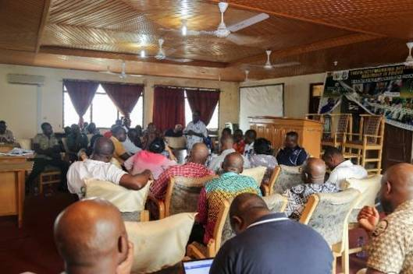
Stakeholder engagement at Twifo/Atti-Morkwa District Assembly

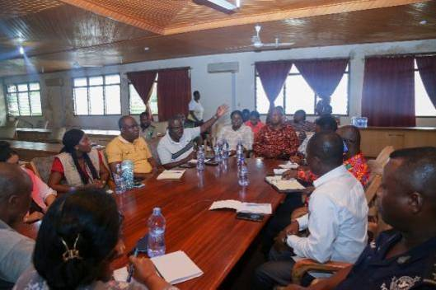
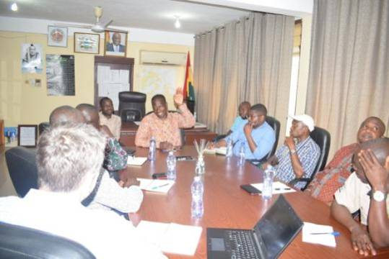
Stakeholder engagement with officers of Kwahu South District Assembly

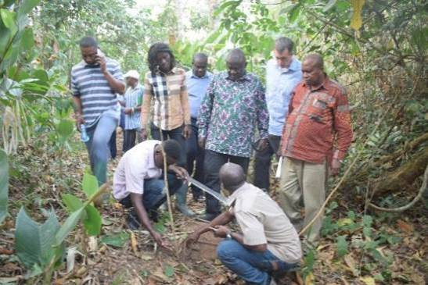
Field Interaction with Forest staff at Kwahu South

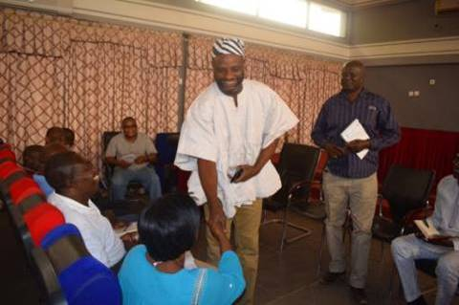
Stakeholder Consultation at West Mamprusi Municipality

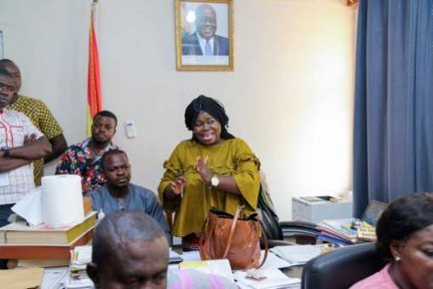
Stakeholder Consultation at Kwahu West District Assembly

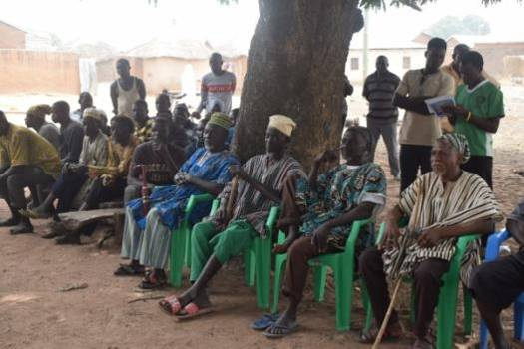
Community Engagement at Takorayiri community - West Mamprusi Municipal, North East Region

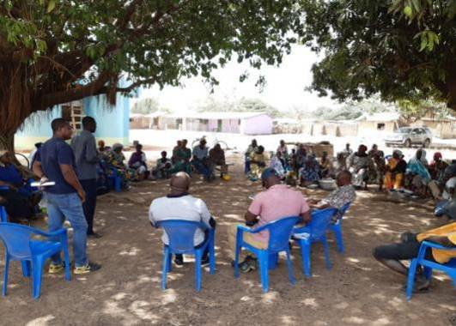
Community Engagement at Goyiri community in STK District, Savannah Region
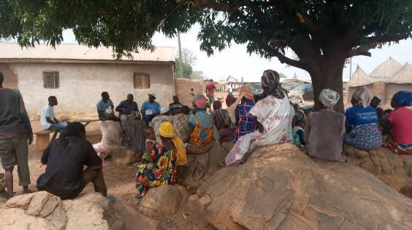
Community engagement at Sagadugu community in the West Mamprusi Municipal, North East Region

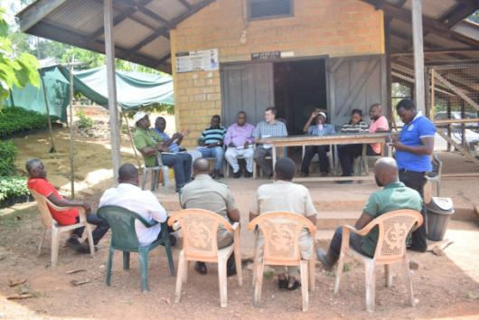
Interaction with officers of the Seed Production Unit in Juaso (COCOBOD)

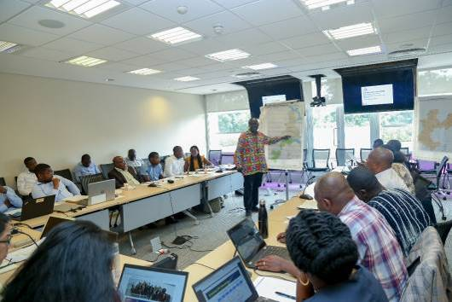
Consultation with IA’s and World Bank
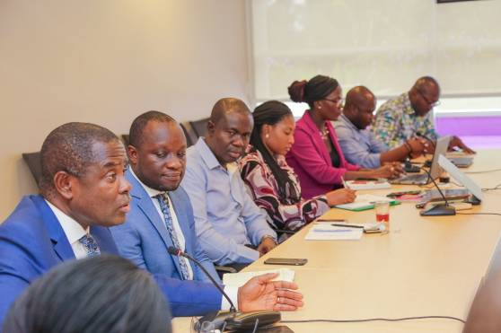
Joint consultation with I As, WB, COCOBOD, FIP etc

Annex 12: Complaints Submission Form

Reference No:
Full Name:
Contact information and preferred method of communication  Please mark how you wish to be contacted (mail, telephone, e-mail). | By Post: Please provide postal address: ________________________________________________________________________________________________________________________________________________________________________  By Telephone: __________________________________________  By E-mail ______________________________________________
Nature of Grievance or Complaint
Description of grievance: What happened? Where did it happen? Who was involved?
What is the result of the problem? Source and duration of the problem?
Date of incident/grievance | One-time incident/grievance (date _______________)  Happened more than once (how many times? _____)  On-going (currently experiencing problem)
Receiver | Name: ____________________________________________________________________  Signature ______________________________________________  Date ______________________________________________
Filer | Name: ________________________________________________________________________________________________________________________________________  Signature ______________________________________________  Date ______________________________________________  Relationship to Complainant (if different from Complainant): ________________________________________________________________________________________________________________________________________
Review/Resolution
Date of Conciliation Session: ____________________________________________________________________________
Was Filer/Complainant Present? Yes/ No
Was field verification of complaint conducted? Yes/ No
Findings of field investigation
_______________________________________________________________________________________________________________________________________________________________________________________________________________________________________________________________________________________________________________________________________________________________________________________________________________________________________________________________________________________________________________
Summary of Conciliation Session Discussion

_______________________________________________________________________________________________________________________________________________________________________________________________________________________________________________________________________________________________________________________________________________________________________________________________________________________________________________________________________________________________________________
Issues

_______________________________________________________________________________________________________________________________________________________________________________________________________________________________________________________________________________________________________________________________________________________________________________________________________________________________________________________________________________________________________________
Was agreement reached on the issues? Yes, No If agreement was reached, detail the agreement
_________________________________________________________________________________________________________________________________________________________________________________________________________________________________________________________________________________________________________

If agreement was not reached, specify the points of disagreement
_________________________________________________________________________________________________________________________________________________________________________________________________________________________________________________________________________________________________________
Signed (Conciliator): ___________________________________
Signed (Filer/Complainant): _____________________________________

Signed: _________________________________________________
(Independent Observer e.g. Assembly Member/Opinion Leader)

Date: _______________________________

Implementation of Agreement
Date of implementation: __________________________________________
Feedback from Filer/Complainant: Satisfied /Not Satisfied
If satisfied, sign off & date_____________________________________________________
(Filer/Complainant) (Mediator)
If not satisfied, recommendation/way forward ____________________________________________________________________________________________________________________________________________________________________________________________________________________________________________________________________________________________________________________________________________________________________________________________________________
(Signature & date of Filer/Complainant) ______________________________________________________

(Signature & date of Mediator) ________________________________________________________________

Annex 13 Grievance Register

Unique reference number | Date of incoming grievance | Location (where the grievance was received/  submitted) | Complainant’s name | Contact details (Leave it blank in case of anonymous enquiries and grievances) | Summary of Complaint | Identification of parties responsible for addressing and resolution of complaint | Investigation launch date | Investigation completion date | Findings of investigation | Proposed corrective actions | Deadlines for internal actions required from staff | Indication of satisfaction with compliant | Close out date | Any outstanding actions for non-closed grievances

Annex 14: Target Wildlife Protected Areas and Forest Reserves

Gbele Resource Reserve (GRR)
The Gbele Resource Reserve is located in the north-west of the country (the nearest town is Tumu to the north-east). It was established and gazetted in 1975. It has a total land area of 565 square kilometers. The topography is rather flat; it is traversed by a seasonal, sandy river (the Kulpawn) flowing from the west to the south-east. The vegetation consists mainly of various types of broad-leaved Sudanian woodland. In the vicinity of Gbele village, in the north-centre, there are some thicket clumps with Adansonia digitata, Acacia albida and Ficus sycomorus. The Kulpawn river is flanked by an interrupted line of low thickets or patches of dry forest; these are more extensive in the north, on the edge of permanent large pools. Between Gbele village and the reserve entrance in the north, the soil is shallow, or even rocky, and the woodland there is rather short and open, especially around flat rock slabs. According to records from park management the annual average number of tourists to the reserve annually is ten (10).

Flora and Fauna: The trees and shrub species in the Gbele Resource Reserve are mainly fire resistant and adapted to the annual bushfires. Scrub savannah areas include Acacia gourmaensis and Gardinia sp. Woodlands are dominated by Burkeaafricana, Vitellariaparadoxa, Parkiabiglobosa, Terminalia spp., Isoberliniadoka, Afzeliaafricana, Combretumsp. (including C. fragrans), Pseudocedrelakotschyi, Pterocarpuserinaceus, Stereospermumkunthianum, and Anogeissusleiocarpus. The Gbele Resource Reserve is home to diverse mammal species (antelope, hartebeest, bushbuck, waterbuck, savannah duikers, warthogs baboon, patas, green monkey etc.). There is also a very rich birdlife with about 194 species.

Communities: There are no communities residing within Gbele Resource Reserve. The old Gbele Community was located inside the Reserve area since before its gazettment. Resettlement had been planned since 1980ies and was completed by the FC and the local District Assembly in 2020. the is currently located with the GRR. The community occupies an area less than 1km². The community has a population of about 362 people with 27 households. The population is very much dependent on the Reserve for their livelihood. Agriculture (crop farming, livestock rearing) and gathering various nuts and fruits from the Reserve provide both food and income to the population. The FC has made progress to resettle the Gbele community outside the GRR. New Gbele has 120 rooms on a 13-hectare land. The site has been provided with a mosque, 300 hectares of land for farming, dug outs for use by their cattle and for farming purposes, a school (three classroom block under construction) a clinic and a community meeting place with support from the government of Ghana, the District Assembly and the Sustainable Land and Water Management (SLWM) project. Inauguration of the new settlement has not yet been done, however some settlers of the old community have started farming at the new site.
The Reserve has about 30 fringe communities. Of these communities, 10 are within 7 km from the reserve’s boundaries, another 20 villages being located some 8 to 20 km. While most of these communities have no original land ownership rights involving the area within the boundaries of the GRR, their activities have various effects on its status and management. The villages surrounding the GRR are mostly populated by Sissala and some other ethnic groups in the minority (mainly Dagabas) who practice subsistence farming. Some also continue to poach in the reserve. Local women are mainly housewives, and most engage in the collection and processing of Shea butter and spices from African Locust Bean (“Dawadawa” or Parkiabiglobosa), and Tamarind, during the dry season; they also are allowed to pick shea nuts inside the reserve, based upon agreement with the FC. Few local people are traders.

Digya National Park
The Digya National Park is situated on a peninsular off the central section of the western shore of Lake Volta. The park has an area of 65,000 ha when it was first established in 1909 during the British colonial era. The creation of the Volta Lake in 1965 resulted in expansion of the park to its present size of 347,830 ha, including the original location of some sixteen settlements. The reserve was legally gazetted as a national park in 1971 on the basis of its importance as wild animal habitat and also as part of the complex policy related management issues of the Volta basin. Digya is considered as very strategic in the stabilization of the shores of the Volta Lake. It is surrounded by a large human population made up of fishers and farmers, comprising indigenous communities as well as migrants who moved into the area with the creation of the Volta dam. Most of the people in the fringe communities live in houses constructed out of improvised local materials, notably switch for wall construction and thatch for roofing. According mangement records of the reserve the annnual number of tourist tt the park is fifty (50).

Flora and Fuana: Digya National Park falls under the Guinea Savanna classification. Taylor (1952), based on mainly trees, classified the vegetation of Digya National Park as Guinea Savanna Woodland. Rose Innes (1977) classified the area as Interior Savanna, consisting of Derived Savanna and Guinea Savanna. In a full account of the vegetation of the park by Schmitt and Adu-Nsiah (1994), four main groups have been distinguished: Tall-grass savanna, Boval vegetation, Riparian forest and Aquatic vegetation. Typical trees and shrubs include Lophira lanceolata, Terminalia avicennioides, Vitellaria paradoxa, Daniecllia oliveri, Borassus aethiopum, Burkea africana, Combretum fragrans, Annona senegalensis, Maytenus senegalensis, Bridelia ferruginea, Hymenocardia acida and Parinari polyandra.

The park supports low populations of the African Elephant (Loxodonta africana), together with a number of ungulates including Hartebeests (Alcelaphus buselaphus), Roan Antelope (Hippotragus equines), Bushbuck (Tragelaphus scriptus), Bay Duiker (Cephalophus dorsalis), Bush Duiker (Sylvicapra grimmia), Red-flanked Duiker (Cephalophus rufilatus), Waterbuck (Kobus ellipsiprymnus) and Burron's Kob (Kobus kob). The African Buffalo (Syncerus caffer), Oribi (Ourebia ourebi) Bongo (Tragelaphus euryceros), Bush Pig (Potamochoerus larvatus) and Common Warthog (Phacochoerus africanus) are also known to occur in the park. Additionally, the park harbours aquatic species of conservation significance such as the Manatee (Trichechussenegalensis), Hippopotamus (Hippopotamus amphibious) and African Clawless Otter (Aonyx capensis) together with numerous fish species in the adjoining Lake Volta (Wildlife Department, 1995; EPA, 1996). At least six primate species including Olive Baboon (Papio anubis), Velvet Monkey (Cercopithecus pygerythrus), Mona Monkey (Cercopithecus mona), Lesser Spotnosed Monkey (Cecopithecus nictitans), the Western Pied Colobus (Colobus polykomos) and Patas Monkey (Cercopithecus (Erythrocebus) patas) are reported to occur in the park. Common carnivores are the Cusimanse (Crossarchus obscures) and some mongoose species. The park is reported to be the historical home of two species that are presently locally extinct namely the Black Rhinoceros (Diceros bicornis) and the Wildebeest (Connochaetes taurinus).

Settlements Within the Digya National Park: Currently there is only one recognised / admitted human settlement within the boundaries of Digya NP known as Dome-Nkeneku, located within a 5-kilometer square land at the western side and close to the Sene River. However, there are other several smaller fishing communities mainly dotted along the main Volta boundaries. The people in these fishing communities in the park are settling there illegally. Some notable illegal settlements include the following: (1) Atigagome, (2) Supom-Odome, (3)Sakpeti, (4)Mepekope, (5)Tsita, (6) Korlekope, (7) Agrave, (8) Hedzro and (9) Waaso.

The people in the Dome-Nkeneku settler area are mainly crop farmers with a few of them engaging in livestock rearing on small holder basis. Among the crops cultivated by the farmers in the admitted area include maize, yam, plantain, cowpea and rain season vegetable (Garden eggs, Tomato and pepper) cultivation. A zone of influence of 1295 ha was demarcated for them in 1988. The population of the inhabitants of the admitted community continue to grow thereby putting pressure on the limited land allocated to the people. Current human population is estimated to be around five hundred (500). Demand for extra farmlands, lack of well-defined exclusive boundary, and the use of unproductive agriculture practices, indiscriminate cutting of trees for charcoal production and hunting for bush meat and bush burning are some of the activities that have detrimental effects on the biodiversity of the area. Residents of the community and the staff living within the community use the Sene River as their source of water. The people lack the most basic social amenities like health centre, potable drinking water, electricity, and a functional school. The only school in the community which also serve the staff who live there is up to Primary Four and located in some dilapidated structure.

Tano Offin Forest Reserve
The Tano Offin Forest Reserve derives its name from the Tano and Offin Rivers that drain the reserve. The reserve is part of Forest Management Unit (FMU) 35. It lies between Latitudes 6º 54’ and 6º 35’ North and Longitudes 1º 57’ and 2º 17’ West. The reserve covers a total area of 402.23 km² (40,223 Ha). An area of 18,846.25ha (46.85%) is also constituted into a Globally Significant Biodiversity Area (GSBA). The Tano Forest reserve is located within the Atwima District of the Ashanti Region and is situated between the Kumasi–Wiowso–Tepa and Kumasi–Bibiani roads; the Kumasi–Wiowso–Tepa road forms the northern boundary of the reserve. The site comprises much of the Nyinahin hills, which run north-east–south-west, with Aya Bepo (740m) the highest point, and which serve as the catchment area for several streams, tributaries of the Tano and Offin rivers. The reserve falls within the moist semi-deciduous forest zone and includes 34,100 ha of upland evergreen forest.

Flora and Fauna: The Tano Offin Forest Reserve harbours a wide range of biological resource within the GSBA. It is rich in fauna and flora resources. The reserve has a Genetic Heat Index (GHI) value of 176.4. Taylor (1961) identified the Tano Offin Forest Reserve as belonging to the Celtis – Triplochiton Association whilst Hall and Swaine (1976) classified the reserve under Upland Evergreen Forest because of its location on isolated hills within the Moist Semi-Deciduous Forest Type. Tano-Offin forest reserve supports several nationally rare species such as Columba unicincta, Cercococcyx olivinus and Tockus camuru. It also supports over a hundred bird speciess. The two classifications by Taylor and, Hall and Swaine further described the structure of the reserve as consisting of three distinct layers. These are upper, middle and lower canopies. The upper layer consists of tall emergent trees exceeding an average height of about 45m. The reserve could be described as an open forest. The gaps are evenly spread over the entire reserve with openings being wider in recently logged areas where the undergrowth is dense and more pronounce where illegal farming is taking place.

Settlements within the Tano Offin Forest Reserve and Fringe Communities: Kyekyewere is a settlement community that was admitted during the reservation of the forest reserve and has a total area of 546.88ha. The forest reserve also has a total admitted farm area of 80.94ha. The Kyekyewere community has outgrown its original size over time resulting in the illegal extension of the settlement and farms. This has resulted in the upsurge of illegal chainsawing, farming, unregulated hunting, illegal mining (Galamsay) and charcoal production.
Residents of the fringe communities are predominantly Ashantis. Other ethnic groups identified in the area include the Ewes, Bonos, Northerners, Krobos, etc. Agriculture is the main occupation in the area constituting 80% of all other activities. Cocoa is the main cash crop (75%), while Oil Palm and Citrus (8%) are also significant tree crops in the area. Food crops in the area include plantain (5%), cocoyam (2%), cassava (5%), and maize (5%). Apart from agriculture, basket weaving, trading, hunting, tailoring, hairdressing and masonry are the other economic activities identified in the area.

Mole National Park
Mole National Park is the largest national park in Ghana and has the widest range of wildlife. The park was established in 1958 and gazzeted in 1971. It has a total land area of 4,577 square kilometres. It is the most tourists attracted park of the four to be covered by the project with an annual average of eighteen thousand (18,000) tourists.

Flora and Fauna: The park is home to over 93 mammal species, and the large mammals of the park include an elephant population, hippos, buffalo, and warthogs. The park is considered a primarily African preserve for antelope species including kob, defassa waterbuck, roan, hartebeest, oribi, the bushbuck, and two duikers, the red duiker and yellow-backed duiker. The park is also home to Olive baboons, black-and-white colobus monkeys, the green vervet, and patas monkeys are the known species of monkeys resident in the park.

Tree species of the park include Burkea africana, Isoberlinia doka, and Terminalia macroptera. The savanna grasses are somewhat low in diversity but known species include a spikesedge, Kyllinga echinata, an Aneilema, Aneilema setiferum var. Tree species of the park include Burkea africana, Isoberlinia doka, and Terminalia macroptera. The savanna grasses are somewhat low in diversity but known species include a spikesedge, Kyllinga echinata, an Aneilema, Aneilema setiferum var.

Communities: The communities surrounding MNP occupy three traditional areas: Gonja, Wa and Mamprusi. Community members are mainly subsistence farmers who also rear livestock, hunt, and gather wild fruits and other non-traditional forest products (NTFPs). The park is surrounded by 33 communities with a population of about 40,000 people, who still make use of the Park’s resources in diverse ways. Some of the communities surrounding the park are involved in a CREMA while others are not.

Kogyae Strict Nature Reserve
Kogyae Strict Nature Reserve (or Kogyae) is a strict nature reserve, that covers an area of 386 km²and shared by the Kumawu and Kwamang traditional areas in the Sekyere West District of the Ashanti Region. According to management of the reserve annual visits is almost nil.

Flora and Fauna: Much of the reserve area is covered in semi-deciduous forest woodlands and open grassland often interrupted by woodlands. Some of the animals found here include baboons, buffalos, civets, elephants, red duiker, waterbuck, black duiker, kob, roan antelope, yellow-backed duiker, western hartebeest, grey duiker and the royal antelope. There are more than 82 different species of birds in the park with regular sights of hornbill and Francolins.

Settlements Within the Kogyae Strict Nature Reserve
- The Birem settlement is located right on the reserve boundary: half of it is in the reserve and within the Special Use Zone and the other half outside the reserve
- The Kyeyiase is also located right on the reserve boundary with part including a school Chichibon settlement: Only Teachers’ quarters and three (3) churches are in the reserve within the Special Use Zone while the main settlement is located just outside the reserve boundary
- Asasebonso- the whole community is in the reserve and within the Special Use Zone.
- Asasabonso Konkomba-Entire settlement is in the reserve and within the Special use Zone
- Asasebonso: Entire settlement is in the reserve and within the special use zone
- Nyamebekyere Dagomba: The Entire settlement is in the reserve and within the Special Use Zone.
- Dome: Entire settlement is in the reserve and within the special use zone
- Atakpame-Part settlement is within the reserve and within the Special use Zone.
- Aberewanko: Entire settlement is located within the reserve and within the Special Use Zone.
- Yahayakuraa: The settlement is located within is in the reserve and within the Special Use Zone.
- (primary and JHS) located in the reserve in the Special Use Zone.

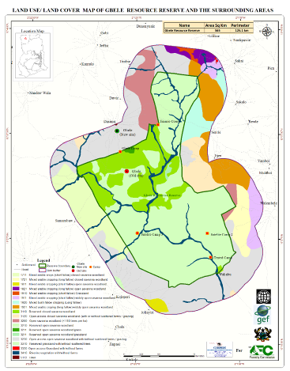 | 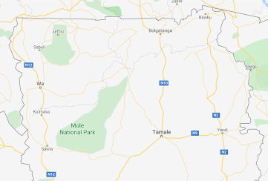
a) Map of Gbele Resource Reserve | - Map of Mole National Park
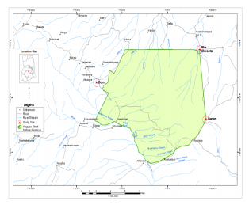 | 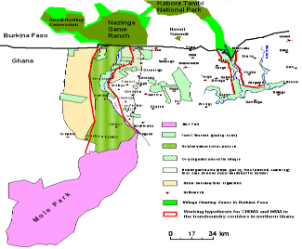
c) Map of Kogyae Strict Nature Reserve | d) Map of Western Wildlife Migration Corridor
Figure 8 : Map of Environmentally Sensitive and Protected Areas

COCOA FOREST LANDSCAPE (PRA RIVER BASIN)
No. | Region | Forest District | Political District |  | Forest Reserve Within the Project Area | Area (Km2) | Status Management Plans | No. Admitted Farms / settlement | Estimated Total Area of Admitted Farms/settlement (km2) |  | Estimated Total Perimeter of Admitted Farms/settlement (Km)
 |  |  |  |  |  |  |  |  | Admitted Farm | Settlement | Estimated Total Perimeter of Admitted Farms/settlement (Km)
1 | Central | Assin Fosu | Assin North |  | Nil | Nil | Nil | Nil | Nil | Nil | Nil
2 | Central | Assin Fosu | Twifo Ati Morkwa |  | Nil | Nil | Nil | Nil | Nil | Nil | Nil
3 | Eastern | Mpreaso | Kwahu South |  | Southern Scarp | 116.55 | No Management plans | 400 | 29.26 | Nil | 350.14
4 | Eastern | Mpreaso | Kwahu East |  | Northern Scarp East | 48.53 | No Management plans | 104 | 15.56 | Nil | 54.82
5 | Eastern | Mpreaso | Kwahu East |  | Northern Scarp West | 64.65 | No Management plans | 299 | 2.93 | Nil | 13.83
6 | Eastern | Akim Oda | Asante Akim South |  | Pra Anum | 132.87 | Written & Published Management Plan | 87 | 3.87 | 4.86 | 51.02
8 | Ashanti | Juaso | Asante Akim South |  | South Fomangsu | 33.00 | Management Plans preparation is ongoing by FC | 30 | 1.32 | 7.22 | 38.63
9 | Ashanti |  |  |  | Prakaw | 20.14 | No Management plans | 5 | 0.46 |  | 5.74
11 | Ashanti | Nkawie | Atwima Mponua |  | Tano Offin | 402.23 | Written & Published Management Plan | 20 | 0.81 | 5.47 | Unknown
12 | Ashanti |  |  |  | Offin Shelterbelt | 60.23 | No Management plans | 9 | 0.03 | Nil | 2.85
13 | Ashanti | Bekwai | Adansi North, Bosome Freho |  | Fum Headwaters | 85.83 | Written & published Management Plans | 14 | 0.60 | Nil | 11.06
14 | Western | Tarkwa | Prestea Huni Valley |  | Bonsa River | 160.58 | Written & Published Management Plan | 57 | 8.34 | Nil | 57.28
Sub Total |  |  |  |  |  | 1152.14 |  | 1025 | 63.19 | 17.55 | 593.67

SAVANNA LANDSCAPE
Bawku
Bawku | Bawku West | Red Volta East | 217.61 | No Management plans | Nil |  | Nil | Nil | Nil
Tumu | Sissala East | Chira Headwaters | 33.67 | No Management plans | Nil |  | Nil | Nil | Nil
Lawra | Wa East | Ambalara | 132.45 | Written & published Management Plans | Nil |  | Nil | Nil | Nil
Lawra | DBI | Kulpawn Tributries | 100.30 | Written & published Management Plans | Nil |  | Nil | Nil | Nil
Sub Total |  |  | 486.20 |  | Nil | Nil |  | Nil | Nil
Total Area |  |  | 1638.34 |  | 1025 | 63.19 |  | 17.55 | 593.67
Source: Forestry Commission, Ghana (FSD)

Annex 15: Incident Reporting Form and Types of Incidents to be Reported

Incident Reporting: Project-Related

(Note: It is important that incidences of child abuse and sexual harassment and severe criminality / social risks that may involve Project staff are documented and brought to attention of MLNR and EPA promptly for information and determination if further investigation is needed to avoid any possible negative consequences on the Project)

Fatalities must be reported promptly, with initial reporting submitted within 24 hours to the World Bank.

1 | From:
2 | Title
3 | To:
4 | Title / Organisation
5 | Date of submission:
6 | Date of re-submission
7 | Details of Incidence
8 | Incident No. (month/No) e.g. first fatal in October
9 | Nature of Incident (e.g. Multiple Fatality)
10 | Severity of incident
11 | Who is the victim / survivor?
12 | Name / Occupation of Project staff involved / suspected to be involved? (if known at this stage)
13 | Date Incident Happened
14 | Location of Incident
15 | Date / Time Incident Reported to Contractor / Consultant
16 | Details of Person(s) Who Reported
17 | To Whom was incident Reported?
18 | Mode of Reporting (verbal/written report) – if written attach report.
19 | Details of the Incident (key facts pertaining to the incident and how it happened)
20 | Who else was informed about this incident?
21 | What Action (s) has been taken by Contractor / Consultant to address the problem? And When?
 | Details of Actions By responsible agency
 | Name / position of responsible staff incident was reported
 | Comments / Recommendations for responsible agency staff for which Incident was first reported
 | 2nd Name/Position / Department for which incident was reported to in responsible agency  Comments / Follow up Action Recommended. | .

Indicative Incident

Environmental | Social | Occupational Health & Safety
Small-volume hydrocarbon or chemical spills | Small-scale crop damage or livestock deaths | Underuse of personal protective equipment (PPE) by Works Contractor
Localized dust, light, or noise pollution | Grievances due to Project use of public roads | Local increase in the occurrence of communicable disease
Illegal hunting of wildlife (non- endangered) | Project interference with locally significant practices or sites | Minor job site injuries
Small volume sediment, pesticide, or fertilizer run-off into local waterways | Vehicle damage to public or private roads caused by Works Contractors | Poor “housekeeping” at site, e.g., littering and random disposal of solid waste
Minor off-site disposal of solid waste from Project | Nuisance-level contact between employees and community | Lack of understandable warning or traffic control signage
Poor quality or delayed site restoration and revegetation | Minor instances of inappropriate behavior of security forces or other Contractor personnel | Almost empty first aid kit at work site
Poorly functioning erosion- control measures | Overloading of local commercial services from use by Project personnel | Poorly organized or sporadic health & safety induction and training
 | Minor impacts on livelihood restoration and/or access to community natural resources | Multiple “slip and trip” hazards throughout the site
 | Minor impacts on cultural sites/areas | Lack of Health & Safety plan and/or training for staff
 | Minor social conflict related to or affecting the Project
 | Some problems with consultation/outreach about the Project
 | Delays by GRM in handling/addressing grievances

Serious Incidents
Environmental | Social | Occupational Health & Safety
Large-volume hydrocarbon or chemical spills, or other hazardous substances impacting the environment | Widespread crop damage or livestock deaths | Injury/ies requiring off-site medical attention
Over-exploitation of local natural resources | Cases of mistreatment of communities potentially, including vulnerable groups, by Project workers or security forces, including incidents such as sexual harassment | Instances of serious communicable diseases among workforce
Large-volume or long-term sediment, pesticide, or herbicide runoff into waterways | Significant impacts to protected physical cultural resources | Consistent lack of health & safety plans and training at work site
Medium to large-scale deforestation | Works have commenced without compensation and resettlement being completed | Chronic non-use of PPE at Project work site
Lack of implementation of agreed environmental restoration program | Significant and repeated community impacts from Project vehicles and construction activities | Repeated non-compliance or failure to remedy non- compliance
 | Lack of clarity about consultations with Indigenous Peoples and broad community support for the Project
 | GRM not functioning
 | Inadequate consultation and engagement of stakeholders in the Project leading to significant conflict and/or delays
 | Non-violent community protests against the Project, or mild community unrest

Severe Incidents
Environmental | Social | Health & Safety
Hydrocarbon or chemical spills, or release of other hazardous substances into the environment, causing widespread impacts, and/or requiring large-scale remediation | Forced evictions or resettlement of communities without due process or compensation | Any fatality Permanent disability
Poaching or hunting and trafficking of threatened or endangered species | Abuses of community members (including vulnerable groups e.g., women, children, youth, elderly, disabled/sick, LGBT) by site security forces or other Project workers, including but not limited to GBV | Outbreak of life-threatening communicable disease
Sediment, pesticide, or herbicide runoff causing permanent damage to waterways | Significant damage to nationally protected areas or to UNESCO World Heritage sites | Criminal and political attacks at worksite
Destruction of internationally recognized critical habitat | Human trafficking and child labor | Forced labor by Project’s Works Contractor
Major river contamination causing decimation of fish population or other aquatic resources | Violent community protests against the Project | Works Contractor is unresponsive regarding ongoing worksite risks of bodily injury
 | Significant impacts on Indigenous Peoples’ land/natural resources and/or culture and there is no evidence of consultation, broad community support, mitigation of harm and/or culturally appropriate benefit-sharing | Persistent non-compliance and/or inability or unwillingness to remedy non-compliance that could result in bodily injury or harm Murders, kidnappings, manslaughter and assaults, while criminal matters and not safeguards incidents per se, have occurred in Bank Projects and should be treated as severe incidents. These incidents would be referred to local authorities with notification to WB Security

Appendix 16: INTEGRATED PEST MANAGEMENT PLAN(IPMP)

REBUBLIC OF GHANA


MINISTRY OF ENVIRONMENT SCIENCE TECHNOLOGY AND INNOVATION (MESTI)
MINISTRY OF LANDS AND NATURAL RESOURCES (MLNR)

GHANA LANDSCAPE RESTORATION AND SMALL-SCALE MINING PROJECT
(GLRSSMP)
(P171933)

INTEGRATED PEST MANAGEMENT PLAN
(IPMP)

JANUARY 2021

This Integrated Pest Management Plan (IPMP) is an annex to the Environmental and Social Management Framework (ESMF)

Citation:
Environmental Protection Agency. 2021. Integrated Pest Management Plan (IPMP) Ghana Landscape Restoration and Small-Scale Mining Project (GLRSSMP).

For more information, contact:
Isaac Charles Acquah (Jnr.)
Project Coordinator
Ghana Landscape Restoration and Small-Scale Mining Project
Environmental Protection Agency

1.0 INTRODUCTION

1.1 Background
The Government of Ghana (GoG) with support of the World Bank (WB) under the proposed Ghana Landscape Restoration and Small-Scale Mining Project (GLRSSMP) will: (a) support restoration of degraded lands for agricultural productivity; (b) strengthen sustainable management of forest landscapes for biodiversity conservation and ecosystem services; (c) support formalization of illegal ASM for sustainable mining; and (d) support land use planning for integrated landscape management to optimize land use to land characteristics. Specifically, the project will be implemented through the following components: (1) Institutional Strengthening of Governance and Partnerships for Participatory Landscape Management (2) Regulatory strengthening and formalization of sustainable ASM, (3) Investments for Sustainable Crop Management and Production, (4) Forest Landscape Management and Restoration, (5) Landscape Monitoring and Project and Knowledge Management, and (6) Contingency Emergency Response.

The main beneficiaries of the proposed project are small-scale crop farmers investing in improved practices for crop production and landscape planning and management and ASM operators who will benefit from enhanced productivity due to formalization, introduction of new technologies, and alternative livelihoods support. The project will support agriculture activities such as cocoa, cashew and food crop production. Food crops likely to be supported will include maize, groundnut, cassava, soya bean, yam, plantain, cocoyam etc. To provide a general impact identification framework to assist project implementers to screen the project activities (including the agricultural activities) and institute measures to address adverse Environmental and Social (E&S) impacts associated with them, the project has prepared an Environmental and Social Management Framework (ESMF). This Integrated Pest Management Plan (IPMP) is an annex to the ESMF and has been prepared to meet the requirements of a productive and sustainable agriculture that minimizes health and environmental risks.

1.2 Rationale and objectives of the Integrated Pest Management Plan
One of the objectives of the World Bank ESS3 is to minimize and manage the risks and impacts associated with pesticide use. Pest populations are to be controlled through Integrated Pest Management (IPM) approaches such as biological control, cultural practices, and the development and use of crop varieties that are resistant or tolerant to the pest. IPM refers to a mix of farmer-driven, ecologically based pest control practices that seek to reduce the heavy reliance on synthetic chemical pesticides. It involves the following:
Managing pests and keeping them below economic injury levels rather than eradicating them;
Integrating multiple methods (relying more on biological, physical and cultural) to keep pest populations low;
Appropriate selection and application of pesticides where necessary, to minimize adverse effects on beneficial organisms, humans and the environment.

The general objective of the IPMP is to prevent or mitigate the impacts of pests and pesticides on human and biological environment and to provide an effective integrated pest control framework. The plan also highlights the different categories of actors whose roles and activities have differential impacts on the effectiveness of environmental and health management. The specific objectives of the project’s IPMP are to:
Identify approved pesticides for use in the project, their characterization and any specific conditions of use,
Ensure integration of appropriate pest management techniques into agroforestry technologies and sustainable land management practices within the project area,
Identification of suitable good agricultural practices and safe practices that reduce human and environmental risk from the exposure and use of pesticides,
Monitor pesticide use and identify pest issues among participating farmers,
Promote implementation of an Integrated Pest and Crop Management (IPCM) in cocoa, cashew, food crop production and to a limited extent, poultry and livestock production.

This IPMP provides the information to address three key objectives around the ESS3 requirements for the GLRSSMPP:
Promoting the IPM approach for the cocoa landscape activities (in particular rejuvenation of moribund farms), including the promotion and adaptation of climate smart cocoa;
Promoting the IPM approach in the northern savannah zone for the production of cashew and food crops such as cowpea and maize;
Providing insight and recommendations on capacity building opportunities for the promotion of IPM and rational use of pesticides in tree crops (cocoa and cashew), cereals and tuber production.

1.3 Use of Pesticides Under the Project
The use of pesticides is expected to be very low during project implementation – and at lower levels than the current baseline. The use of pesticides under the project will be limited to the following situations:
Zero tillage under SLWM - minimal and extremely localized use. This SLWM option is not a very popular option currently in the selected intervenion landscapes.
Cowpea establishment - use will be targeted to cowpea plants only.
Maize cultivation- use will be targeted at sites with fall army worm infestation.
Cashew establishment – use will be targeted at cashew pests only
Nursery operations by Forest Service Division and COCOBOD - limited use, both FSD and COCOBOD have standard procedures and trained staff; pesticides are only used by the agencies’ trained staff. Insecticide application in cocoa farms / application is done by trained spraying gangs, using standard protocols developed by CRIG and included in the Cocoa Manual. The project will only work on 1,000 ha of cocoa, investing in rejuvenation of moribund cocoa farms.
Community nurseries only raise indigenous tree species from seeds and wildlets (seedlings) picked from the forest, with no need for pest treatment.

1.4 Lessons Learned

The Sustainable Land and Water Management Project has provided lessons that formed the basis for the design of the GLRSSMP:
The operational direction of the extension services must shift from a top-down to a farmer-driven approach, i.e., learning with farmers, in line with the Farmer Field School (FFS) approach which is needed to deliver integrated pest management messages successfully;
IPM farmers trained in the FFS approach (a) developed the capacity to make farm decisions regarding whether to take measures to reduce the pest populations, (b) became knowledgeable about pesticide use and its effects and impacts, and (c) appreciate the effects of pesticide applications on insect population biology;
Adequate dialogue with farmers through the participation of local authorities and careful selection of field extension workers is necessary for a successful IPM programme;
Yield losses can be minimized by (a) adopting an integrated approach to pest management consisting of monitoring pest populations, (b) adopting improved agronomic practices, (c)using pest resistant varieties, (d) using nonchemical measures to keep pest populations below economic thresholds, and (e) using pesticides judiciously;
Pests do not have to be eradicated fully to maintain good yields; rather, pest populations must be kept below economic injury levels;

1.5. Methodology

The methodology adopted for the development of this IPMP is based on a participatory approach, involving all stakeholders and partners concerned with GLRSSMP. This participatory approach allowed the opinions and proposals of the different actors to be integrated into the IPMP. To achieve the results of the study, the under listed strategies were adopted:
An analysis of program documents (Concept papers and draft Project Appraisal Document) for a better understanding of the objectives, components of GLRSSMP and its potential activities; as well as other strategic and planning documents and training tools at the national or local levels;
A bibliographic review of national laws and regulations on the protection of the environment and natural resources, agriculture (phytosanitary regulations) and Environmental and Social Framework established by the World Bank;
A review of IPMP of similar World Bank funded projects such Ghana Commercial Agriculture Project (GCAP) and the Forest Investment Programme (FIP) – Enhancing Carbon Stocks in Natural Forests and Agroforest Landscapes
A review of literature and other documents such as:
Pesticide use and Policies in Ghana by Gerken, et al. (2001).
Environmental Protection Agency, Accra, Revised Register of Pesticides as at December 2009 under the Part ii of the Environmental Protection Act, 1994 (Act 490).
Handbook of crop Protection Recommendations in Ghana: An IPM Approach, vols. 1, 2, 3 & 4
Pesticide Dealers’ Handbook, Suglo; 2002.
Pesticide use patterns in Ghana for the production of three key staple food commodities - maize, rice and soybean, grown for both local and international markets.
Meetings and consultations of institutional and socio-professional actors mainly concerned by the GLRSSMP: Ministry of Food and Agriculture (MoFA); Ministry of the Environment, Science, Technology and Innovation (MESTI), NGOs and farmers’ organizations;
Site visits and interviews with beneficiaries and potentially affected persons, officials and resource persons in the various localities concerned.

2.0 PEST MANAGEMENT RELATED POLICY, LEGAL AND INSTITUTIONAL FRAMEWORK
For an enabling environment of the project activities in general and IPM in particular, the policy and legal framework of the country, the donor requirements and international conventions have been reviewed. This section discusses and summarizes, the provisions of Ghana’s policy and legal framework of pest management in Ghana in general and use of pesticides in particular, and indicates how this PMP meets those requirements. This section also discusses other international policies/ regulations on use of pesticides as well as the WB Environmental and Social Framework and its key requirements, noting that the development of this IPMP responds to those requirements.

A gap analysis between relevant ESSs for the project, including ES3, and the Ghana national legal and regulatory requirements is included in the ESMF.

2.1 Policies and Regulations

2.1.1 National Regulations
The relevant national laws governing environmental pollution, plant protection, and pest and pesticide management and control include:
Environmental Protection Agency Act, 1994, Act 490;
Environmental Assessment Regulations, 1999, LI 1652;
Plants and Fertilizer Act, 2010, Act 803; and
Water Resources Commission Act, 1996, Act 522.
Environmental Protection Agency Act, 1994, Act 490
This Act establishes and mandates the EPA to seek and request information on any undertaking that in the opinion of the Agency can have adverse environmental effects and to instruct the proponent to take necessary measures to prevent the adverse impacts. This law aims at controlling the volumes, types, components, wastes effects or other sources of pollution elements or substances that are potentially dangerous for the quality of life, human health and the environment. Part II of the Act 490 deals with pesticides control and management and this was formally an Act on its own (Pesticides Control and Management Act of 1996, Act 528). This section of Act 490 provides the rules for registration, pesticides classification, approval, clearance, using, disposing of and non-disclosure of confidential information, the granting of license, labelling, and pesticides inspections. The registration authority (EPA) confirms that authorized products are safe and efficacious for intended uses. The EPA is the national authority responsible for the overall pesticide regulatory program in the country.

Environmental Assessment Regulations, 1999, LI 1652
The Environmental Assessment Regulations 1999, LI 1652 list activities for which an environmental assessment is mandatory. The Regulations describe the procedures to be followed to obtain permits for both existing and proposed undertakings through the conduct of environmental impact assessments and preparation of environmental management plans.

Plants and Fertilizer Act 2010, Act 803
The Plants and Fertilizer Act of 2010 combines the Seed Inspection and Certification Decree, NRCD 100 of 1972 and the Prevention & Control of Pests and Diseases of Plants Act of 1965, Act 307. The Act provides for the efficient conduct of plant protection to prevent the introduction and spread of pests and diseases to regulate imports and exports of plants and planting materials; the regulation and monitoring of the exports, imports and commercial transaction in seeds and related matters; and control and regulation of fertilizer trade.

Water Resources Commission Act, 1996, Act 522
The Water Resources Commission Act 522 (1996) conferred on the Water Resource Commission (WRC) the mandate to regulate and control the use of water resources through granting of water rights and water use permits. The Water Use Regulations, (L.I.1692) provides the procedure for allocating permits for various water uses including domestic, commercial, municipal, industrial, agricultural, power generation, water transport, fisheries (aqua culture), and recreational.

2.1.2 World Bank Group Framework on Pesticides
ESS3 sets out the requirements to address resource efficiency and pollution prevention and management throughout the project life cycle consistent with Global International Industry Practice (GIIP). Key objective of ESS3 is to minimize and manage the risks and impacts associated with pesticide use. ESS3 requires that where projects involve recourse to pest management measures, the Borrower will give preference to integrated pest management (IPM) or integrated vector management (IVM) approaches using combined or multiple tactics.
In the procurement of any pesticide the Borrower will assess the nature and degree of associated risks, taking into account the proposed use and the intended users. The Borrower will not use any pesticides or pesticide products or formulations unless such use is in compliance with the Environmental, Health and Safety Guidelines. In addition, the Borrower will also not use any pesticide products that contain active ingredients that are restricted under applicable international conventions or their protocols or that are listed in, or meeting, the criteria of their annexes, unless for an acceptable purpose as defined by such conventions, their protocols, or annexes, or if an exemption has been obtained by the Borrower under such conventions, their protocol, or annexes, consistent with Borrower commitments under these and other applicable international agreements. The Borrower will also not use any formulated pesticide products that meet the criteria of carcinogenicity, mutagenicity, or reproductive toxicity as set forth by relevant international agencies. For any other pesticide products that pose other potentially serious risk to human health or the environment and that are identified in internationally recognized classification and labelling systems, the Borrower will not use pesticide formulations of products if: (a) the country lacks restrictions on their distribution, management, and use; or (b) they are likely to be used by, or be accessible to, lay personnel, farmers, or others without training, equipment, and facilities to handle, store, and apply these products properly.

2.1.3 Key International Conventions
The International Plant Protection Convention (IPPC) is an international treaty that aims to secure coordinated, effective action to prevent and to control the introduction and spread of pests of plants and plant products. It takes into consideration both direct and indirect damage by pests, so it includes weeds. It also covers vehicles, aircraft and vessels, containers, storage places, soil and other objects or material that can harbor or spread pests. The International Plant Protection Convention came into force on 3 April 1952. The Convention has been adopted by the Food and Agriculture Organization of the United Nations. Its implementation involves collaboration by National Plant Protection Organizations (NPPOs) — the official services established by governments to discharge the functions specified by the IPPC — and Regional Plant Protection Organizations (RPPOs), which can act as coordinating bodies at a regional level to achieve the objectives of the IPPC. Ghana’s National Plant Protection Organization is the Plant Protection and Regulatory Services Directorate of MoFA. Ghana adopted the IPPC convention in February 1991.
Other relevant international conventions ratified by Ghana include:
International Code of Conduct for the distribution and use of FAO pesticides;
The Basel Convention on the Transboundary Movement of Hazardous Wastes and their Disposal (adopted) i n 1989; entered into force in 1992).
The Rotterdam Convention on the Prior Informed Consent (PIC) Procedure for Certain Hazardous Chemicals and Pesticides in International Trade (adopted in 1998; entered into force in 2004);
The Montreal Protocol on Substances that Deplete the Ozone Layer (adopted in 1987; entered into force in 1989).
The Codex Alimentarius, Committee on Pesticide Residues (operational since 1966).
The Basel Convention on Persistent Organic Pollutants (POP’s) in 1998 and entered into force in 2004
The Stockholm Convention on persistent organic pollutants in 2001, entered into force in 2004 and
International Standards for Phytosanitary Measures (ISPM) FAO;

2.2 National Institutions Responsible for Safe Management of Agro-Chemicals and Pesticides

2.2.1 Public Sector Institutions
The key national institutions responsible for the safe management of agro-chemicals and its related matters are represented below:
Environmental Protection Agency (EPA)
The Environmental protection Agency has the mandate to regulate, coordinate and manage the environment. The EPA has the oversight responsibility for pest management and control and it has the following prerogatives:
The registration of pesticides
The limitation or banning of the use of a pesticide if necessary
The granting of licenses to all categories of pesticides’ resellers
The levying of penalties.
The EPA and in particular its Chemical Control and Management Centre (CCMC), is responsible for pesticides control and management. The Agency periodically provides a list of registered pesticides and banned pesticides for public consumption. The recent list is attached as a separate document. The list is periodically updated and there is the need to liaise with the Agency for any updates during project implementation.

Ghana Cocoa Board (COCOBOD)
Ghana Cocoa Board (COCOBOD) under the Ministry of Food and Agriculture functions through its centres of production, research, extension, internal and external marketing and quality control of cocoa. The functions are classified into two main sectors; Pre-harvest and Post-harvest. The Pre-Harvest Sector functions are performed by the Cocoa Research Institute of Ghana (CRIG), the Seed Production Division (SPD), and the Cocoa Health and Extension Division (CHED). It is the responsibility of the CRIG, to screen all pesticides used in the cocoa industry to ensure that they comply with EU, Japanese and other markets requirements for food safety, Maximum Residual Limit (MRL) levels and sanitary and phyto-sanitary standards before they are certified for use on cocoa. The CHED deals with cocoa swollen shoot viral disease and other pests and diseases at the farm level. It is the responsibility of the Cocoa Extension Services of the COCOBOD to regularly upgrade farmers’ skills in the application of pesticides. At the district levels, the CHED also performs the functions of the cocoa extension services.

Ministry of Food and Agriculture (MoFA)
The Ministry of Food and Agriculture’s (MoFA)-Plant Protection and Regulation Services Directorate is responsible for the regulation of crop pesticides use in the country. The national plant protection policy is the Integrated Pest Management (IPM) Plan. The Plant Protection and Regulation Services Directorate (PPRSD) of MoFA was established in 1965 by an Act of Parliament: Prevention and Control of Pests and Diseases of Plants Act of 1965, Act 307, which is now replaced by “Plants and Fertilizer Act, 2010 (Act 803). The PPRSD is the National Institution with mandate and capacity to organize, regulate, implement and coordinate the plant protection services (including pests’ management and pesticide use) needed for the country in support of sustainable growth and development of Agriculture. The PPRSD has its headquarters in Pokuase near Accra and there are also regional officers in all the sixteen regions of the country. It also represented at the main entry and exit points throughout the country. It is not directly represented at the district level; however, it collaborates with the district MOFA offices to carry out its functions at that level. The PPRSD is divided into four main Divisions and these include:
Crop Pests & Disease Management Division
Pesticide and Fertilizer Regulatory Services Division
Ghana Seed Inspection Division
Plant Quarantine Division
For the Agriculture sector, the Veterinary Services Directorate (VSD) is responsible for the regulation and management of livestock pests and diseases as well as veterinary pesticides and pharmaceuticals.

Ghana Standards Authority (GSA)
Ghana Standards Authority (GSA) ensures that goods and services are of acceptable quality for both local and international consumers. The Authority makes routine analyses of pesticide residues in fruits and vegetables in order to facilitate the exportation of such products and also ensure public health and safety.

The GSA has central facilities in Accra and regional offices in Ho (Volta region), Koforidua (Eastern Region), Takoradi (Western and Central Regions), Kumasi (Ashanti and Brong Ahafo Regions) and Tamale (Northern sector). GSA has been supported by the World Bank funded AgSSIP and by UNIDO to bring its MRL analysis capacity up to ISO 17025 requirements.

Customs Division (CD)
The Customs Division of the Ghana Revenue Authority (GRA) works in close collaboration with the EPA, VSD and PPRSD, and reviews the EPA documents, certificates/licenses to make sure they concern the importation of approved chemicals, meat, poultry and agrochemical products. The importation reports of chemical products are submitted by the CD of GRA to the EPA on a quarterly basis. The CD staff are members to various technical committees at EPA including the hazardous waste committee, the pesticide technical Committee and other projects undertaken by the EPA. The CD is also a member of the national Coordination team of the Convention of Stockholm on the POPs.

2.2.2 Non-Governmental Organizations/Private Institutions

Farmers’ Associations
Private institutions dealing with pest and pesticide issues are mainly involved in crop farming, agro-input trading, and the trade and export of agriculture products. The Ghana Agro-Input Dealers Association (GAIDA) is an apex body for agriculture inputs (including pesticides) dealers and distributors in Ghana. Various farmer associations abound but they are weak. The Ghana Federation of Agriculture Producers (GFAP) comprises of four major apex farmers associations - the Apex Farmers Organisation of Ghana (APFOG), Farmers Organisation of Ghana (FONG), Peasant Farmers Association of Ghana (PFAG) and the Ghana National Association of Farmers and Fishermen (GNAFF) under one umbrella.

Others such as the Vegetable Producers Exporters Association of Ghana (VEPEAG), and the Seed Producers Association of Ghana (SEEDPAG) also exist to see to the interest of membership. There is the Ghana Agricultural Associations’ Business and Information Centre (GAABIC). These organizations take care of members’ interest and support members to meet the requirements of EPA/PPRSD.

Cocoa and Cashew farmers/Stakeholders Associations
The major interest groups include:
The Ghana Cocoa Coffee and Shea-nut Farmers Association (COCOSHE)
Cocoa Abrabopa Association (CAA)
Kuapa Kokoo
The Ghana Cocoa Platform
Private License Buying Companies
Ghana Cashew Farmer’s Cooperative
The Ghana Cocoa Coffee and Shea-nut Farmers Association
The Ghana cocoa, coffee and Shea-nut farmer’s association is the parent body for cocoa, coffee and shea-nut producers in the country. It was officially founded in 1980 to campaign for better price for the crops.

Cocoa Abrabopa Association
The Cocoa Abrabopa Association (CAA) is an independent organisation for and formed by cocoa farmers in Ghana. It is non-political and non-profit and, seeks to create a better life for its membership by professionalising cocoa farming. It was officially established in 2008 after being piloted at Bonsu Nkwanta in the Western Region of Ghana two years earlier. Members use CAA inputs and guidance packages and additionally, provide services and programmes such as, Advocacy and Lobbying, Certification and Premium Payments, Cocoa Abrabopa Pension Scheme, Extension Services and Training, Planting Shade Trees, Mapping Farms and Farm Plans, Traceability and Transparency, Gender Equality among others to members. Cocoa Abrabopa Association works closely with COCOBOD.

Kuapa Kokoo Cooperative Cocoa Farmers and Marketing Union Limited
Kuapa Kokoo Cooperative Cocoa Farmers and Marketing Union Limited (KKFU) formerly known as Kuapa Kokoo Farmers Union is Ghana’s pioneer and leading producer of ethical cocoa beans. KKFU is a co-operative organization registered under the Co-operative Societies decree of 1968 (NLCD 252) and Co-operative Societies Regulations, 1968 (L.I. 604) as a co-operative Union in Ghana. The Union has over 100,000 registered members who are primarily smallholder cocoa farmers organized into about 1,300 communities in 57 primary Societies (District) in six cocoa growing regions. The cooperative works at improving the social, economic and political wellbeing of its members. Kuapa Kookoo simply means Good Cocoa Farming. It seeks to develop itself into a formidable farmer-based organisation capable of mobilising quality cocoa products, improving the livelihood of members and satisfying customers.

The Ghana Cocoa Platform
The Ghana Cocoa Platform is an avenue created by the Ghana Cocoa Board (COCOBOD) with other supporting stakeholders to provide convening and coordination on technical issues beyond the topic of extension and into other thematic areas of the cocoa sector that would support public-private partnership approach to cocoa development. The goal of the Platform is to boost sustainable production in Ghana´s cocoa sector through enhanced partnership and cooperation among stakeholders

The platform, through plenary sessions provides opportunities for a wider inclusion of sector stakeholders to discuss a mirage of issues that will have a positive impact on the cocoa sector. The Platform is led by COCOBOD, with UNDP providing technical advice, facilitation and organization support to set up and run the platform.

Private License Buying Companies (LBCs)
COCOBOD licenses private companies to purchase cocoa beans from individual farmers at approved prices. The LBCs e.g. Olam, Armajaro and others, however, provide numerous corporate social responsibility services to the farmers in their catchment areas, including extension services, inputs, and sensitization on application of agrochemicals. The promotion of IPM by the LBCs is an important element in the overall national effort to advance IPM in Ghana.

Ghana Cashew Farmers’ Cooperative
There are currently 24 District Cashew Farmers Associations who have come together to form the Ghana Cashew Farmers’ Cooperative. The cooperative seeks to promote the interest of cashew farmers and provide technical support to its members. The appropriate use of pesticides is core to their operations to ensure the safety of both cashew products and farmers.

2.3 Regulatory and Institutional Gap Analysis

2.3.1 Legislative and regulatory Gap
Ghana’s effort towards the sound management of pesticides has been enhanced greatly by the enactment and implementation of the EPA Act 1994, Act 490. Consequently, the EPA has established a pesticide management scheme, which involves the management of pesticides from cradle to grave. Despite these efforts, there are still some challenges in the effective implementation of the law. This is due to the absence of a full complement of relevant regulations to give effect to some of the provisions of the law. There is therefore a need to address the gap in the legal framework and other legislative inadequacies by reviewing and enacting the relevant regulations to enhance compliance.
2.3.2 Institutional Capacity Gaps
The gaps identified are in terms of human and institutional capacity. All the institutions involved with pesticide regulation or management have inadequate experts to handle the enormous workload resulting in heavy work pressure. The remuneration and motivation in most state institutions is low causing experts to be poached by foreign and private organisations that offer better conditions of service. The low number of personnel is exacerbated by the absence of logistics and funds to carry out post registration and licensing monitoring activities on pesticides. For instance, the EPA is in the process of establishing a pesticide quality control laboratory. The laboratory requires equipment and accreditation to be fully operational. However, the agency has limited financial and human resources to handle the demands of the laboratory in effect. From this, it is evident that the EPA and all the relevant institutions in research, regulation, awareness among others will require financial support and institutional capacity to effectively handle pesticide regulation and use.

As part of the extension capacity of IPM approaches and methods, there are also several gaps. Access of farmers to extension services is inadequate in Ghana. One extension officer, who is hardly resourced with the necessary transportation logistics and equipment, is responsible for over 2,200 farmers. It is therefore work in progress towards achieving the UN-recommended ratio of one extension officer to 500 farmers and to ensure the availability of adequate extension delivery tools and equipment, technologies and good practices to aid integrated pest management.

3.0 BASELINE AND POTENTIAL IMPACTS

3.1 Cocoa: Major Pest and Diseases and Pest Management
Integrated Pest Management is promoted and practiced by Ghana’s COCOBOD, a partner agency under GLRSSMP. The Cocoa Manual (Cocoa Research Institute of Ghana (CRIG), 2010. www.crig.org) outlines the rationale and practice of integrated pest management and integrated crop management in Cocoa in Ghana. A combination of cultural, biological, and chemical control measures is outlined for major and minor pests and diseases of cocoa trees and pods (Summarized in Table 1 below). It also covers good agricultural practices generally, including the management of soil nutrients, water and compost in addition to IPM. Consumer markets and standards are important in shaping pest management approaches in the cocoa landscape. Ghana recognizes that Europe is the major market for cocoa beans and processed cocoa and defines standards for pesticide, herbicide and fungicide use based on European standards (or USA-based standards where those are available). Potential pesticides are screened for use by COCOBOD and only those acceptable in environmentally sensitive markets are allowed. COCOBOD also promotes several certification systems for documenting sustainable cocoa production methods. The Cocoa Manual describes five certification systems managed by its partners including UTZ, Rainforest Alliance, Fairtrade, Organic Certificates, and IMO Social and Fair-Trade Certification.

Cocoa extension agents and the Cocoa Research Institute promote these pest and disease control measures and provide information, technical assistance to farmers. COCOBOD, mainly through CRIG, also develops and promotes improved varieties of cocoa trees that are more resistant to pests and diseases and distribute them to farmers. COCOBOD, through the Cocoa Health and Extension Division (CHED), organizes national campaigns to combat economically destructive diseases, such as Cocoa Swollen Shoot Virus Disease (CSSVD) using non-chemical cultural and physical measures (cutting, burning, and replanting diseased areas).

Table 1: Common Pests and Diseases of Cocoa in Ghana and their Control Measures
Pest/Disease |  | Reasons for Control |  |  | Control Measures |  |  |  |  |  | Pesticides Used |  |  |  |  |  | Pesticide Management
Weeds |  | Competition for nutrients, water, light  Increase incidence of insects, rodents and diseases  Reduce harvest efficiency |  |  | Manual weed control, 3-4 times/yr  Leguminous ground cover  Herbicide, 3x per year |  |  |  |  |  | Glyphosate  1.5-2 liters in 100 litres of water per ha |  |  |  |  |  | Apply with approved backpack sprayer  Avoid contract with cocoa seedlings, food crops  Spray in early morning or late afternoon to avoid drift  Apply with 4 hours of dry weather, not in advance of rain  Wear protective clothing  Do not eat, drink or smoke while spraying  Wash down (clothes, hands, shoes) after use  Avoid contaminating streams or water bodies  Dispose of containers by burying  Do not use containers for water or food
Major Pests
Mirids (or  Capsids) |  | Nymphs and adults feed on tender shoots and pods by sucking sap  Cause economic damage by creating lesions that may also result in fungal invasion |  |  | Chemical control is considered most reliable,  5x/year  Botanical control: Aqueous Neem Seed Extract is used on organic cocoa (limited area)  Increase shade: unshaded cocoa is more severely attacked by mirids  Biological control: Mirid sex pheromones and traps are now being assessed. |  |  |  |  |  | Bifenthrin (Akate Master, 500 ml/ha  Thiomethoxam  (Actara), 85 ml/ha  Imidacloprid  (Confidor) (200  SL), 150 ml/ha |  |  |  |  |  | Apply with approved backpack sprayer  Do not eat, drink or smoke while spraying  Wash down after use  Avoid contaminating streams or water bodies  Ensure that pesticide containers are disposed of in a safe manner.  Empty containers should be returned to the agrochemical companies that supplied them for proper disposal, which may include incineration  Alternate pesticides every 2 years to prevent development of resistant strains of mirids
Mealybugs |  | • Colonies suck sap from shoots and  pods |  |  | • Biological control:  Parasitoids and predators have been tried with little |  |  |  |  |  | None |  |  |  |  |  | Control of CCSVD is achieved by removing infected trees (see below)
 |  |  | Mealybugs transmit CCSVD (see below)  Ants may transport mealybugs from tree to tree |  |  |  | success, partly because ants provide protection  Chemical control: difficult to control with sprays due to the mealy covering, which is water proof  Some systemic pesticides have been banned due to toxicity and residue in cocoa beans
Stem borers |  |  | Moth Larvae bore into cocoa stems, branches  Leaves exit holes and dark stains on bark  Weakens the tree leads to yield loss and tree death |  |  |  | Manual control: Blocking exit hole with twig or cotton stops adults from emerging and further spreading, but is very tedious and not practical for large infestations  Chemical control: Cotton plugs can be treated with recommended pesticides  Using cotton plugs with kerosene is not recommended due to fire danger
Termites |  |  | Important pests at establishment stage  Can eat and damage seedling tissues  Wilting and death may result |  |  |  | • Preventive control: Soil treatment and watering with Confidor solution |  |  |  |  |  | • Imidacloprid  (Confidor) (200 SL), 30 ml/11 liters of water |  | Apply with approved backpack sprayer  Do not eat, drink or smoke while spraying  Wash down after use  Avoid contaminating streams or water bodies  Ensure that pesticide containers are disposed of in a safe manner.  Empty containers should be returned to the agrochemical companies that supplied them for proper disposal, which may include incineration
Minor Pests
Defoliators: Earis and Anomis Caterpillars + Grasshoppers |  |  | Feed on leaves and growing shoots, delaying growth and canopy formation |  |  | Cultural control: Increased shade reduces incidence  Chemical control: only necessary for serious outbreaks  Biological control: a myco pesticide containing Metarhizium anisoplea has proven effective for grasshoppers |  |  |  |  |  | Insecticides approved by COCOBOD  Pyrethroids |  |  |  | Same as for mirids, see above
Aphids and Psillids |  |  | Soft bodied insects suck sap from shoots and flowers reducing growth and yield |  |  | Cultural control: unshaded cocoa is more susceptible to damage  More damage can occur during drought periods, due to desiccation and death of buds, flowers, new shoots |  |  |  |  |  | Same as for mirids, see above |  |  |  | Same as for mirids, see above
Rodents |  |  | May dig out and eat seedlings in nurseries  May chew cocoa husk and feed on beans |  |  | Manual control: Weed areas to keep clear of habitat  Poorly maintained farms with undergrowth and excess shade suffer more rodent damage |  |  |  |  |  | None recommended
Major Diseases
Cocoa swollen shoot virus disease  (CSSVD) |  |  | Virus lives in plant tissues  Movement is aided by transmission through mealybugs  Causes bleaching of chlorophyll in leaves  Advanced infections lead to swelling of stems, new growth, etc  Stems and shoots may die back reducing growth and yield, threatens entire areas  Can survive also in alternative host plants |  |  |  |  |  | High prevalence in eastern and western regions  Manual control: remove and destroy infected trees (a national campaign managed by COCOBOD)  Cultural control: plant barrier of immune crops around new cocoa areas (mealybugs lose the virus after 48 hours, so this increases the time it takes for mealybugs to reach cocoa trees, reducing the transmission)  Biological control: mild strains of the CCSV have been introduced to provide some cross protection against more virulent forms  Cultural control: breeding for CCSV resistance is underway using rapid screening approaches
Pod rot diseases (black pod, phytophthora) | or |  |  | Causes browning, blackening and rotting of pods and beans  Causes root rot, stem canker and leaf blight  Pod rot losses are most economically important  Some strains can cause entire crop loss in one season  Fungal spread is aided by direct contact, rain splash, or transmission by  insects, animals or man |  |  |  | Cultural control: Least expensive. Reducing humidity and moisture will reduce incidence and spread. Implies judicious reduction of shade, regular weeding and pruning to admit light.  Harvest every month; Sort harvested pods; destroy diseased pods  Chemical control: spray fungicides beginning in May, then every 3-4 weeks |  | 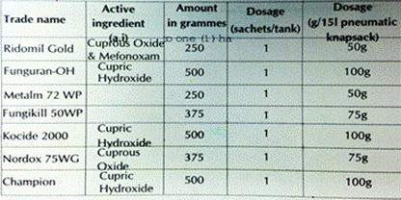  Fungicide use and management guidelines, as above for pesticides
Minor Diseases
Thread blight, charcoal pod rot, root rot, cushion gall, and mealy pod disease |  |  |  |  |  |  |  | • Treated with fungicides, as above, when infestation is severe
Source: Cocoa Manual, Cocoa Research Institute of Ghana (CRIG), 2010. www.crig.org

3.2 Cashew, Cereals, Legumes and Other Food Crops: Major Pests and Diseases and Pest Management

The major pests and diseases associated with cashew, cereals, legumes and other food crops are presented below:
Maize
Major pests and Diseases | Damage
Armyworms (Spodoptera exempta) | Attack leaves
Fall Army Worm (FAW) (Spodoptera frugiperda) | Attack growing point
Larger grain borers (Prostephanus truncatus) | Attack stored maize grain
Greater grain weevil (Sitophilus spp.) | Attack stored maize grain
Stem borers (Busseola fusca, Sesamia calamistis, Eldana saccharina) | Destruction of leaves and boring into stems
Maize streak virus (virus transmitted by insects known as leaf hoppers) | Can be recognized by the long white streaks on maize  leaves, interrupted by yellow and white sections
Striga (witchweed) (Striga hermonthica, S.  asiatica) | Is a parasitic weed that grows on the roots of maize  and prevents the crop from growing properly
Cowpea
Major pests and Diseases | Comments
Aphids (Aphis craccivora and other species) | Small, round, black insects that suck the sap of the green parts (leaves, stems and green pods) of the plant
Cowpea storage weevils (Callosobruchus maculates) | Is a major storage problem. Adult make holes in the cowpea grains and lay eggs inside. Recognized by visible holes (windows) on stored cowpea grains
Flower thrips (Megalurothrips sjoestedtii) | Thrips are very small, very mobile, long black and brown insects that one can find in large numbers inside cowpea flowers. Suck the sap and cause many flowers to turn brown, die and drop off. Also feed on green pods.
Pod borers (Maruca vitrata, Euchrysops sp.) | Pod borers are key pests of cowpea at the flowering and podding stages. Are small, whitish caterpillars that bore into the flowers and green pods and eat the entire contents.
Sucking bugs (Anoplocnemis spp., Clavigralla spp. And other species) | Sucking bugs refer to a group of six insect species that attack cowpea at the podding stage. Are brown to black, with hard bugs and spiny outgrowths. Suck contents of pods and soft growing tips of stems.
Anthracnose disease (Colletotrichum lindemuthianum) | Disease attacks from stem showing dark brown areas which later join up to cover the entire stem, branches, peduncles and petioles. In severe infestations, stems die.
Cowpea mosaic virus diseases | Cowpea mosai virus (CMV) is transmitted by aphids. Attacked plants show mottling and poor formation of young leaves at tips of stems. CMV affects cowpea at the vegetative, pre-flowering, flowering and podding stages
Cowpea wilt disease (Fusarium oxysporum) | Fungus disease that attacks cowpea causing rapid wilting and death. Older plants become stunted, their leaves turn yellow and drop off and dies
Striga (witchweed) (Striga gesnerioides) | Parasitic weed can attack cowpea and prevents the crop from producing any pods. Unlike the Striga that occurs in cereals, cowpea striga is smaller and has whitish-pink flowers, and attacks only pulses. It grows into the roots of cowpea and interferes with plant development.
Cassava (Manihot esculenta)
Major Insect pests and Diseases | Damage
Variegated grasshopper,  Zonocerus variegatus | Adults and nymphs defoliate and sometimes strip the bark of cassava completely. Tuber yield is reduced significantly by defoliation only towards the end of the dry season after natural leaf regeneration has begun.  The damaging stages are from threeinstar nymph to adults.  Defoliation of leaves of up to seven months old cassava can cause 60% reduction in yield but above nine months old cassava, little or no reduction in tuber yield occurs.
Cassava Mealybug, Phenacoccus manihoti (Homoptera:  Pseudococcidae) | They may attack the growing points of the plant, later the leaves senesce and fall, sometimes accompanied by die bark of the shoot.  Attack on stems results in stunted growth of shoots with highly reduced internodes possibly due to introduction of a toxin.  Damage is greater in late planted crop than early planted because high pest infestation during the dry season occurs when the tubers have not yet formed. In early-planted cassava most of the tubers are formed before high pest abundance.
Striped mealybug  (Ferrisia virgata), Green mealybug (Phenacoccus madeirensis) | These are indigenous minor pests which suck sap of cassava plants but do not inject poison into the plants.  Severely attacked plants show general symptoms of weakness and stunting, but do not show leaf distortion.
The green spider mite, Mononychellus tanajoa | Feeding on young leaves causes shrivelling, deformation and drying up of the leaves.  Young shoots die, the whole plant becomes shrunken and deformed with a greatly reduced tuber yield. Damage is most serious in the dry season.
White flies Bemisia  tabaci | Adults suck sap and secrete copious amounts of honeydew to cover the leaves and stem with sooty moulds.  Affected leaves dry and drop.
Termites (Macrotermes and Odontermes species) | Termites are occasional pests, particularly under very dry conditions. They attack cassava planted late or during the dry season. They can destroy the whole rooting system
Millipes (Myriapoda) | These are occasional pests which bore into cassava tubers and feed, causing secondary infection that may lead to rotting.
Yam (Dioscorea Sp)
Major Insect pests and  Diseases | Damage
The yam beetle, Heteroligus meles and Prionoryctes spp(Coleoptera: Scarabaeidae) | In Ghana, yam tuber beetles can cause serious economic losses by making extensive feeding holes in the yam tubers, often only just before harvest.
Leaf beetles Crioceris livida and Lema armata | Yam leaves beetles are occasional pests and do not usually cause any serious problem.
Termites, Microtermes spp. | Termites are occasionally serious pests of yam in Ghana.  They burrow into the developing tubers and make a network of tunnels that are invisible until the tuber is cut.
Scale insects Aspidiella hartii | Yam scale insects mainly attack tubers in storage. They suck the sap causing shriveling and also promote attack by fungal rots, and can inhibit subsequent germination of tubers.  Occasional severe infestation can kill young shoots in the field.
Yam nematodes- The important species of yam nematodes are the spiral nematode Scutellonema bradys, the liesion nematode Pratylenchus spp. and the root knot nematode  Meloidogyne spp. | Infections by above-ground yam nematodes are rarely noticed in the field, except occasionally as a general chlorosis and stunting of yam vines.
Sweet Potatao (Ipomoea Batatus Poir.)
Major Insect pests and Diseases | Damage
Variegated grasshopper,  Zonocerus variegatus | Adults and nymphs defoliate and sometimes strip the bark of cassava completely. Tuber yield is reduced significantly by defoliation only towards the end of the dry season after natural leaf regeneration has begun.  The damaging stages are from three instar nymph to adults.  Defoliation of leaves of up to seven months old cassava can cause 60% reduction in yield but above nine months old cassava, little or no reduction in tuber yield occurs.
Cassava Mealybug, Phenacoccus manihoti (Homoptera:  Pseudococcidae) | They may attack the growing points of the plant, later the leaves senesce and fall, sometimes accompanied by die bark of the shoot.  Attack on stems results in stunted growth of shoots with highly reduced internodes possibly due to introduction of a toxin.  Damage is greater in late planted crop than early planted because high pest infestation during the dry season occurs when the tubers have not yet formed. In early-planted cassava most of the tubers are formed before high pest abundance.
Striped mealybug  (Ferrisia virgata), Green mealybug (Phenacoccus madeirensis) | These are indigenous minor pests which suck sap of cassava plants but do not inject poison into the plants.  Severely attacked plants show general symptoms of weakness and stunting, but do not show leaf distortion.
Mites-Several mite species attack sweet potato. Aceria spp is a tiny whitish mite and causes leaf blister on sweet potato | The feeding of the mite induces the epidermis of the young shoots to form a dense growth, which covers the tips of the stem and young leaves. The infested stems are short and abnormally thick. Yield may be reduced by 80% in severe attacks.
Nematodes- Important nematodes, which attack sweet potato are root knot nematode Meloidogyne spp,  Rotylenchus reniformisandDitylen chus spp. | Like R. reinformis, it causes the splitting of the tuber-forming roots.  Ditylenchus spp is endoparasitic nematode which produces necrosis on the tubers
Rice
Major Insect pests and Diseases | Damage
Armyworms (Spodoptera exempta) | Cause serious defoliation in upland rice plants, leaving only the stems. Are regarded as occasional pests but when there is outbreak they completely devastate farms
African gall midges  (Orseolina oryzivora) | bore into stems and up to the apical or lateral buds, feeding on the tissues of the buds. Attack young rice plants.
Stalked-eye shoot flies (Diopsis spp) | Dark brown fly. Lay eggs at the base of rice plants and hatched maggots feed on the stem tissues.
Stem borers (Chilo spp, Maliarpha separatella,  Sesamia calamistis) | Caterpillars bore into the stem of rice, attack rice at full tillering stage prevent the grains from filling up and ripening. (e.g white borer, striped borer, pink borer and yellow borer)
Rice blast (Pyricularia oryzae) | Most widespread and destructive disease. Affects all the leaves and stem of plant, starting with spots on leaves
Rice brown leaf spot (Helminthosporium oryzae) | Fungus disease which starts as tiny brown spots on rice leaves. Attack seedlings more often.
Rice yellow mottle virus (RYMV) | Attacked rice plants show yellow leaves and stunted growth
Sorghum
Major Insect pests and Diseases | Damage
Armyworms (Spodoptera exempta) | Attack leaves
Greater grain weevil  (Sitophilus spp.) | Attack stored sorghum grains
Sorghum shoot flies  (Atherigona soccata) | Most important insect pest of sorghum seedlings. White larvae of sorghum shoot fly bore into the seedlings and feed inside. Result in ‘deadhearts’ phenomenon.
Sorghum midges  (Contarinia sorghicola) | Pest sucks developing seeds and removes all contents. Adults lay eggs inside flowering heads and small orange larvae that hatch feed on developing seeds.
Stem borers (Busseola fusca, Sesamia calamistis, Eldana  saccharina) | Destruction of leaves and boring into stems. Same species which attach maize, millet also attach sorghum.
Downy mildew  (Sclerospora sorghi) | Fungus disease causes dwarfing or reduction of upper internodes. Results in ‘crazy top’ phenomenon.
Striga (witchweed)  (Striga hermonthica, S.  asiatica) | Is a parasitic weed that grows on the roots of sorghum plants and prevents the crop from growing properly
Soya Bean
Major Insect pests and Diseases | Damage
Aphids (Aphis craccivora and other species) | Small, soft round, black or green insects that suck the sap of the young succulent green parts (leaves, stems and green pods) of the plant
Storage mothss (Ephestia cantella, Corcyra  cephabonica) | Two species of moths attack soybean seeds in storage. The caterpillars of these moths feed on the grains, causing extensive damage by weaving threads around the grains, reducing their quality.
Storage weevils  (Callosobruchus maculates) | Storage weevils attack soybean during storage
Sucking bugs  (Anoplocnemis spp., Clavigralla spp. and  other species) | Same group of six insect species that attack cowpea also attack soybean plants
Anthracnose disease  (Colletotrichum truncatum) | Disease affects all the growth stages of soybean. Attacks from stem and later appears on pods and petioles as irregularly shaped brown areas. The infected areas then become covered with a black dust and necrosis occurs in the leaves.
Pepper
Major Insect pests and Diseases | Damage
Root-knot nematodes (Meloidogyne spp) | Are same nematodes that attack eggplant and okra. Affected roots develops gall become malformed inhibiting plant growth; leaves become yellow, then curl and drop off before they mature. Pepper plants attacked by nematodes are also easily infected by wilt diseases and attacked by termites
White flies (Bemisia tabaci) and Aphids (Ahis  gossypii) | White flies and aphids are important as vectors of virus diseases. Same aphids attack cabbage and same white flies attack tomatoes
Leaf spot (Cercospora capsicii) | Disease affects mainly leaves of pepper seedlings. Initial symptoms are small dark spots on leaves and these spots later enlarge to cover whole leaf, causing leaf to turn yellow and drop off.
Pepper leaf curl mosaic virus | Virus disease infects pepper leaves, stems and fruits and is transmitted by white flies. Leaves become yellow, mottled, distorted, small and cup-
Okra
Major Insect pests and Diseases | Damage
Aphids (Aphis gossypii, Myzus persicae) | Several species of aphids affect okra leaves and young fruits. Are very small, light to dark green, round insects that suck sap from okra leaves, causing leaves to turn yellow and become  twisted; later plants may wilt and die
Cotton stainers  (Dysdercus spp.) and other sucking bugs  (Nezara viridula) | Cotton stainer adults and nymphs are very common on okra plants at fruiting stage and abundant during dry season. When strainers attack mature fruits, they damage the seeds. The bugs are conspicuously red, with black bands. They pierce through both young and mature fruits and suck the seeds inside. Attacked fruits shrivel and then fall.
 | Other bugs that attack okra plants are stink bugs and shield bugs. These bugs make feeding holes in okra fruits causing necrosis and these results in spotting, deformation and shedding of fruits.
Flea beetles (Nisotra spp., Podagrica spp.) | Very common pest that occur on almost all okra plants. Feed on okra leaves and make many small holes in the leaves
Root-knot nematodes  (Meloidogyne spp.) | Several species of soil-living root-not nematodes are major pests of okra plants. These same species also attack eggplant, tomato, pepper, cabbage, carrot and other vegetables. Form swellings known as galls and other malformations on okra roots. Plant become stunted and may die
Anthracnose disease  (Colletotrichum spp.) | Disease affects leaves of okra, on which dark necrotic spots will begin to appear; later leaves become badly wrinkled and are then completely destroyed. Sometimes affects petioles of okra flowers and fruits causing many to drop off.
Leaf curl virus and  mosaic virus | Okra suffers from these two major virus diseases. In affected plants, leaves become small, cup-shaped and/ or yellow (chlorotic), mottled
Tomato
Major Insect pests and Diseases | Damage
Aphids (Aphis gossypii) | Occasionally attack tomato heavily. Feed on the soft terminal shoots and on the underside of leaves. May also transmit virus disease during feeding. Honeydew produced by aphids’ cause’s unsightly black moulds on tomatoes which reduces their market value. Attacked plants may wilt and die
Fruit borers (American bollworms [Helicoverpa armigera] and leaf-eating caterpillars (cotton leafworms [Spodoptera  littoralis]) | Different kinds of caterpillars attack developing and mature fruits of tomato. The American bollworm comes in various colours. A single caterpillar can bore into m ay tomato fruits in one night. Fungi and bacteria enter these fruits through the holes and cause the fruits to rot and  become worthless. The cotton leaf worm feeds on leaves of tomato and bores into the fruits, especially those lower down the plant
Fruit fly  (Rhagoletisochraspis) | It is an important pest of tomato at the fruiting stage. It pierces fruits and leaves rotten spots. Adult fly pierces fruit to lay eggs inside. The small white maggots or larvae develop in the fruit and pupation occurs in the soil below the host plant.
Cashew
Major Insect pests and Diseases | Damage
Cashew Anthracnose disease | This fungal disease caused by Colletotrichum gloeosporoides Penzis. The disease attacks all young and tender vegetative organs together with nuts and pseudo fruits. Early symptoms are reddish brown shinny water-soaked lesions and resin exudation on the affected parts.
Cashew Dieback disease | This fungal disease caused by phomopsis anacardii. The symptoms of the disease include withering of the panicles, followed by a progressive dieback of small flower stalks. This starts from the tips then advances downward to the main floral shoots.
Cashew Pestalotia leaf spot disease | Pestalotia leaf spot is a disease caused by a fungus known as Pestalotia heterocornis. The fungus attacks mature leaves, forming angular to irregular leaf lesions, reddish brown on upper surface and pale gray to whitish on underside of leaves.
Cashew Damping off disease | Damping off cashew disease is caused by number of fungal organisms including Fusarium spp, Pythium spp, Phytophthora palmivora Butler, Cylindrocladium scoparium Morgan, Selerotium rolfsii Sacc and Pythium ultimum Trow; most of which occurs mainly at nursery.  It mainly infects young cashew seedlings in the nursery with poor drainage or container-raised young plants. The infected plantlets cease to grow and wither gradually and show circular water soaked stripes on the root collar. The roots may rot, leading to lodging of the plants.
Cashew Leaf and nut blight disease | Caused by Cryptosporipsis spp.
Angular leaf spot (Septoria anacardii) | Angular cream colored lesions with dark-brown margins on leaves of seedlings; angular black lesions with chlorotic halos on mature trees; defoliated seedlings.
Cashew weevil (Mecicorynus loripes) | Brown-black gummy frass (insect excrement) on trunk and branches; girdling of branches; plants dying.
Helopeltis bugs  (Helopeltis schoutedeni)  (Helopeltis anacardii) | Deformed leaves with angular lesions along veins; leaves may drop from plant; elongated green lesions on young shoots which may exude gummy substance; dieback of shoots

3.3 General Pest Problems and their Management
Common pests in the project area include: rodents and insect pests such as locusts, fall army worm and armyworms. IPM strategies are recommended and used by some farmers because the adequate reduction in the economic injury level of pests requires the use of a combination of more than on practice at intervals or concurrently.
Armyworms
Armyworms, especially the fall armyworm (FAW) are serious pests because their devastation is rapid and massive. The fall armyworm (Spodoptera frugiperda) is a lepidopteran pest that feeds on leaves and stems in clusters. They are pests of more than 80 plant species, causing major damage to maize, rice, sorghum, sugarcane, some vegetable crops and cotton. FAW is native to tropical and subtropical regions of the Americas. In 2016 it was reported for the first time in Africa, where it is causing significant damage to maize crops and has great potential for further spread and economic damage.
Rodents
Rodents, particularly the field rats (rattus rattus), the small house mice (rattus norwegicus) and multi- mammate shamba rat, (Mastomys natalensis) are key pests of food crops. They mostly feed on maize, millet, paddy and cassava. The damage caused by rodents starts at early booting and continues through to maturity, at harvest and storage.

Maize is the most susceptible of all the crops. At the pre-harvest stage, maize is attacked at planting (the rodents retrieve sown seeds from the soil causing sparse germination). The rodents cut and eat the fresh stems and parts of the panicle.
Farmers are strongly advised to do the following to reduce potential damage to crops and the environment: Weeding for clean bunds and fields and regular surveillance. The earlier the presence of rodents is observed, the cheaper and simpler any subsequent action will be and losses will remain negligible. The following practices can be adopted:
Improve farm sanitation - It is much easier to notice the presence of rodents if the farm is clean and tidy
Proofing i.e. making the storage area rat-proof in order to reduce rodent invasion
Trapping - place traps in strategic positions
Predation -keep cats in stores and homesteads.

Migratory and Outbreak Pests
The key migratory and outbreak pests of economic significance in Ghana are armyworm (Spodoptera exempta), and the red locusts. With the exception of the elegant grasshopper, the management of the rest of the pests under this heading is coordinated by the PPRSD of the Ministry of Food and Agriculture.

Locust
Locusts live and breed in numerous grassland plains/savanna zones. During periods with favorable weather, locusts multiply rapidly and form large swarms that can cause huge damage to plants in very short periods.
The grasshopper has become increasingly damaging to cereal crops (maize, sorghum, rice and millets) in parts of the country. There is currently no research into the management of the pest, therefore, farmers are forced to use any recommended broad-spectrum insecticide whenever outbreaks occur.

Armyworm
The African armyworm (Spodoptera exempta) is a major threat to cereal production in a number of African countries. It is a major pest of cereal crops (maize, rice, sorghum and millets) as well as pasture (grass family) and therefore a threat to food security and livestock. The problem with armyworms is that they are highly migratory such that larval outbreaks can appear suddenly at alarming densities, catching farmers unaware and unprepared. Armyworm (Spodoptere Exempta) outbreak have occurred in Ghana twice in the last ten years. The first outbreak i occurred in 2002 and the second in 2006 where large expanses of farmlands were destroyed in such instances.
In 2016, Fall army Worm (FAW) was first reported in the Yilo Korbo District of Ghana. In 2017, the FAW assumed a national dimension and the Ministry of Food and Agriculture (MoFA) in collaboration with Centre for Agriculture Biosciences International (CABI) and other stakeholder developed a short to medium term management plan to contain the pest. Public awareness campaigns were launched using SMS, Radio, TV broadcast, printed materials and video screening to increase awareness; research evidence and impact studies contributed to shape policy especially on types of pesticides to use; collaborative research and validation trials for pesticides and other cultural control methods were launched to help in the management of the pest. Protocols for the management of the pest have since been developed for farmers and extension service providers.

Invasive Species
Invasive alien species have become a problem in diverse ecosystems in Ghana. They affect both savannahs and tropical forests and they are found on land, in fresh water systems and along the coast in the country. The World Conservation Union (IUCN) identified 26 invasive alien species in Ghana which include following key pests:
Larger grain borer (LGB), Prostephenus truncates;
Siam weed, Chromolaena odorata;
Water hyacinth, Eichornia crasspes;
Mango mealybug, Rastracoccus invadens; and
Invasive fruit fly, Aleurodicus disperses.
These invasive alien species have had a huge adverse effect on the production of major staple food crops such as maize, cassava and plantain and also on the export of mangoes.

3.4 Pesticides Registration and List
Ghana has a list of registered pesticides and a list of banned pesticides (negative list). These pesticides are tested and appreciated; In order to improve the quality of the pesticides used (the reduction of the toxicity and the increase of the efficiency for example). Lists are regularly updated and registered products are made available to farmers through licensed chemical sellers.

Table 2: Summary of Register of Pesticides as at February 2017
Category | FRE  (Full  Registration) | PCL  (Provisional Clearance) | Banned | Total
Insecticides | 153 | 51 | 32 | 236
Fungicides | 59 | 15 | 0 | 74
Herbicides | 173 | 50 | 0 | 223
Plant Growth Regulators | 8 | 2 | 0 | 10
Molluscicide | 1 | 0 | 0 | 1
Rodenticides | 0 | 2 | 0 | 2
Nematicides | 4 | 2 | 0 | 6
Adjuvants | 5 | 0 | 0 | 5
Biocides | 11 | 0 | 0 | 11
Repellents | 0 | 1 | 0 | 1
Total | 414 | 123 | 32 | 569

Table 3: Legend to Register of Pesticide
FRE - Full  Registration  (valid for 3 years) | The Agency may approve and register a pesticide subject to such other conditions as it may determine and may only register a pesticide if it is satisfied that the pesticide is safe and effective for the use for which it is intended and that the pesticide has been tested for efficacy and safety under local conditions (Section 31, Part II of Act 490)
PCL - Provisional Clearance Permit (Valid for a maximum of 1  year) | Where in respect of an application for registration of a pesticide, the Agency is satisfied that most information required for its registration has been provided to the Agency, and the pesticide does not present a toxicological risk to people, animals, crops or the environment, it may clear the pesticide for use without the registration, and this clearance shall be known as provisional clearance and shall be temporary pending the registration by the Agency of the pesticide (Section 32, Part II of Act 490)
Experimental permit | The Agency may authorize the importation of unregistered pesticide if the pesticide is imported for experimental or research purposes and not for distribution Section 28, (2), (a),  (i).
General use  pesticides (G) | Pesticides when applied for the use for which it is registered will not have unreasonable adverse effects on people, animals, crops or on the environment (Section 30 (1), (a) of Part  II of Act 490)
Restricted use  pesticides (R) | Pesticide when used in accordance with widespread commonly recognized practice in the absence of additional regulatory restrictions may cause unreasonable adverse effect on people, animals, crops or on the environment (section 30 (1), (b) of Part II of Act 490). Such pesticides are restricted for use on only selected crops by competent pesticide applicators and should be sold by dealers licensed to handle restricted pesticides
Suspended or  Banned Pesticides | Pesticide when used in accordance with widespread commonly recognized practice even in the presence of additional regulatory restrictions will cause unreasonable adverse effect on people, animals, crops or on the environment. Such pesticides are prohibited for use in the country (Section 30, (1), (c).
Source: EPA/CCMC, 2018

Table 4: list of approved insecticides for the 2018/19 CODAPEC programme
S/No | Insecticides | Dosage Per Tank Filling (ml) | Area Covered Per Tank Filling (Ha) | Rounds per Litre | Area Covered by a Litre (Ha)
1 | Confidor Oteq | 30 | 0.20 | 33 | 6.6
2 | Actara 240sC | 17 | 0.20 | 58 | 11.6
3 | Okumakate | 24 | 0.20 | 41 | 8.2
4 | D-Lion Akate Global | 20 | 0.20 | 50 | 10
5 | Akatiwura | 20 | 0.20 | 50 | 10
6 | Actaladiz 240 SC | 50 | 0.20 | 20 | 4
7 | Transform Akate | 17 | 0.20 | 58 | 11.6
8 | Akatemaster | 100 | 0.20 | 10 | 2
9 | Akate Star 3EC | 20 | 0.20 | 50 | 10
10 | Akate Asa | 75 | 0.20 | 13 | 2.6
11 | Seizer 100 EC | 30 | 0.20 | 33 | 6.6
12 | Pyrethrum 5 EW (Agropy 5 EW) | 80 | 0.20 | 12 | 2.4
13 | Inspire 30 EC | 60 | 0.20 | 16 | 3.2
14 | Akate Kaptain | 10 | 0.20 | 100 | 20
15 | Miricon EC | 66 | 0.20 | 15 | 3
16 | Regent 200 EC | 15 | 0.20 | 66 | 13.2
17 | AF Confidence | 200 | 0.20 | 5 | 1
18 | Galil 300 | 13 | 0.20 | 76 | 15.2
19 | Acetastar | 120 | 0.20 | 8 | 1.6
20 | Callifan Super | 20 | 0.20 | 50 | 10
21 | Akate Commando | 50 | 0.20 | 20 | 4
22 | Lufu 150 | 52 | 0.20 | 19 | 3.8
23 | Nomax 150 | 52 | 0.20 | 19 | 3.8
Copper based fungicides used to control anthracnose at 100gm/15 liters of water. Cyperdem insecticide is used to control cashew pests

3.5 Potential Negative Impacts Associated with Pesticide Use
Agrochemicals will where necessary be used minimally in recommended quantities as approved by the Environmental Protection Agency and PPRS during the implementation of activities under the GLRSSMP in the selected landscapes. This section assesses the likely potential impacts from the external environment on the project and vice-versa.
Impact of pesticides on water bodies
The use of agro-chemicals could impact natural water sources. The main water body within the Pra basin project area is the river Pra whilst for the savannah zone there is the Sissili, Kulpawn and the Black Volta. Apart from these, there a number of seasonal rivers and creeks within the project’s catchment zone. The excessive use of agro‐chemicals such as herbicides can contaminate the water bodies through run off especially during the rainy season and instances of water logging. Increased concentration of toxic chemicals in water is a major health risk for local populations and aquatic/fish life. This is because some households rely mainly on lakes and creeks for water for domestic use (drinking, cooking, laundry etc.). Another source of water pollution may be from the return flow of irrigation water heavy with pollutants and inorganic salts. Draining excess water contaminated with agro‐chemicals from irrigation fields into the lakes and creeks within the project zone is also a potential source of water pollution.

Impact of pesticides on aquatic fauna
Pollution from agrochemicals may also affect aquatic animals in water bodies. A host of animal diseases are associated with the implementation of irrigation schemes. Some of the common diseases are loiasis and brugian among large herbivores and encephalitis (inflammation of the brain) in birds. The animals act as host vectors of pathogens and viruses some of which are zoonotic and can be transmitted to human beings by contact or through consumption of contaminated meat or diary productions.

General Health Problems and Environmental Hazards Associated with Pesticides
There are acute and chronic health effects and these effects may manifest as local or systemic effects. They include skin irritations, such as itching, rashes, blisters, burns, wounds, irritation of throat leading to cough or difficulty in breathing with or without wheezing or choking, chest pain, burning mouth and throat with pain on swallowing, runny nose, sore throat, head ache, dizziness, sudden collapse with or without unconsciousness. The table 5 below provides a summary of pesticide problems relating to human health, environment and crops.

Table 5: Pesticide Problems Relating to Health, Environment and Crops
Hazards to health | Hazards to Environment | Hazards to crops
Acute poisoning: 3 million poisonings including 20,000 unintentional deaths occur annually worldwide (WHO). Symptoms of acute poisoning include severe headaches, nausea, depression vomiting, diarrhoea, eye irritation, severe fatigue and skin rashes. Chronic ill-health problems can affect women and men, girls and boys exposed to pesticides, whether because of their occupation or because they live near areas of use. Such problems can include neurological disorders, cancers, infertility and birth defects and other reproductive disorders. | Contamination of drinking water and ground water. Water contamination kills fish. Soil contamination. Wildlife and domestic animals can be killed by spray drift or drinking contaminated water. Exposure may also cause infertility and behavioural disruption. Persistence in the environment and accumulation in the food chain leads to diverse environmental impacts. Loss of biodiversity in natural and agricultural environments | Pesticide resistance: 520 species of insects and mites, 150 plant diseases; and 113 weeds are resistant to pesticides (FAO). Resistance can create treadmill syndrome, as farmers use increasing inputs to little effect, while elimination of beneficial insects causes secondary pest outbreaks. High cost of pesticides can lead to falling incomes for farmers: Newer products are often safer, but are more expensive. Farming communities lose knowledge of good horticultural practices and become dependent on expensive external inputs.
Source: Ghana MoFA GCAP PMP –draft final, November 2011
Mycotoxin poisoning from poor maize drying closely linked with mold development because of inadequate and delayed drying of maize. A number of studies by the Food Research Institute have confirmed the presence of myco-toxins in maize and maize products at unsafe levels, varying from 20 to 355 μg/kg aflatoxin from silo-stored maize and from 0.7 to 313 μg/kg aflatoxin in fermented maize-dough collected from major processing sites. These high levels have carcinogenic effects (liver), stunt growth and cognitive behavior in children, and weakens the immune system. The exact impacts of these high levels of myco-toxins on human health in Ghana are not known and documented. Ghana has adopted the Codex acceptable level of 15μg/kg (or 15ppb) for aflatoxin content in maize and products thereof, including fermented maize dough.
3.6 Challenges Associated with Pesticide Use
Improper pesticide use and disposal of pesticide containers
This is caused by poor knowledge, inadequate equipment and storage, application of unregistered and non-approved pesticides and the use of excessive dosages. With an average annual use of 12,355 metric tonnes of pesticides over the period 2007 – 2010, pesticides use is relatively moderate in Ghana. There are pockets of high use in vegetable cultivation, such as in tomatoes, cabbage, onion and okra. The inappropriate use of pesticides is reflected in the pesticide content on vegetables. According to Amoah et al, 2006, a survey in three major cities in Ghana, showed up to 80 percent of the vegetables contaminated, often with residue levels exceeding the MRLs.
The production of cereals and pulses will increase under the GLRSSMP and this will require proper storage to prevent pests from ravaging the grains. Improper use of pesticides during storage is also a concern as pesticide residues above the MRLs are more likely to occur with stored grains.
Pesticide containers have been found to be reused to meet domestic needs (e.g., remodeled into drinking cups, funnels, storage containers). Improper washing or cleaning could lead to harmful consequences. The population groups at risk include women, children, elderly and rural farmers who are mostly illiterate and principal users of empty containers without proper treatment. An increase in pesticide containers in the project area is expected during the implementation stage and a proper retrieval and disposal system is required to minimize reuse of containers for domestic activities, combined with adequate awareness creation for the farmers on dangers of residual poisoning as a result of reusing pesticide containers.

Accidents Resulting from Pesticide Use
The Ghana Poison Control Centre keeps records on pesticide poisoning and accidents. Currently, the data on pesticide poisoning and accidents seems to be fragmented and still remains low mostly as news items by various media houses that have reported such cases, and also various hospital records. There is the need to create awareness that will target the different pesticide users in order to reduce the occurrence of accidents.

4.0 STRATEGIES FOR INTEGRATED PEST MANAGEMENT AND SAFE USE OF PESTICIDES

The project will adopt an Integrated pest management (IPM) strategy for pest control and management which is efficient and economical to protect the integrity of the environment. It aims to reduce pesticide residues in fruits and crops and maintain pests at a tolerable level while promoting the existence of natural enemies in the context of sustainable agriculture. Integrated pest management aims to combine all possible and useful control methods against the pest including incorporating minimal dosages of chemical pesticides at low toxicity. Thus, several Specific categories of pest control are: biological control; cultural (agronomic) control, reasoned chemical control, varietal selection; mechanical fight, the Genetic fight and the legislative fight.
Using the IPM strategy, the use of chemical pesticides will be the last resort during project implementation.

4.1Preventive
Preventive control is more important for pests such as locusts. With the help of international cooperation, prospecting teams are working during the indicated periods of the year in order to follow the evolution of their populations. Surveillance of other agricultural pests is the responsibility of farmers. However, plant protection services also identify pests to determine hot spot areas that are likely to compromise food security.
At the population level, preventive control consists of the destruction of the causative agent in the fields of the target and surrounding crops. They can also be crushed using bio-mixtures such as neem grains and oil to repel insects.

The following methods can be used for preventive control:
Prophylactic measures: In many crops, seeds are used as propagation material. They can be contaminated (internally and externally) by fungi, bacteria, viruses and nematodes. These parasites will develop with the germination and growth of plants. Prophylactic measures consist of:

The use of only seeds, seedlings, discards or tubers of known and certified origin produced by official bodies. The seeds can be disinfected, by fumigation or by coating;
Choosing soils with good natural drainage, suitable for planting;
Destroying the residues of previous crops that showed symptoms of pest infestation. Plant residues (stems, roots) or even fruits and tubers that remain in the plots after harvest often contain pests or diseases, thus constituting a source of infestation for the next crop. Indeed, parasites can survive during the dry season and infest the next crop. It is recommended to (i) burn stems and stubble, (ii) compost with residues;
Rotating crops, i.e., plant crops that do not belong to the same family and have common pests (e.g. rotation of cereals with root and tuber crops). Crop rotation prevents the proliferation of diseases and pests by breaking their development cycle;
Making physical barriers by protecting crops from pest attack with nets. Vertical nets, insect-proof plastic films, silica-based inert powders with abrasive and drying properties.

Genetic control: This control technique is based on the use of resistant or disease tolerant varieties. The cultivation of resistant varieties is the simplest and often least costly solution for the farmer in the fight against plant diseases. In the absence of adequate resistance characteristics, tolerant varieties can be used, however, they can be infected and serve as a reservoir of pathogens and therefore a source of contamination for sensitive varieties.

Cultural or agronomic control: it is carried out by the adoption of favorable cultural techniques. These include: (i) ploughing, (ii) use of appropriate cropping system, (iii) good planting date and plant stands, (iv) use of beneficial cover crops, (v) weeding, (vi) use of crop associations.

Biological control: Biological control is a method of pest control of crops (insects, mites, rodents, etc.), diseases (fungal, bacterial, viral, etc.) or weeds (weeds) by means of living organisms’ antagonists, called biological control agents or auxiliaries of crops.
Biological control ensures the preservation of fauna or flora useful (create environments favorable to the development of auxiliaries.).

An auxiliary is defined as a predatory or parasitic animal that, by its way of life, assists in the destruction of pests that are harmful to crops. Most of these auxiliaries are insects (usually wasps), and a small proportion of nematodes and mites. Auxiliary organisms have demographics related to those of the populations of their "hosts". They are dependent on the density of the pest populations (disease, pest and weed).

Predation, competition and parasitism of the auxiliaries are the main biotic factors that influence the evolution of pests, and control the stability of their populations. When the auxiliary and pest (pest) populations are in equilibrium, they are active auxiliaries that play a regulating role and prevent outbreaks.
Environmental management is based on two complementary practices:
planting hedges: predators need this resource to reach sexual maturity and thus reproduce, providing prey / replacement hosts, shelter during work or treatment on the plot.
The creation of grass strips: the implementation of grass strips is relatively simple, inexpensive and their impact is fast. Different and complementary devices can be set up according to the auxiliaries that one seeks to promote. Grass strips make it possible to meet the specific requirements (varieties of pollen, nectar) of many auxiliaries, to give them easier access to these resources, and to attract them to the immediate vicinity of crops.

4.2 Curative
Farmers facing pest problems are getting closer to the competent MoFA services to eventually receive control advice that they will apply in the field. Also, decentralized plant protection services play a very important advisory role at this level. Neem grains and other pesticide mixtures help control the diseases and pests identified in the target crops. The healing methods are as follows:

Mechanical control: There are a number of physical processes that can reduce parasite populations or bio-aggressors when they are already installed in cultivated plots:
Destruction of diseased or infested plants: This method is particularly indicated in cases where there is a disease that can disperse quickly in the plots (fungi, viruses, nematodes ...). An example is the case of the fruit fly (Rhagoletisochraspis) for tomato crops. Plants affected by the pest should be isolated, desiccated and buried or incinerated;
Trapping pests (insects and rodents): it is achieved by the installation of traps classic (trapping live animals) type box with a rocking input system. It is a very effective method but quite restrictive and time consuming (takes time). Trapping is also used to estimate a population of animals (rodents) on a plot;
Pickup
Harvest or sanitary size.

Biological control: it is also used in curative by techniques such as:
Inundative release of auxiliary or predatory insects, and parasitoid: In all ecosystems, there are organisms called "auxiliaries" which are natural enemies of "pests". Biological control consists in favoring the populations of these auxiliaries by releases. This keeps the "pest" populations under control. An example is the Trichogram flood release to control sugar cane drillers.
Plant extracts or biopesticides: Many plants produce insecticidal substances that can be sprayed on crops after extraction. It is a preparation based on Neem, Tobacco and papaya leaf. In Ghana, very few programs are being developed to initiate experimentation with the use of biological pesticides.

In addition, subregional initiatives led by structures such as ITRA and ICAT in Togo have led to convincing results. The use of chemical pesticides is replaced by biocidal plant extracts such as "neem" (Azadirachta indica), Lannea microcarpa, red pepper, cow dung, etc., which are used as a natural pesticide.
ITRA has particularly initiated the experimentation of the use of biological pesticides (especially extracts of the leaves of "neem" or Azadirachta indica) on vegetable crops. However, certain constraints have been encountered in the purification of the molecule extracted from the "neem". The difficulties of using these approaches by farmers are related to the availability of neem leaves and grains and the influence of climatic conditions in coastal areas. Other promising tests were also made from papaya leaf extracts. These different results of proven initiatives could be capitalized as part of integrated pest management in Ghana.

Reasonable chemical control: the rational use of pesticides, i.e. the application of pesticides at effective doses during treatments that are as few as desirable, carried out at the most appropriate times and with the required treatment equipment. This control method has the advantage of (i) effectively protecting its crop and harvest, (ii) respecting maximum pesticide residue limits (MRLs), (iii) improving its income by reducing the use of inputs (fertilizer and especially pesticides).

4.3 Alternatives to pesticides
Alternatives to POPs (Persistent Organic Pollutants) have been developed with the aim of reducing the use of pesticides in agriculture in particular and the areas of use of these pesticides. These alternatives are the legislative or administrative struggle, cultural control, physical control, genetic control, integrated pest management, the use of bio-pesticides, biological control, the use of pesticides of the organophosphorus family, carbamates, Pyrethroids, etc.

Some forms of control are being tested and are alternatives to POPs pesticides. Many other plants (garlic, pepper, onion, tobacco, pyrethrum) are also used as bio-pesticides and research is continuing. Research is ongoing to test bio-pesticides on cashew nuts. The results of this research will make it possible to propose actions of information and sensitization of the populations on the necessity to use these biopesticides. Practices such as the use of neem grains, or bark of caïlédrat as bio-pesticides in market gardening; the use of oxen or goats’ excrement to protect crops against ruminants; sands, ashes, chilli powder for the preservation of corn, and others (powders of mahogany bark, neem leaves) are mentioned as alternatives. However, the preference for chemical pesticides lies in their efficiency and availability (to treat large areas) compared to these alternative methods.
4.4 Prevention of new Pest Infestations
The project will endeavor to treat and manage any new pest infestations as soon as they are identified.
Early Detection and Eradication: a process for the reporting and identification of unusual plants and animals as already set up by COCOBOD and MOFA will be followed. Farmers will be required to report unusual plants, animals and pest sightings to the district MoFA, COCOBOD extension officers or to the nearest farmer group or association. The district Department of Agriculture and Cocoa Health and Extension Division of COCOBOD will carry out periodic interviews with farmers on new or strange plants/pests/animals damaging their crops to detect new infestations. A rapid response process for the management of new infestations will be available through COCOBOD, MOFA and the EPA.

Prevention of Spread: the project will follow established COCOBOD and MOFA practices and protocols for appropriately managing risks of all human assisted transport of declared pests.

4.5 Management of Established Pests
GLRSSMP will encourage that established pest infestations are effectively managed by following protocols developed by MOFA and COCOBOD. Priorities for pest management will be regularly reviewed. These will include the reduction of Class 3 pests (environmental weeds) where appropriate. MoFA through the District Departments of Agriculture will be required to properly document the current methods in managing established pests, so that such information can be made available to beneficiary farmers to follow and adopt.

4.6 Management of Post-Harvest Pests of Cereal Crops
Losses due to damage caused by the larger grain borer, weevils, rats/rodents, aflatoxins, and grain moths can be minimized through the following IPM strategies:
Selection of tolerant varieties
Timely harvest
Dehusking and shelling
Proper drying
Sorting and cleaning of the produce before storage
Cleaning & repair of storage facilities
Use rodent guards in areas with rat problems
Use improved granaries
Use appropriate natural grain protectants where applicable
Use recommended insecticides at recommended dosage
Store grain in air tight containers. Where airtight containers are used store these in a shady place, preferably in-doors on raised platform to allow air circulations and prevent attack by mould.
Carry out regular inspection of the store and produce. Timely detection of any damage to the grain and/or storage structure is essential to minimise potential loss or damage

4.7 Management of Post-Harvest Pest of Pulses
The most important post-harvest pest of pulses includes the storage weevil for cowpea and soybean and the storage beetle and grub for groundnuts. Losses due to damage caused by these pests can be minimized through the following IPM strategies:
Dry seeds properly immediately after harvest and before storage to prevent attack by storage pests and diseases.
Divide seeds into batches for short term (less than 3 months) and long-term storage, and treat only the long-term batch, if necessary, using neem oil at a rate of 2-4 ml/ kg of seed, or a recommended pesticide.
Clean the store properly before storing pulses there; use containers that are airtight and clean, and do not allow humidity to build up.
For storing cowpea and soybean, use triple bagging with polythene bags.
Adopt solar disinfestations by heating cowpea and soybean grains between black and transparent plastic sheets.
Treat small quantities of pulses for storage with wood ash, groundnut oil, neem oil or black pepper powder
Use rodent guards in areas with rat/rodent problems
4.8 Safe Use Action Plan
A decision to use chemical pesticides should be taken only as the very last resort and should also be based on conclusions reached from an agro-ecosystem analyses (AESA).
The project will adopt strategies for safe use of pesticides which will focus on (i) routine actions that must be promoted by the project and its partners during project implementation, and (ii) capacity building.

4.8.1 Routine Actions
Pest Inventory - The project through the District Department of Agriculture, MoFA and COCOBOD will collaborate with farmer groups and other stakeholders to identify the types, abundance and location of pest plants and animals by conducting interviews and surveys among farmers, and relevant district level institutions as well as CBOs/community-based farmer organizations. This information will be used for fine tuning, prevention, IPM application, training and capacity building, and other interventions.
Reliance on pesticides – farmers do not normally select crop varieties -on the basis of “creating reliance on pesticides” but more on expected economic returns. However, in order to minimize the potential losses from pests and diseases, a useful starting point is to obtain appropriate planting materials of crop varieties that have been proven, through local field trials, to demonstrate acceptable levels of resistance or tolerance to major pests and diseases. Such materials can be obtained from national agricultural research institutes or international agricultural centers such as International Institute of Tropical Agriculture (IITA).
Pesticides selection - If it is absolutely necessary to spray crops with pesticides, pesticides from the approved list will be recommended and use of selective rather than broad-spectrum pesticides will be promoted. The list of pesticides can change as new products are recommended and/or some of the chemicals are withdrawn, therefore, retailer/stock list will be consulted regularly.
Access to appropriate protective equipment- Because of the comparatively high cost of protective clothing and the inconveniences caused by the hot and humid weather in Ghana, farmers are reluctant to wear protective clothing while applying pesticides. For general use, the project will work with local service providers, input shops to develop a service market for pesticides whereby the input dealer provides or facilitates access to the services of a trained pesticide sprayer/applicator for their farmer clients. Under this scheme, farmers will receive initial and/or ongoing training in proper application, safe use and best practices.
Application of Herbicides - All herbicides should be applied using knapsack sprayers.
Prevent reuse of pesticide containers – A major source of pesticide poisoning is careless disposal of used pesticide containers which are often collected and re-used domestically. The project will work and maintain regular programs of public awareness, education and training of all beneficiaries on the risks associated with reuse of pesticide containers.
Pre-harvest interval violations – ensure that training content in the safe and effective use of pesticides always includes adequate attention to pre-harvest intervals between the last pesticide application and harvest. Strict compliance with this interval, which will vary with the crop and pesticide, would minimize the risk of unacceptable high levels of pesticide residues in harvested products. This is particularly important for all crops (for domestic consumption and export).
Unsafe storage, transport and handling – pesticide use will be restricted to specific crops under the project. The project will therefore not encourage large use of pesticides. However, if it becomes necessary to procure and use pesticides, extreme care will be taken in the transportation, storage and handling of pesticides. Pesticides would be transported in well-sealed containers and isolated from other materials in the vehicles. Entry into and handling of the products would be restricted to only a few persons who have received adequate training in the proper management of pesticide storage and product handling. All spray operators would also be trained in the proper handling of pesticides. Small holder farmers will be encouraged to hire the services of pesticide sprayers/applicators to be established under the project as referred to above.
Application by women and children – women, especially pregnant and nursing mothers, as well as children represent a highly vulnerable group for pesticides poisoning. Experience elsewhere shows that high levels of pesticides residues can be found in human breast milk where pesticide management has been very poor. Beneficiary farm management would as much as possible, exclude women from applying pesticides and also completely prevent situations where children are exposed to pesticides.
Potential for using pesticides more than necessary – a basic principle of Integrated Pest Management is judicious use of pesticides in the context of IPM. This means that chemical pesticides will be used only as a last resort, for example, in the case of unexpected pest invasion by migratory pests such as armyworms and grasshoppers or grain eating birds. Pesticides would also only be used when it is economic to do so, on a need basis, after detailed field surveys and assessment of the extent of the pest distribution schedule to prevent pest incidence and damage.
Use lower-toxicity products – The WHO and USEPA hazard classification of pesticides (see table 6), as well as the list of products approved by the designated national authorities, would be used as the guide for the choice of pesticides for use in crop protection. As much as possible, farmers would be encouraged to avoid choosing class 1a and 1b pesticides, while concentrating on the search for pesticides only within class III. If pesticide in class II must be used, efforts would be made to ensure that adequate safety precautions are taken on safe use of products and the protection of applicators. In addition, farmers would be well supervised to do the right thing, more so because, most of the pesticides on the EPA approved lists belong to the class II. The reason, being the difficulty in accessing class III pesticides, according to reliable source from the EPA.
Avoid products and spray locations that might contaminate ground and surface water – In addition to avoiding spraying around homes, every precaution would be taken to minimize spraying near standing water bodies or streams or pouring pesticides on the ground in homes, near wells and playing grounds. In particular, spray operators would be trained on the risks associated with (a) pouring excess and leftover pesticide mixtures in rivers, streams or ponds, (b) washing pesticide application equipment in rivers, streams, ponds and other water bodies and (c) discarding empty pesticide containers in river, streams and ponds.
Monitor use and promote safe use of pesticides – As an important part of routine activities, the project will establish a monitoring and supervision plan and protocol for the safe and effective use of pesticides as well as protecting harvested produce and the environment.

4.8.2 Capacity Building

Awareness Creation - The project will create awareness among farmers and local communities on the importance of pest management. The project will ensure that all farmers benefiting from the project have access to information regarding declared pest plants.

Education and Training - This study has shown that training activities in the safe and effective use of pesticides need to be better coordinated within target districts. The project will organize technical consultations to support activities on the safe and efficient use of pesticides and good agricultural practices under the auspices of the PPRSD and EPA for farmers, local service providers, and input shops. The COCOBOD, MoFA and EPA will incorporate pest management awareness into all environmental training programs. The general training content will include:
Overview of the crop production system, crops types grown, varieties, ecological requirements for good plant growth and high yields
Environmental factors influencing the particular crop yields in the different ecological zones in Ghana
Patterns of crop losses and the economic aspects of pest/disease damage to crops.
Economic and social consequences of yield losses caused by crop pests/diseases
Elements of Good Agricultural Practices
Fundamentals of decision making on crop protection
Economics of crop protection methods
Principles of Integrated Pest Management
Pesticide use in crop protection
Consideration of criteria for choice and use of pesticides,
National legislation and regulations governing the importation, distribution, marketing, transportation, storage, selection and use of pesticides
Pesticide application – techniques and application efficiency; protective clothing and safe use pictograms
Hazards of pesticide use- Briefs on WHO hazard classification of pesticides, FAO activities in pesticide management, International commitments and agreements (PIC, POPS etc.); Pesticide residues in harvested crops and international requirements for Maximum Residue Levels and GLOBAL-GAP.
Environmental effects of pesticide application; risks in pesticide use

Communication: The Regional EPA/ TCO in collaboration with MOFA and COCOBOD will communicate the content of the Pest Management Plan with the relevant agencies at the district assemblies/local government institutions, district COCOBOD and MoFA pest management representatives. The district MoFA, and COCOBOD will inform farmer groups or individuals of its pest management policies, practices and achievements. Importantly, the project will encourage innovative communication and outreach to farmers and communities.

Table 6: Integrated Pest and Pesticide Management Action Plan
Impact issue / Pest & pesticide threat/ risk | Mitigation Measures | Implementation tool | Expected result | Responsibility/ Key implementing actors
Pollution of water resources and aquatic life | Control and supervise pesticide use by farmers | Adoption of IPM approaches/ techniques | Farmers trained in IPM techniques | MoFA (PPRSD, DAES),  Rregional & District Agriculture officers, COCOBOD
Pollution of water resources and aquatic life | Water quality monitoring (Monitor pesticides in water resources) | Environmental quality monitoring plan (linkage with Project ESMP) | Pesticide concentration in water resources | EPA, WRC
Public health concerns from water-borne or water related diseases in project areas under irrigation |  | Selection of experienced and proven contractors and consultants for project designs and construction and inclusion of appropriate measures in their activities and as part of monitoring;  Effective operational maintenance system |  | GIDA, PCU,EPA
 | Require all contractors to design and implement measures to avoid creation of pools of stagnant water on site
Improper use of pesticides by farmers and farm assistants | Educate farmers and farm assistants on proper use of pesticides and pesticide  use hazards | Pesticide hazards and use guide manual or leaflet for the project (include simple pictorial  presentations) | Proper use of pesticides by farmers and farm assistants | PPRSD-MoFA,  GHS/local hospitals and clinics
Improper use of pesticides by farmers and farm assistants | Control and supervise pesticide use on farms | Adoption of IPM approaches/ techniques | Farmers trained in IPM techniques | MoFA (PPRSD, DAES), Regional & District Agriculture officers
Poisoning from improper disposal of pesticide containers | 1. Educate farmers, farm assistants and local communities on health hazards associated with use of pesticide  Containers | 1. Pesticide hazards and use guide manual or leaflet for the project | Farmers, farm assistants, FBOs, local communities educated on pesticide health hazards | 1. a) MoFA, COCOBOD  b) GHS/local hospitals and clinics
Poisoning from improper disposal of pesticide containers | 2. Properly dispose pesticide containers | 2. Pesticide container retrieval and disposal plan | Pesticide container cleaning and disposal | 2. PPRSD/EPA
Production and market losses from fruit fly pest and armyworm outbreaks | Educated and train farmers to adopt good agricultural practices (GAP) | Adoption of IPM techniques/ approaches | 1. Farmers trained in IPM techniques and GAP | MoFA (PPRSD, DAES) Regional & District Agriculture offices
 | Establish pest surveillance system | Early detection and warning system in place | Zero or minimal armyworm cases | PPRSD-MoFA; MoFA-  DAES/Regional officers
 | Apply EPA approved and PPRSD recommended pesticide if necessary | Inspection of pesticides at farm/storage gate prior to use (Project Policy) | Applied pesticides registered and approved by key stakeholders and in conformity with IPM  Principles | MoFA; (PPRSD, DAES) Regional & District Agriculture Offices
Threat from other crop pests and diseases | Educated and train farmers to adopt good agricultural practices (GAP) | Adoption of IPM techniques/ approaches | Farmers trained in IPM techniques and GAP | MoFA (PPRSD, DAES) Regional & District Agriculture Offices
Threat from other crop pests and diseases | Apply EPA approved and PPRSD recommended pesticide if necessary | Inspection of pesticides at farm/storage gate prior to use (Project Policy) | Applied pesticides registered and approved by key stakeholders and in conformity with IPM  Principles | MoFA (PPRSD, DAES) Regional & District Agriculture Offices
Impact on post-harvest losses due to pests | 1. Monitor incidence of Post- harvest pests | Post-harvest loss reduction plan based on IPM techniques in place | a.) Post harvest losses avoided or minimised  b) Applied pesticides registered and approved by key stakeholders and  in conformity with IPM principles | MoFA(AESD), Regional & District Agriculture Offices
Abuses in pesticide supply and sales | Identify all pesticide distributors and resellers interested in providing services and products to farmers under the Project | Registration policy for all interested distributors and resellers under project | Only approved and licensed dealers and resellers supply pesticides under project | MoFA (PPRSD ), EPA (CCMC)
Abuses in pesticide supply and sales | Confirm status and integrity of pesticides supplied under project | a.) All pesticides are to be in the original well labeled pesticide containers prior to use  b.) No decanting of pesticides under this project | a) Only approved and registered pesticides used under project  b) Banned pesticides avoided  c) Fake and expired pesticides avoided | PPRSD-MoFA; MoFA-  DAES/ MoFA Regional Officers
General health and safety of Farmers, crops and environment | Educate farmers to adopt Good Agricultural Practices (GAP) based upon IPM techniques; | IPM techniques with emphasis on cultural and biological forms of pest control | Compliance with national IPM policy and WB policy on Pest/ pesticide management | MoFA (DAES. DCS),  Regional & District Agriculture Offices
General health and safety of Farmers, crops and environment | Provide PPEs to farmers/  farm assistants for pesticide use in the fields | Health and safety policy for farm  Work | Farmers and  accompanying dependents (children) protected against pesticide exposure in the  fields | MoFA
General health and safety of Farmers, crops and environment | Educate farmers/ farm assistants in the proper use of pesticides | Pesticide hazards and use guide manual or leaflet for the project (include simple pictorial presentations) | Farmers know and use pesticides properly; pesticide hazards and use guide leaflet or flyers produced | MoFA/EPA
General health and safety of Farmers, crops and environment | Properly dispose obsolete and unused pesticides | Obsolete and unused pesticide disposal plan | obsolete and unused pesticide disposal plan prepared and  implemented | MoFA (PPRSD), EPA (CCMC)
General health and safety of Farmers, crops and environment | Educate farmers to obtain or purchase quantities of pesticides required at a given time and to avoid long term storage of  Pesticides | Pesticide use policy/plan | Only pesticides needed are purchased; long term storage of pesticides by farmers avoided | MoFA (PPRSD), EPA (CCMC)

5.0 IMPLEMENTATION STRATEGIES
5.1 Cocoa Landscape
GLRSSMP will promote IPM in cocoa farming and forestry in the context of a large number of similar initiatives that provide IPM guidance and support IPM implementation on the ground. Some of these are spearheaded by the Government through COCOBOD, MoFA and other entities, others through NGOs like Rainforest Alliance, yet others through private sector companies engaged in cocoa industry. It is important to note that GLRSSMP will endeavor to pursue objectives of the Pest Management Plan (ESS3) and promote IPM in this context, aiming to synergistically complement rather than substitute or suppress the ongoing efforts. GLRSSMP will use the following specific strategies to achieve an effective pest management process.

5.1.1 Planning
The responsibility for implementing the PMP rests with MOFA and COCOBOD who will discharge the corresponding duties through different levels of sector staff. A close collaboration is required and will be established across sectors, particularly among all relevant district and regional implementing agencies and all relevant farmer based organisations or groups and corresponding LCBs. All site-specific activities that may require pesticide use and management will be identified early by the District Department of Agriculture and CHED through application of the screening guided by the Project ESMF and included in a pest management planning process to be developed in close association with MOFA, COCOBOD and other stakeholders. The regional EPA & PPRSD will compile a database of all key persons in pesticide management from the relevant district Departments of Agriculture, CHED, farmer groups, NGOs and LCBs which will be shared among all stakeholders.

5.1.2 IPM Capacity Building and Training
There will be extensive collaboration between IA’s (MoFA) and COCOBOD to provide basic training in Integrated Pest Management (IPM) and Good Agricultural Practices (GAP) to beneficiary local farmers within the project areas and key NGOs providing support to cocoa farmers in the area. As much as possible, existing channels within the MoFA and COCOBOD for pest management will be utilized and therefore no new platforms will need to be created. The MoFA/COCOBOD extension officers will educate farmers/key NGOs in the cocoa sector on common pests and diseases associated with the food crops grown in the area such as maize, cassava, plantain and vegetables and how to control and manage such pests/diseases through IPM and GAP approaches in order to minimize the use of pesticides.

The purpose of the capacity building of beneficiary farmers in particular is to encourage farmers to develop their IPM approaches to the management of pests and diseases under the Project. Key NGOs in the cocoa sector trained in IPM will also transfer their knowledge to farmers for improved cocoa production. The success of IPM depends largely on developing and sustaining institutional and human capacity to facilitate informed decision making by farmers and local communities, and empowering them to integrate scientific and traditional knowledge to solve location-specific problems, and respond to market opportunities. Under the project, all cocoa pest treatment will be done by spraying gangs trained and facilitated by COCOBOD.

Farmer Field Schools (FFS), Farmer participatory research (FPR) and participatory learning (PL) approaches in capacity building efforts help to bridge this gap and make research results more understandable and useful to farmers and farm assistants. This is particularly the case in knowledge intensive disciplines such as IPM.

The GLRSSMP through IA’s will collaborate with the local government institutions such as the MDA’s and the as part of the IPM capacity building to train farmers/key NGOs in adoption of ecologically sound and environmentally friendly management practices especially among smallholder farmers in the project area. The farmers will learn cultural, biological and ecological processes underpinning IPM options, and use the newly acquired knowledge to choose compatible methods to reduce losses in production and post-harvest storage. In addition to local government institutions, there will be collaboration with the traditional authorities in the project area to deliver messages and promote IPM on the ground.
Training Responsibilities and Materials
The GLRSSMP management team represented by MoFA, COCOBOD and EPA will liaise with cocoa farmers’ associations in the sector to plan training implementation; provide technical support such as in preparing and delivering specific training materials, and evaluating resource materials; identify and select suitable local training resource persons and materials.
Existing training materials in the system will be used and where necessary updated. Some useful materials in the system include:
Cocoa Manual, A source book for sustainable cocoa production, by CRIG, 2010.
Cocoa Trainers’ Information Sheets – April 2012.
Sustainable Production of Cocoa by Rainforest Alliance, version 2012.
The COCOBOD (Regional/District Officers) will collaborate with farmers’ associations to identify and organize farmers groups for training (i.e. use of farmer field school to teach farmers on the efficient and responsible use of pesticides); prepare, organize and supervise training implementation plan; verify reports of persisting pest problems and farmers training needs; monitor performance of farmer trainers and post-training assignments; and prepare training progress reports.

5.1.3 Monitoring and Evaluation

The district department of agriculture and CHED will liaise with the respective district PPRSD and zonal EPA for regular monitoring and evaluation of control programs to determine the level of progress being made in controlling the spread of any declared plant pests and the reduction of infested areas. The following monitoring indicators will be incorporated into a participatory monitoring and evaluation plan.

Table 7: Monitoring Indicators
No | Area | Indicators
1.0 | Training and awareness creation in IPM and GAP (Good Agronomical Practices) | Number of extension agents educated or trained on IPM and GAP  Number of farmers educated or trained on IPM and GAP  Number of awareness programs relating to pest management undertaken
2.0 | Technology acceptance/ field application | Category and number of farmers who correctly apply the skills they had learnt.  Type of New management practices adopted most by farmers.
3.0 | Pesticide container disposal plan developed and implemented | Number of farmers/resellers aware of pesticide container disposal plan
4.0 | Pesticide concentration in water resources | Levels of pesticides in water resources
5.0 | Only approved and licensed dealers and resellers supply pesticides under project | a) Company registration documents  b) Evidence of license/permit to operate in pesticides  c) Evidence of location and contacts of suppliers/resellers
6.0 | Compliance with national IPM policy and WB policy on Pest/ pesticide management | Number of farmers trained in IPM techniques;  Number of farmers implementing IPM on their farms  Frequency of chemical pesticides usage
7.0 | Health and safety policy for farm Work | Quantities and types of PPEs supplied or made available under the project  Number of farmers having copies of the pesticide hazard and use guide flyers;
8.0 | Risk to human health | Number of annual complaints received pesticide poisoning occurring under the project

5.1.4 Reporting
Periodic report on the progress of pest management within the areas will be prepared by district departments of agriculture and CHED and consolidated at the respective regional and TCOs, and it will form part of the environmental and social reporting framework for the project. The PMP report information will include:
common pests identified or declared in the project areas,
Procurement and use of pesticides under the project;
common pesticides used by farmers, sources of pesticides used by farmers,
level of success of treatment of pests under the project,
the amount and type of herbicide used,
IPM knowledge and practices among farmers, etc.
District departments of agriculture and CHEDs will be responsible for their respective district reports.

5.1.5 Annual Reviews
The GLRSSMP management team will undertake annual pest and pesticide control and management reviews to confirm the implementation of the control measures or programmes provided in the PMP, as part of the regular annual project performance review. Recommendations from the reviews will help the GLRSSMP Project Coordinator refocus and plan effectively towards achieving IPM targets. The management review team will include:

Representatives of the Ministry of Lands and Natural Resources/Project Coordinators
Representatives of the Forestry Commission
Representatives of COCOBOD & CRIG
Representatives of the Ministry of Food and Agriculture
Representatives of the EPA
Representatives of PPRSD

5.2 Savannah Landscape
GLRSSMP will adopt the following specific strategies to achieve an effective pest and pesticide management process in the northern savannah zone.

Formation of a Safeguard Team:
The Technical Coordination Office (TCO) in Bolgatanga and Ashanti Regions will team up with the Safeguard team to oversee and ensure that the project complies with relevant safeguard issues policy documents prepared for the project including this PMP.

Registration and Training of all Interested Pesticide Distributors/Resellers under the Project:
GLRSSMP will notify pesticide distributors or publish in the national dailies that all interested pesticide distributors or resellers interested in providing services or products for the Project are to register with the Project by providing specific requested information which will include but not limited to the following:
Certificate of registration or incorporation with the Register General’s Department of Ghana;
License or permit to operate from EPA or PPRSD;
Locations of company; and
Type of activities or services or products to be provided.
The Project will organize an orientation workshop for all registered pesticide distributors/resellers under the project on the following but not limited to these:
EPA registered and banned pesticides
EPA/PPRSD requirements on purchase, supply and safe distribution of pesticides
USAID Africa list of pesticides products recommended

PMP Communication and IPM/PMP Orientation Workshop:
The GLRSSMP Project coordinator will communicate the content of the Pest Management Plan to all upstream project actors or participants such as the EPA, PPRSD, MoFA at the national, relevant regional and district levels (i.e. within project beneficiary regions). It will establish on-going communication with both the national and relevant regional and district levels pest and pesticide management representatives. The GLRSSMP will also organize orientation workshops on IPM techniques as well as the PMP for relevant primary communities, who will be at the forefront in terms of use of pesticides and are likely to be exposed to its various and gradual risks.

Education and Awareness Creation:
GLRSSMP will create awareness among downstream project actors or participants (pesticide distributors/resellers, farmers, farm assistants) of the importance of pest and pesticide management in the framework of this PMP and the national IPM strategy; avenues created or available for obtaining appropriate pesticides among other things.
Availability of Information:

The GLRSSMP will ensure that all downstream actors or participants have access to information on relevant crop pests/diseases, MoFA-PPRSD IPM strategies regarding pest control, declared pest plants, current EPA list of registered and banned pesticides, USAID/USEPA list of registered and approved pesticides. Key information on crop pests/diseases, IPM strategies regarding pest control as well as pesticide use toolkits will be provided in easy to read and understand format/pictorial presentations for easy understanding and use by illiterate beneficiary communities. The awareness creation programme will be regular, say every 3 months or 6 months to enable communities become used to the schedule.

Education and Training:
The GLRSSMP management team and implementers will incorporate pest management awareness into environmental training programs.

Participatory Pests Inventory and Monitoring Measures:
The project will track and document all pest cases, be it minor or major in a pest inventory register. It will identify the types, abundance, location of pest plants, date first spotted or seen and date reported. This information will be gathered from surveillance or monitoring system to be put in place, periodic surveys to be conducted and feedback from farmers/farm assistants. The data will be managed in a standardized way so that trends can be established.

Stakeholder and Interest Group Consultation and Involvement:
The PMP implementers will coordinate the pest management process with all relevant stakeholders (LBCs, farmer associations, etc) and other major land users in the project areas (such as traditional authorities/landowners, cattle rearers/herdsmen and other farmers). Any activities that may have an impact on pest management will be identified and included in the pest management planning process at the respective district or community levels. Contacts will be established with important neighboring land managers and consult with them when appropriate and co-ordinate management activities with representatives of the identified government agencies and other land users when appropriate and necessary.

Prevention of new Pest Infestations:
The Project will endeavor to treat and manage new pest infestations as soon as they are identified.

Surveillance, Early Detection and Eradication:
A process for the reporting and identification of unusual plants, animals and pests will be established. Pest surveys will be conducted on a regular basis to detect new infestations and a rapid response process for the management of new infestations will be established.

Prevention of Spread:
The PMP will establish protocols for appropriately managing risks of all human assisted transport of declared pests.

Management of established Pests:
The PMP will ensure that established pest infestations are effectively managed. Priorities for pest management will be regularly reviewed. These will include the reduction of Class 3 pests (environmental weeds) where appropriate. The impact on non-target species, particularly those of environmental significance, will be minimized.
IPM Capacity Building:
The purpose of the capacity building of farmers in particular is to help farmers develop their IPM approaches to the management of pests and diseases under the Project. The success of IPM depends largely on developing and sustaining institutional and human capacity to facilitate informed decision making by farmers and farm assistants, and empowering them to integrate scientific and traditional knowledge to solve location-specific problems, and respond to market opportunities. Poor communication between farmers/farm assistants, extension agents and researchers has often led to poorly-targeted research or to poor adoption of promising options generated by research. The full benefits of investments in agricultural research thereby remain untapped under these circumstances.

Farmer Field Schools (FFS), Farmer participatory research (FPR) and participatory learning (PL) approaches in capacity building efforts help to bridge this gap and make research results more understandable and useful to farmers and farm assistants. This is particularly the case in knowledge intensive disciplines such as IPM.

Farmers will have the capacity to accurately identify and diagnose pests and pest problems, understand trophic relationships that underpin biological control opportunities, and use such knowledge to guide pesticide and other kinds of interventions. Through the participatory approaches, the Project will build local capacity to ensure rapid spread and adoption of ecologically sound and environmentally friendly management practices especially among smallholder farmers in the project area. The farmers will learn cultural, biological and ecological processes underpinning IPM options, and use the newly acquired knowledge to choose compatible methods to reduce losses in production and post- harvest storage.

A foundation element of the capacity building exercise is the accurate diagnosis of the pest problem and to provide baseline information that will enable stakeholder groups to develop a shared vision on felt needs and IPM strategies. Through informal interviews, field visits, and planning meetings, stakeholder groups will develop joint understanding of the key issues affecting production and develop a common IPM plan based on agreed concerns.

The PMP implementation will be anchored at the District Department of Agriculture with field action by farmer groups which will receive training and advisory services from extension officers and lead farmers, who would have graduated from Training of Trainers (ToT) sessions. Training at all levels will be based on participatory learning modules for capacity building in IPM information delivery. The participants will be equipped with skills in facilitation, group dynamics, and non-formal education methods to encourage adult learning. Farmer training will focus on farmers’ group learning for informed decision making on IPM issues. Group learning will be experimental through farmer-led field trials and discussions on practical aspects of crop production and pest management including indigenous and traditional knowledge/technologies. Farmer group learning will be facilitated by trained extension agents.

Group decision making will be achieved through Agro-Ecosystem Analysis (AESA) involving a comparison of IPM practices with normal farmer practices. At each AESA, farmers observe, record and monitor changes in soil, crop and trophic relationships affecting crop growth. Farmers analyse and discuss their findings and recommend corrective action based on the results of their own analyses. Group learning helps to increase scientific literacy, ownership of biological and ecological information and knowledge, and informed decision-making habits in the communities. Also trained farmers and leaders of farmer’ associations will be expected to promote secondary adoption of proven options. For example, leaders of farmers’ associations trained will be expected to assist in training new farmers through demonstrations and farm visits. Additionally, the trained farmers will organize field days to train other farmers and explain new/improved IPM practices they have learnt. Field day participants will include representatives of the PIU, Implementing Agencies, District staff of implementing agencies, local community leaders, local FM stations and farmers

Institutional Arrangements and Training Responsibilities:
Annual work plans will be developed in consultation with participating farmers/investors and in line with their respective farm work plans to indicate institutions and networks that will be required to provide research and development support. The principal actors will include a number of local institutions directly involved in the implementation of the PMP while other agencies (partners) will include international and national institutions to provide technical and other support for implementation of the plan.

Training Responsibilities:
The PIU/MoFA with input from PPRSD/EPA are to standardize training needs assessment across sites; and organize appropriate workshops to develop participatory learning modules. The PPRSD with input from the EPA, will liaise with appropriate farmers’ associations to plan training implementation; provide technical support such as in preparing and delivering specific training materials, and evaluating resource materials; identify and select suitable local training resource persons and materials; and prepare training progress reports.
The MoFA (Regional/District Officers) will collaborate with farmers’/agriculture associations to identify and organize farmers groups for training (i.e. use of farmer field school to teach farmers on the efficient and responsible use of pesticides); prepare, organize and supervise training implementation plan; verify reports of persisting pest problems and farmers training needs; monitor performance of farmer trainers and post-training assignments; and prepare training progress reports. Farmers/local communities as the principal beneficiaries, will be organized into farmer groups for training and adoption of IPM practices.

Table 8: Actors and Partners
Actors | Partners
The actors will collaborate with the project:  Contribute field staff to be trained as IPM Trainers.  Organize its members into farmer groups for training and promotion of IPM practices.  Facilitate extension and farmer training  Prepare and produce field guides and other relevant IPM information materials  Provide policy guidance/oversight for implementation of the PMP  Monitor, supervise and coordinate IPM activities  Document user compliance on pesticide use  Examples of actors:  MoFA/PIU  EPA (national and regional officers)  PPRSD (national and regional officers)  COCOBOD  Ministry of Health/Ghana Health Service (for disease vector control)  Farmers and Farmers Associations (e.g. GFAP, GAABIC, SEEDPAG, VEPEAG, APFOG)  Agric-input dealers (e.g. GAIDA) | The partners will be IPM experts who:  Serve as technical reviewers for IPM activities.  Provide technical support in pest and natural enemy identification  Assist to organize study tours and networking with international IPM groups.  Provide expertise in planning, training and field implementation of IPM  Examples of partners:  The CGIAR System wide Program on Integrated Pest Management (SP-IPM) which is dedicated to breaking isolation barriers to the full realization of IPM research results  The Global IPM Facility which assists interested Governments and NGOs to initiate, develop and expand IPM programmes mostly through farmer field school training.  Research Institutes (Council for Scientific and Industrial Research, CSIR), and Universities.  NGOs

Participatory Monitoring and Evaluation:
There will be regular monitoring and evaluation of control programs to determine the level of progress being made with regard to pest and pesticide management and control issues identified in the PMP. Monitoring indicators are provided in the action plan under the previous section. The following performance indicators will be incorporated into a participatory monitoring and evaluation plan.

Sustainability Issues
Scientific information, adapted into user-friendly format will strengthen training and extension delivery, and increase IPM literacy in project sites/communities. Strategic alliances with international IPM groups will strengthen national capacities to integrate new IPM options in crop production. Farmer-educational activities will be central to the exit strategy which will feature increased roles and responsibilities of committed national and local farmers’ associations and communities to take primary responsibilities in the development of action plans and expertise exchange for IPM development and promotion. Short-term technical study visits (to other West African countries with proven experience in IPM development and implementation) for hands-on laboratory and field training, and farmer participatory learning will help to create favourable conditions for continuity of IPM processes and results. The tour will involve representatives from PIU, PPRSD, and selected farmers’ associations.

Reporting:
Annual report on the progress of pest and pesticide management at the project sites will be prepared. The reports will indicate the pest cases identified and treated using IPM approaches, location of pests, level of success of treatment, the amount and type of herbicide/pesticide used, level of corporation from farmers and other relevant information (e.g. training programmes organized, farmer field schools held etc).

Management Reviews:
The PIU will undertake annual pest and pesticide control and management reviews to confirm the implementation of the various control measures or programmes or actions outlined in the PMP. Recommendations from the reviews will help the PIU to refocus and plan effectively towards achieving planned targets. The management review team will include:
Project Implementing Agencies and Project Coordinators
Representative of the Ministry of Food and Agriculture
Representatives of the EPA
Representative of PPRS

6.0 STAKEHOLDER CONSULTATIONS AND INVOLVEMENT

Stakeholder consultations are crucial component in the preparation and implementation of PMP. Specifically, it aims to achieve the following objectives:

To provide information about the project and its potential impacts to interested parties or beneficiaries or those affected by the project, and solicit their opinion in that regard
To educate and solicit views from all stakeholders to enhance the implementation mechanisms and processes
To manage expectations and streamline misconceptions regarding the project
To ensure participation and acceptance of the project by all relevant stakeholders

The preparation of the PMP was informed by an extensive engagement and consultation process organized for the GLRSSMP preparatory and design phase. There were face to face interactions with MDA’s, communities and other relevant stakeholders. Discussions on the issues of pests and pest management were integrated to the consultations undertaken during preparatory and project design phase of the that took place in the cocoa landscape, the transitional zone and the northern savannah region.

6.1 Pest Management Issues and Views Raised by Farmers during Consultations

Key pest-management-related issues raised during these consultations included the following:
Inadequate pesticides for cocoa farmers (the farmers consulted indicated that currently they buy pesticides themselves and outsource the spraying to sprayer gangs); availability of required pesticides on the local market;
Spread of diseases on citrus farms
Destruction of rice farms due to farmers inability to purchase nets to cover the rice
The fall army worm menace in areas where maize is grown was a major worry to farmers
Spraying gangs from COCOBOD are inadequate numerically to provide services to all farmers.
Illegal sale of the pesticides that normally should be provided by the COCOBOD at no cost to cocoa farmers under their extension program;
Inadequate provision of agro-chemicals to farmers
Potential increase in use of agrochemicals in agroforestry and its associated effect on soil and water bodies
Chemical spraying has led to extinction of some plant species such as natural mushrooms which hitherto were available for consumption
Farmers inability to control weeds due to use of manual tools like cutlass and hoes
Inadequate sensitization by agriculture extension agents on use and management of chemicals
Lack of PPE’s for spraying

Continued stakeholder engagement on promoting IPM in cocoa, cereals, vegetables and forest management is envisaged under GLRSSMP through close interaction of District level extension staff with farmers and forest managers, and through the annual reports on PMP implementation planned to be produced under this PMP. The PMP will be improved and revised based on this continued engagement and feedback, to reflect advancement in IPM in Ghana brought about by other actors (COCOBOD, CRIG, EPA, FC, private companies, etc.)

7.0 TENTATIVE BUDGET FOR THE IMPLEMENTATION OF GLRSSMP PMP
A budget estimate of USD is estimated required to implement the PMP during a 5- year period. Details of estimates are provided in the table 9 below. Most of these activities outlined in the table below will be implemented whiles implementing the broader project activities
Table 9: Tentative Budget for PMP Implementation
Item No. | Activity/Programmed | Duration of Project
1.0 | Capacity Building | Year 1 | Year 2 | Year 3 | Year 4 | Year 5 | Total
1.1` | Orientation Workshops on PMP and IPM | 20,000 | - | - | - | - | 20,000
1.2 | Training and capacity strengthening of COCOBOD extension officers on good agronomic practices (GAPs), climate smart cocoa |  | 39, 774 - |  | - | - | 39,774
 | Training and capacity strengthening of CMWT and Local Cocoa Facilitators (LCFs) on good agronomic practices (GAPs), climate smart cocoa |  | 37,800
 | Radio sensitization Programmes (COCOBOD)
 | Sub-Total | 37,000 | - | 28,000 |  |  | 115,000
2.0 | Environmental Management
2.1 | Pesticide monitoring in surface water/land | 20,000 |  | 15,000 |  | 20,000 | 55,000
2.2 | Equipment (PPE’s support | 5,000 | 5,000 | 5,000 | 5,000 | 5,000 | 25,000
 | Sub-Total | 15,000 | 5,000 | 15,000 | 5,000 | 15,000 | 80,000
3.0 | PMP Management
3.1 | Monitoring &Evaluation (Safeguards monitoring of project activities) | 3000 | 3,000 | 3,000 | 3,000 | 3,000 | 15,000
 | Sub-Total | 13,000 | 12,000 | 12,000 | 11,000 | 11,000 | 62,000
 | Grand Total |  |  |  |  |  | 392,000

8.0 EPA REVISED REGISTER OF PESTICIDES UNDER THE EPA ACT, 1994(ACT 490)
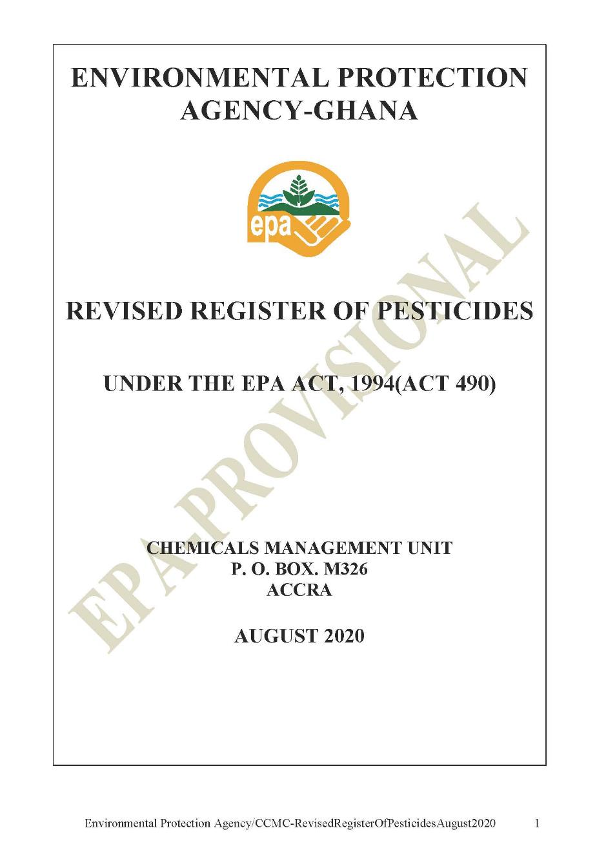
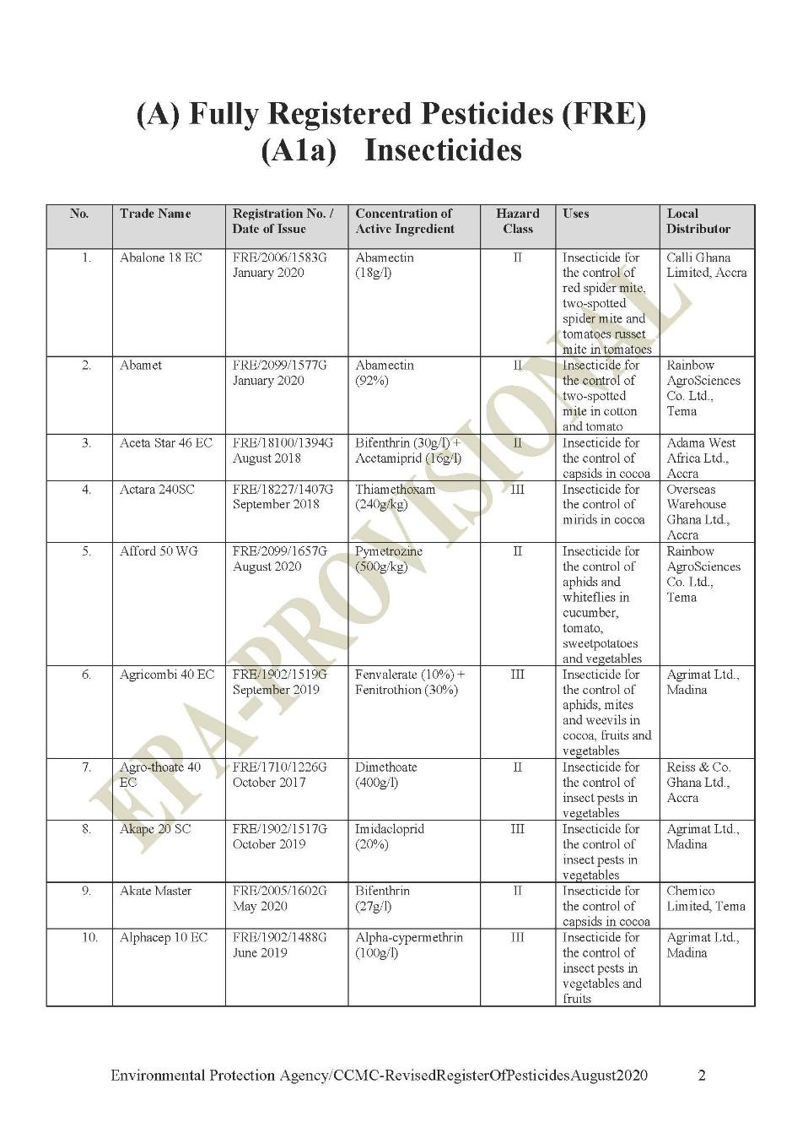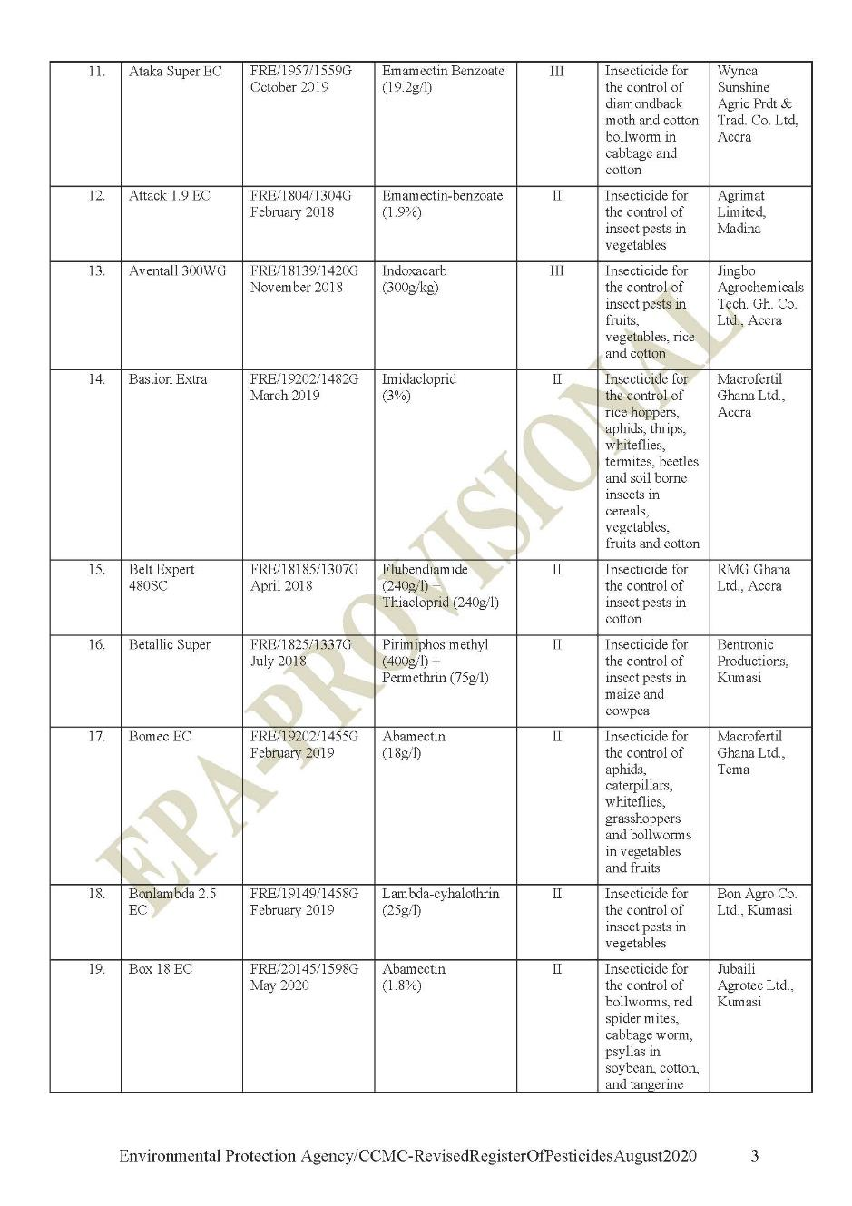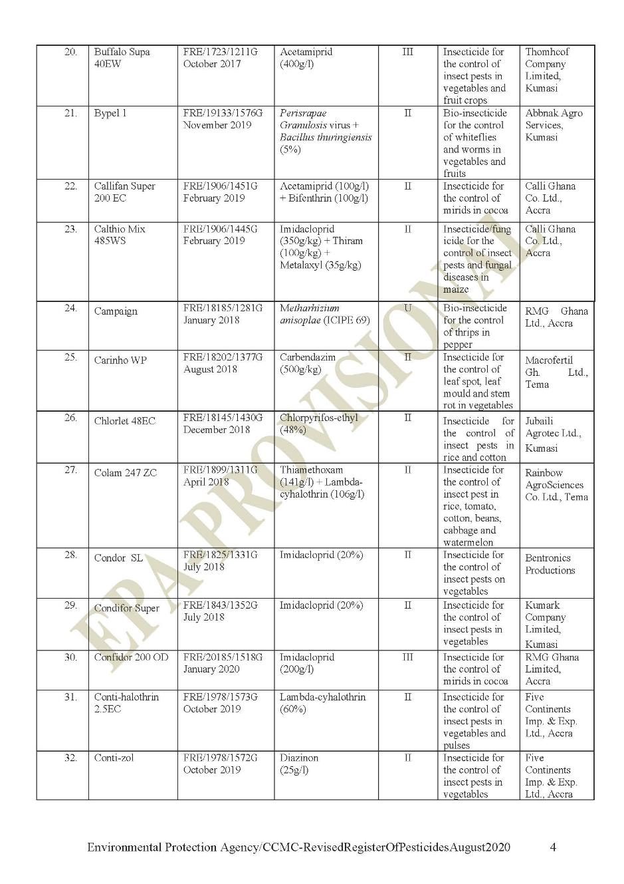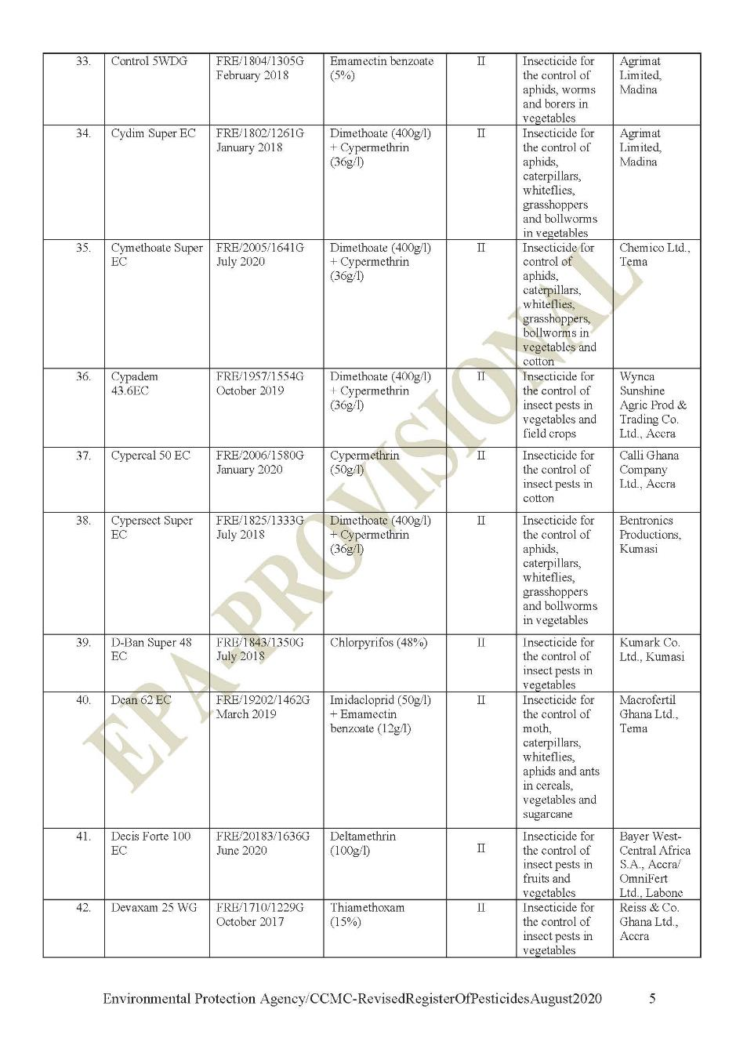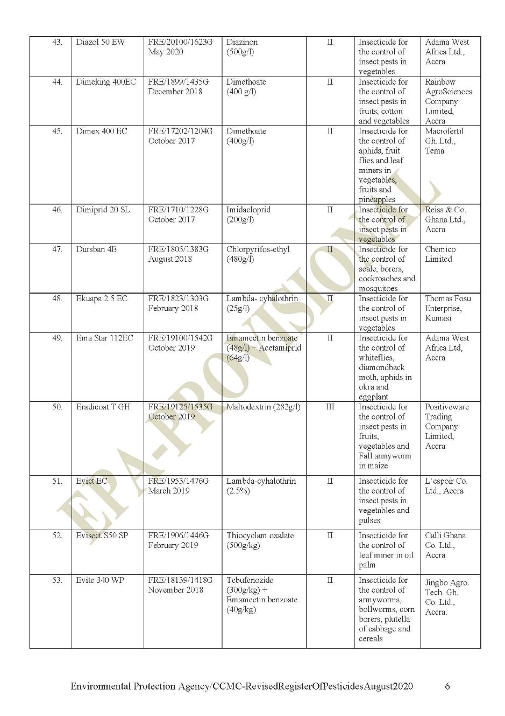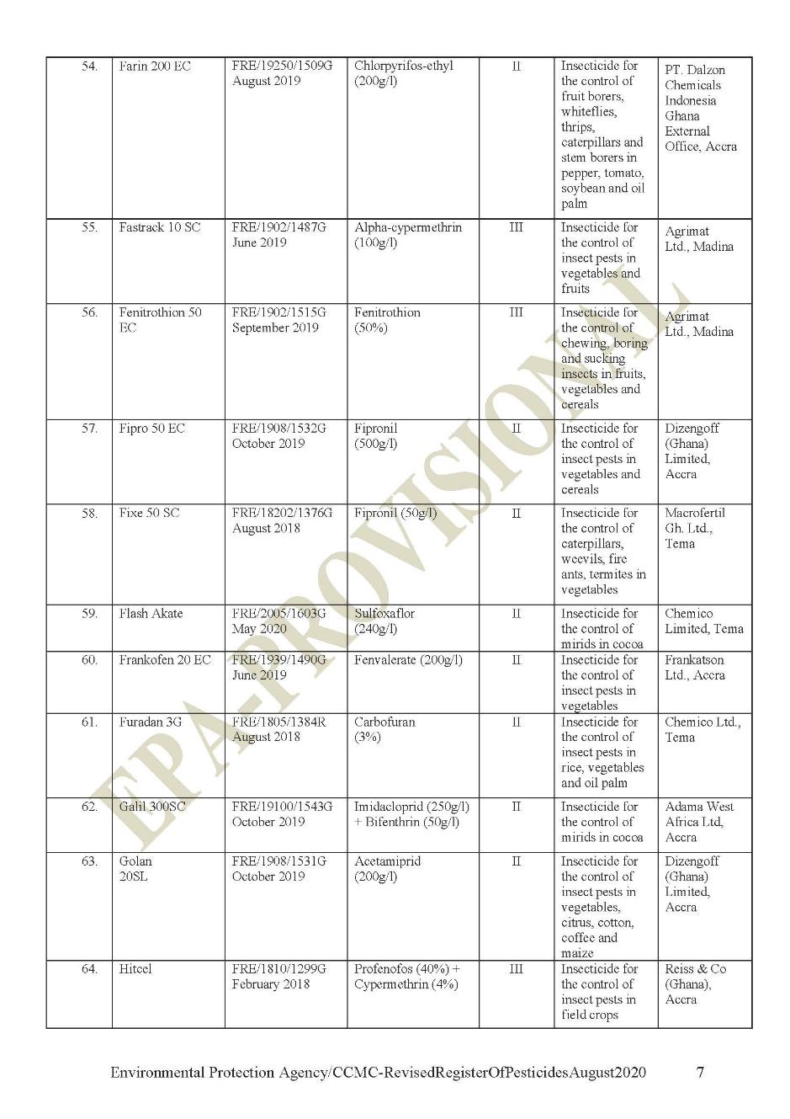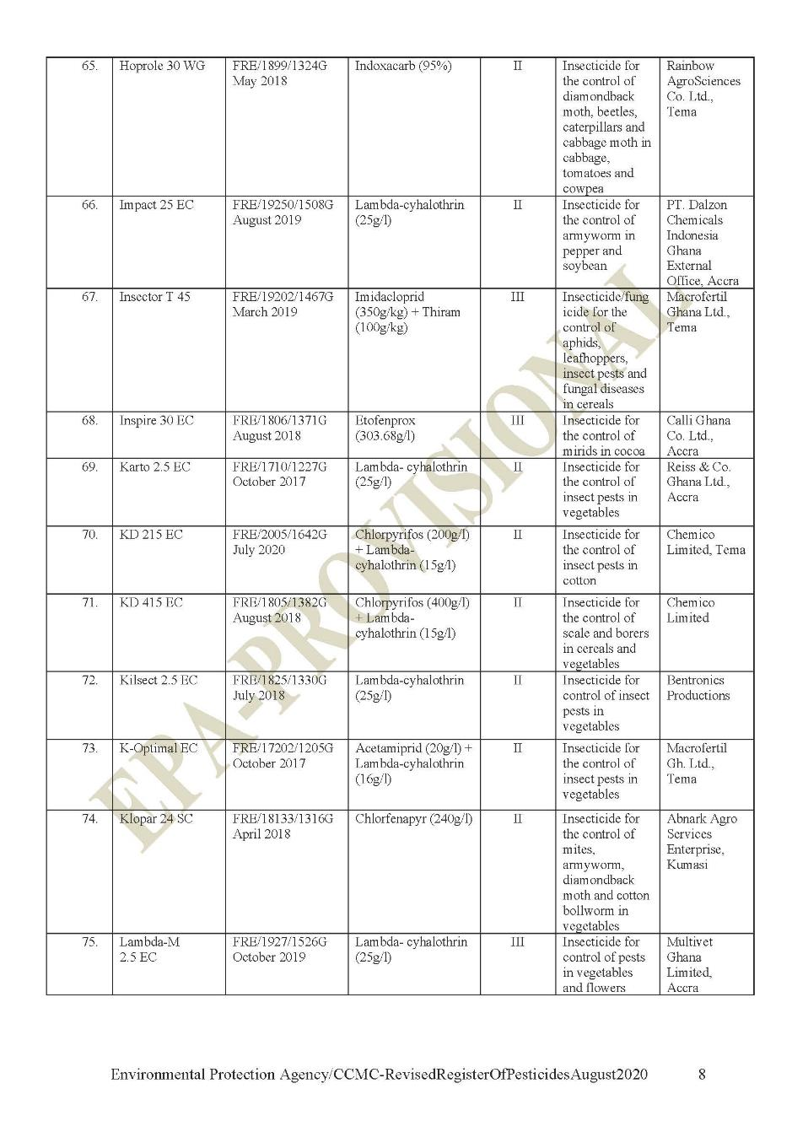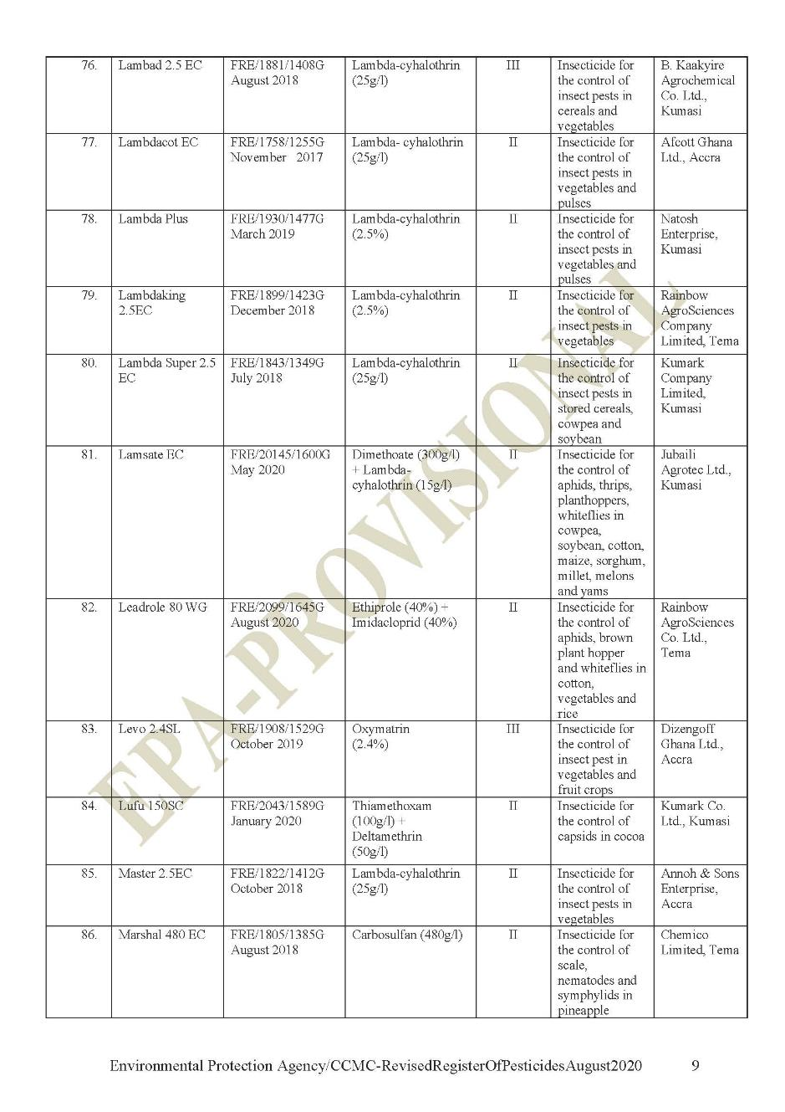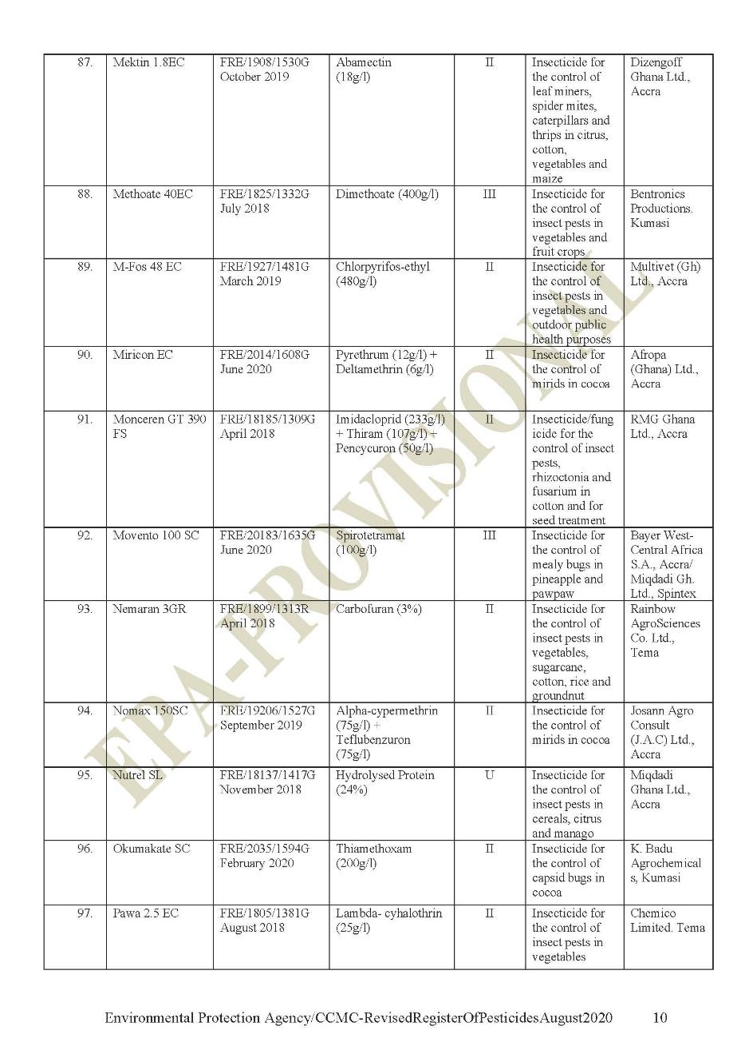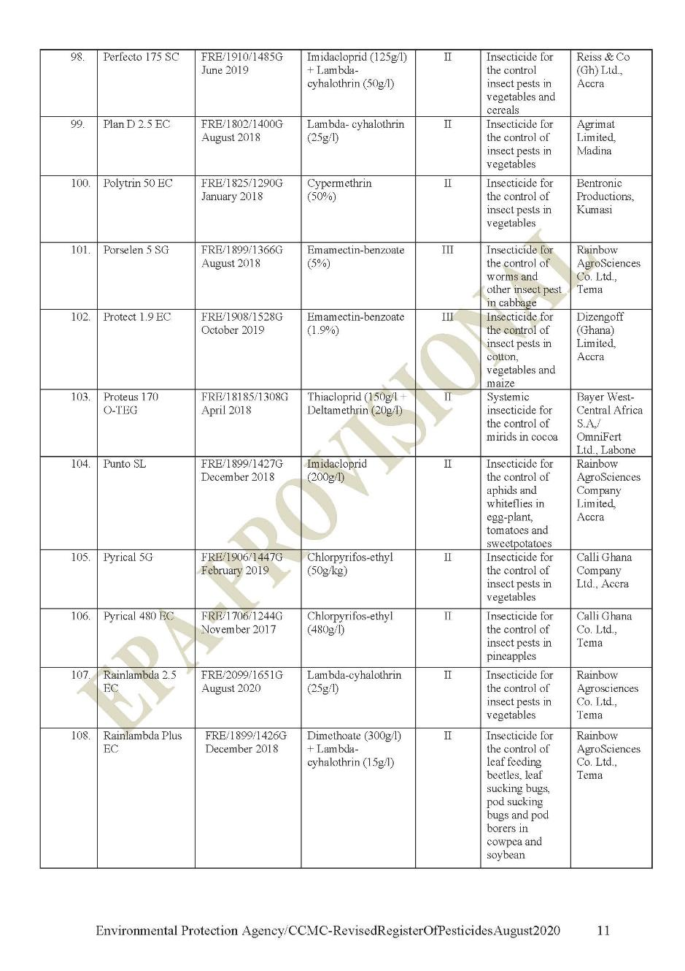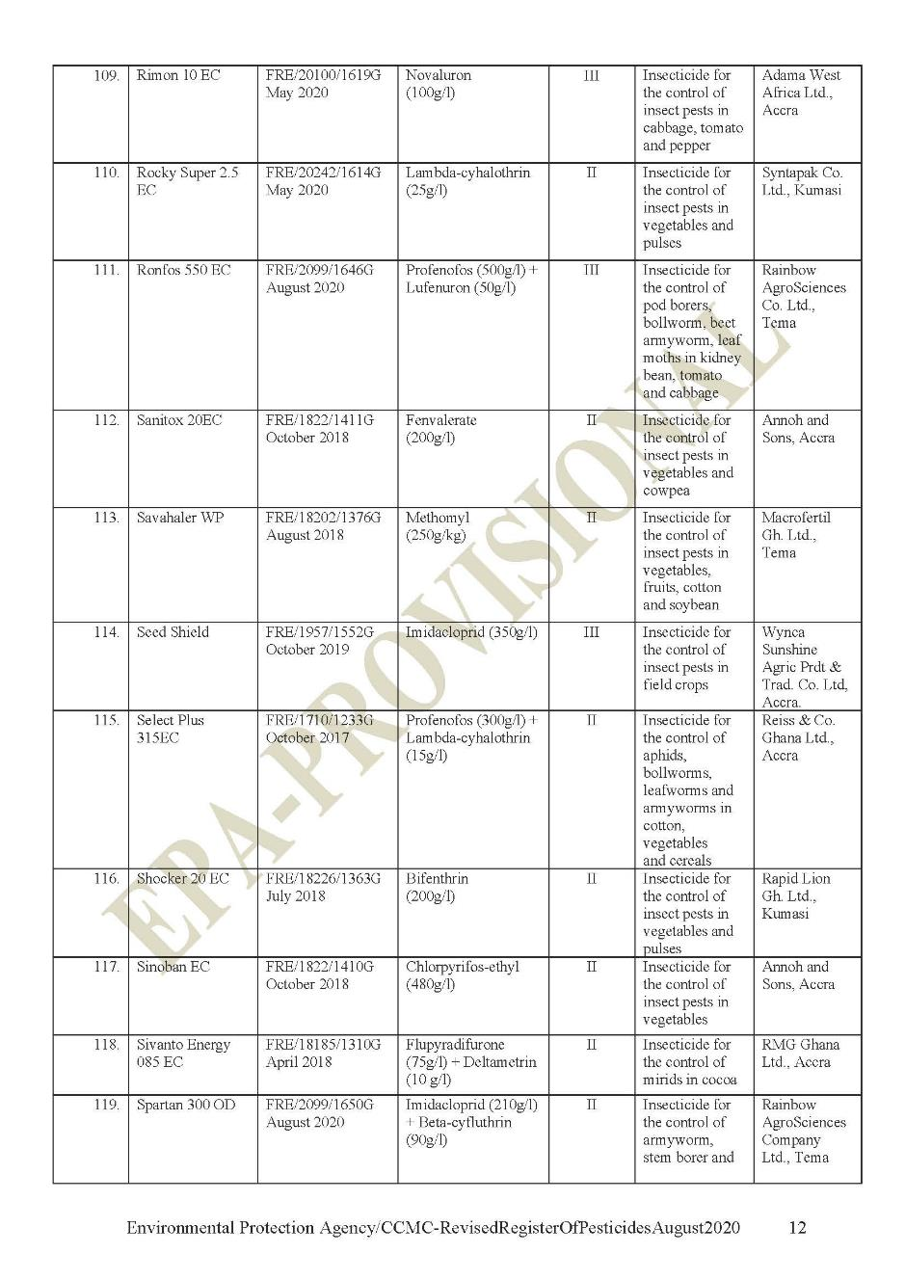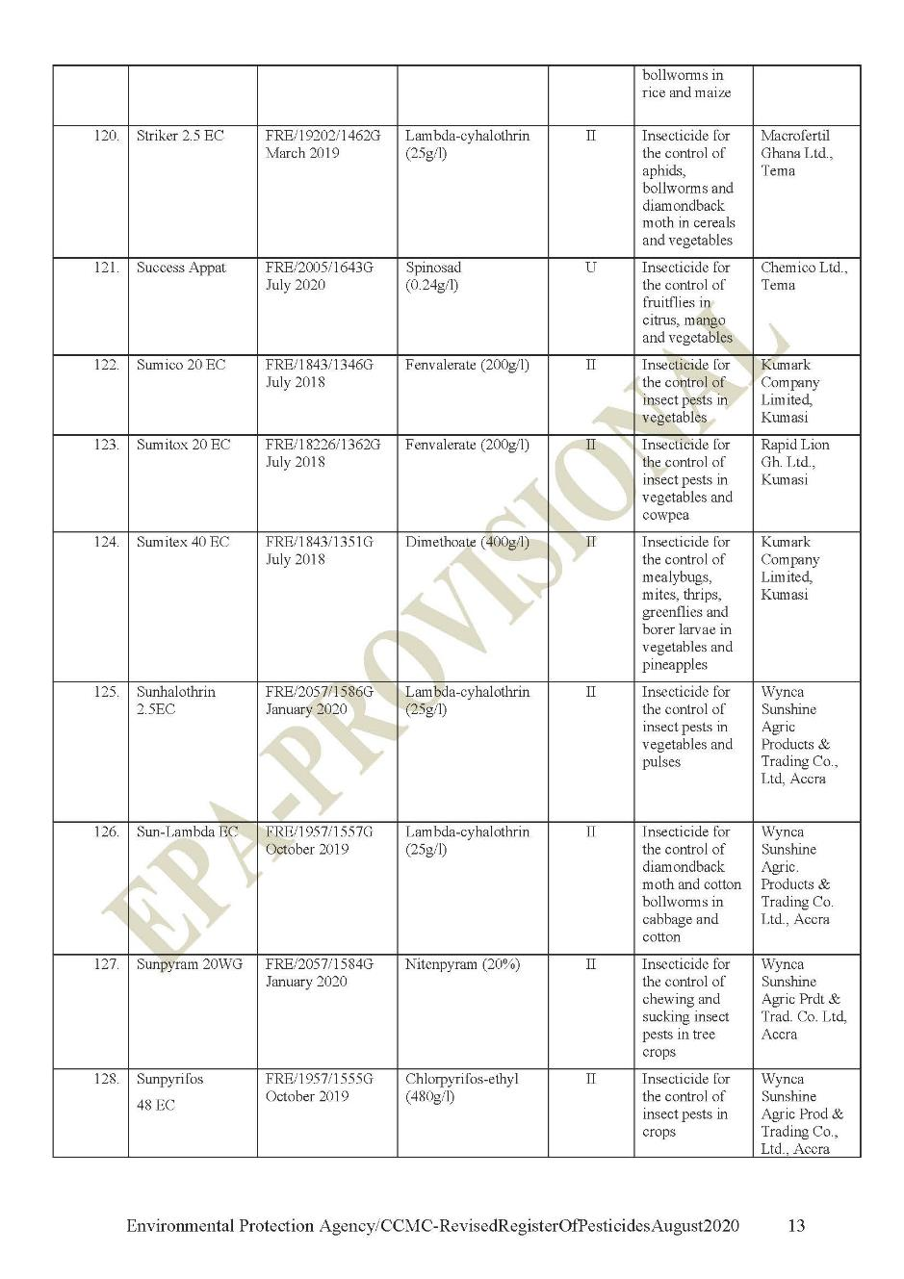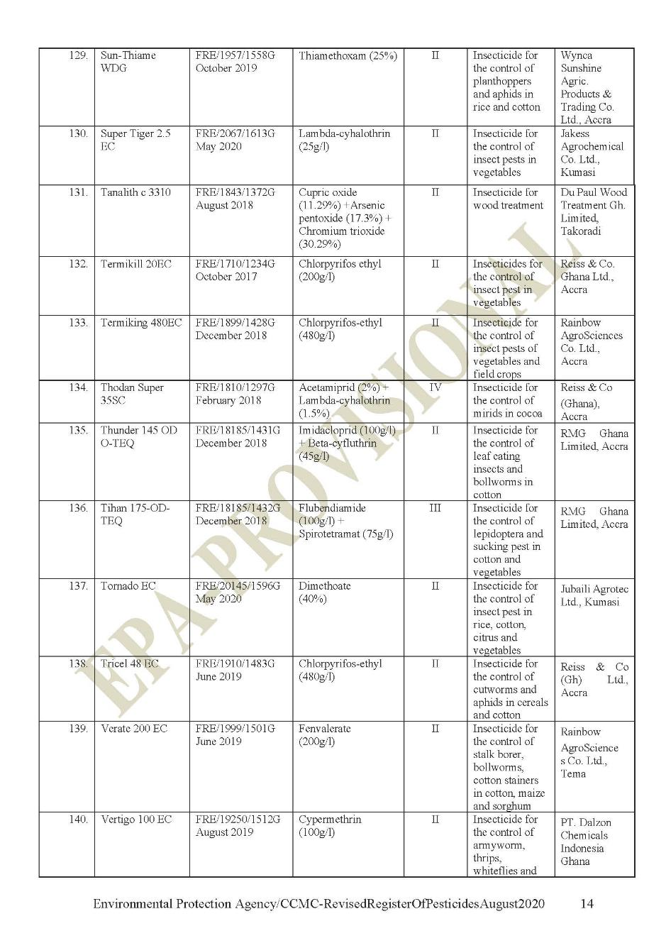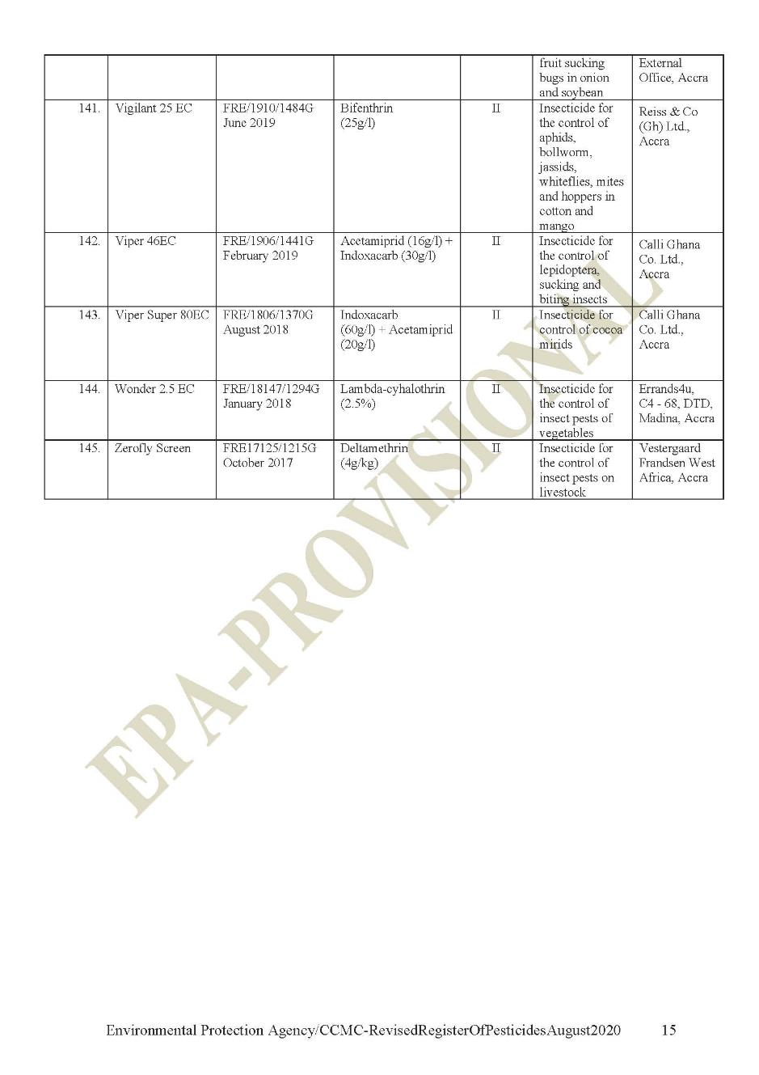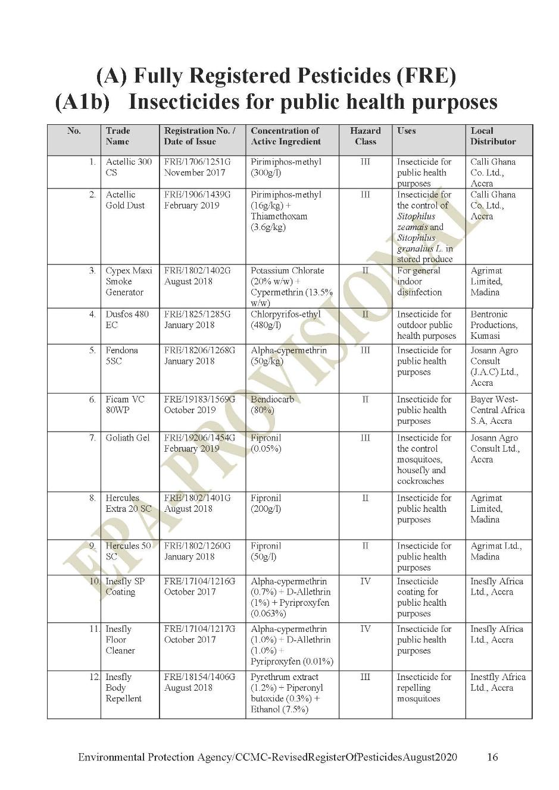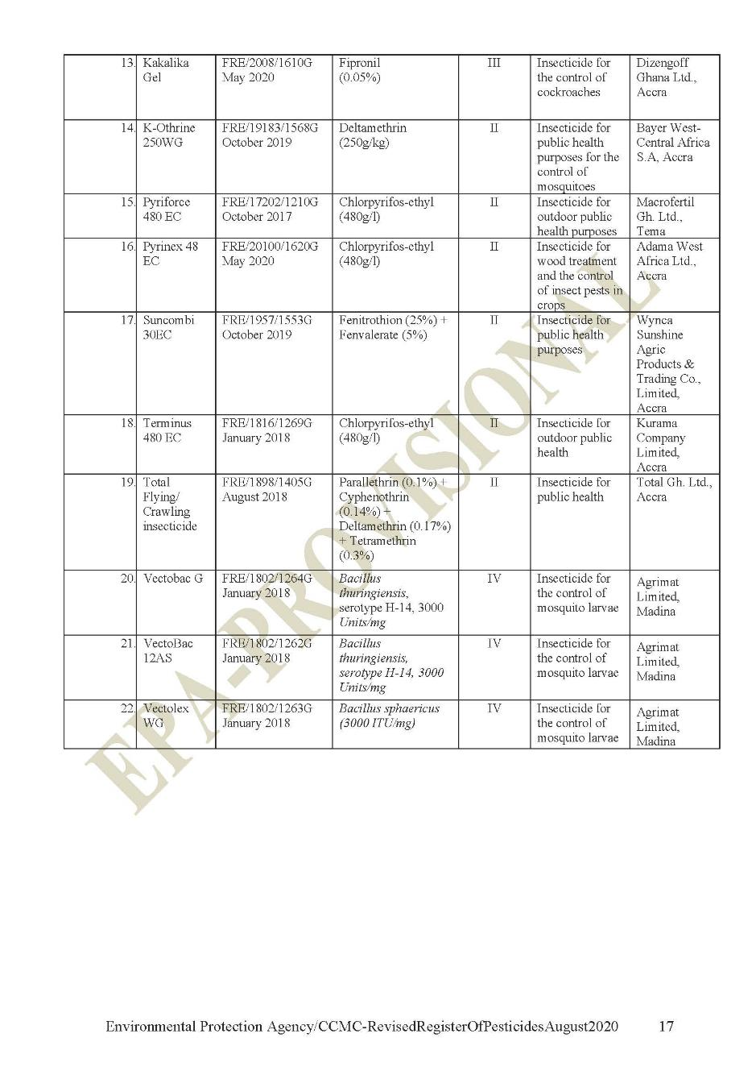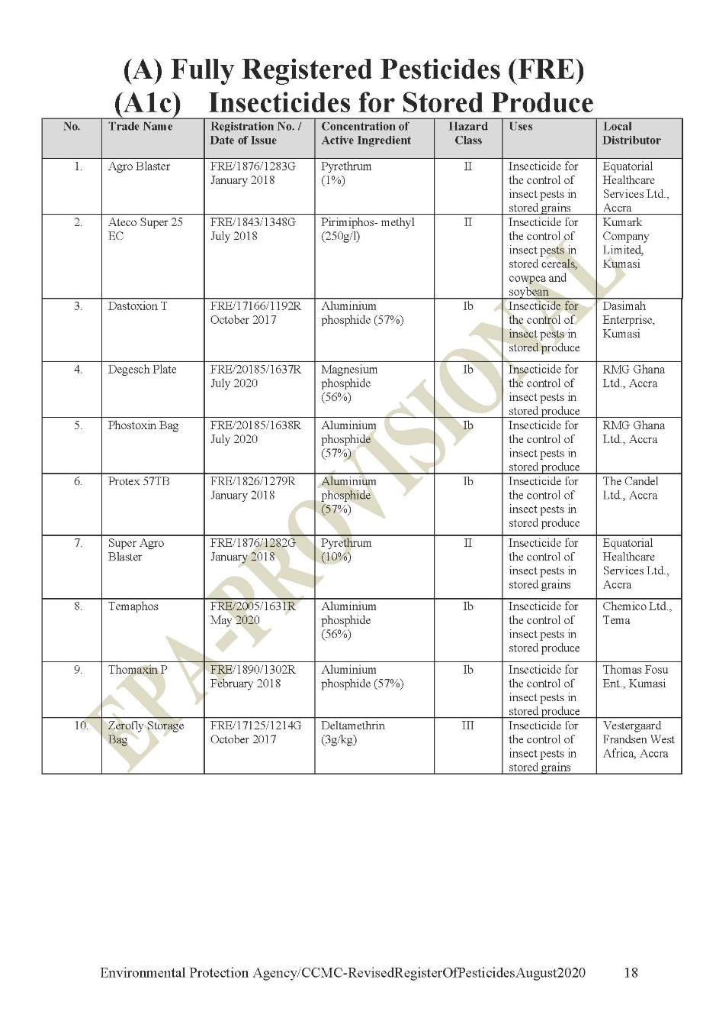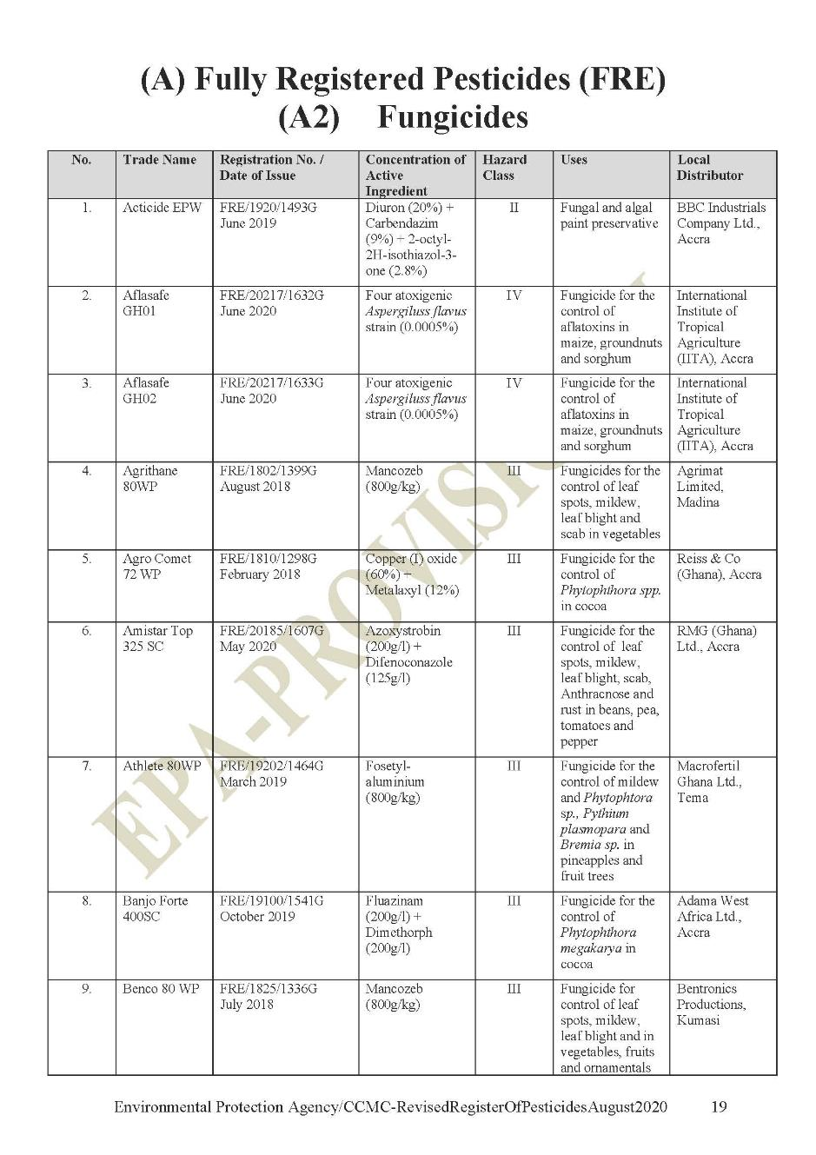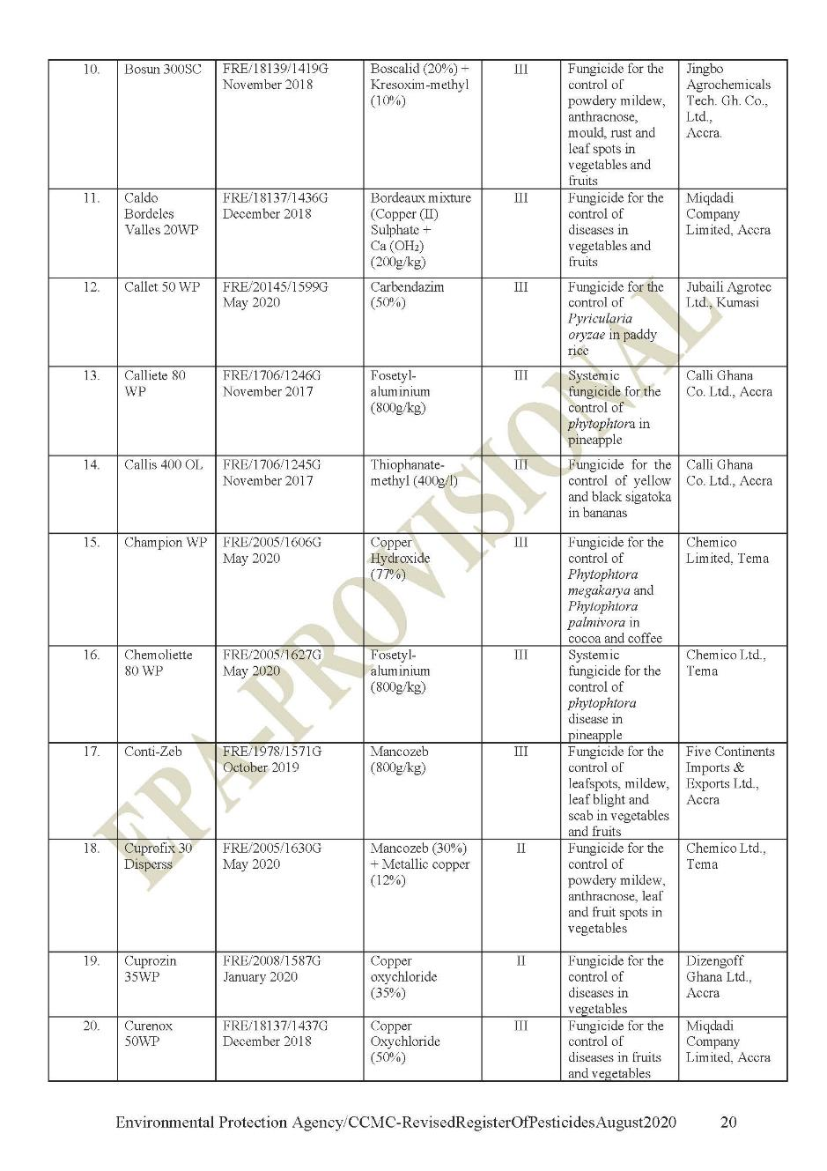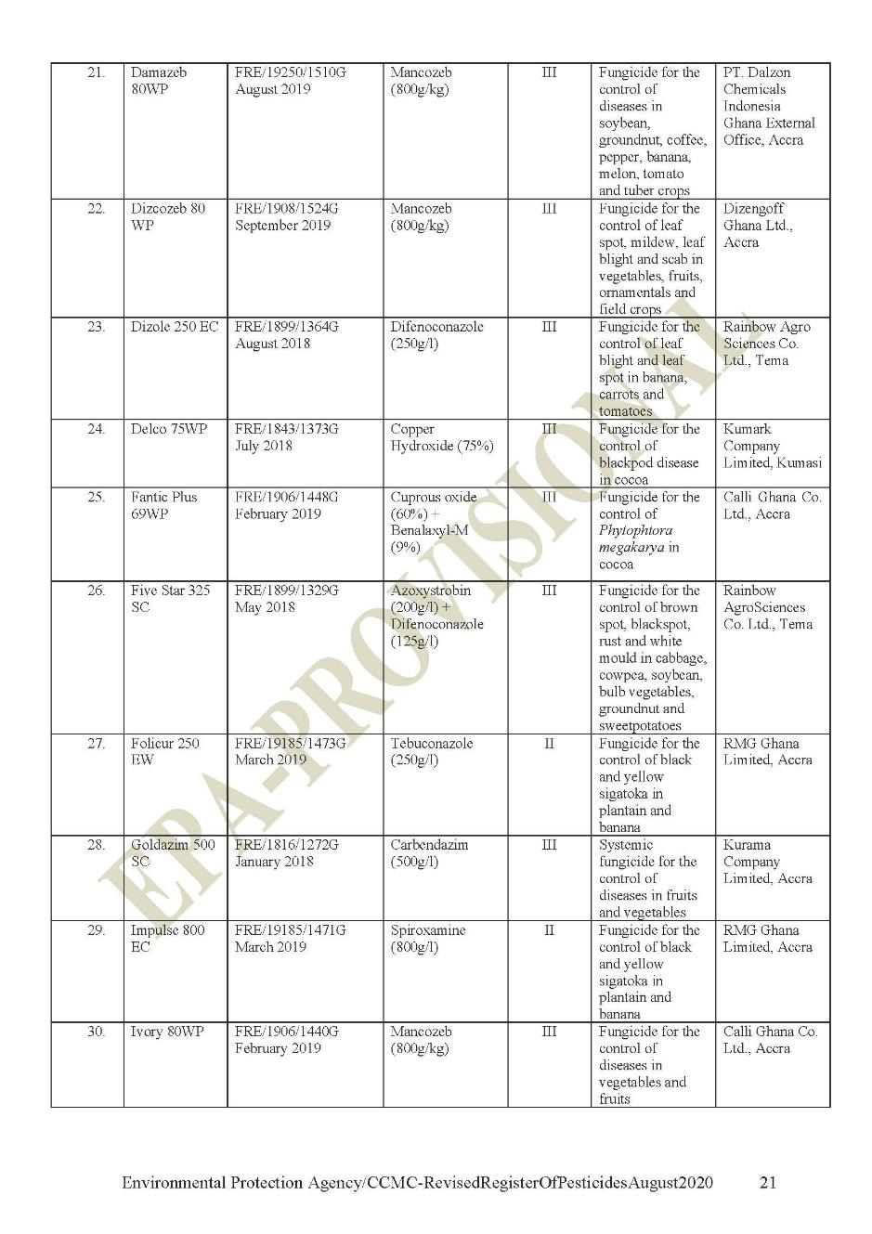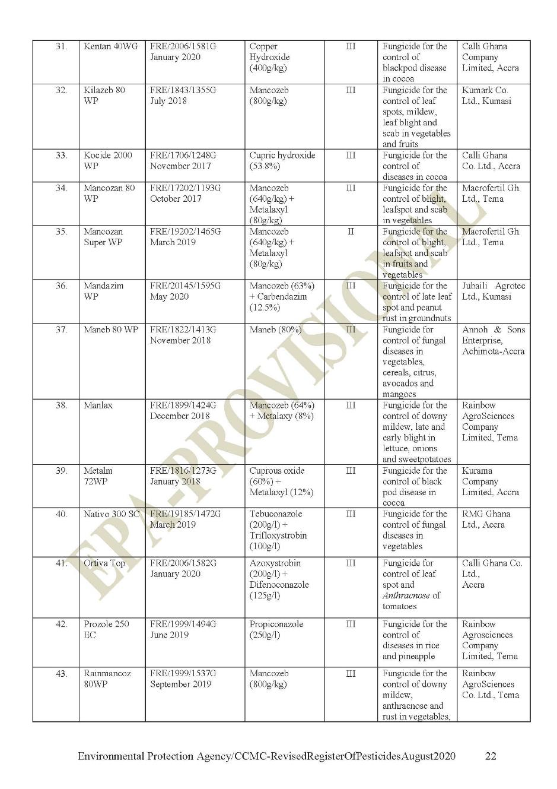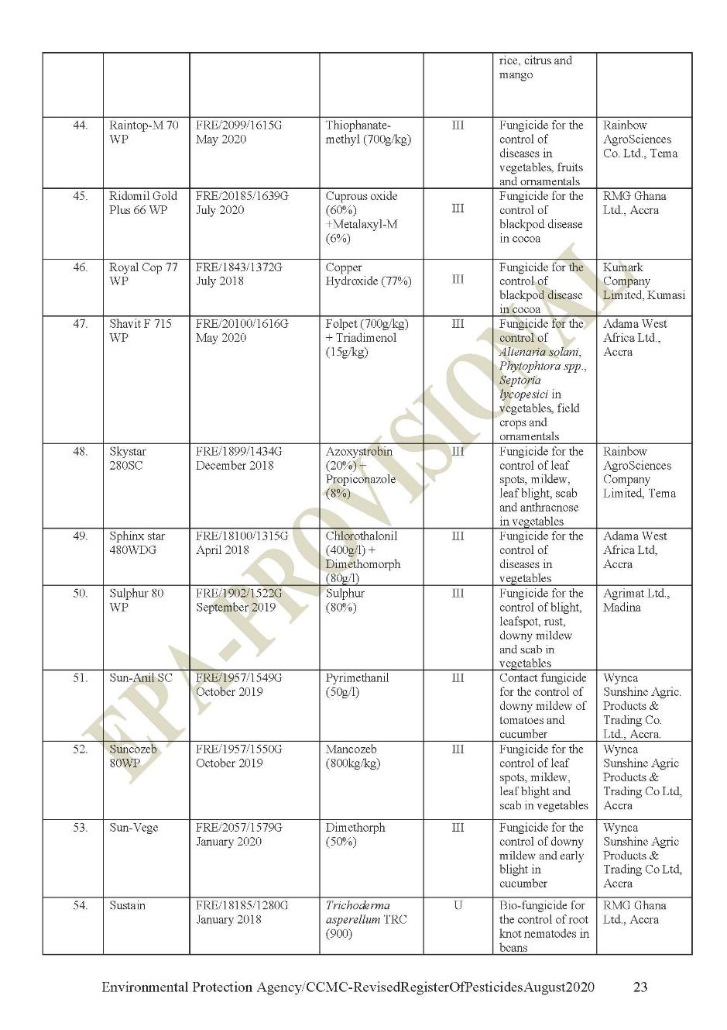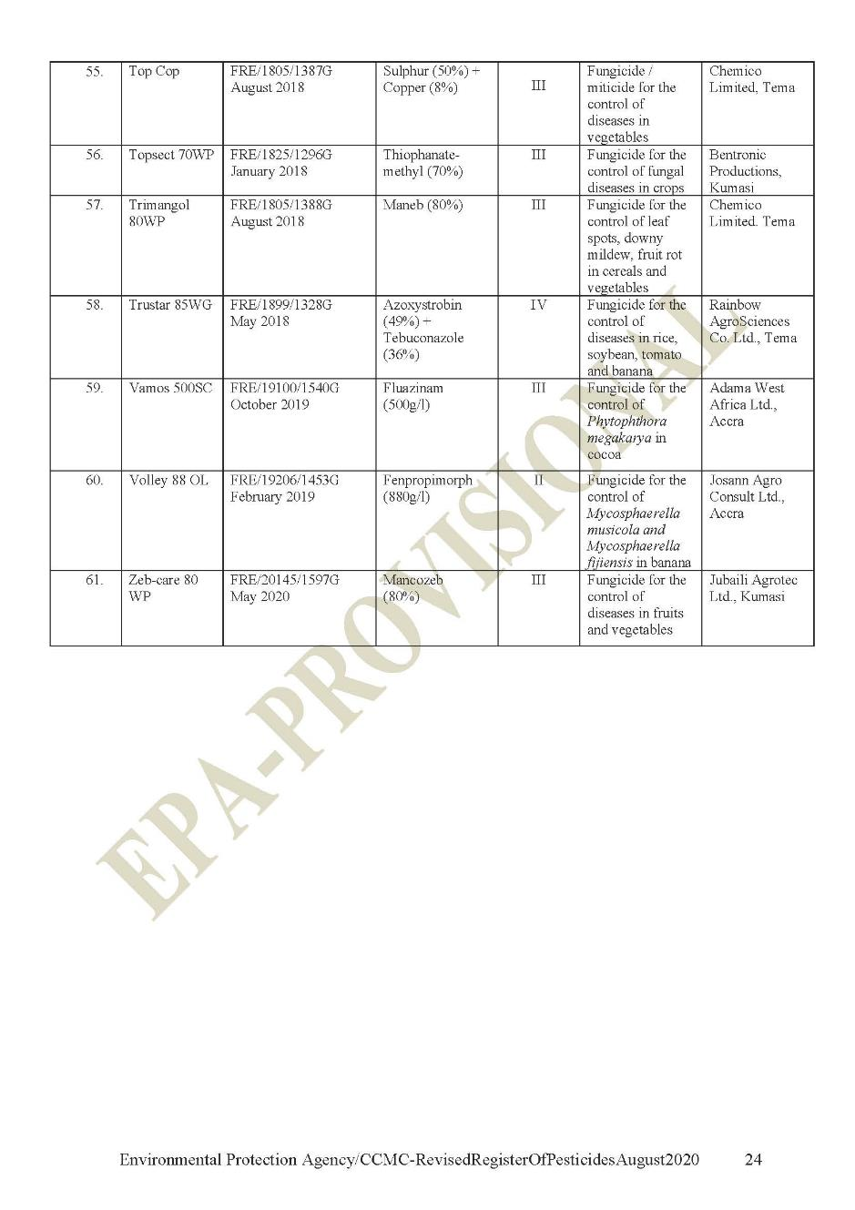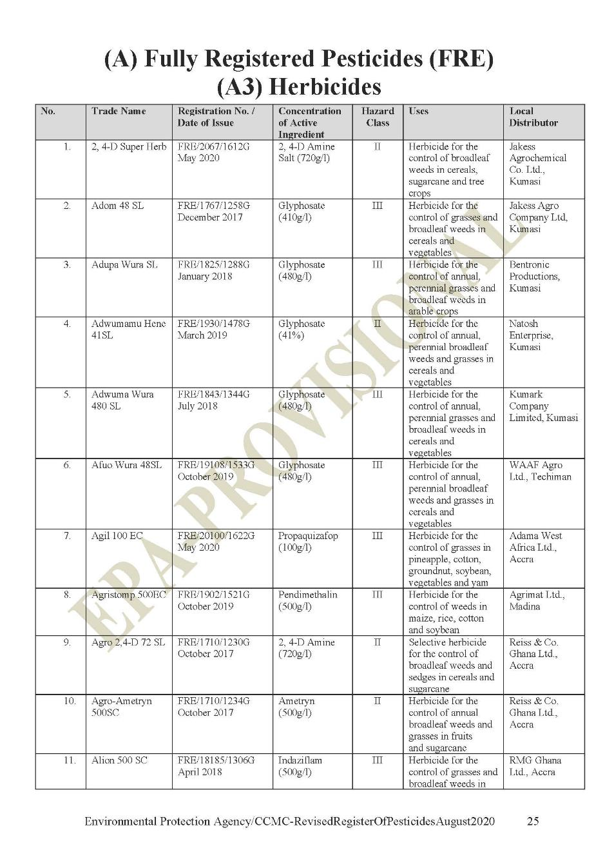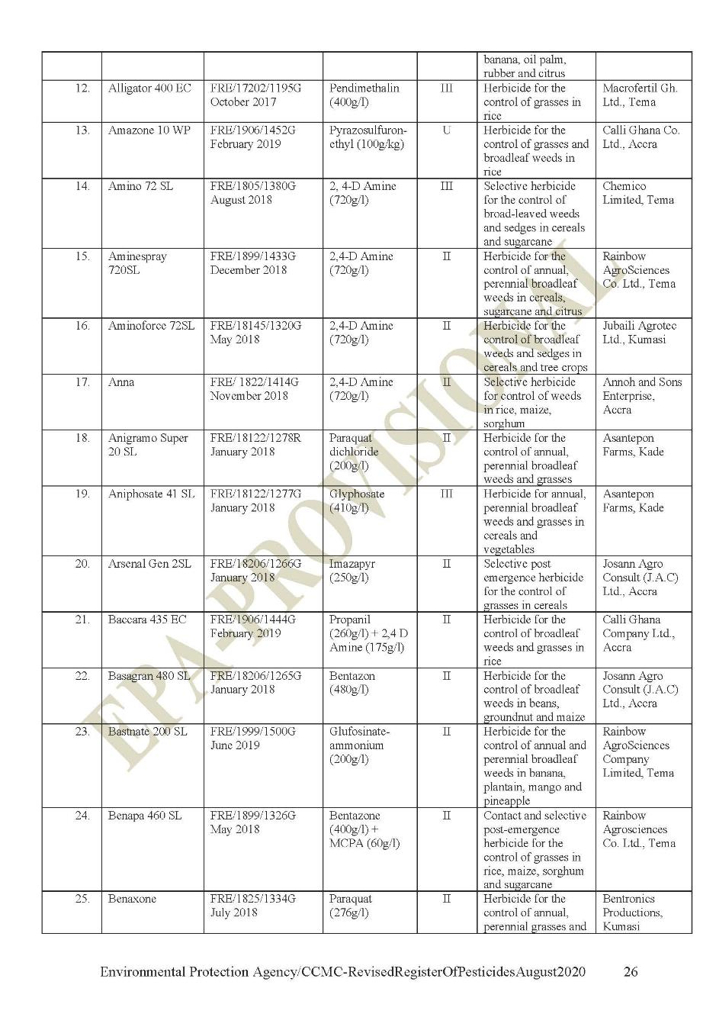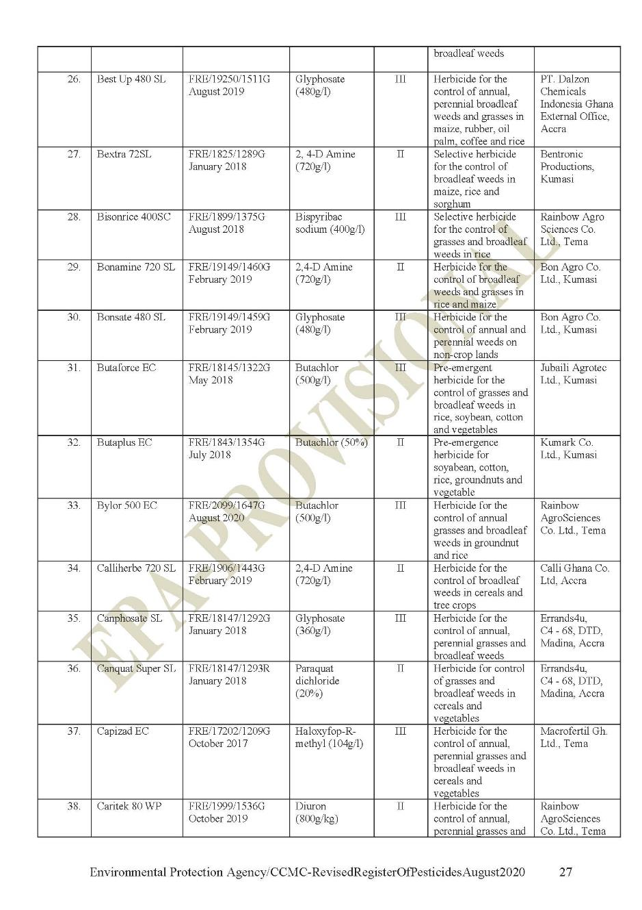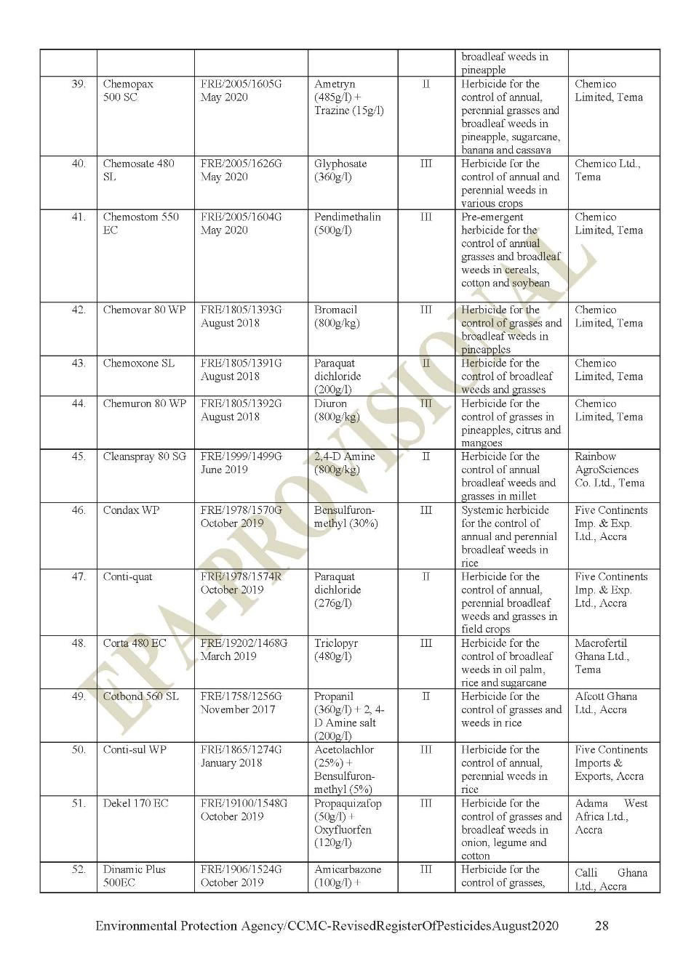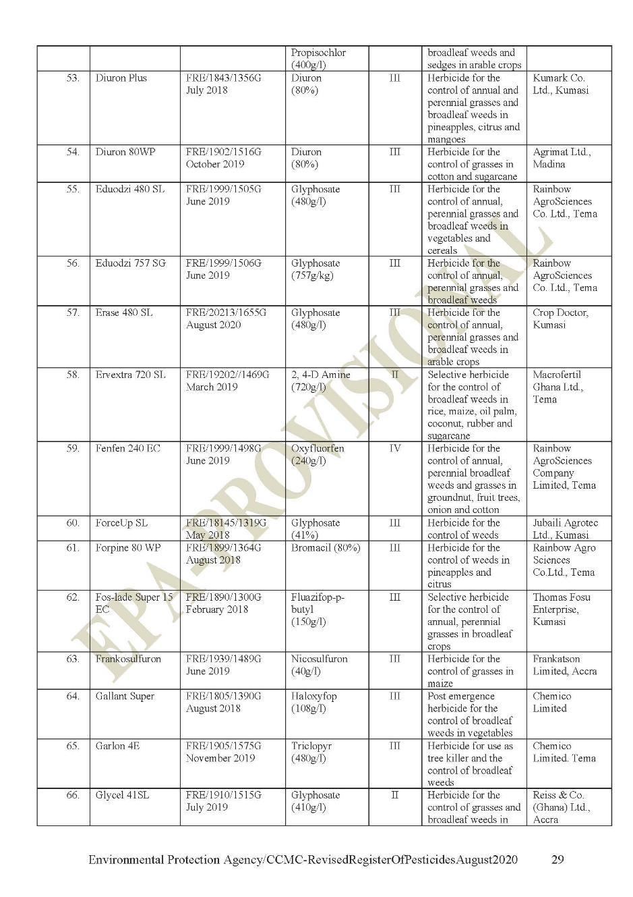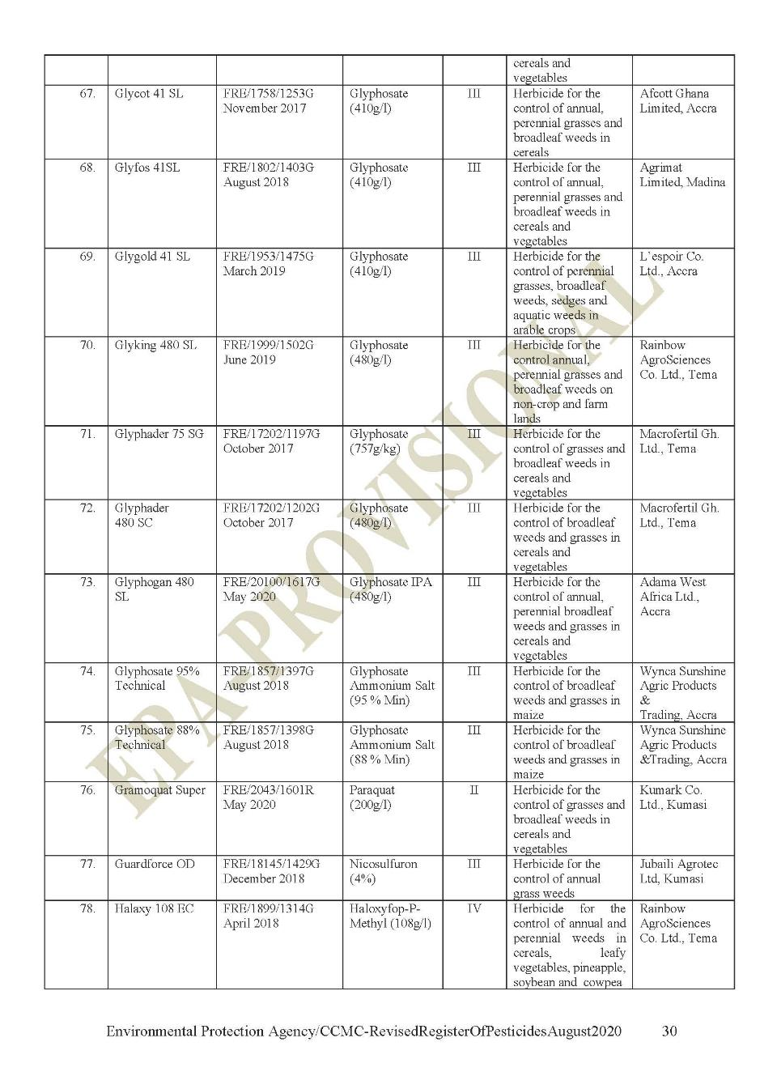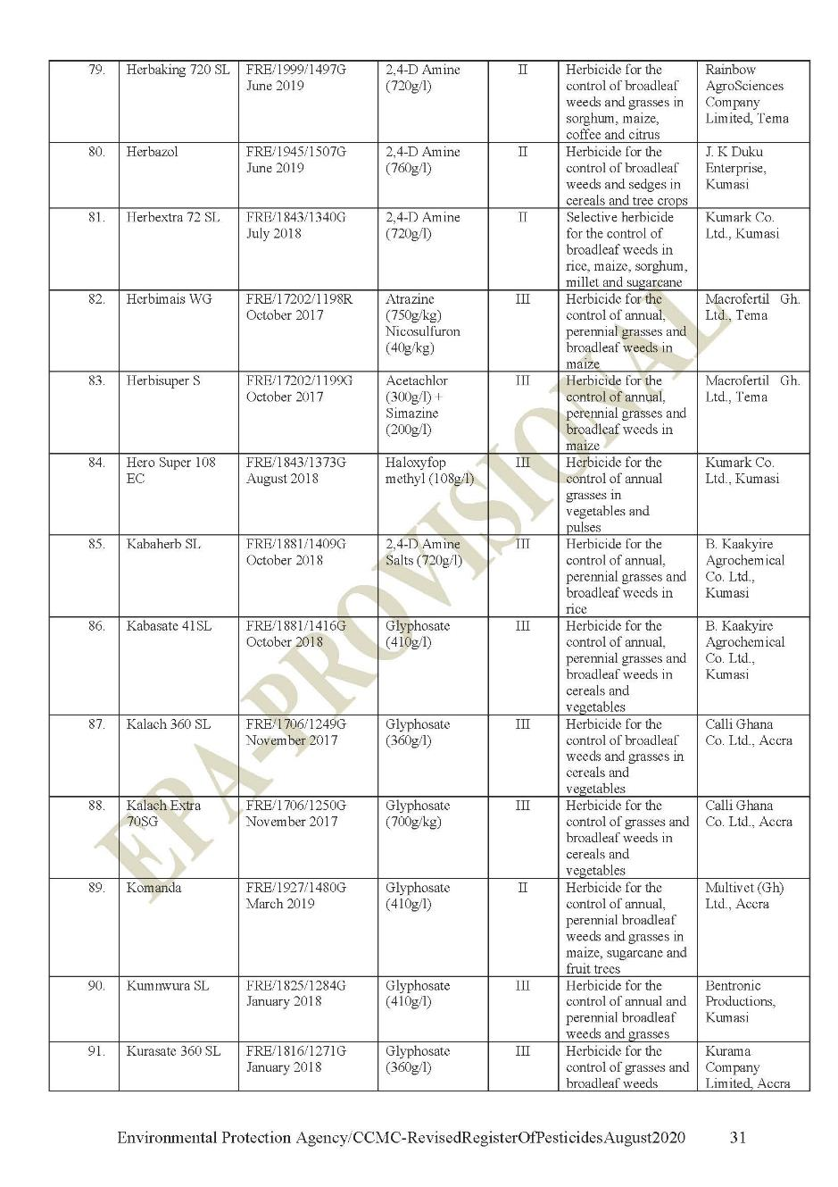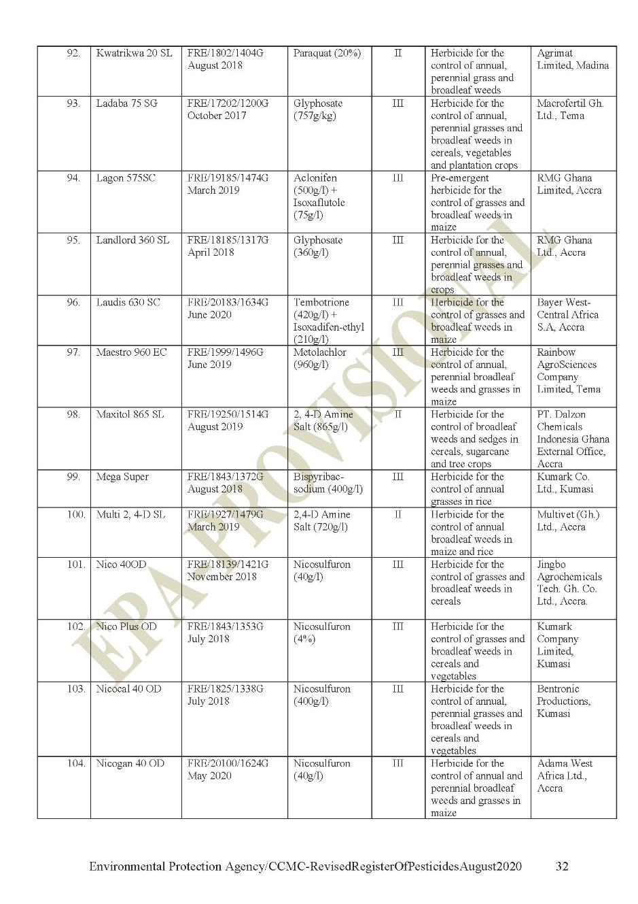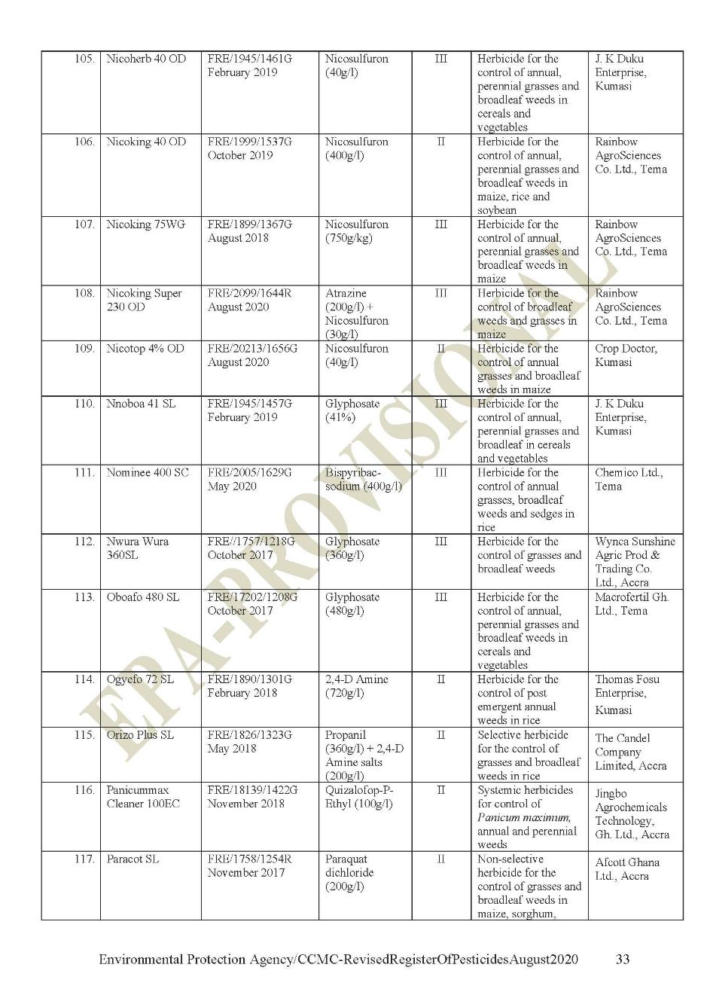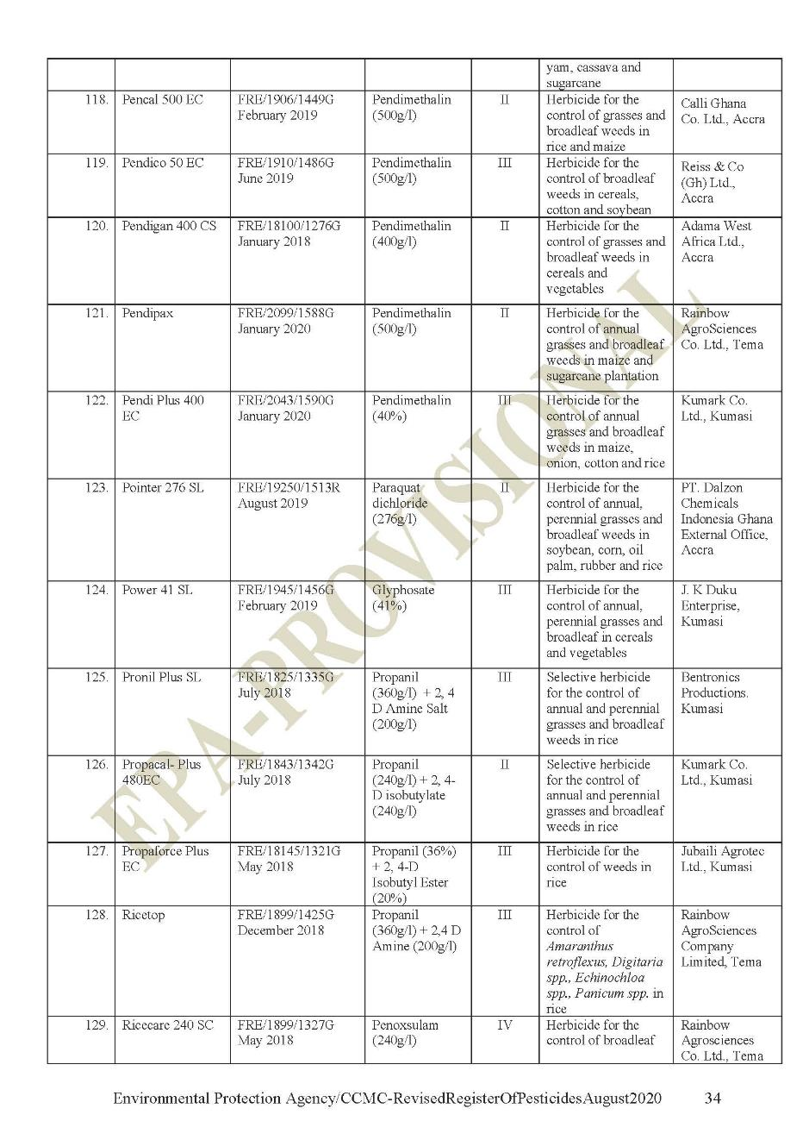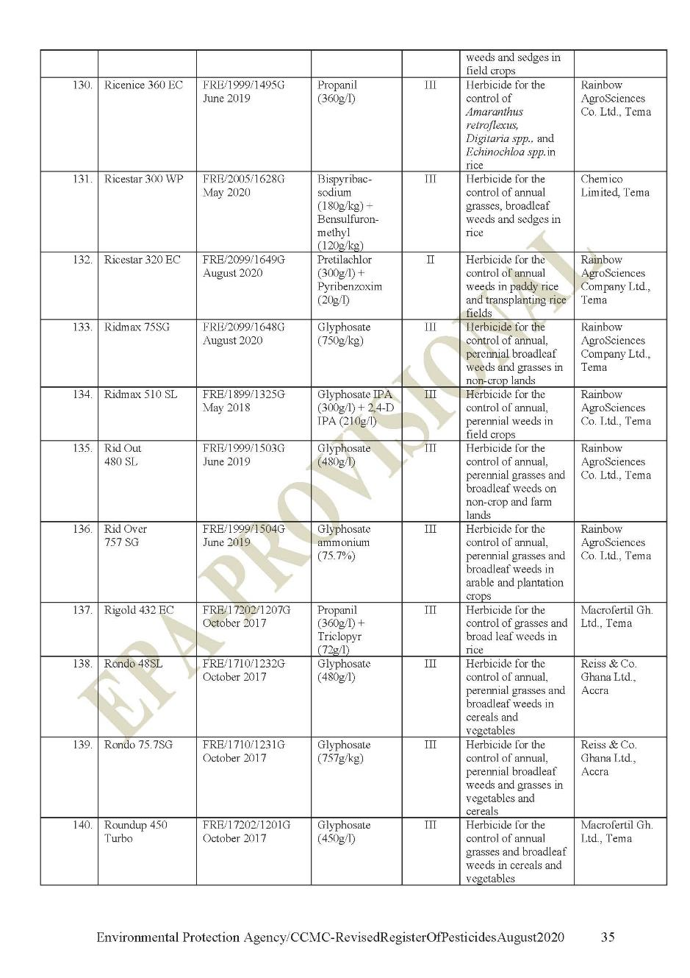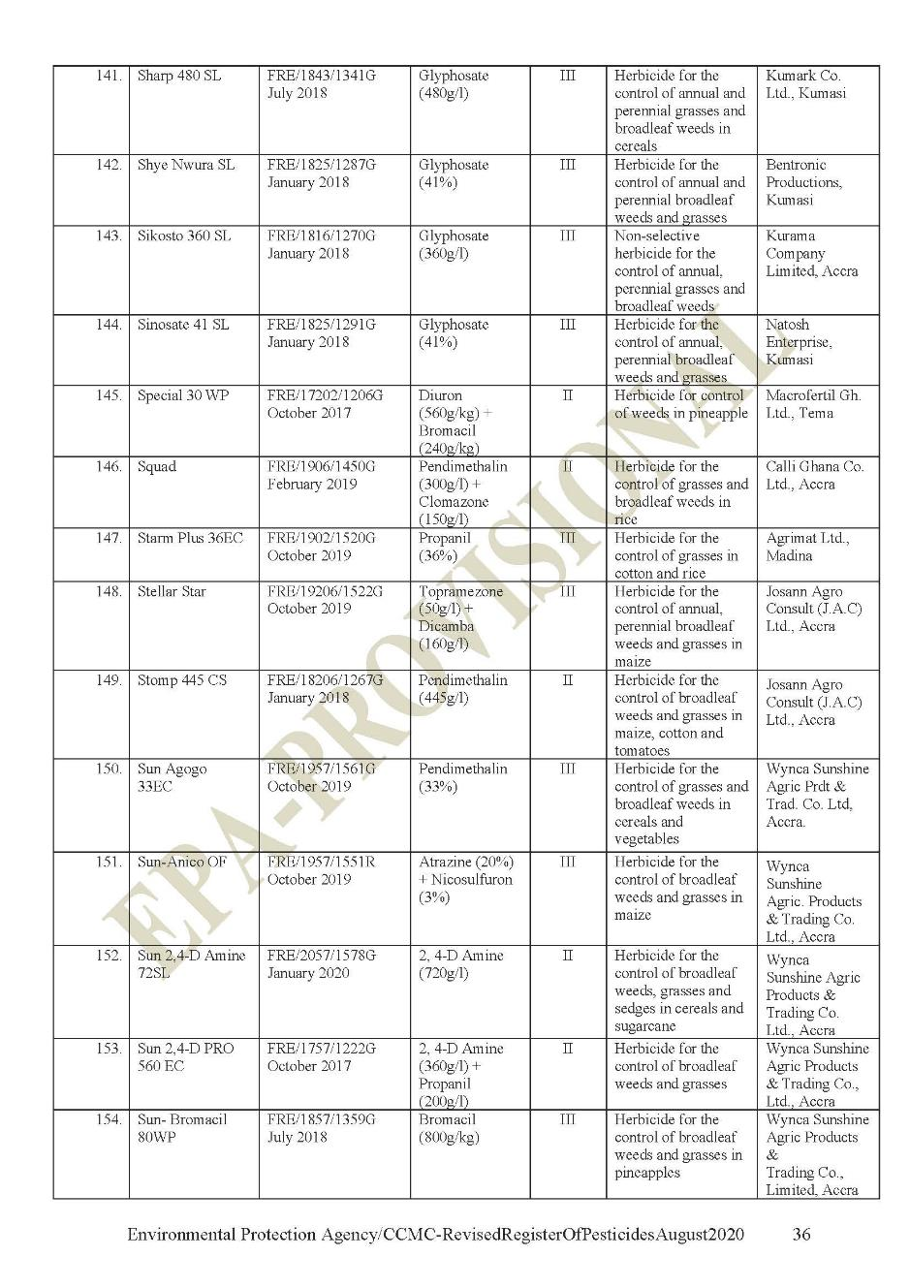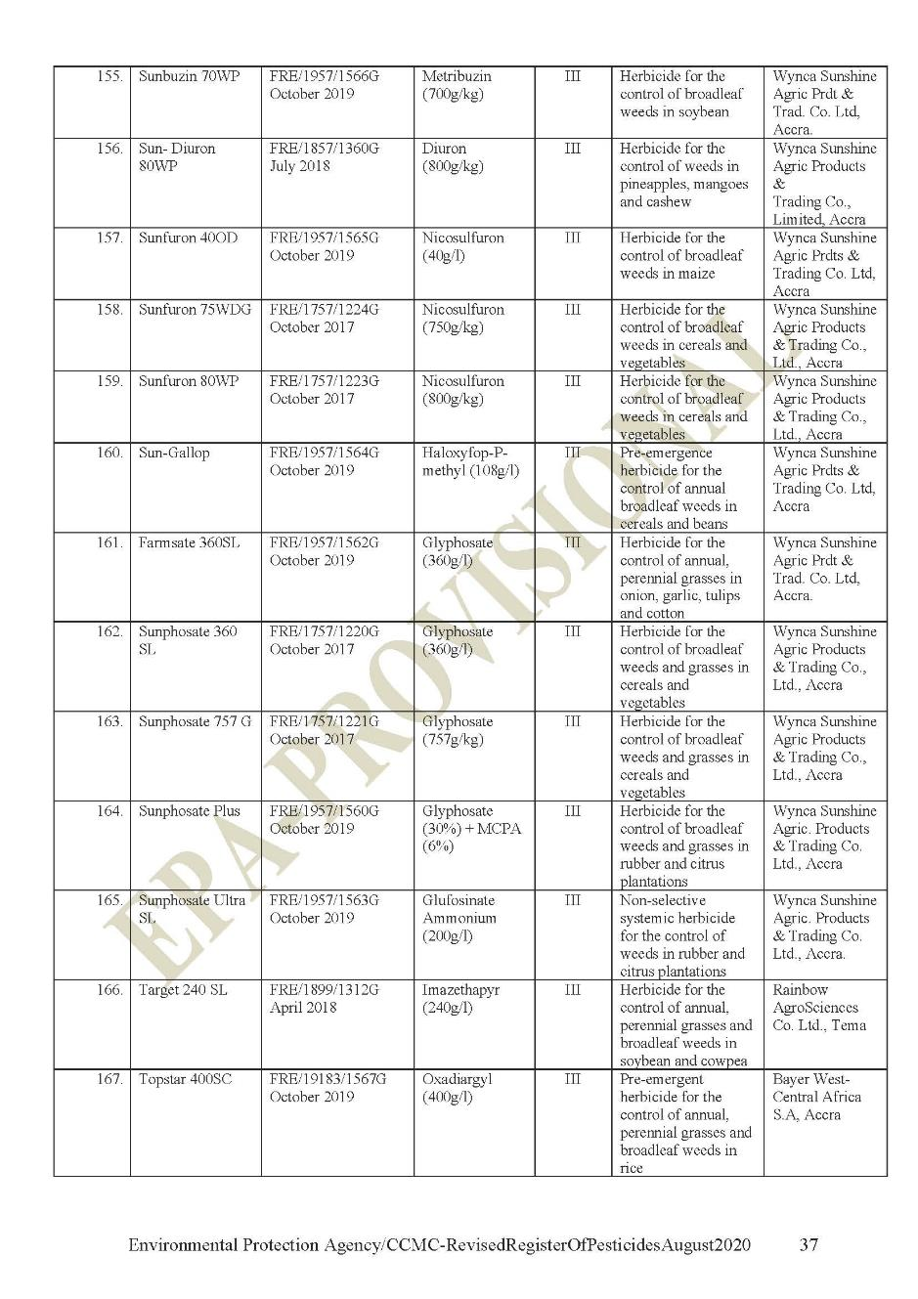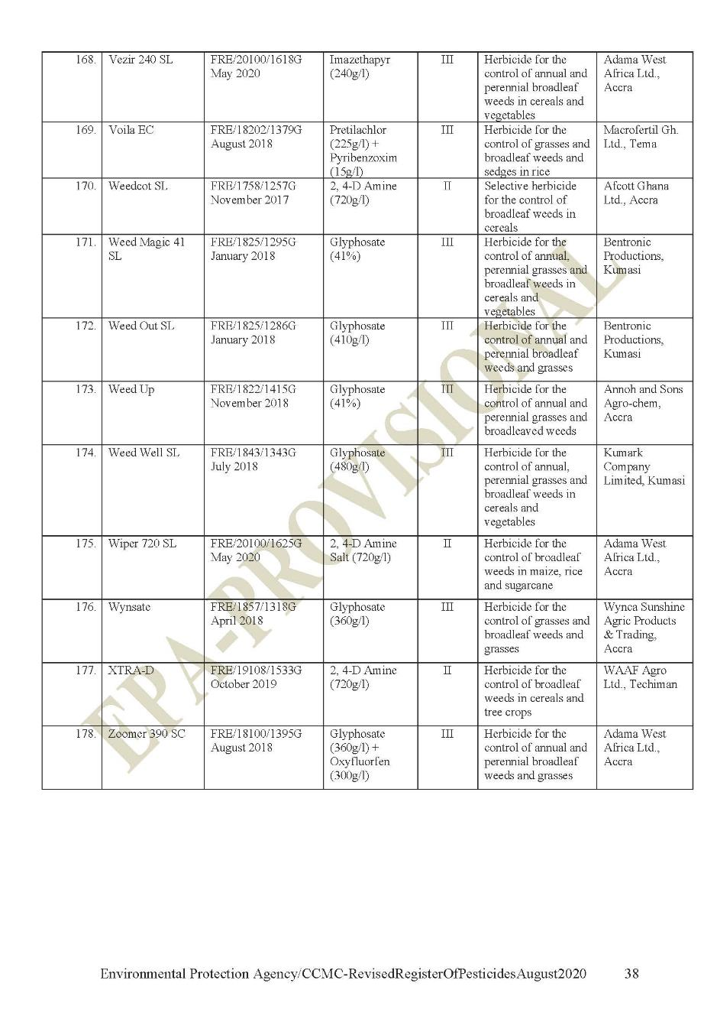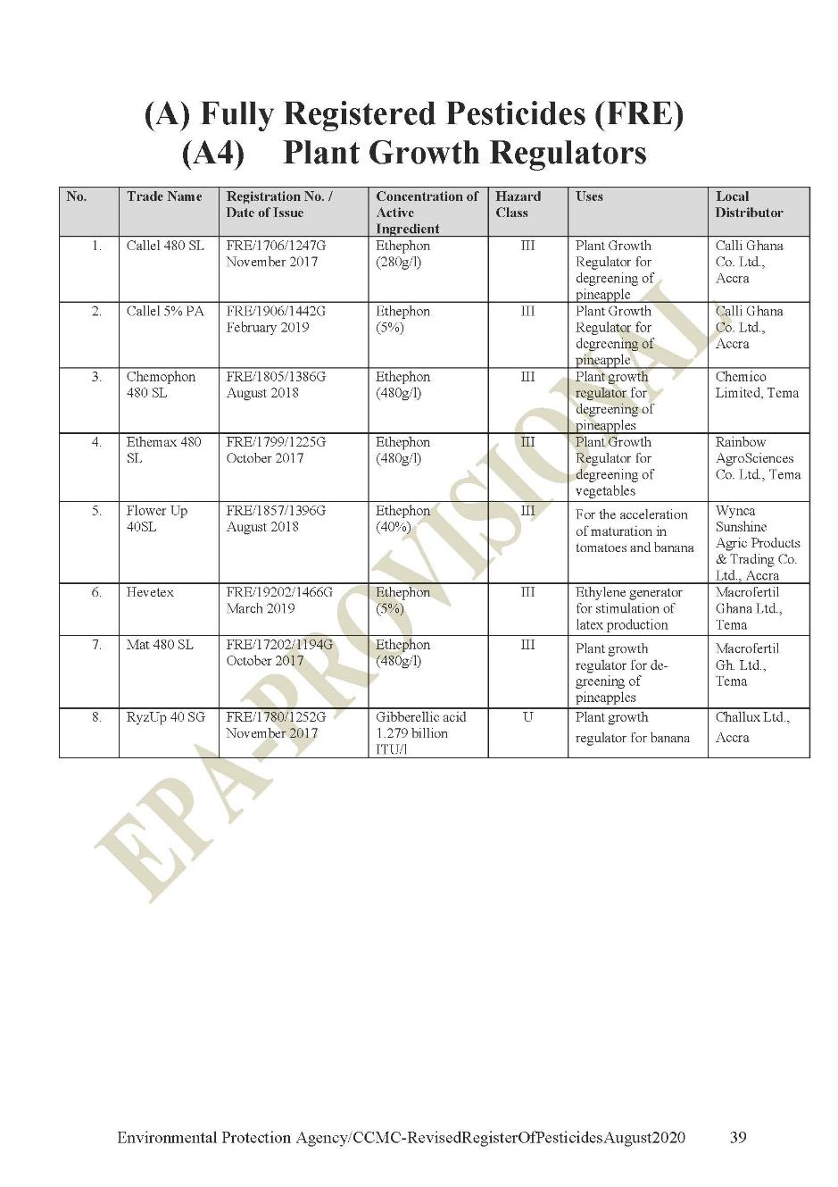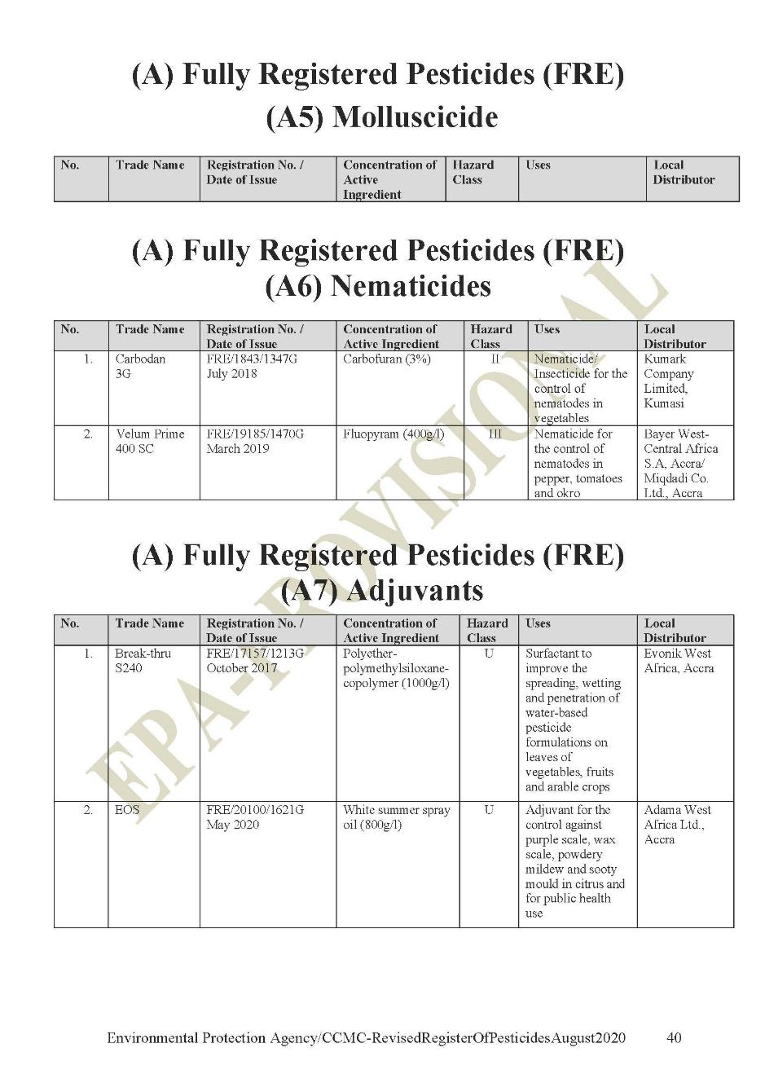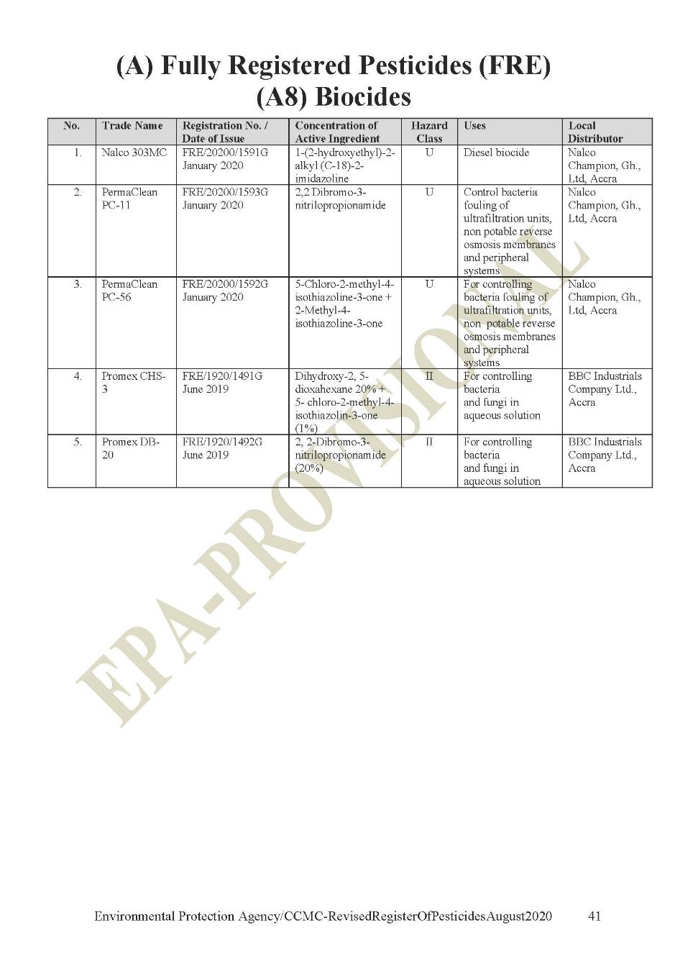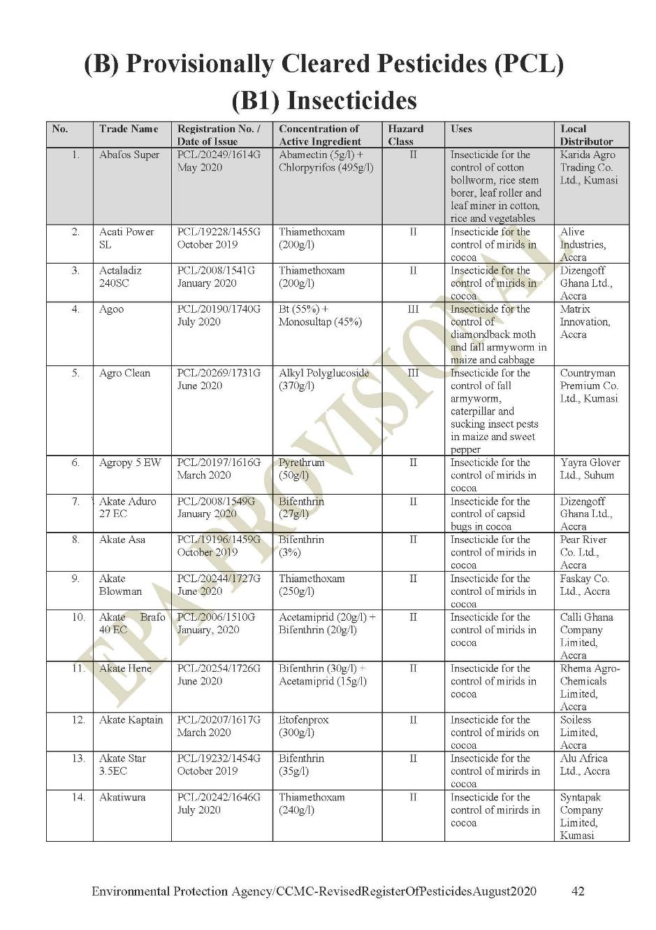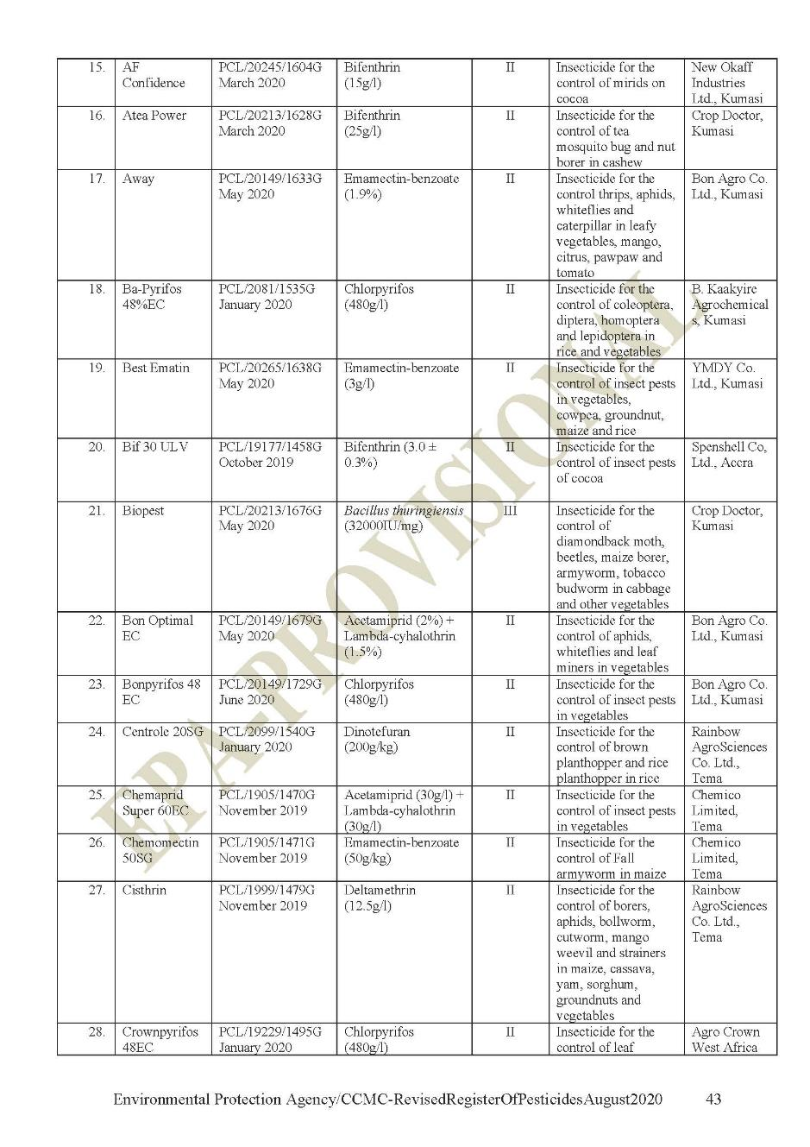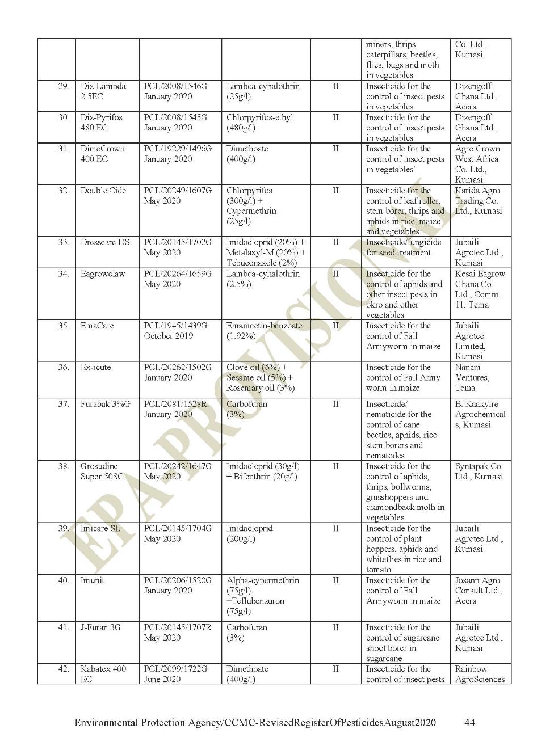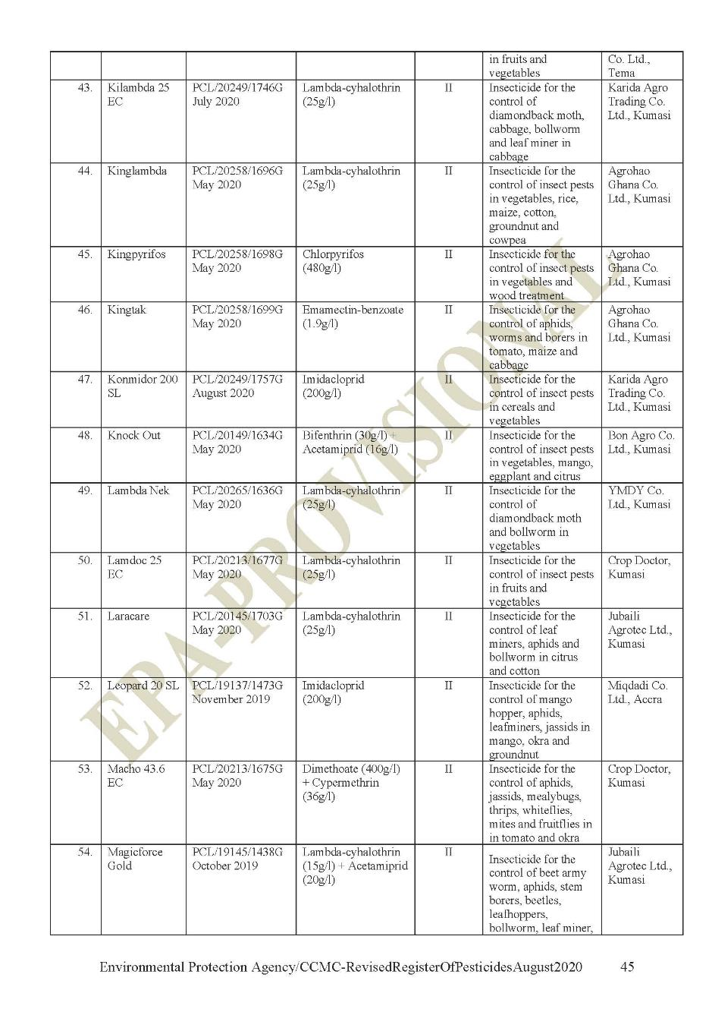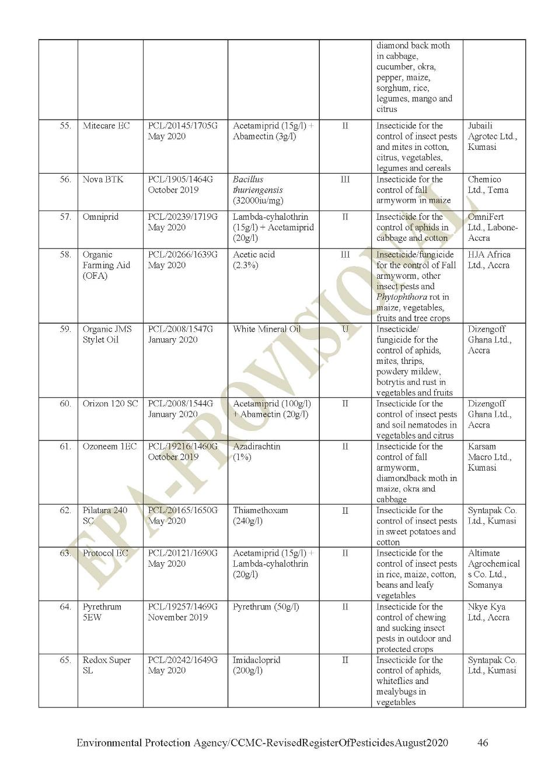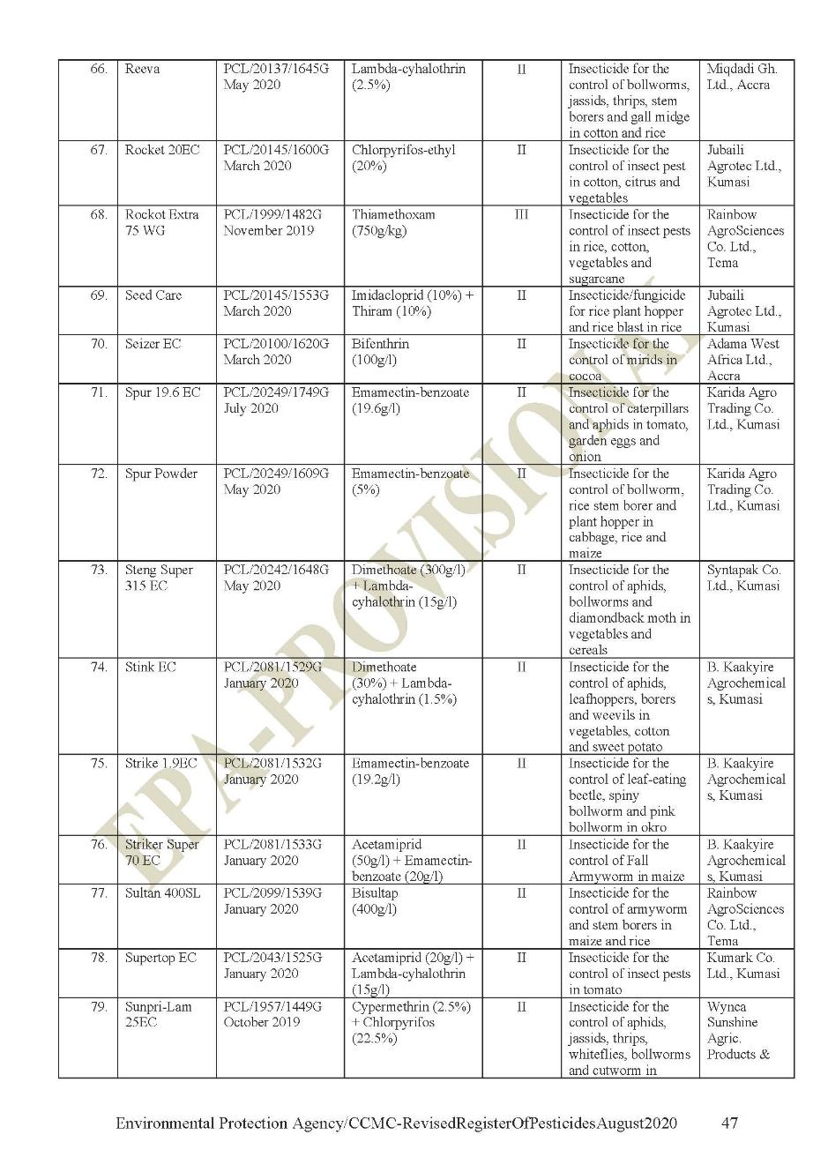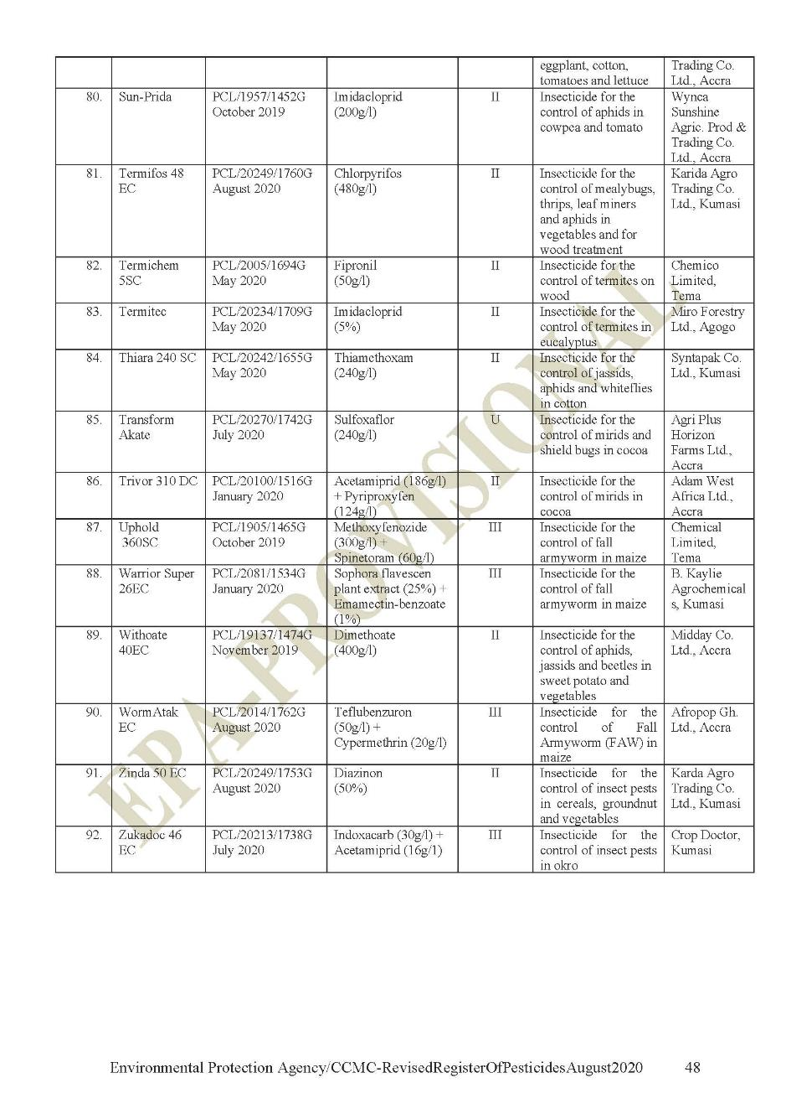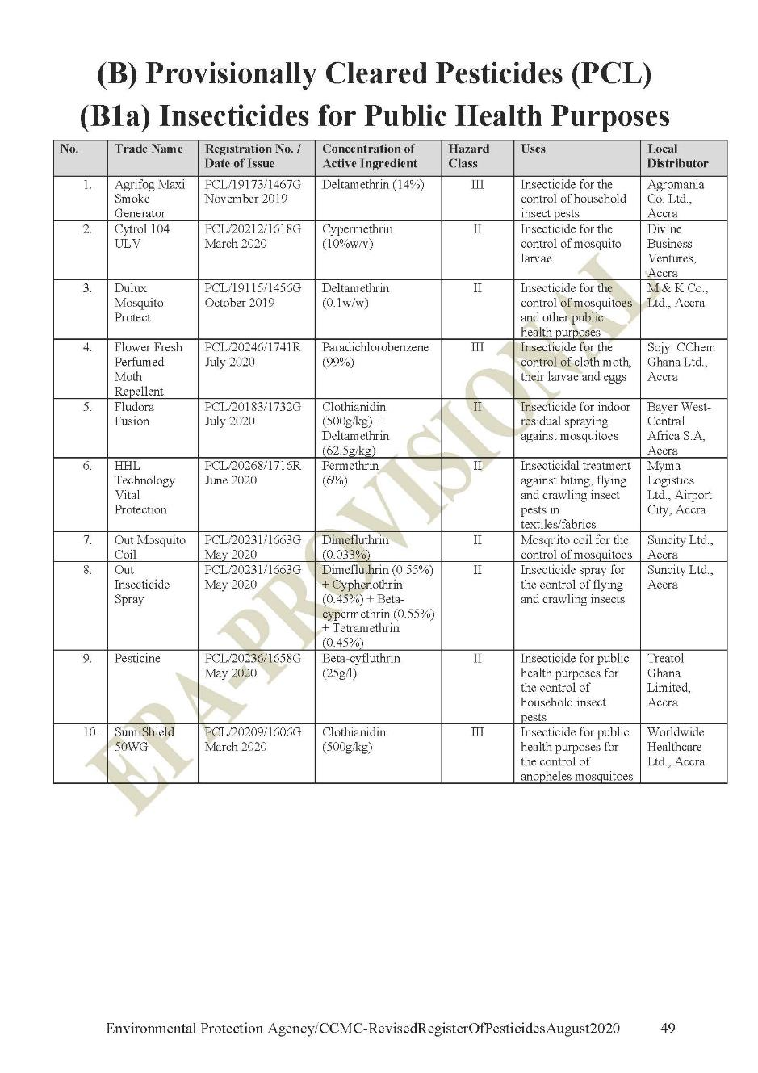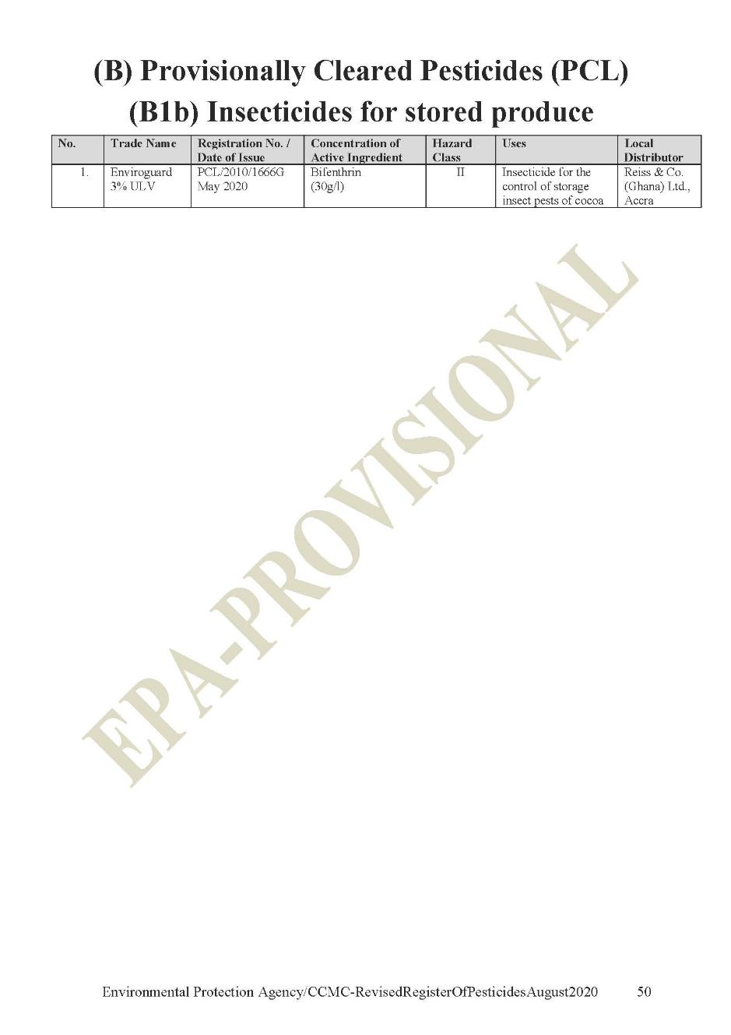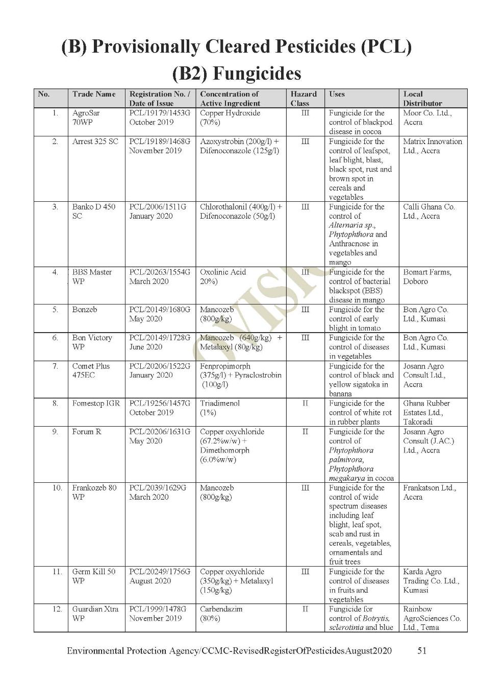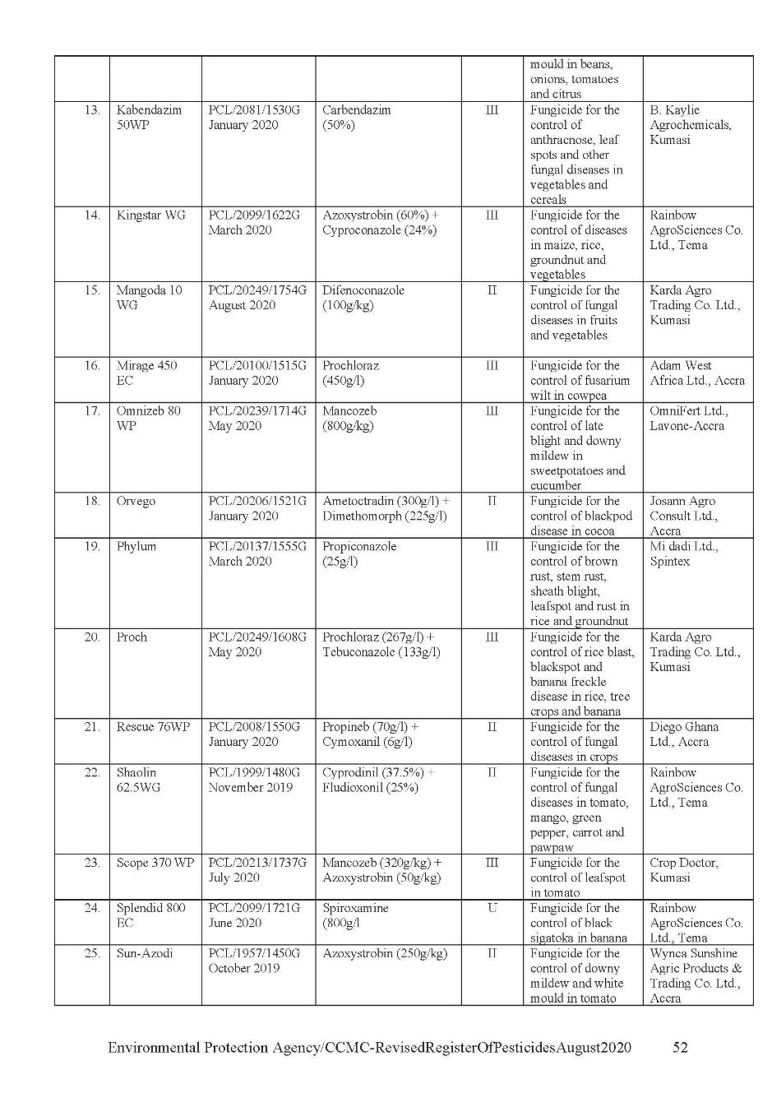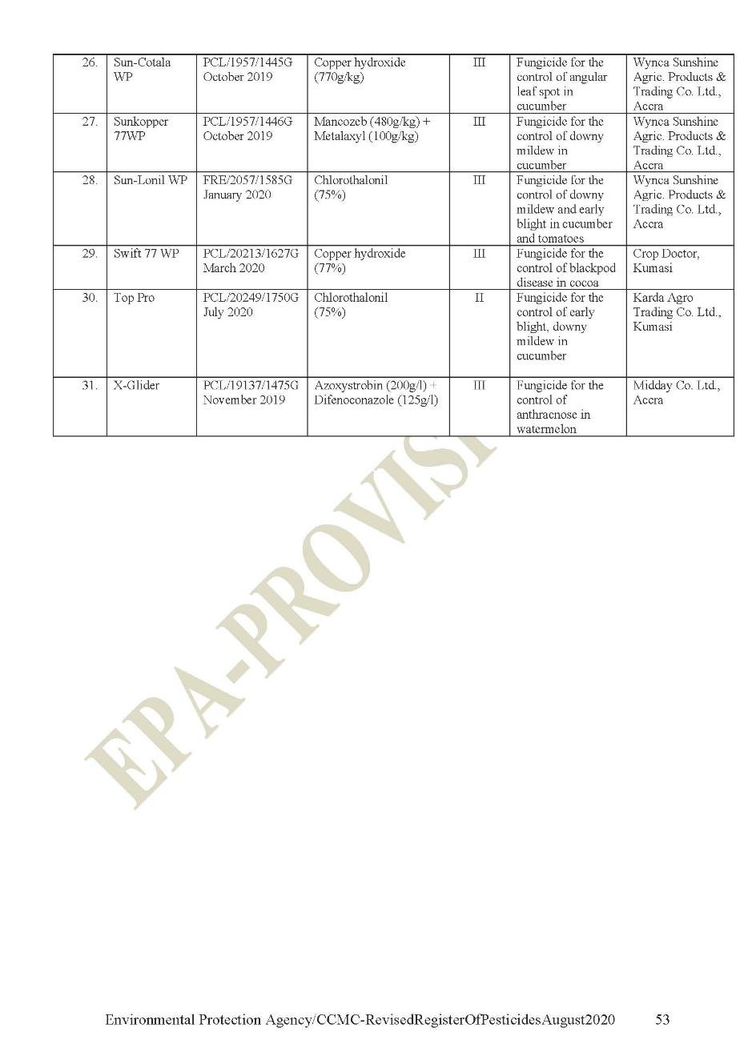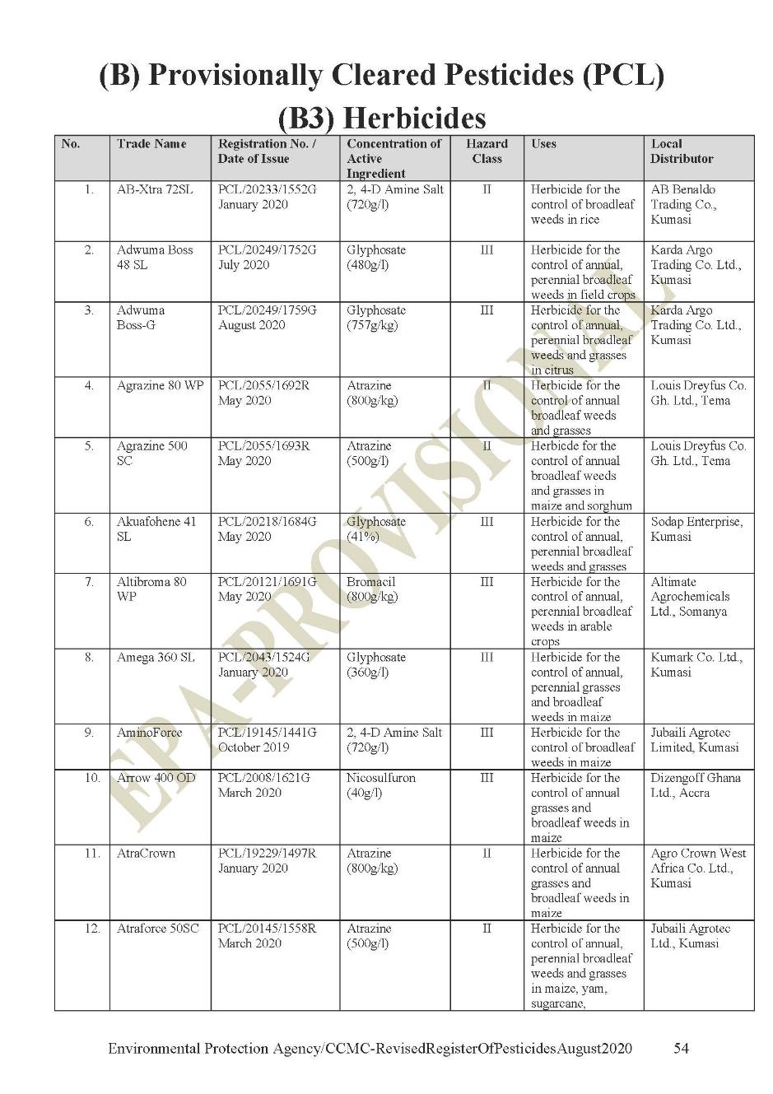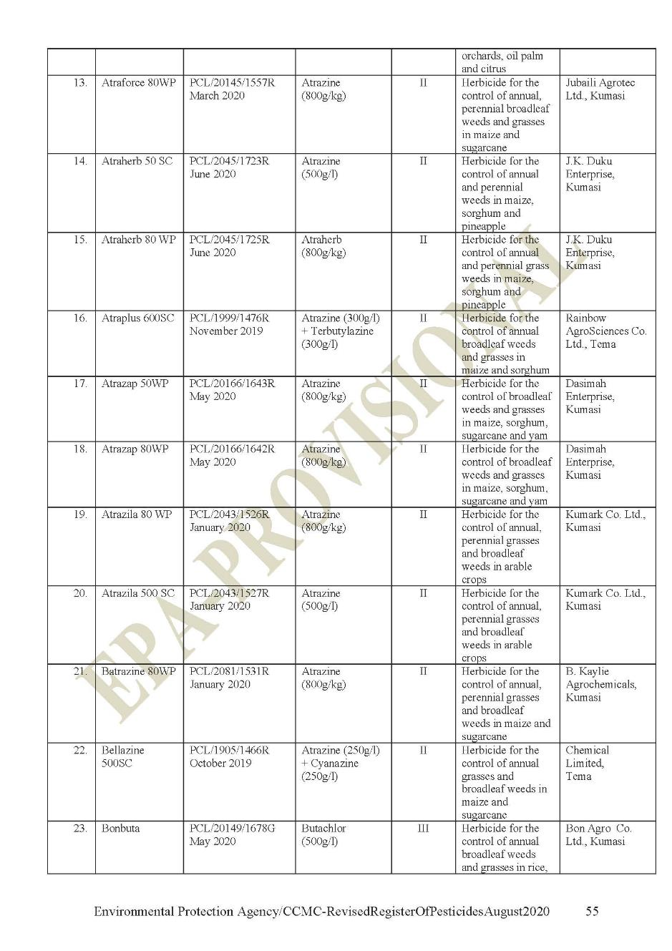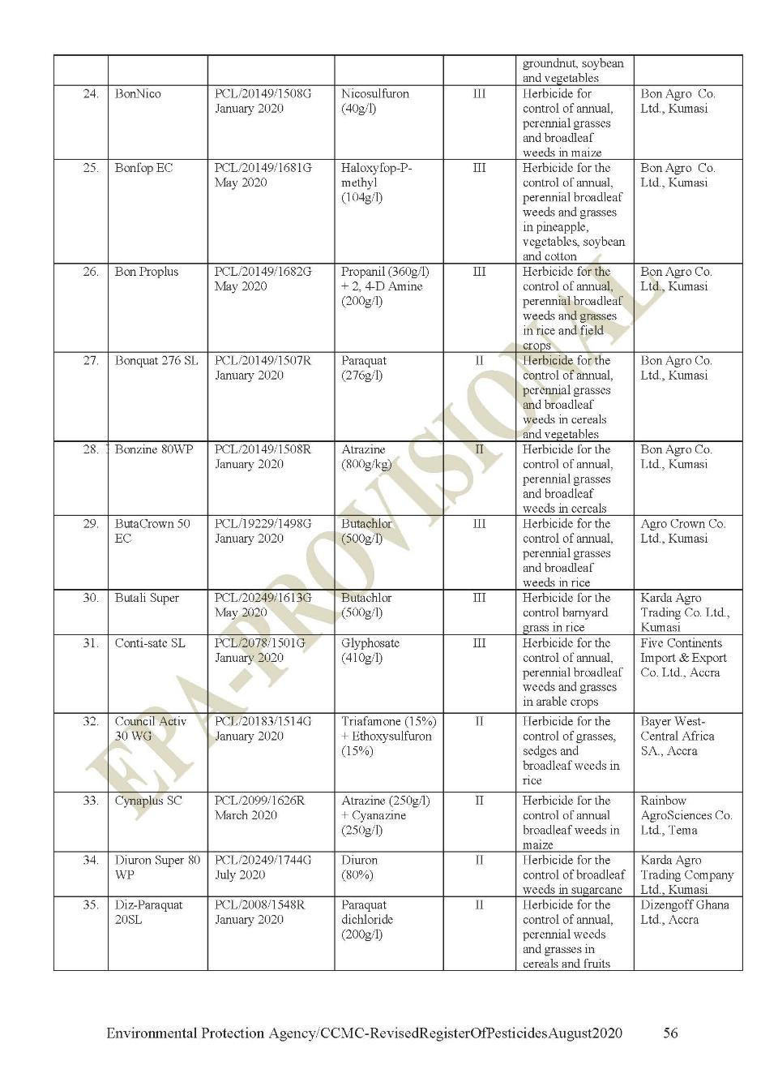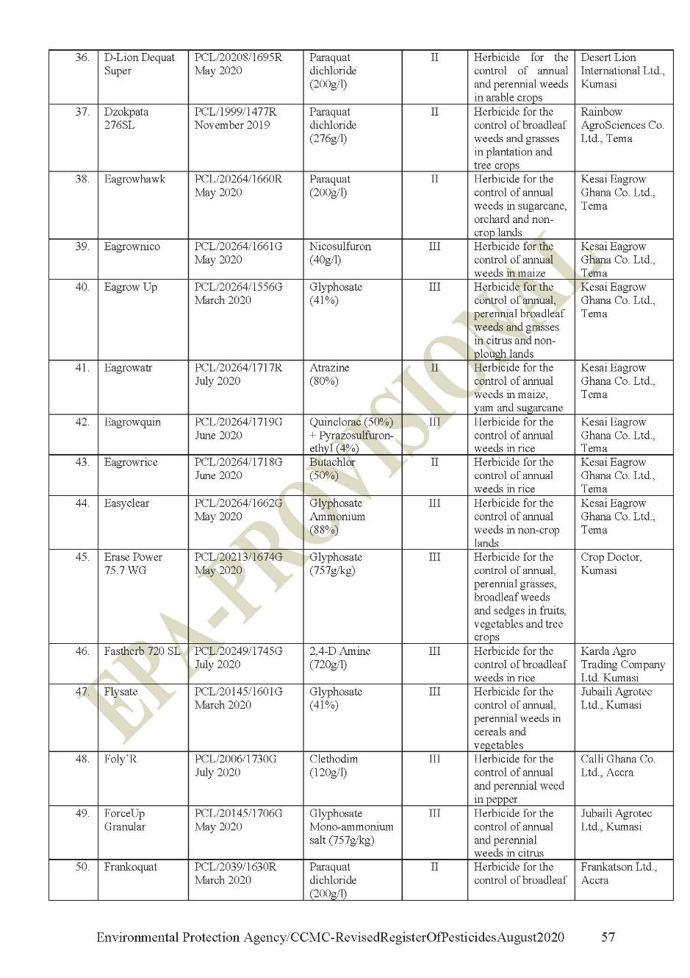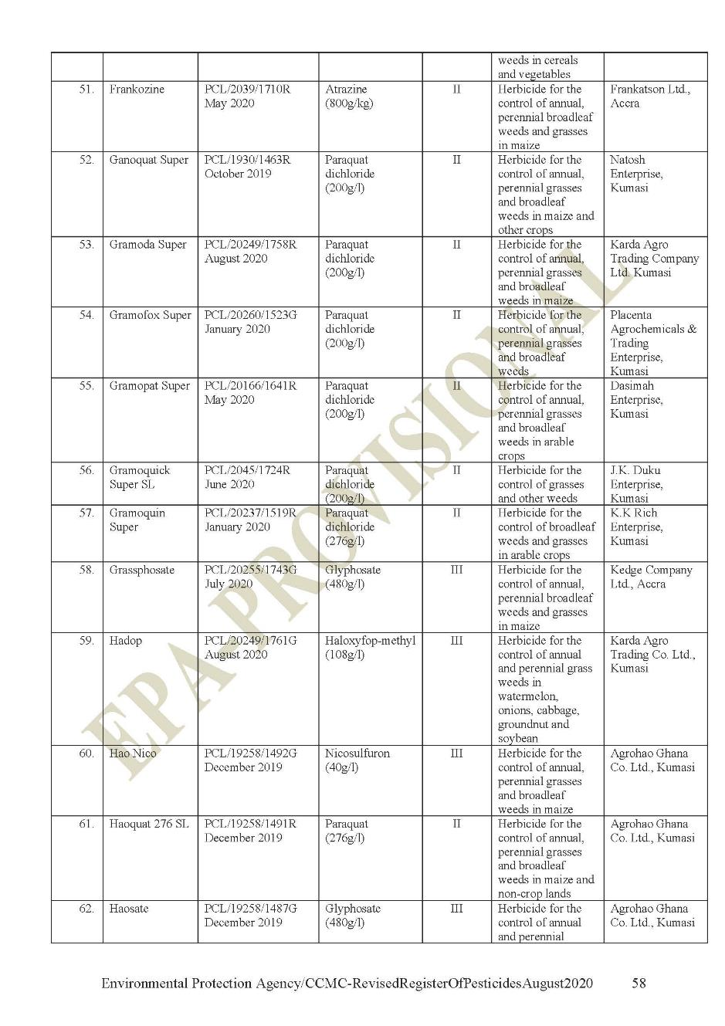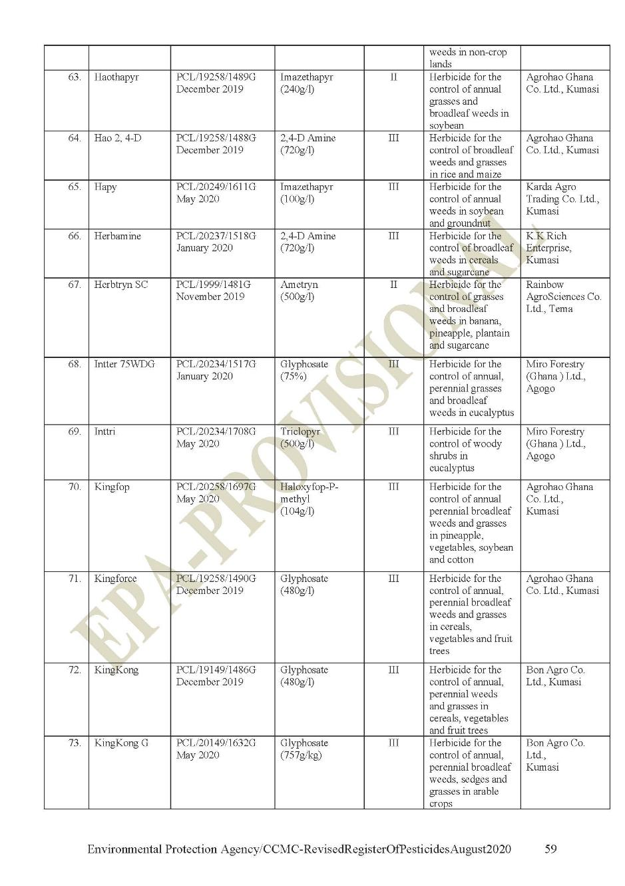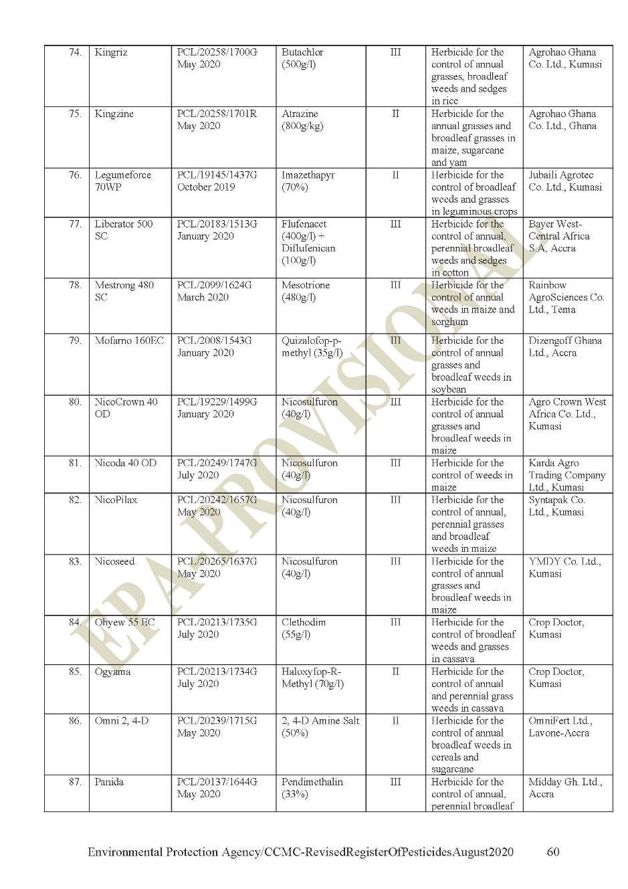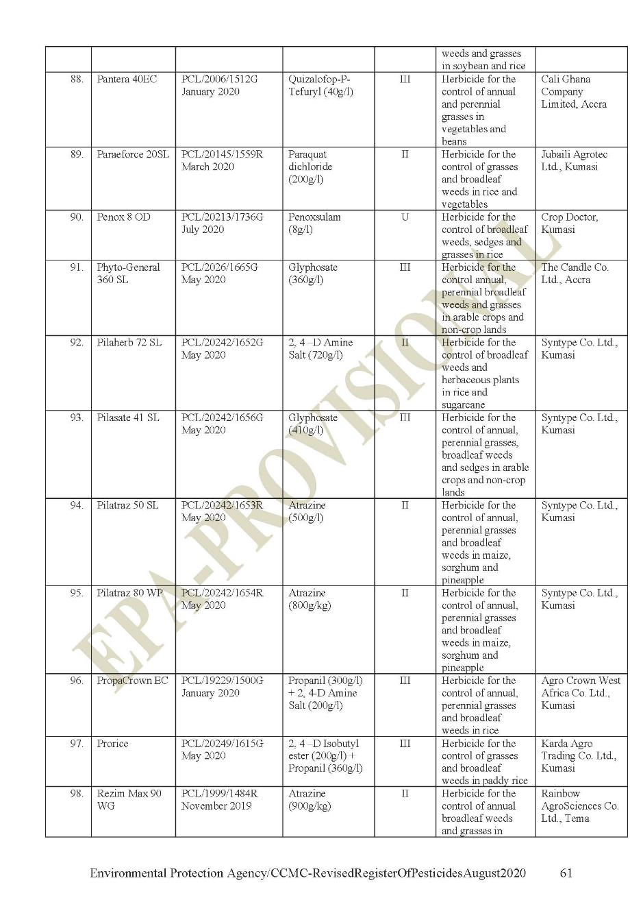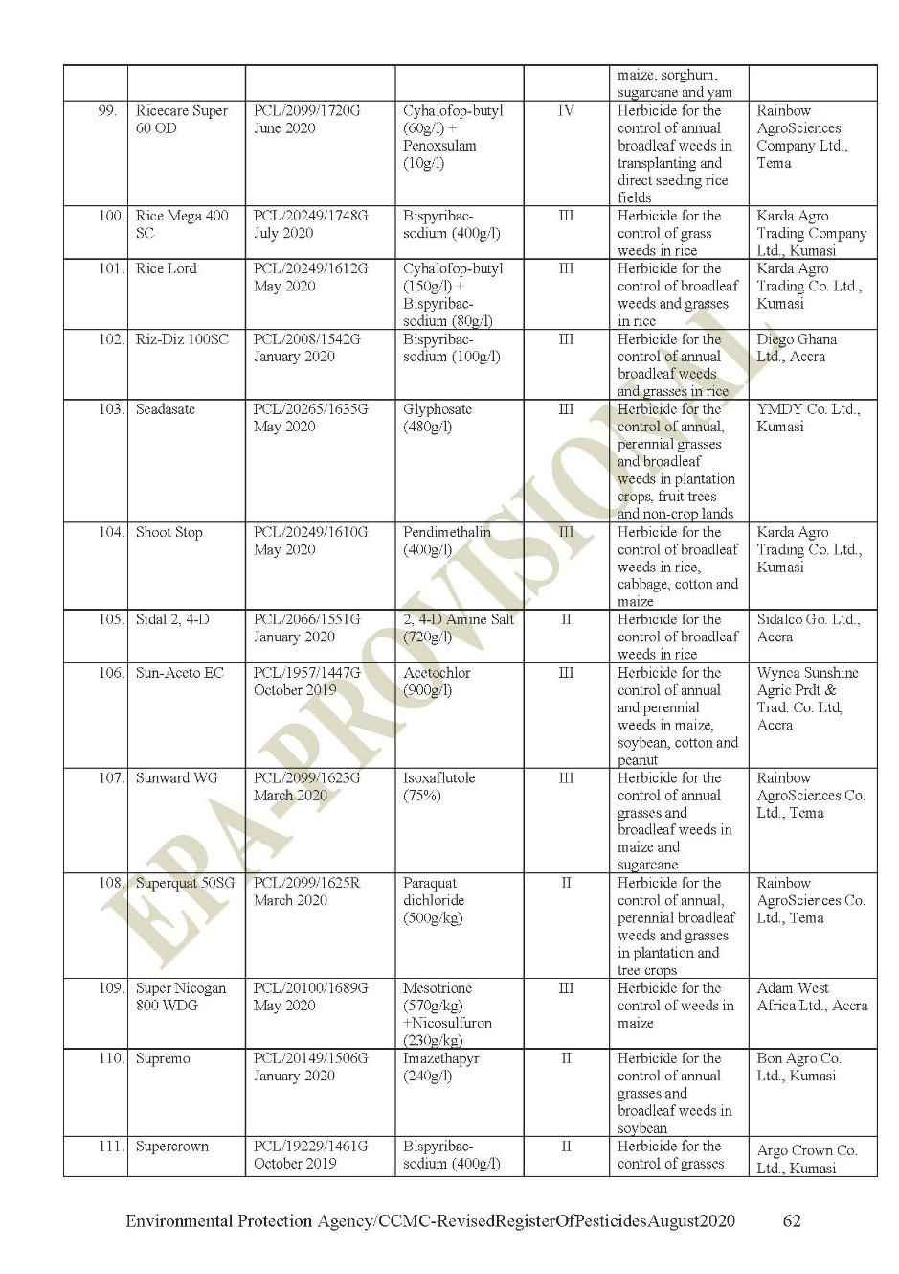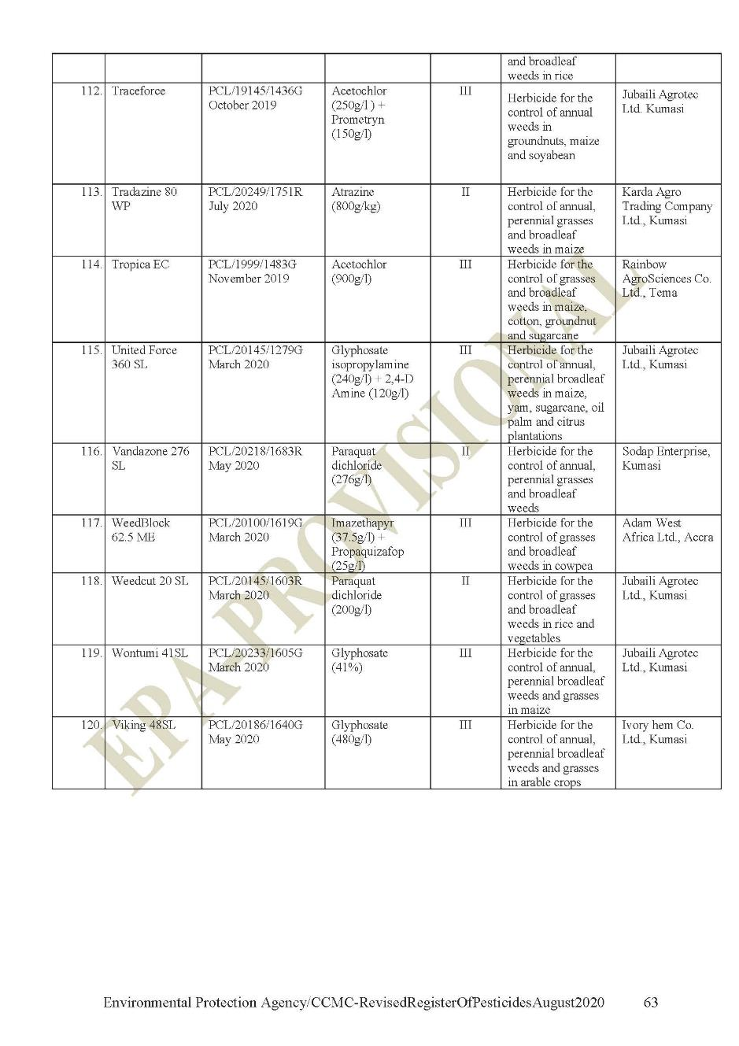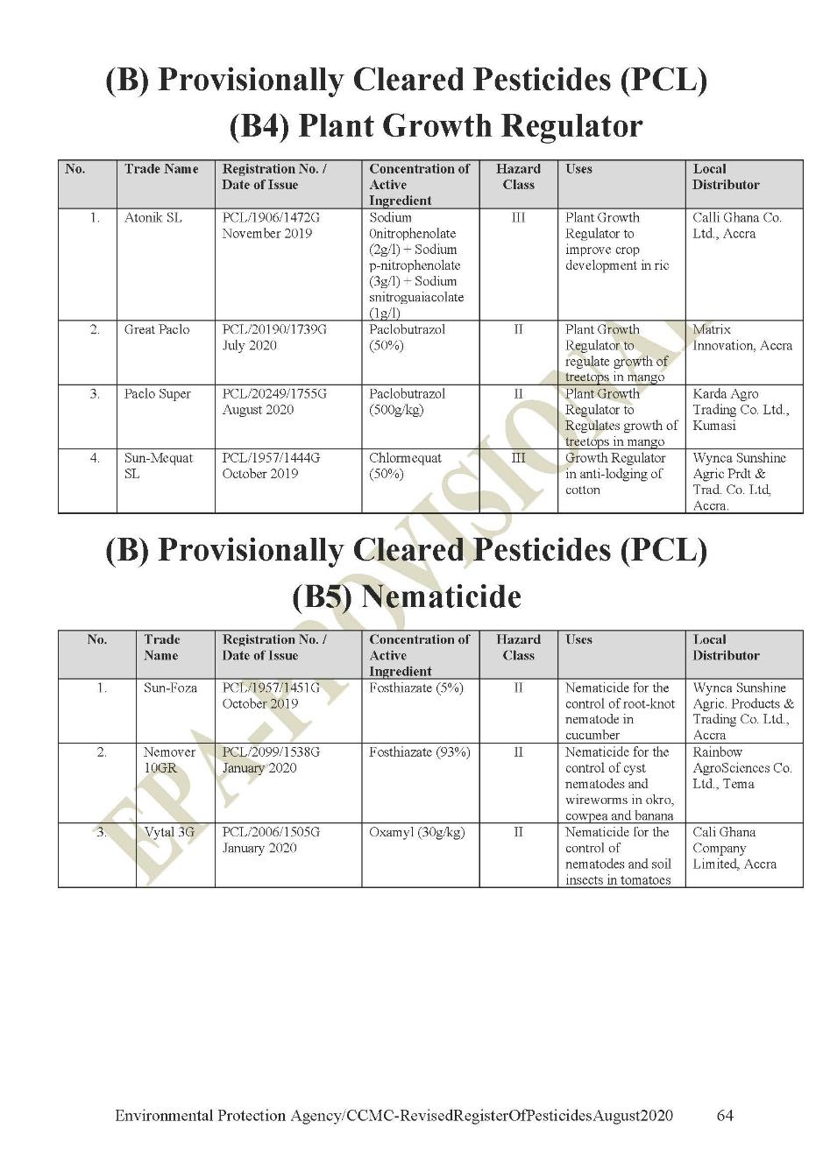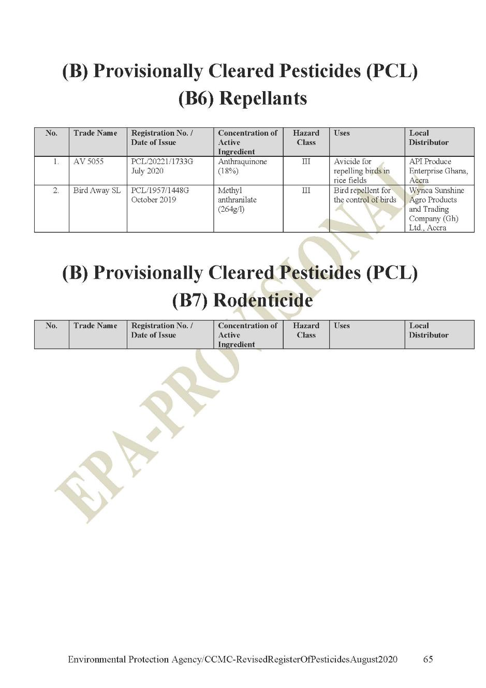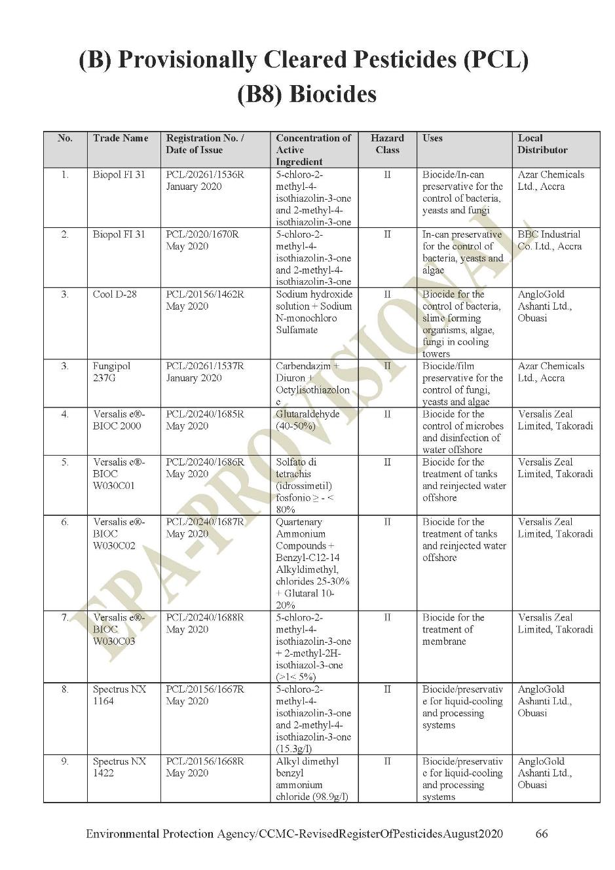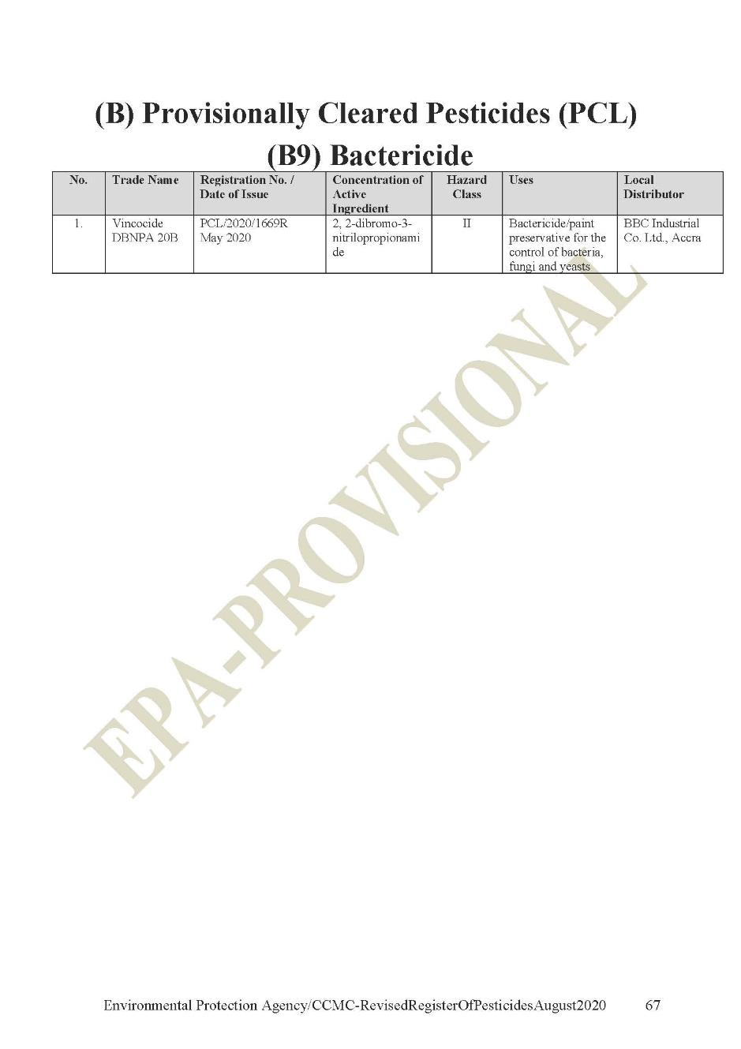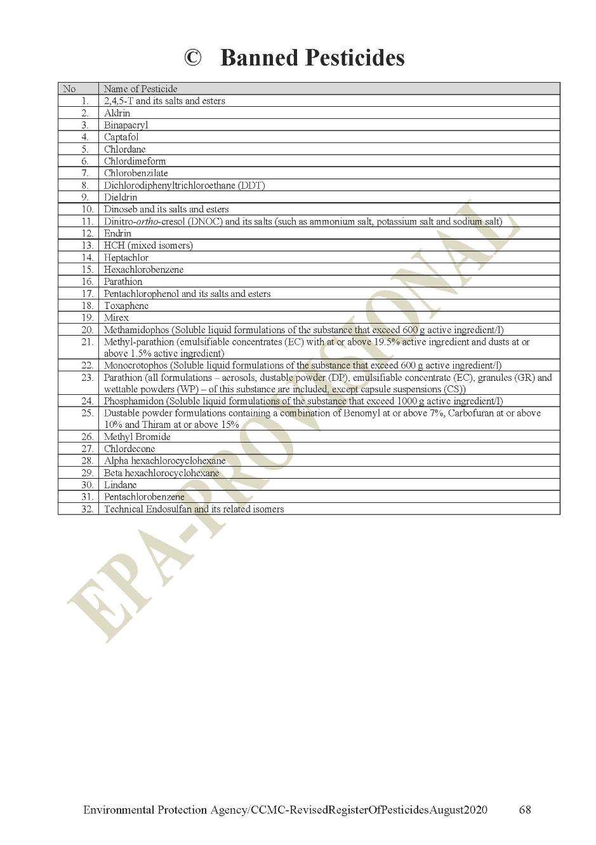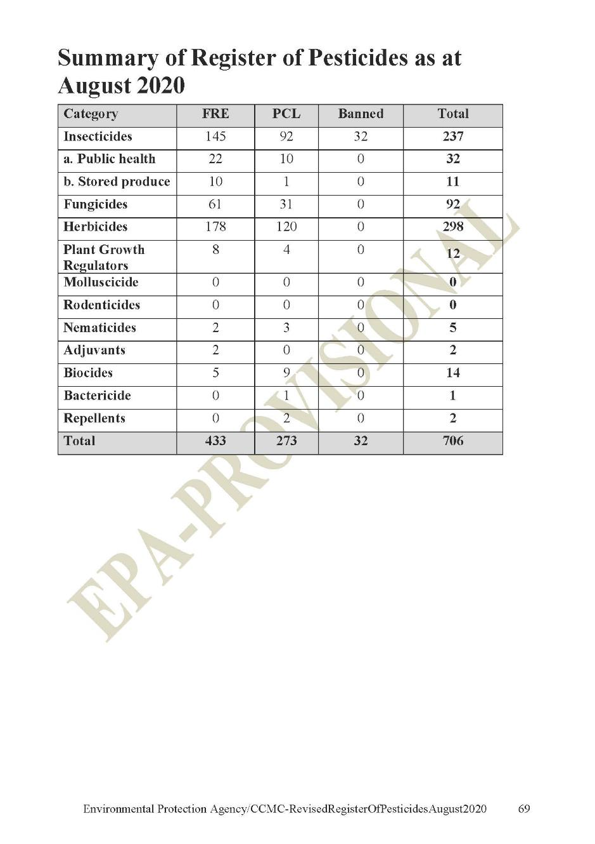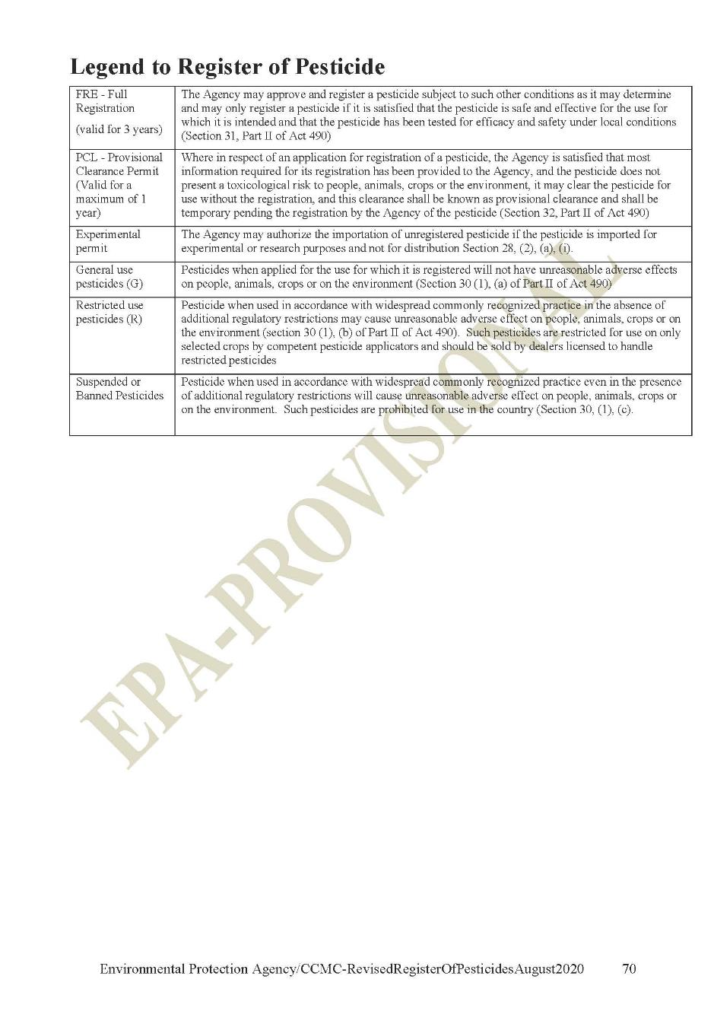

https://cocoainitiative.org/news-media-post/cocoa-farmers-in-ghana-experience-poverty-and-economic-vulnerability/
GSS (2016) 2015 Labour Force Report, the Ghana Statistical Service (GSS) – December 2016. http://statsghana.gov.gh/gssmain/fileUpload/Demography/LFS%20REPORT_fianl_21-3-17.pdf.
Ghana Country Environmental Analysis, World Bank 2020.
Mantey, Jones, Kwabena Nyarko, and Frederick Owusu-Nimo. 2016. Costed Reclamation and Decommissioning Strategy for Galamsey Operations in 11 Selected MDAs of the Western Region, Ghana. S-33205-GHA-1. London: International Growth Centre.
Delve, www.delvedatabase.org.
Minerals Commission, 2018.
https://eros.usgs.gov/westafrica/land-cover/deforestation-upper-guinean-forest
https://cocobod.gh/weakly_purchase.php
https://www.ifc.org/wps/wcm/connect/595149ed-8bef-4241-8d7c-50e91d8e459d/Final%2B-%2BMining.pdf?MOD=AJPERES&CVID=jqezAit&id=1323153264157
Sub-national levels include regional and district levels.
https://www.ifc.org/wps/wcm/connect/595149ed-8bef-4241-8d7c-50e91d8e459d/Final%2B-%2BMining.pdf?MOD=AJPERES&CVID=jqezAit&id=1323153264157
Institutional strengthening of Governance and Partnerships includes key agencies and stakeholders who are relevant to integrated landscape management and overall delivery of the Project development objective.
Sub-national levels include regional and district levels.
- The 1992 Constitution of the Republic of Ghana sets out the Rights, Freedom, Duties and Obligation of every citizen of Ghana. These are these are the constitutional rights of Ghanaians. The constitution also defines specific requirements for the protection of the Environment such as provided under: Article 37(3); Article 39(6); Article 41(k); Article 268 and Article 269.
- National Environmental Policy (Revised) 2010 comes in to replace the 1992 National Environmental Policy broad vision founded on and directed by respect for all relevant principles and themes of environment and sustainable development. The policy describes major environmental challenges in Ghana and recommends operational policies, sector strategic goals and sector environmental policies to combat them.

